NEAP 2005 | Unit 3 Chemistry | Trial Examination Solutions

Section A – Multiple choice questions
Question 1 A
An oxidant will undergo reduction during a redox reaction. Oxidation number decrease indicates reduction.
Oxidation Number of N in HNO₃ is +5.
Oxidation Number of N in NO is +2
Reactions in B, C and D show no change in the oxidation number of N.

Question 2 C
Sulfur burns in air: S (s) + O₂ (g) → SO₂ (g)
SO₂ reacts with water: SO₂ (g) + H₂O (l) → H₂SO₃ (aq)
H₂SO₃ is a weak acid: H₂SO₃ (aq) + H₂O (l) → HSO₃⁻ (aq) + H₃O⁺ (aq)

Question 3 A
A – bond formation is an exothermic process
B – cracking reaction ∴ endothermic
C – bond breaking ∴ endothermic
D – SO₃ (g) + H₂O (l) → H₂SO₄ (aq) is exothermic, hence the reverse process is endothermic

Question 4 C
 | SO₂ | NO₂ | SO₃ | NO
n_{i} | 2.0 | 2.0 | 0 | 0
change | –1.6 | –1.6 | +1.6 | +1.6
n_{e} | 0.40 | 0.40 | 1.6 | 1.6
c_{e} | 0.40 | 0.40 | 1.6 | 1.6
K = 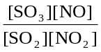 = 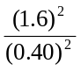 = 16

Question 5 B
The polymer shown is a polyester (–COO–) formed by condensation polymerisation ∴ not A or C.
Monomers are a dioic acid | 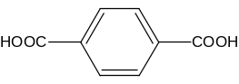 | and a diol, HO-CH₂-C₆H₁₀-CHOH

Question 6 D
Ba(OH)₂ (aq) 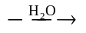 Ba²⁺ (aq) + 2 OH⁻ (aq)
[OH⁻] = 2 × [Ba(OH)₂] = 2 × 0.00500 = 0.0100 M
[H₃O⁺] = 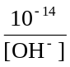 = 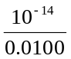 = 10^{-12.0} M
pH = –log[H₃O⁺] = –log10^{-12.0} = 12.0

Question 7 C
C | H | O | N | Na
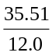 | 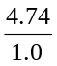 | 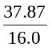 | 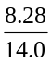 | 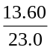
2.959 | 4.74 | 2.367 | 0.591 | 0.591
5 | 8 | 4 | 1 | 1 | C₅H₈O₄NNa

Question 8 A
Rate is increased by increased concentration of reactants (∴ A) and increased temperature (∴ not B). Removal of produce will not alter rate (∴ not C). Pressure increase will increase the rate of gaseous reactions, but the reaction shown is in aqueous solution (∴ not D)

Question 9 B
Chlorobutene C₄H₇Cl
CH₃CHClCH₂CH₃ C₄H₉Cl

Question 10 A
Relevant equation is: 2 SO₂ (g) + O₂ (g)  2 SO₃ (g)
Rate is fast (∴ not B). As reaction proceeds, pressure decreases (∴ not C). Reaction is exothermic (∴ not D).

Question 11 D
From the graph, [Na] = 1.75 mg mL⁻¹. Dilution factor of , [Na] = 5 × 1.75 = 8.75 mg mL⁻¹.

Question 12 C
n(AgCl) = 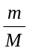 = 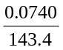 = 5.16 × 10⁻⁴ mol
n(Na⁺) = n(NaCl) = n(AgCl)
m(Na⁺) = n × M = 5.16 × 10⁻⁴ × 23.0 = 0.0119 g
[Na⁺] = 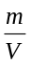 = 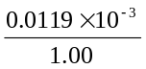 = 11.9 mg mL⁻¹

Question 13 B
The gravimetric analysis result is higher than the spectroscopy result. A wet precipitate or a contaminated precipitate would produce a higher than expected result, hence A, C and D could account for the different result. The dilution factor is not an explanation, since any dilution is included in the calculations.

Question 14 B
n(Mg) = = 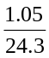 = 0.0432 mol
n(H₂) = n(Mg) = 0.0432 mol
V(H₂)_{SLC} = n × 24.5 = 0.0432 × 24.5 = 1.06 L

Question 15 A
Relevant equation: 2 NaOH (aq) + CO₂ (g) → Na₂CO₃ (aq) + H₂O (l)
CO₂ is an acidic oxide.
As the NaOH is reacted, the solution becomes less alkaline, hence pH decreases.
Water evaporating would concentrate the solution, rasing pH ∴ not C.

Question 16 D
K = 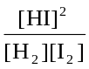
∴ 2.02 = 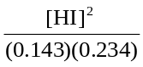
∴ [HI] = 0.260 M

Question 17 D
n(H₂) = c × V = 0.143 × 2.00 = 0.286 mol
n(I₂) = c × V = 0.234 × 2.00 = 0.468 mol
n(HI) = c × V = 0.260 × 2.00 = 0.520 mol
n_{total} = 1.274 mol
P = 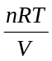 = 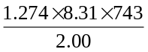 = 3.93 × 10³ kPa

Question 18 D
Water in the burette would lower the calculated concentration. Water in the pipette would raise the calculated concentration. Hence, the overall effect would depend on the relative amounts of water in the glassware.

Question 19 B
If more acid is added to reach the endpoint, the calculated concentration will be lower than the actual concentration, ie. the acid appears less concentrated.

Question 20 C
When titrating with a weak acid, the same volume of acid will be needed to reach the endpoint, since both reactions involve the same stoichiometry.
HCl (aq) + NaOH (aq) → NaCl (aq) + H₂O (l)
CH₃COOH (aq) + NaOH (aq) → CH₃COONa (aq) + H₂O (l)
In the weak acid titration, the product CH₃COO⁻ is a weak base. This will produce a slightly alkaline solution at the endpoint (pH ~8-9)

Section B – Short Answer Questions

Question 1
(a) | Each component adsorbs to the stationary phase and desorbs into the mobile phase. | (1 mark)
 | Components move at different rates due to their differing degrees of adsorption and desorption. | (1 mark)
(b) | 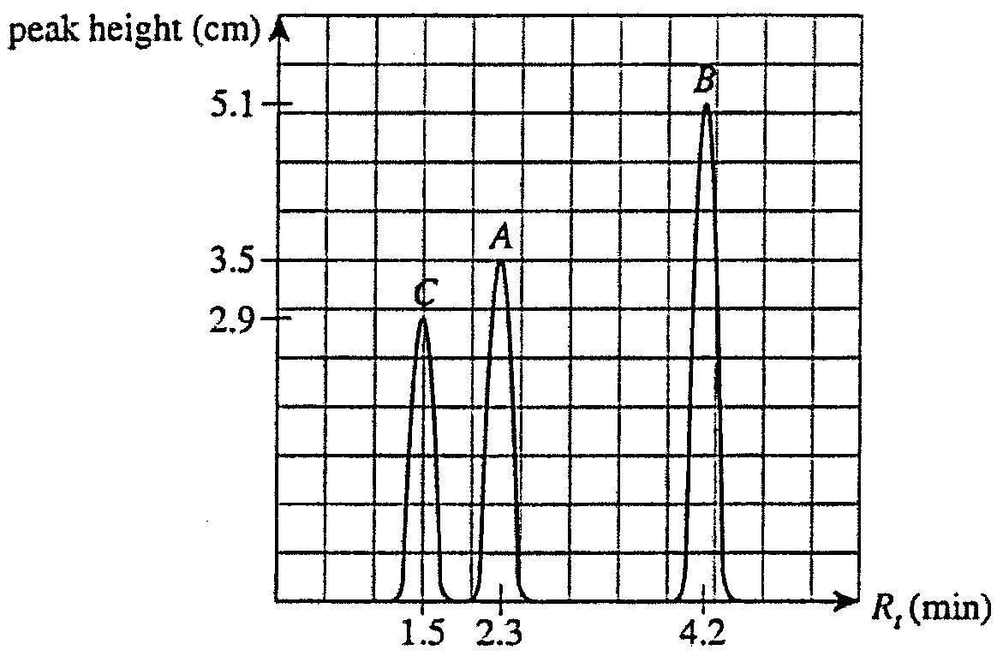 | (3 marks)
1 mark for correct locations and peak heights
1 mark for correct labelling of axes
1 mark for correct labelling of peaks
(c) | Component C – Propanol is the smallest/lightest of the three alcohols. It will be least strongly absorbed to the stationary phase (least dispersion forces) and so have the shortest retention time. | (2 marks)
 | Total 7 marks

Question 2
(a) | 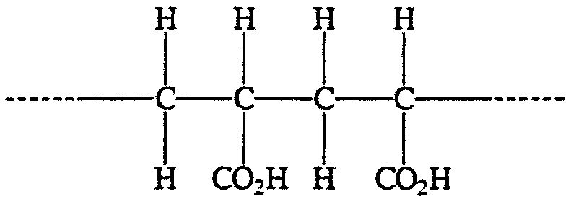 |  |  |  |  |  | (1 mark)
(b) | i. | K_{a} = 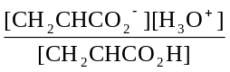 |  |  |  |  | (1 mark)
 | ii. | Let [H₃O⁺] = x  ∴ [CH₂CHCO₂⁻] = x  and [CH₂CHCO₂H]_{eq} = 0.10 – x ≅ 0.10 (since x is small for a weak acid)  K_{a} = 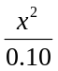 = 5.6 × 10⁻⁵ |  |  |  |  | (1 mark)
 | ii. | ∴ x = 2.4 × 10⁻³  ∴ pH = -log x = 2.6 |  |  |  |  | (1 mark)
(c) | Characteristic |  | Effect of dilution: the characteristic
 |  |  | increases | decreases | is unchanged
 | pH |  | ✓
 | value of K_{a} |  |  |  | ✓
 | percent ionisation of CH₂CHCO₂H |  | ✓ |  |  |  | (3 marks)
 | Total 7 marks

Question 3
(a) | Each component adsorbs to the stationary phase and desorbs into the mobile phase. |  | (1 mark)
(b) | i. | As pH increases, [H₃O⁺] decreases. By Le Chatelier’s principle, the reaction will move to the right (forward) to increase [H₃O⁺]. Hence [HOCl] decreases. | (2 marks)
 | ii. | Acidic conditions (low pH) may irritate swimmers’ eyes and skin.  OR  Acidic conditions may cause pool fittings to deteriorate. | (1 mark)
(c) | i. | n(S₂O₃²⁻) = c × V = 0.400 × 19.16 × 10⁻³ = 7.66 × 10⁻³ mol | (1 mark)
 | ii. | n(I₂) = ½ n(S₂O₃²⁻) = 3.83 × 10⁻³ mol | (1 mark)
 |  | Note: all I₂ in S₂O₃²⁻ reaction comes from the I₂ produced in the OCl⁻ reaction.

 | iii. | n(OCl⁻) = n(I₂)  n(NaOCl) = n(OCl⁻) = 3.83 × 10⁻³ mol | (1 mark)
 |  | m(NaOCl) = n × M = 3.83 × 10⁻³ × 74.5 = 0.285 g | (1 mark)
 | iv. | [NaOCl] = = 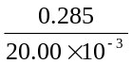 = 14.3 g L⁻¹ | (1 mark)
 | Total 9 marks

Question 4
(a) | Bonding between alkene molecules is by dispersion forces. As molecular size increases, the strength of dispersion forces increases, hence boiling point increases. |  |  |  |  | (1 mark)
(b) | C₆H₁₂
 | For example:
 | 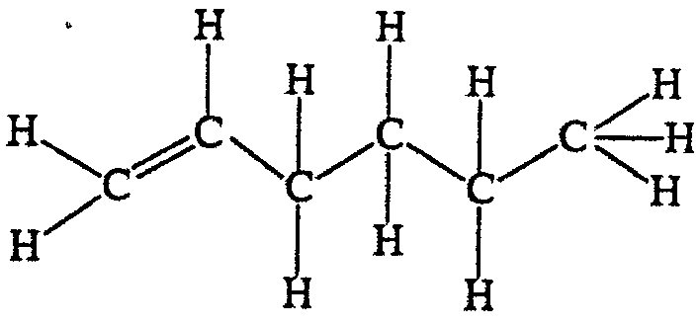 |  | 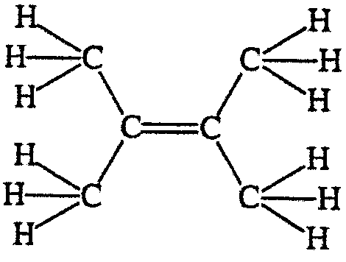 |  |  | (2 marks)
(c) | i. | C₆H₁₄ |  |  |  | (1 mark)
 | ii. | Feature |  | Tick in this column if the feature occurs during cracking |  | (1 mark)
 |  | Breaking of a C-C bond |  | ✓
 |  | Breaking of a C-H bond |  | ✓
 |  | Increase in the number of particles present |  | ✓
 |  | Pressure in reaction vessel decreases
 |  | Production of an alkene |  | ✓ |  | (2 marks)
 | Total 6 marks

Question 5
(a) | Exothermic. |  | (1 mark)
 | As temperature increases, the K value decreases. |  | (1 mark)
(b) | i. | As the reaction proceeds, the pressure decreases due to a decreased number of mole of gas particles present (4 mol → 2 mol) | (1 mark)
 |  | By Le Chatelier’s principle, high pressure will move the reaction in the forward direction to lower the pressure. More produce will form. | (1 mark)
 | ii. | Presence of impurities might poison the catalyst in the reactor. | (1 mark)
 | Total 5 marks

Question 6
(a) | Q |  | 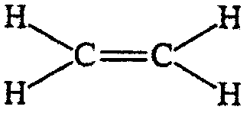 | (1 mark)
 | S |  | 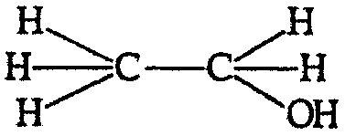 | (1 mark)
 | T |  | 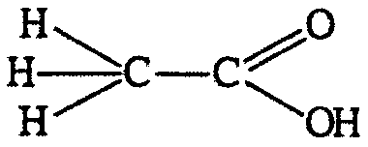 | (1 mark)
(b) | NaOH |  |  | (3 marks)
(c) | i. | D |  | (1 mark)
 | ii. | A or C |  | (1 mark)
 | Total 6 marks

