NEAP 2005 | Chemistry Unit 4 | Solutions

Section A - Multiple Choice Questions
1. | C | The coal-fired power station has an efficiency of approximately 35%. The largest percentage of chemical energy is ‘lost’ as heat.
2. | D | Let % abundance of ¹⁴N = x  RAM = Σ(RIM × abundance fraction)  ∴ 14.006 = 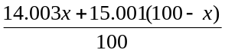  ∴ x = 99.699
3. | B | Oxidants present: Ni²⁺, H₂O. Strongest oxidant is Ni²⁺.  Reductants present: H₂O  Reduction half-equation: Ni²⁺ (aq) + 2 e⁻ → Ni (s)  Oxidation half equation: 2 H₂O (l) → O₂ (g) + 4 H⁺ (aq) + 4 e⁻  Water is therefore the reductant and the solvent.
4. | D | In a galvanic cell, electrons are released spontaneously at the anode, creating a negative charge. In an electrolytic cell, a forced release of electrons (oxidation) occurs at the positively charged electrode. The statements in D are incorrect.
5. | B | Transition metals are generally harder (∴ not D), have higher melting points (∴ not A) and are more likely to form complex ions (∴ not C) than the Group I/II metals.
6. | C | Enzymes are highly efficient and are only required in small quantities. Statement C is incorrect and so is the required response.
7. | A | Cr₂O₇²⁻  CrO₂  Cr³⁺ in Cr₂(SO₄)₃  Cr³⁺ in CrCl₃ |  |  |  |  | O.N. Cr = +6  O.N. Cr = +4  O.N. Cr = +3  O.N. Cr = +3
8. | D | Al (Z = 13)  Al³⁺  excited state |  |  | 1s²2s²2p⁶3s²3p¹  1s²2s²2p⁶  eg. 1s²2s²2p⁵3p¹
9. | B | n(e) = 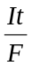 = 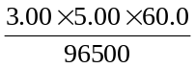 = 9.33 × 10⁻³ mol  Cu²⁺ (aq) + 2 e⁻ → Cu (s)  n(Cu²⁺) = ½ n(e) = 4.666 × 10⁻³ mol  [Cu²⁺] = 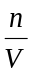 = 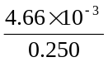 = 1.87 × 10⁻² M
10. | A | Protein is hydrolysed to amino acids. Amino acids are deaminated to produce urea ((NH₂)₂CO). The remaining CHO component is ultimately metabolised to produce CO₂ and H₂O.
11. | C | Mass numbers: 209 + 58 = 266 + 1  Atomic numbers: 83 + 26 = 109 + 0  ∴ the particle is 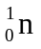, a neutron.
12. | B | Down’s cell: |  |  |  | molten NaCl/CaCl₂ electrolyte  high temperature required  anode: 2 Cl⁻ (l) → Cl₂ (g) + 2 e⁻  cathode: Na⁺ (l) + e⁻ → Na (l)
 |  | Membrane cell: |  |  |  | concentrated NaCl (aq) electrolyte  high temperature not required  anode: 2 Cl⁻ (l) → Cl₂ (g) + 2 e⁻  cathode: 2 H₂O (l) + 2 e⁻ → H₂ (g) + 2 OH⁻ (aq)
13. | A | Consider the electron configuration and the nuclear charge of each species.
 |  |  | O²⁺ | 8+ |  |  |  | 1s²2s²2p⁶
 |  |  | O | 8+ |  |  |  | 1s²2s²2p⁴
 |  |  | Al³⁺ | 13+ |  |  |  | 1s²2s²2p⁶
 |  |  | Na⁺ | 11+ |  |  |  | 1s²2s²2p⁶
O²⁻, Al³⁺, Na⁺ are isoelectric; O²⁻ has the smallest nuclear charge and therefore will have the largest radius.
O²⁻ will have a larger radius than O due to the increased repulsion by the added electrons (ie. anions are larger than their corresponding atoms).
14. | C | Denitrifying bacteria return N₂ to the atmosphere.
15. | A | Ionisation energy across a period increases due to the increasing pull on outer shell electrons by the increasing number of protons in the nucleus.
16. | B | 2 mol O₃ = 6.02 × 2 × 10²³ molecules produce 285 kJ  ∴ 6.02 × 10¹⁸ molecules produce x kJ  ∴ x = 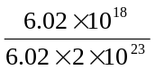 × 285 kJ  ∴ x = 143 × 10⁻⁵ kJ = 1.43 J
17. | D | Electronegativity decreases down groups due to the increasing distance between the nucleus and the outer shell electrons. (Core charge remains constant down a group.) D is therefore incorrect and so is the required response.
18. | A | Oxidation at the anode ∴ A or C.  Alkaline electrolyte ∴ A
19. | D | Cathode reaction is: O₂ (g) + 2 H₂O (l) + 4 e⁻ → 4 OH⁻ (aq)  ∴ OH⁻ is produced, raising the pH.
20. | C | - Cl₂ (g) → 2 Cl (g)  - Cl₂ (s) → Cl₂ (g)  - Cl (g) + e⁻ → Cl⁻ (g)  - Cl (g) → Cl⁺ (g) + e⁻ |  |  |  |  |  |  | bond breaking, ∴ endothermic  bond breaking, ∴ endothermic  addition of an electron to form the more stable Cl⁻ ion, ∴ exothermic  ionisation/removal of electron, ∴ endothermic

Section B – Answers to Short Answer Questions

Question 1
- i. eg. SO₂ (g) + H₂O (l) → H₂SO₃ (aq)
ii. eg. MgO (s) + 2 HCl (aq) → MgCl₂ (aq) + H₂O (l)
iii. eg. Al₂O₃ (s) + 2 NaOH (aq) + 3 H₂O (l) → 2 NaAl(OH)₄ (aq)
1 + 1 + 1 = 3 marks
- i. 6 CO₂ (g) + 6 H₂O (l) 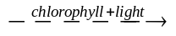 C₆H₁₂O₆ (aq) + 6 O₂ (g)
ii. eg. 4 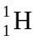 → 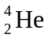 + 2 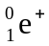
iii. 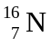 → 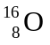 + 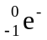
1 + 1 + 1 = 3 marks
Total 6 marks

Question 2
- B. Lipid B has the largest percentage of polyunsaturated fatty acids.
1 mark
The C=C double bonds in these fatty acids are the site of oxidation by oxygen in the air.
The higher degree of unsaturation, the greater the extent of oxidation.
1 mark

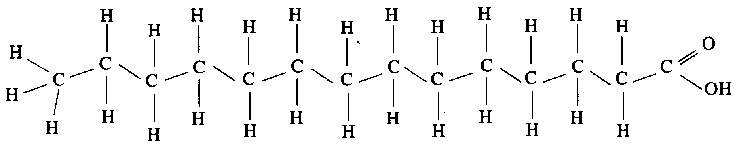
1 mark
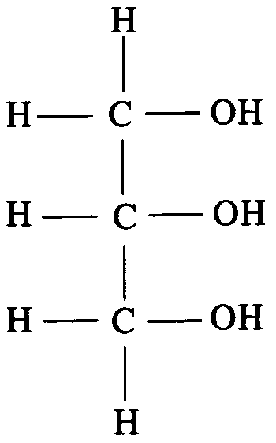
1 mark
- Any two of:
- addition of antioxidants to prevent/slow oxidative rancidity
- refrigeration to slow the rate of oxidation and hydrolysis reactions
- exclusion of air to prevent/slow oxidative rancidity
2 × 1 = 2 marks
Total 6 marks

Question 3
- Concentration. Predictions using the E⁰ table are only strictly correct at a concentration of 1.0 M. At higher/lower concentrations, other reactions may occur (eg. production of Cl₂ rather than O₂ at the anode for a concentrated Cl⁻ solution).
1 mark
Electrodes. Inert electrodes will produce a deposit of Cu at the cathode and Cl₂ or O₂ at the anode. If Cu electrodes are used, Cu²⁺ will be produced at the anode.
1 mark
- Any two of:
- insulation: to ensure no heat is lost to or absorbed from the calorimeter surroundings
- thermometer: to record change in temperature as reaction occurs
- stirrer: to ensure even heat distribution
2 × 1 = 2 marks
Total 4 marks

Question 4
- H₂O and a suitable enzyme
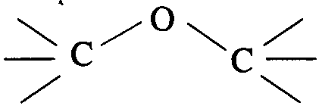
1 mark
- i. Ether linkages between monomers.
1 mark
ii. Presence of a –NHCOCH₃ side group on the ring structure.
1 mark
Total 3 marks

Question 5
- i. Energy released = c.f. × ΔT
= 1.5 × 6.90 kJ
Energy content = 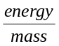
= 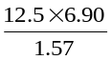
= 54.9 kJ g⁻¹

1 mark
ii. Energy content = 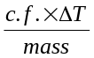
= 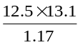
= 140 kJ g⁻¹
1 mark
- i. A is the negatively charged cathode. Reduction of the strongest oxidant occurs here.
2 H₂O (l) + 2 e⁻ → H₂ (g) + 2 OH⁻ (aq)
1 mark
ii. B is the positively charged anode. Oxidation of the strongest reductant occurs here.
2 H₂O (l) → O₂ (g) + 4 H⁺ (aq) + 4 e⁻
1 mark
iii. At A. n (H₂) = ½ n(e⁻) V(H₂) = n × V_{M}
At B. n (O₂) = ¼ n(e⁻) V(O₂) = n × V_{M}
1 mark
∴ 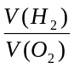 = 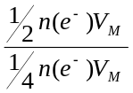 = 2
1 mark
iv. Electrolysis is an expensive process. The H₂ could not be economically produced.
1 mark
- i. m(H₂) = ⅓ m(petrol) = ⅓ × 29.6 kg
1 mark
n(H₂) = 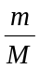 = × 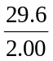 × 10³ mol
V(H₂) = 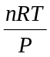 = × × 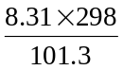 × 10³
1 mark
= 1.21 × 10⁵ L
1 mark
ii. Use of H₂ gas would not be viable due to the huge storage tank required.
1 mark
Total11 marks

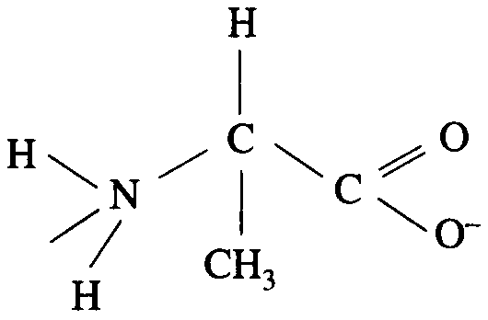
Question 6

1 mark
- i.
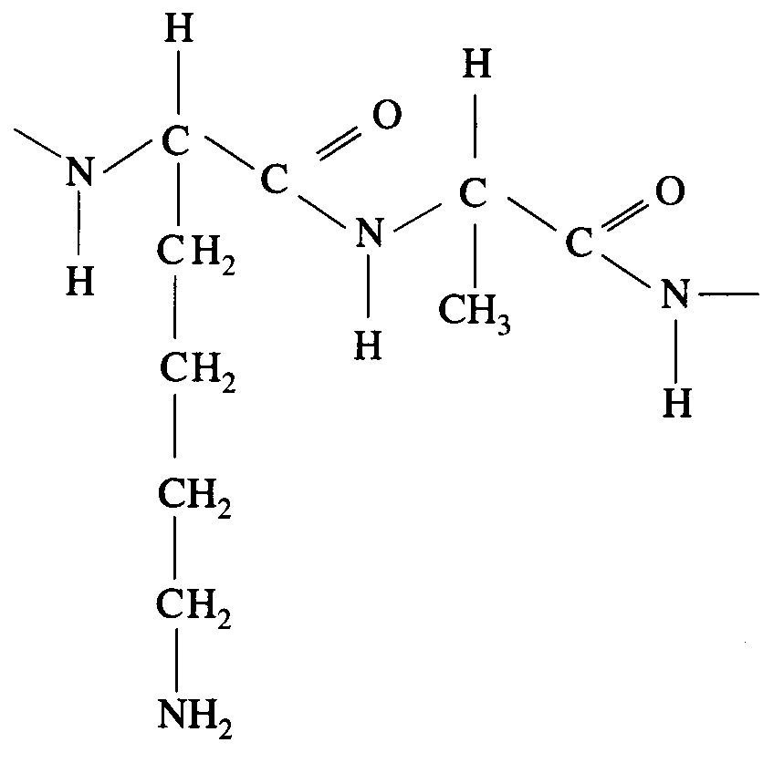 | OR | 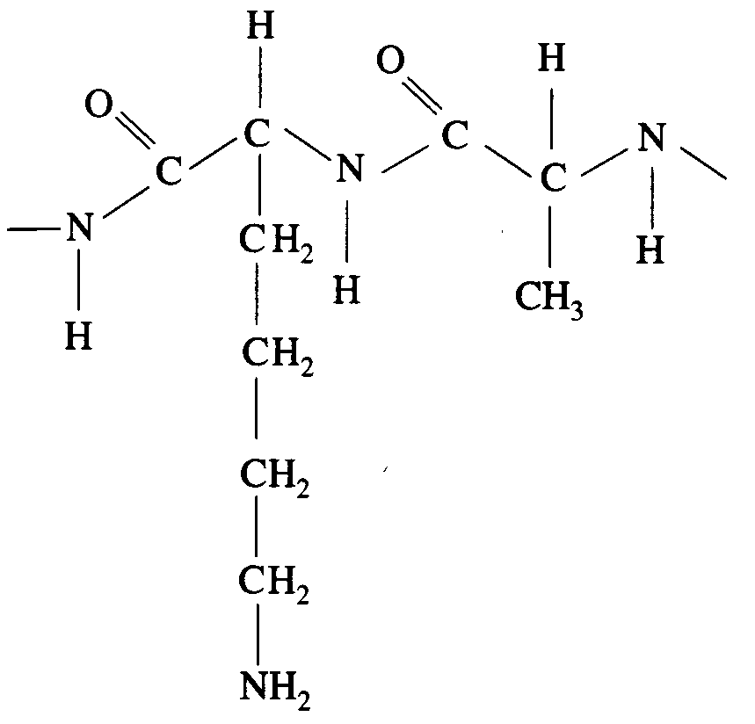
2 marks
ii. Glu has a polar side group. Val has a non-polar side group.
1 mark
Side groups are involved in the bonding which gives the protein its complex, three-dimensional shape. Altering the bonding therefore affects the structure.
1 mark
Total5 marks

Question 7
- Mendeleev arranged elements horizontally in order of increasing mass (1 mark) and vertically in groups of elements with similar chemical properties. (1 mark)
2 marks
By considering gaps in his table, Mendeleev was able to predict the existence of elements and use the properties of groups to predict the unknown elements’ properties.
1 mark
- Trends in properties result from changes in core and outer shell electron configuration.
1 mark
For these transition metals the outer shell configuration (4s²) is constant. The core charge is also constant (as for each proton added to the nucleus, an electron is added to the inner 3d shell).
1 mark
Total 5 marks

