STAV 2005 | Unit 3 Chemistry | Trial Examination Solutions

Section A – Multiple choice questions

- C
- A
- D
- D
- B
- D
- A
- B
- C
- C
- D
- C
- C
- A
- A
- B
- D
- A
- C
- B
- D
- B

Guidelines for Section A solutions

Question 1
n(M):n(O₂) = 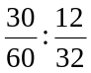 = 0.5:0.375 = 4:3 Hence, M₄(O₂)₃) = M₄O₆
Hence the empirical formula is M₂O₃ (Answer C)

Question 2
Retention time is determined by factors such as the pressure used to push the solvent through the column, the length of the column, the oven temperature and the affinity (attraction) of the component to the mobile phase (and also its affinity to the stationary phase). The greater the pressure, the shorter the column length, the higher the oven temperature and the greater the affinity of the component for the mobile phase – the shorter the retention time of the component. (Answer A)

Question 3
In gas chromatography the gas used for the mobile phase must be inert. Helium, neon and nitrogen are inert gases. (Answer D)

Question 4
The substance with the greater R_{f} value is less strongly adsorbed to the stationary phase. This is substance B.
R_{f} = | distance moved from origin by substance
R_{f} = | distance moved from origin by solvent
Hence distance moved form origin by substance = R_{f} × distance moved from origin by solvent
Therefore distance moved by substance B = 0.65 × 9.5 = 6.175 = 6.2 cm. (Answer D)

Question 5
n(NaN₃) = 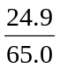 = 0.383 mol n(KNO₃) = 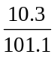 = 0.102 mol
10 mol of NaN₃ reacts with 2 mol KNO₃

Divide by 10 × 0.383

Therefore 0.383 mol of NaN₃ reacts with 0.0766 mol
Hence there is excess KNO and NaN₃ is the limiting reactant (to be used in further calculations).
n(N₂) = 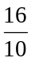 × n(NaN₃) = 1.6 × 0.383 = 0.613 mol
V(N₂) = n(N₂) × V_{m} = 0.613 × 24.5 = 15.0 L (Answer B)

Question 6
n(Ca²⁺) = cV = 1.00 × 10⁻³ × 10.0 = 1.00 × 10⁻² mol = n(Na₂CO₃.10H₂O)
M(Na₂CO₃.10H₂O) = 2 × 23.0 + 12.0 + 3 × 16.0 + 10 × 18.0 = 286.0 g mol⁻¹
mass (Na₂CO₃.H₂O) = n × M = .00 × 10⁻² × 286.0 = 2.86 g (Answer D)

Question 7
 | 2 NaBr (aq) | + | H₂O₂ (aq) | + | H₂SO₄ (aq) | → | Na₂SO₄ (aq) | + | Br₂ (aq) | + | 2 H₂O (l)
oxidation number of  the elements involved | +1 -1 |  | +1 -1 |  | +1 +6 -2 |  | +1 +6 -2 |  | 0 |  | +1 -2

The oxidation number of each atom is shown beneath the elements. Reduction involves a decrease in the oxidation number. This only occurs for oxygen: -1 in H₂O₂ to -2 in H₂O. (Answer A)

Question 8
Gravimetric analysis involves making a known mass of the sample into a solution; making this solution up to a specific volume; adding excess of a reagent to precipitate the component of the sample to be analysed; collecting, drying and weighing the precipitate. (Answer B)

Question 9
Increasing the volume of the reaction vessel for a system at equilibrium will cause the reaction to proceed in the direction of more particles according tot eh stoichiometry of the equation. Adding hydrogen will cause the reaction to move away from the side of the equation with hydrogen.

Alternative | Effect of increasing volume | Effect of adding hydrogen
A | none | Move towards reactants – the reverse direction
B | Move towards reactants – the reverse direction | Move towards products – the forward direction
C | none | Move towards products – the forward direction
D | Move towards products – the forward direction | Move towards reactants – the reverse direction

Therefore only alternative C will definitely result in the reaction moving in a forward direction. (Answer C)

Question 10
K₁ = 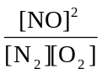 and K₂ = 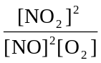
Therefore K₁ × K₂ = 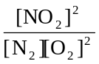 which is equal to the K value for the third equation. (Answer C)

Question 11
This is the titration of a weak acid with a strong base (typical of the curves shown in alternatives C and D). The titration curve showing the pH must start at a relatively low value indicating the presence of an acid in the conical flask (typical of alternatives B and D). The curve begins at a low pH and ends at a high basic pH. The pH change at the equivalence point (pH > 7) is not as rapid and sharp as that for a strong acid with a strong base titration (typical of the curves shown in alternatives A and B). (Answer D)

Question 12
n(NaOH) = CV = 0.0500 × 0.01950 = 0.000975 mol
n(diluted CH₃COOH) = n(NaOH)
c(diluted CH₃COOH) = 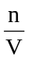 = 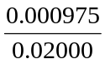 = 0.04875 M
c(CH₃COOH) in undiluted vinegar) = 10 × 0.04875 = 0.488 M (Answer C)

Question 13
The rinsing of the volumetric flask with water will not effect the calculated concentration of the vinegar as the vinegar in the flask is diluted with distilled water when the solution is made up to the calibration mark on the flask. (Answer C)

Question 14
K_{c} = 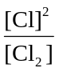 = 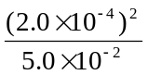 = 8.0 × 10⁻⁷ (Answer A)

Question 15
In an aqueous solution the species with the highest concentration is the water molecules. With a weak acid the acid molecule will be the next most abundant species followed by the hydronium ion. The concentration of the hydronium ion is also contributed to by the self-ionisation of water. (Answer A)

Question 16
K_{a} = 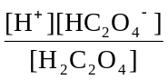 = 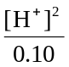 = 1.8 × 10⁻⁵ Hence: [H⁺]² = 1.8 × 10⁻⁶ and [H⁺] = 1.34 × 10⁻³
Therefore pH = -log₁₀[H⁺] = 2.87 (Answer B)

Question 17
From the graph, the % mass of X increases with a decrease in temperature. This is typical for the product of an exothermic reaction. (Answer D)

Question 18
The extent of a chemical reaction and the rate of the reaction are totally independent. (Answer A)

Question 19
2-butene has the structural formula: CH₃CH=CHCH₃. In the dark, 2-butene will undergo an addition reaction with Cl₂. (Answer C)

Question 20
Cracking involves the formation of alkenes and smaller alkanes (and hydrogen gas). This chemical process in endothermic. Decane has the formula C₁₀H₂₂, ethene, C₂H₄ and chemical formula of the alkane formed can found by subtracting: C₁₀H₂₂ - C₂H₄ to obtain C₈H₁₈. (Answer B)

Question 21
The reaction C₁₀H₂₂  C₂H₄ + C₈H₁₈ is endothermic. Therefore the yield of ethene will be increased by increasing the temperature. Increasing the temperature also increases the rate of the reactions. (Answer D)

Question 22
The chloro group can be attached to carbon atom 1, 2, 3 or 4 to produce four different unbranched isomers.
CH₂ClCH₂CH₂CH₂CH₂CH₂CH₃ 1-chloroheptane
CH₂CH₂ClCH₂CH₂CH₂CH₂CH₃ 2-chloroheptane
CH₂CH₂CH₂ClCH₂CH₂CH₂CH₃ 3-chloroheptane
CH₂CH₂CH₂CH₂ClCH₂CH₂CH₃ 4-chloroheptane
(Answer B)

Section B – Short Answer Questions

Question 1 (Total = 14 marks)
- (i) n(Carbon) = n(CO₂) = 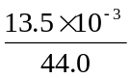 = 3.07 × 10⁻⁴ mol (1 mark)
(ii) H₂O → 2H + O
Therefore n(Hydrogen = 2 n(H₂O) (1 mark)
n(H) = 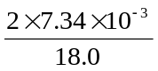 = 8.16 × 10⁻⁴ mol (1 mark)
(iii) mass (Carbon) = n × M = 3.07 × 10⁻⁴ × 12.0 = 3.68 × 10⁻³ g (1 mark)
mass (Hydrogen) = n × M = 8.16 × 10⁻⁴ × 1.0 = 8.2 × 10⁻⁴ g (1 mark)
Therefore mass (Oxygen) = 0.00612 – (0.00368 + 0.000816) = 0.001624 g
mass (Oxygen) = 0.00162 g (or 1.62 mg) (1 mark)
n(Oxygen) = 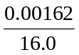 = 1.015 × 10⁻⁴ = 1.02 × 10⁻⁴ mol (1 mark)
- n(C) : n(H) : n(O) = 3.07 × 10⁻⁴ : 8.16 × 10⁻⁴ : 1.015 × 10⁻⁴
n(C) : n(H) : n(O) = 3.02 : 8.04 : 1.00 (1 mark)
Therefore the empirical formula is C₃H₈O (1 mark)
(One mark only for students who work backwards from the molar mass and knowledge that compound is an alcohol)
- Relative formula mass of C₃H₈O is 60.
Therefore the molecular formula is C₃H₈O. (1 mark)
(Allow mark for students who worked backwards from the molar mass and knowledge that compound is an alcohol)
- CO₂ (g) + 2 NaOH (aq) → Na₂CO₃ (aq) + H₂O (l ) (1 mark)
(Allow mark for students who write two stage reaction using NaHCO₃)
- (i) 2 CH₁₂O (l) + 15 O₂ (g) → 10 CO₂ (g) + 12 H₂O (g) (1 mark)
(Deduct 1 mark only if subscripts are incorrect on the equations in part (d) and (e)(i).)
(ii) For example; possible straight chained structures are:
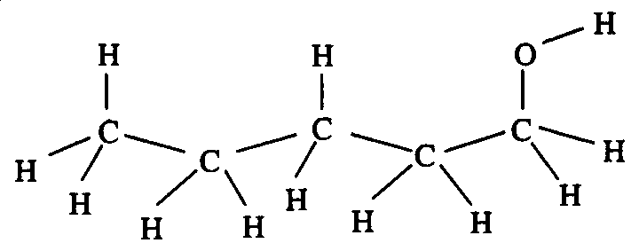  pentan-1-ol or 1-pentanol | and | 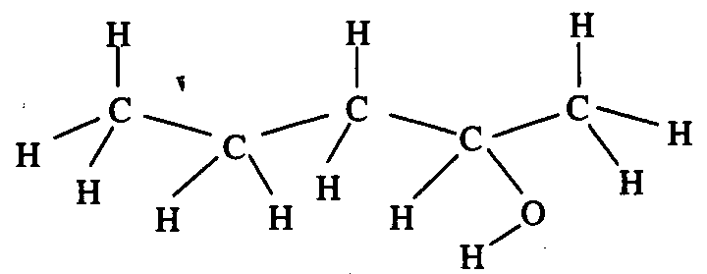  pentan-2-ol or 2-pentanol | and | 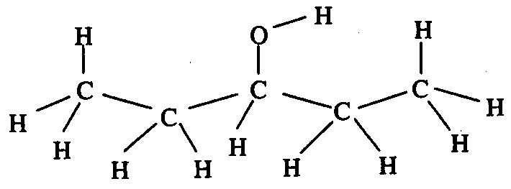  pentan-3-ol or 3-pentanol
(1 mark for structure and 1 mark for name = 2 marks)

Question 2 (Total = 5 marks)
- ‘Retention time’ is the time taken for a substance injected into the column to elute. (1 mark)
- The relative rates of adsorption onto the stationary phase and desorption (dissolution) into the mobile phase determine the retention time for a substance. These rates depend on the structure of the components. (1 mark) Substances that adsorb more strongly have longer retention times. (1 mark)
- (i) The sample of the metabolic produce and peak X have the same retention time (1 mark)
(ii) Metabolic produce: 7.0 ion current units corresponds to 0.010 mg L⁻¹
Peak X: 4.0 ion current units corresponds to ‘unknown’ concentration
Therefore concentration for Peak X = × 0.010 = 0.005714
Concentration of the substance at Peak X is 0.0057 mg L⁻¹. (1 mark)

Question 3 (Total = 6 marks)
- CaCO₃ (s) + 2 HCl (aq) → CaCl₂ (aq) + H₂O (l) + CO₂ (g) (1 mark)
- (i) The decrease in mass is due to the formation of the gaseous produce, CO₂. As each experiment has the same amount of reactants, the mass of CO₂ produced will be the same. (1 mark)
(ii) The section of the graph that is flat indicates the time when the reaction has reached its full extent. (No more product, CO₂, is being formed.) (1 mark)
(iii) Experiment I begins at the faster rate. (1 mark)
(iv) In Experiment I the marble chips would have the greater surface area.(1 mark) The greater the surface area the faster the rate of reaction. (1 mark)

Question 4 (Total = 5 marks)
- Process A: Fractional Distillation (1 mark)
Process B: Thermal (or Catalytic) Cracking (1 mark)
- Compound (i): ethanol (1 mark)
Compound (ii): ethanoic acid (1 mark)
Compound (iii): ethyl ethanoate (1 mark)

Question 5 (Total 9 marks)
- Fe₂O₃ (s) + 3 H₂SO₄ (aq) → Fe₂(SO₄)₃ (aq) + 3 H₂O (l) (1 mark)
- H₂SO₄ is acting as an ACID. (1 mark)
H⁺ ions are being donated by H₂SO₄ to the oxide ions to form water. (1 mark)
OR
It is a typical neutralisation reaction between an acid, H₂SO₄, and a base, Fe₂O₃, to form a salt, Fe₂(SO₄)₃, and water, H₂O. (1 mark)
(i) H₂S₂O₇ (ii) HSO₄⁻ (iii) C₆H₁₂O₆
(iv) SO₂ (v) NaOH (vi) SO₂ (6 × 1 = 6 marks)

Question 6 (Total = 9 marks)
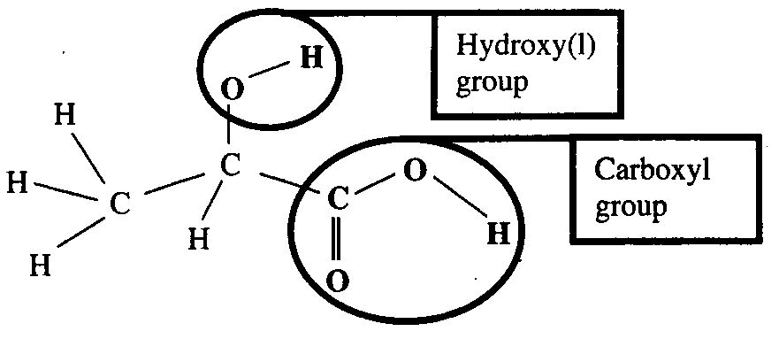

(1 mark for overall structure and
2 × 1 for each functional group = 3 marks)

- CH₃CH(OH)COOH (aq) + H₂O (l)  CH₃CH(OH)COO⁻ (aq) + H₃O⁺ (aq) (1 mark)
- K_{a} = 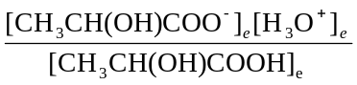 (1 mark)
- % ionisation = 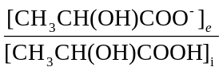 × 100 = 3.7 %
[CH₃CH(OH)COOH]_{i} = 0.900 M
Therefore [CH₃CH(OH)COO⁻]_{e} = 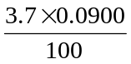 = 0.00333 M (1 mark)
Assuming negligible contribution to [H₃O⁺]_{e} by the self-ionisation of water:
[CH₃CH(OH)COO⁻]_{e} = [H₃O⁺]_{e} = 0.00333 M (1 mark)
Assuming insignificant dissociation of acid:
[CH₃CH(OH)COOH]_{e} = [CH₃CH(OH)COOH]_{i}
Note [X]_{e} indicates the concentration of X when the system is at equilibrium and [X]_{i} indicates the initial concentration of X.
Therefore: K_{a} = 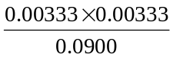 = 1.2321 × 10⁻⁴
K_{a} (lactic acid) = 1.2 × 10⁻⁴ at 25°C (1 mark)
- Atomic Absorption Spectrometer (1 mark)

