STAV 2005 | CHEMISTRY | Unit 4 | Trial Examination Solutions

Section A Multiple Choice Questions

- D
- A
- C
- C
- B
- D
- B
- B
- A
- A
- B
- D
- B
- C
- C
- C
- A
- B
- D
- D

Guidelines for Section A solutions

1 Mass (Al) = n × M = 0.37 × 27.0 = 9.99 g
ΔE = C_{b} m ΔT ∴ΔT = 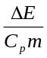 = 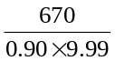 = 75°C
Answer: D

2 The connection between the copper and the iron metals will cause the more rapid corrosion of the iron. The iron is oxidized to Fe²⁺ (aq) and transfers its electrons to the copper. At the surface of the copper, reduction of water in the presence of O₂ will produce OH– (aq). The cathode reaction is: 2 H₂O (l) + O₂ (g) + 4 e– → 4 OH– (aq).
Answer: A

3 The conversion of heat (thermal) energy to mechanical energy (often referred to as the heat engine stage) is typically about 35% efficient and is the least efficient of the energy transformations occurring in a coal-fired power station.
Answer: C

4 The energy change A is the activation energy, the energy change B is equal to ΔH and energy change D does not represent any specific energy change.
Answer: C

5 In galvanic cells the strongest oxidant, Fe³⁺, reacts with the strongest reductant, Co. Note, the connecting of these species on the electrochemical series (on the Data Sheet) gives a negative gradient.
Answer: B

6 All three statements are correct.
Answer: D

7 Alternative B describes the first ionisation energy of sodium. The ionisation of an atom requires energy to remove the electron: and endothermic process.
(Note: alternative A describes the formation of covalent bonding (only). The formation of bonds always releases energy and is therefore an exothermic process.)
Answer: B

8 A decrease in temperature occurs during an endothermic process.
ΔH = H_{products} – H_{reactants} and H_{products} is greater than H_{reactants} for an endothermic process.
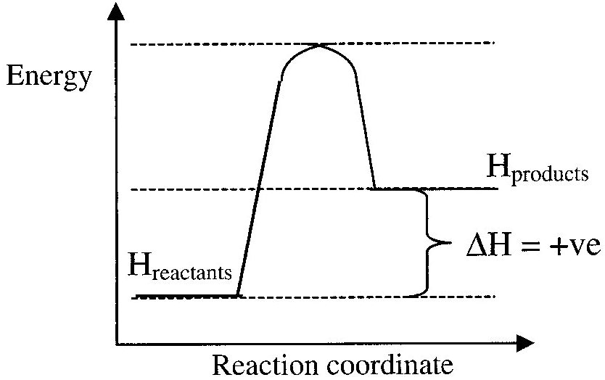
Hence ΔH is positive for an endothermic process.
Answer: B

9 Coal, crude oil and natural gas are fossil fuels. Biofuel is a general name for renewable fuels from plants. This includes wood and ethanol from sugar cane. Other examples include an alternative diesel fuel and lubricants made from the oil from canola (rapeseed).
Answer: A

10 An emulsifier must have a long non-polare ‘tail’ and a polar region. Only nonane, alternative A, has no polar region.
Answer: A

11 The synthesis of polysaccharides involves the formation of glycosidic (ether) groups via the condensation reaction of hydroxyl functional groups.
Answer: B

12 Fats are mainly digested in the alkaline (not acidic) conditions in the duodenum. Digestion is the breaking down of fats to fatty acids. Amylase is involved in the digestion of starch to sugars.
Answer: D

13 Amino acids found in human proteins must be α-amino acids (or 2-amino acids). This means that the amino and carboxyl functional groups must be attached to the same carbon atom in the amino acid. This is not the case for the amino acid shown in alternative B.
Answer: B

14 Monosaccharides have the general formula C_{n}(H₂O)_{n} or C_{n}H_{2n}O_{n} and must contain three to nine carbon atoms.
Answer: C

15 Fats contain ester bonds that undergo hydrolysis to form the hydroxyl and carboxyl functional groups.
Answer: C

16 The actinide series is the second row of f-block elements and corresponds to the filling of the second f subshell. The first f subshell is in the fourth shell and is the 4f subshell and the second f subshell is the 5f subshell.
Answer: C

17 In a mass spectrometer ionisation by a beam of electrons of the gaseous sample productions cations (positive ions) that are accelerated by an electric field. A magnetic field causes the ions to move in curved paths.
Answer: A

18 The mass number of an isotope is approximately equal to the relative isotopic mass of an atom. For vanadium the relative atomic mass is very close to the relative isotopic mass of vanadium-51. Therefore ‘almost’ all naturally occurring vanadium must be vanadium-51. The relative abundance of vanadium-51 is 99.75%.
Answer: B

19 P₄O₁₀ is an acidic oxide: P₄O₁₀ + 6 H₂O → 4 H₃PO₄
Na₂O and CaO are basic oxides and Al₂O₃ is amphoteric.
Answer: D

20 Alternative D defines an emission spectrum.
Answer: D

Section B Short Answer

Question 1 (Total 10 marks)
- i. Molar mass C₈H₁₈ = 8 × 12.0 + 18 × 1.0 = 114.0 g mol^{–1}
10930 kJ of energy is released by 2 mol of octane | 1 mark
∴ 10930 kJ is released by 2 × 114.0 g of octane
∴ 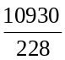 × 10³ kJ is released by 1 kg of octane
Hence, 4.794 × 10⁴ kJ of energy is released per kg of octane. (*) | 1 mark
ii. Molar mass C₂H₆O = 2 × 12.0 + 6 × 1.0 + 1 × 16.0 = 46.0 g mol^{–1}
1370 kJ of energy is released by 1 mol of ethanol
∴ 1370 kJ is released by 46.0 g of ethanol
∴ 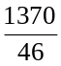 × 10³ kJ is released by 1 kg of ethanol
Hence, 2.98 × 10⁴ kJ of energy is released per kg of ethanol. (*) | 1 mark
- i. n(octane) = 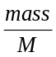 = 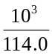 = 8.772 mol
n(CO₂) = 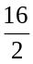 × n(octane) = 8 × 8.772 = 70.18 mol | 1 mark
mass(CO₂) = n × M = 70.18 × 44.0 = 3088 g = 3.09 × 10³ g (*) | 1 mark
ii. n(ethanol) = = 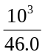 = 21.74 mol
n(CO₂) = 2 × n(ethanol) = 2 × 21.74 = 43.48 mol | 1 mark
mass(CO₂) = n × M = 43.48 × 44.0 = 1913 g = 1.91 × 10³ g (*) | 1 mark
- CO₂ efficiency (octane) = 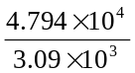 = 15.5
CO₂ efficiency (ethanol) = 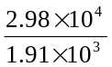 = 15.6 | 1 mark
Therefore ethanol would be (marginally) more useful in terms of CO₂ efficiency in fulfilling the Kyoto Protocol based solely on the mass of CO₂ per kg of fuel. | 1 mark
- Other factors would be the source of the fuel. For example octane is obtained from crude oil while ethanol could be obtained from renewable energy sources such as sugar cane. | 1 mark
Other factors would be the cost of producing the fuel and the availability of the fuel.

Question 2 (Total 3 marks)
- 2 H₂O (l) 2 e– → H₂ (g) + 2 OH– (aq) | 1 mark
- If iron is used as the electrode it would be oxidised because iron is a stronger reductant than the chloride ion, Cl– (aq). | 1 mark
- The membrane cell produces NaOH (aq) which is more pure than that produced by the diaphragm cell. | 1 mark
or  The membrane cell does not use a toxic substance to separate the anodic and cathodic chambers. [Asbestos can cause lung diseases such as asbestosis.] | 1 mark

Question 3 (Total 6 marks
 | 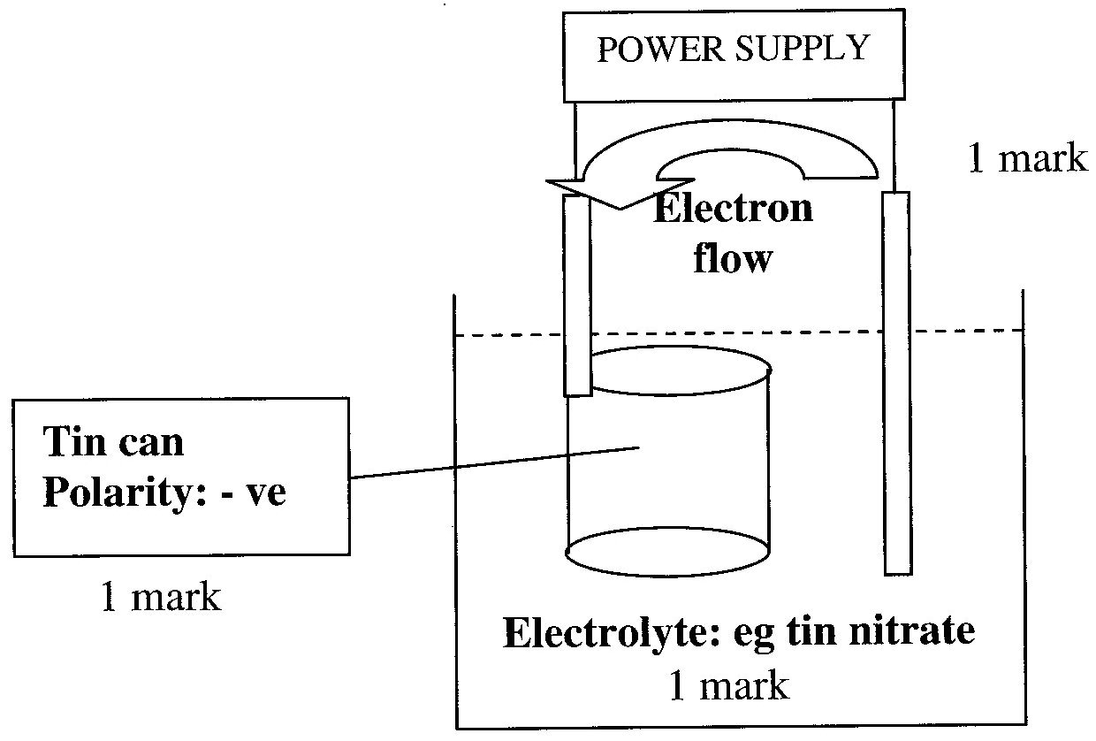
- Using density = 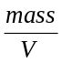
mass(Sn) = d × V = 7.30 × 0.41 = 2.993 g  n(Sn) = = 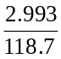 = 0.025215 mol |  | 1 mark
Q = I t = 3.25 × 25.0 × 60 = 4875 C  n(e–) = 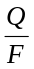 = 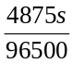 = 0.05052 mol |  | 1 mark
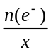 = n(Sn) ∴ x = 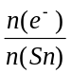 = 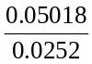 = 2  hence Sn²⁺ + 2 e– → Sn  ∴ the charge on the tin ion is +2. |  | 1 mark

Question 4 (Total 8 marks)
- Oxidation number of nitrogen in: | N₂ is 0  NO₂– is +3 | 2 × 1 = 2 marks
- (i) N₂ (g) + 6 H⁺ (aq) + 6 e– → 2 NH₃ (aq)
(ii) NH₃ (aq) + 2 H₂O (l) → NO₂– (aq) + 7 H⁺ (aq) + 6 e–
(iii) Nitrogen is oxidised in Process I. |  | 3 × 1 = 3 marks
- (i) denitrifying (bacteria)
(ii) nitrogen fixing or nitrifying (bacteria) |  | 2 × 1 = 2 marks
- For example: lightning, higher temperature furnace or internal combustion engine. |  | 1 mark

Question 5 (Total 6 marks)
- The tertiary structure of a protein determines the three dimensional shape of an enzyme. | 1 mark
It is the three dimensional shape that determines whether the substrate molecule can bind to the enzyme (and be catalysed in its reaction). | 1 mark
(For example: the enzyme and substrate act like a ‘lock and key’ mechanism.)
- The enzyme enables the reaction to occur via an alternative pathway with a lower activation energy. | 1 mark
- Weak bonding responsible for maintaining the three dimensional structure of the enzyme is broken by an increase in the temperature. | 1 mark
[The change in shape of a protein means that it will not function as an enzyme and, therefore, is denatured.]
- The carboxyl functional group is acidic and will react with the strong base, KOH, to form the anion, –COO– | 1 mark
The formation of the anion will change the way the enzyme interacts with the original substrate. The changed enzyme will not be as effective in catalysing the reaction. | 1 mark

Question 6 (Total 7 marks)
 | 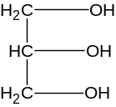 | and | CH₃(CH₂)₁₄COOH | 2 × 1 = 2 marks
- The fatty acid, C₁₅H₃₁COOH, used to make the triglyceride is saturated  as the general formula of the fatty acid, C_{n}H_{2n+1}COOH indicates that all C-C bonds are single bonds. Hence, tripalmitin is saturated |  |  |  |  | 1 mark  1 mark
- The long non-polar alkyl chain, (C₁₅H₃₁)–, causes the triglyceride to be insoluble in water. Non-polar substances do not dissolve in a polar substance, such as water. |  |  |  |  | 1 mark
- Tripalmitin needs to be emulsified prior to digestion to provide a greater surface area for the enzymes to act upon to cause hydrolysis (at a suitable rate). |  |  |  |  | 1 mark
- C₁₆H₃₂O₂ (s) + 23 O₂ (g) → 16 CO₂ (g) + 16 H₂O (g) |  |  |  |  | 1 mark

Question 7 (Total 14 marks)
- i. The first ionisation energy is the minimum amount of energy required to remove an electron from an atom in the gaseous state. |  |  | 1 mark
ii. K (g) → K⁺ (g) + e– |  |  | 1 mark
- In general, the first ionisation energy increases as you move left to right (Na to Ar) across the Period. This is due to the decrease in atomic radius resulting in greater attraction between the nucleus and the outer shell electrons. Hence the outer shell electrons are more strongly bonded to the atom and hance require more energy to remove them. |  |  | 1 mark
Alternatively an increase in core charge causes a greater attraction between the nucleus and the outer shell electrons. |  |  | 1 mark
- Ar atom | 1s²2s²2p⁶3s²3p⁶
S^{2–} ion | 1s²2s²2p⁶3s²3p⁶ | 2 × 1 = 2 marks
- i. The argon atom has 18 protons while the potassium ion has 19 protons. |  |  | 1 mark
The argon atom has 21 neutrons while the potassium ion has 20 neutrons.
[Note: both species have 18 electrons.]
 |  | 2 × 1 = 2 marks
ii. 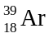 → 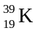 + 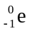 (or β–) |  |  | 1 mark
- The K⁺ ion would be smaller than the K atom. |  |  | 1 mark
The loss of the one electron from the outer shell means that there are only 3 occupied electron shells in the potassium ion rather than the four for the potassium atom. Hence, the ionic radius will be less than the atomic radius. |  |  | 1 mark
- i. Atoms of an element (with the same atomic number and, hence, the same number of protons) with different mass numbers (and, hence, different numbers of neutrons) are isotopes. |  |  | 1 mark
For example, all three isotopes of plutonium have 94 protons. However, Pu-239 has 145 neutrons, Pu-242 has 148 neutrons and Pu-244 has 150 neutrons. |  |  | 1 mark
ii. 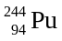 → 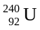 + 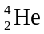 (or α) |  |  | 1 mark
iii. Pu is not a naturally occurring element. Hence, Pu does not have a relative atomic mass. The brackets are used to signify this. |  |  | 1 mark
[Note: the relative atomic mass of an element is the weighted mean of the relative isotopic masses of the naturally occurring isotopes of an element on the carbon-12 scale where an atom of carbon-12 is assigned a value of exactly 12.]

Question 8 (Total 7 marks)
- Co⁴⁺ ion: 1s²2s²2p⁶3s²3p⁶3d⁵ |  |  |  |  |  |  |  |  |  |  |  |  |  |  | 1 mark
- Oxidation numbers |  | Cs | +1 |  |  | Co | +4 |  |  | F | –1 | 3 × 1 = 3 marks
(c) | 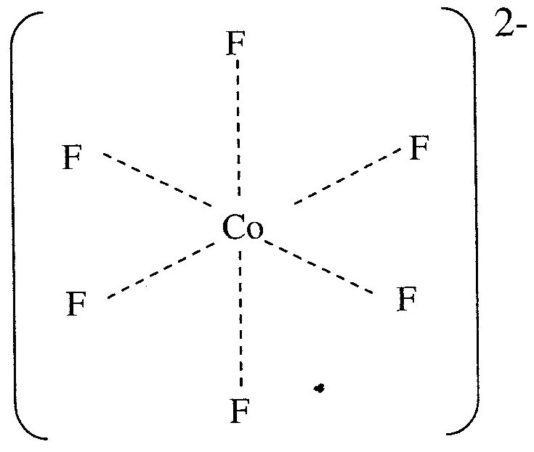 |  |  |  | or |  |  | 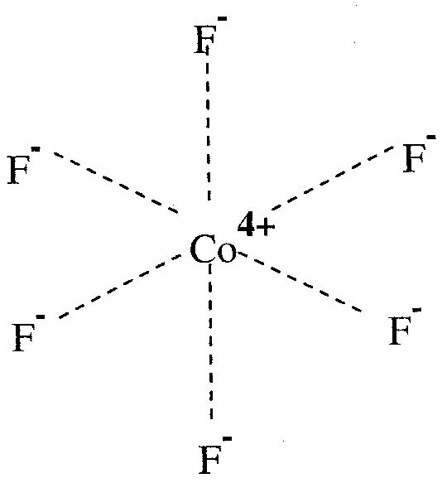 |  |  |  |  |  | 2 × 1 = 2 marks
 | Shape: Octahedral
- Transition metal complex ions are usually coloured due to differences in energies of the 3 d orbitals caused by the anions surrounding the transition metal cations. The differences in energies often correspond to the energies of photons of visible light. These photons are absorbed by the cations causing the transmitted or reflected light to be coloured. |  |  |  |  |  |  |  |  |  |  |  |  |  |  | 1 mark
(The blue light is the light that is not absorbed by the cobalt complex.)

