STAV
2005
UNIT 4 CHEMISTRY

SECTION A – Multiple-choice questions

Question 1
A sample of 0.37 mol of aluminium, specific heat capacity 0.90 J g⁻¹ °C⁻¹, absorbs 0.67 kJ of heat. The temperature increase of the aluminium sample would be closest to
- 0.075°C
- 0.28°C
- 28°C
- 75°C

Question 2
In the construction of hot water systems, two dissimilar metals such as copper and iron should not be welded together because
- the more easily oxidised metal would transfer electrons to the other metal
- an elastic junction is needed to allow for different thermal expansion of the metals
- the metal which has the more positive electrode potential, E₀, value would be oxidised
- the electrical potential produced by such a connection would decompose water

Question 3
In Victoria, the majority of electricity is produced by burning brown coal in the power stations of the Latrobe Valley. The diagram is a simplified flowchart representing the processes, shown as A to D, that occur in a coal-fired power station.
A
D
B
C
Chemical energy in coal | → | Thermal energy of burning coal | → | Thermal energy of steam | → | Mechanical energy of turbine | → | Electrical energy from generator

The process that is least efficient is
- Process A
- Process B
- Process C
- Process D

Question 4
The diagram shows the energy changes occurring during a chemical reaction.
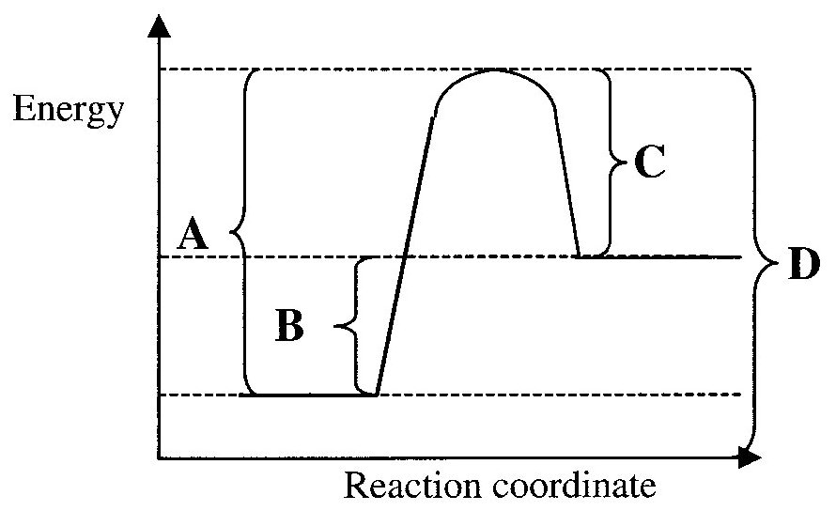
According to the diagram, the letter representing the energy change during the formation of new bonds is
- energy change A
- energy change B
- energy change C
- energy change D

Question 5
The diagram represents a cell set up to investigate the reaction between the conjugate redox pairs of Fe³⁺/Fe²⁺ and Co²⁺/Co.
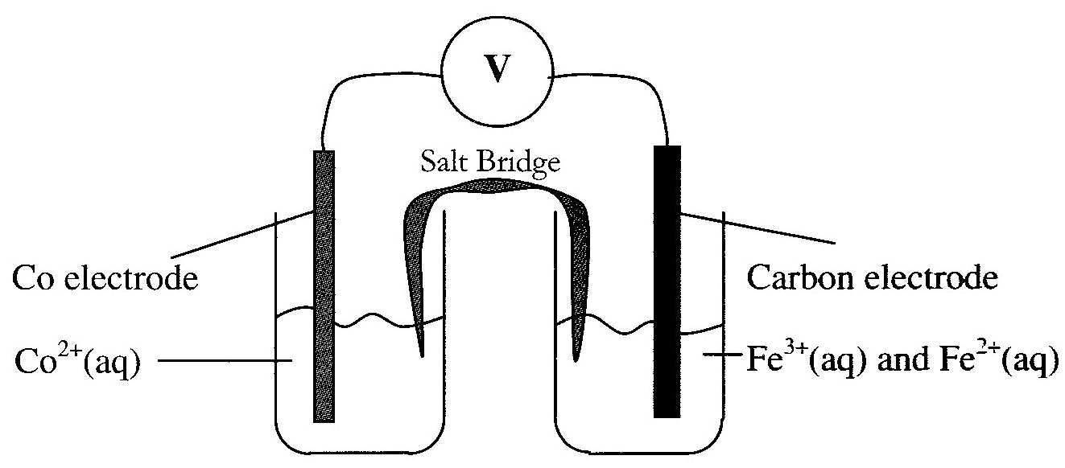
The overall reaction occurring in this cell is
- Fe²⁺ (aq) + Co (s) → Fe (s) + Co²⁺ (aq)
- 2 Fe³⁺ (aq) + Co (s) → 2 Fe²⁺ (s) + Co²⁺ (aq)
- Fe (s) + Co²⁺ (aq) → Fe²⁺ (aq) + Co (s)
- 2 Fe²⁺ (aq) + Co²⁺ (aq) → 2 Fe³⁺ (aq) + Co (s)

Question 6
Suggestions regarding the electrodes of a fuel cell are
I The electrodes enable electrons to move in and out of the cell.
II The electrodes catalyse the reactions of the cell.
III The electrodes are expensive.
The correct alternative for the electrodes in a fuel cell is
- I only
- II and III only
- I and III only
- I, II and III

Question 7
The process that is endothermic is
- Cl (g) + Cl (g) → Cl₂ (g)
- Na (g) → Na⁺ (g) + e
- NaOH (aq) + HCl (aq) → NaCl (aq) + H₂O (l)
- 2 Na (s) + Cl₂ (g) → 2 NaCl (s)

Question 8
When solid NH₄NO₃ dissolves in water the temperature of the mixture drops.
The process is
- endothermic and ΔH is negative
- endothermic and ΔH is positive
- exothermic and ΔH is negative
- exothermic and ΔH is positive

Question 9
Which of the following is not a fossil fuel?
- biofuel
- brown coal
- natural gas
- crude oil

Question 10
Which of the following would be least likely to act as an emulsifier?
- CH₃CH₂CH₂CH₂CH₂CH₂CH₂CH₂CH₃
- CH₃CH₂CH₂CH₂CH₂CH₂CH₂CH₂OH
- CH₃CH₂CH₂CH₂CH₂CH₂CH₂COOH
- H₂NCHCOOH
|
CH₂CH₂CH₂CH₂CH₂CH₂CH₃

Question 11
Which of the following statements concerning biomolecules is not correct?

Triglycerides, proteins and polysaccharides
- are synthesised in cellular processes via condensation reactions
- involve the reaction of the carboxyl functional group in their formation
- undergo hydrolysis during digestion
- are capable of hydrogen bonding with water molecules

Question 12
When lipids are digested
- an acidic environment is needed such as the stomach
- they are stored as fatty acids
- the process beings when the lipid meets the enzyme amylase in the saliva
- surfactants are needed to emulsify them in order to increase the rate of digestion

Question 13
Which of the following could not be found in human protein?
- H₂NCH(CH₃)COOH
- H₂NCH₂CH₂COOH
- H₂NCHCOOH
|
CH₂SH
- H₂NCHCOOH
|
CH₂NH₂

Question 14
Which of the following is a monosaccharide?
- C₂H₄O₂
- C₆H₁₀O₅
- C₆H₁₂O₆
- C₁₂H₂₂O₁₁

Question 15
When a fat molecule (triglyceride) undergoes hydrolysis in the small intestine, the new functional group that are formed are
- only hydroxyl functional groups
- carboxyl functional groups and amino functional groups
- hydroxyl functional groups and carboxyl functional groups
- hydroxyl functional groups and amino functional groups

Question 16
Plutonium is a transuranium element in the actinide series. The electron of highest energy in an atom of plutonium, atomic number 94, is in a
- 6d orbital
- 4f orbital
- 5f orbital
- 6f orbital

Question 17
Which of the following does not occur in a mass spectrometer?
- Anions are accelerated by a magnetic field.
- Atoms can lose one or more electrons.
- High energy electrons are used to bombard a sample.
- Particles are separated on a mass/charge ratio.

Question 18
The element vanadium, relative atomic mass 50.9415, consists of two isotopes, one of mass number 50, vanadium-50, and the other of mass number 51, vanadium-51.
A correct statement about the isotope of vanadium is
- vanadium-50 accounts for almost all of the naturally occurring vanadium
- vanadium-51 accounts for almost all of the naturally occurring vanadium
- vanadium-51 contains one more electron than vanadium-50
- vanadium-50 contains one more electron than vanadium-51

Question 19
Which of the following would be least likely to act as a base?
- Na₂O
- K₂O
- Al₂O₃
- P₄O₁₀

Question 20
An emission spectrum consists of distinct coloured lines on a black background.
The coloured lines correspond to
- the energies of light that are absorbed by the electrons of an atom when it is excited
- quanta of energy present in ultra violet light
- light that is given off by all atoms due to the orbiting of electrons
- different frequencies of light which are given off by excited electrons as they return to more stable energy levels

SECTION B – Short-answer questions

Question 1
The Kyoto Protocol requires signatory countries to restrict their emissions of CO₂. A strategy to counter CO₂ emissions is to use fuels that provide a high CO₂ efficiency.

CO₂ efficiency = | energy released in kJ per kg of fuel
CO₂ efficiency = | CO₂ emission in g per kg of fuel

Table comparing thermochemical data

Fuel | Chemical equation | ΔH
C₈H₁₈ | 2 C₈H₁₈ (g) + 25 O₂ (g) → 16 CO₂ (g) + 18 H₂O (g) | –10930 kJ mol^{–1}
CH₃CH₂OH | C₂H₆O (g) + 3 O₂ (g) → 2 CO₂ + 3 H₂O (g) | –1370 kJ mol^{–1}

- Calculate the energy released, in kJ per kg, of
- octane
__________________________________________________________________________________
__________________________________________________________________________________
__________________________________________________________________________________
__________________________________________________________________________________
__________________________________________________________________________________
- ethanol
__________________________________________________________________________________
__________________________________________________________________________________
__________________________________________________________________________________
__________________________________________________________________________________
__________________________________________________________________________________
- Calculate the mass, in g, of CO₂ emitted per kg of
- octane
__________________________________________________________________________________
__________________________________________________________________________________
__________________________________________________________________________________
__________________________________________________________________________________
__________________________________________________________________________________
- ethanol
__________________________________________________________________________________
__________________________________________________________________________________
__________________________________________________________________________________
__________________________________________________________________________________
__________________________________________________________________________________
- Calculate the efficiency for the two fuels and state which would be more useful in fulfilling the Kyoto Protocol.
_______________________________________________________________________________________
_______________________________________________________________________________________
_______________________________________________________________________________________
_______________________________________________________________________________________
_______________________________________________________________________________________
_______________________________________________________________________________________
- State another factor that would be considered when selecting between the suitability of ethanol and octane as a fuel.
_______________________________________________________________________________________
_______________________________________________________________________________________
_______________________________________________________________________________________
3 + 4 + 2 + 1 = 10 marks
Suggested time = 11 minutes

Question 2
Sodium hydroxide and chlorine are produced by the electrolysis of a concentrated aqueous solution of sodium chloride. Modern electrolytic cells used for the production of chlorine involve the use of a semi-permeable plastic membrane.
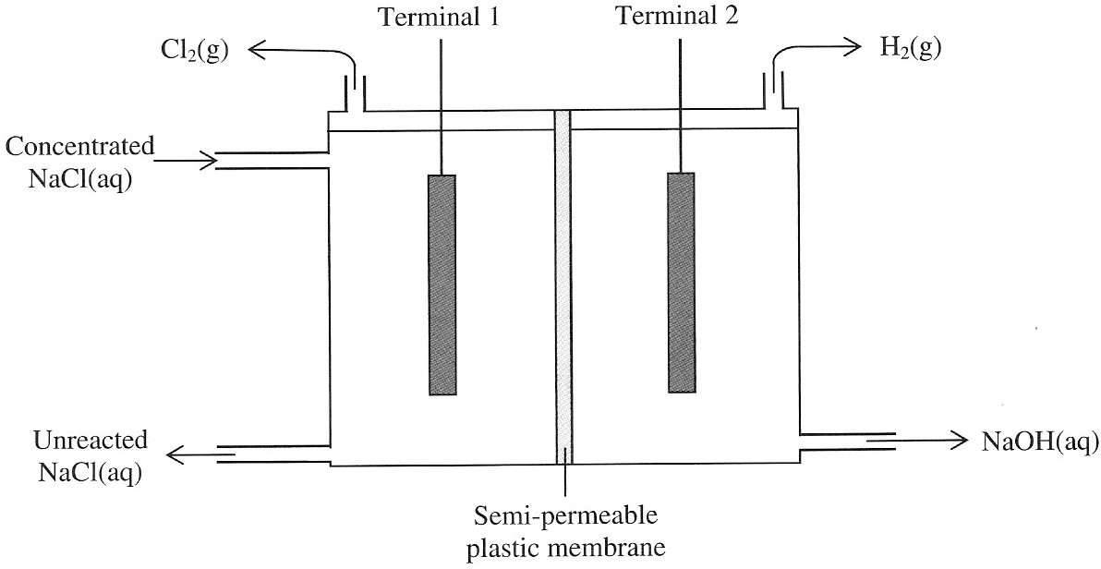
The membrane cell

- Write a balanced half-equation for the reaction occurring at the cathode.
_______________________________________________________________________________________
- In the membrane cell the anode is made of graphite and the cathode is made of iron. Iron is cheaper and a better conductor of electricity than graphite.
Why is graphite used rather than iron for the anode?
_______________________________________________________________________________________
_______________________________________________________________________________________
_______________________________________________________________________________________
_______________________________________________________________________________________
- The diaphragm cell was an older version of the cell used for the production of sodium hydroxide and chlorine. This cell is essentially the same as the membrane cell except for the use of an asbestos diaphragm between the cathodic and anodic chambers.
State one advantage of the membrane cell compared to the diaphragm cell.
_______________________________________________________________________________________
_______________________________________________________________________________________
_______________________________________________________________________________________
1 + 1 + 1 = 3 marks
Suggested time: 4 minutes

Question 3
A steel can may be plated with tin by electrolysis in an aqueous solution containing tin ions.
The equation for the plating can be represented as: Sn^{x+} (aq) + x e– → Sn (s)

- Sketch a diagram of the apparatus that could be sued to electroplate tin, labelling the
- polarity of the steel can in the circuit
- direction of electron flow
- electrolyte

- The following data was obtained from such an electroplating experiment
Volume of tin plate = 0.41 mL
Density of tin = 7.30 g mL^{–1}
Average current = 3.25 A
Time = 25.0 min
Calculate the charge on the tin ion used in the electrolyte.

3 + 3 = 6 marks
Suggested time: 7 minutes

Question 4
The diagram represents a version of the nitrogen cycle.
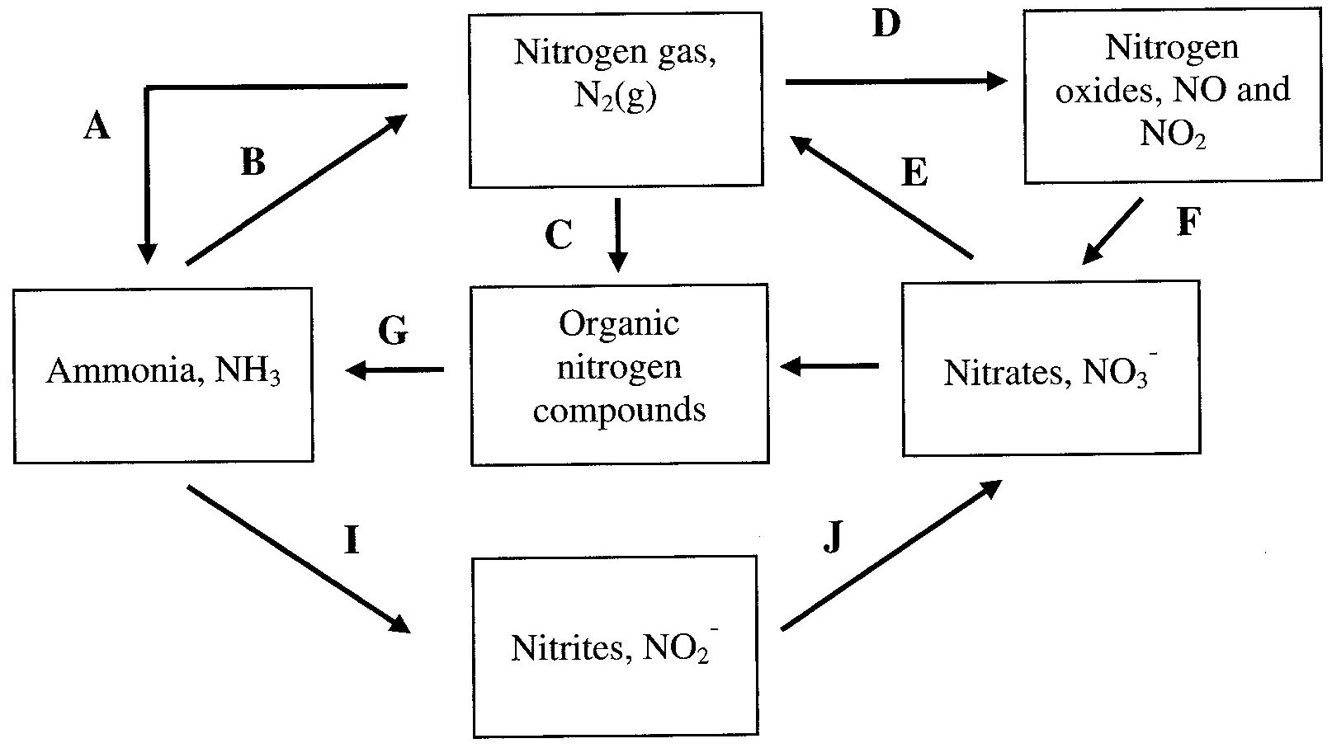
- State the oxidation number of nitrogen in the following chemical species.
N₂ _______________________________________________________________________________
NO₂– ________________________________________________________________________________
- i. Write a balanced half equation to illustrate the process A.
__________________________________________________________________________________
ii. Write a balanced half equation to illustrate the process I.
__________________________________________________________________________________
iii. In which of these processes, A and I, is nitrogen oxidised? _________________________________
- Indicate the type of bacteria responsible for the chemical changes involved in
i. Process B _________________________________
ii. Process C _________________________________
- Give an example of Process D.
_______________________________________________________________________________________
_______________________________________________________________________________________
2 + 3 + 2 + 1 = 8 marks
Suggested time: 9 minutes

Question 5
Enzymes, like all proteins have a precise tertiary structure.

- Explain why the tertiary structure of a protein is important in determining how the enzyme works.
_______________________________________________________________________________________
_______________________________________________________________________________________
_______________________________________________________________________________________
_______________________________________________________________________________________
- Why is a reaction catalysed by an enzyme faster than the reaction in the absence of the enzyme?
_______________________________________________________________________________________
_______________________________________________________________________________________
- Explain why enzymes are denatured by an increase in temperature.
_______________________________________________________________________________________
_______________________________________________________________________________________
_______________________________________________________________________________________
_______________________________________________________________________________________
- The action of some enzymes is very sensitive to pH changes. Some amino acids which react to form proteins contain a carboxyl functional group on their side chain.
Explain how an enzymes containing the carboxyl group may be rendered inactive by the addition of 0.50 M KOH even though the tertiary structure remains unaffected.
_______________________________________________________________________________________
_______________________________________________________________________________________
_______________________________________________________________________________________
_______________________________________________________________________________________
_______________________________________________________________________________________
2 + 1 + 1 + 2 = 6 marks
Suggested time: 7 minutes

Question 6
The fat tripalmitin has the semi-structural formula
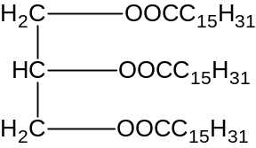
- Give the semi-structural formula of the compound(s) used to synthesis this fat.

- Is tripalmitin a saturated or unsaturated fat? Explain your answer.
_______________________________________________________________________________________
_______________________________________________________________________________________
_______________________________________________________________________________________
- Use the structure of tripalmitin to explain why it is insoluble in water.
_______________________________________________________________________________________
_______________________________________________________________________________________
_______________________________________________________________________________________
- The tripalmitin needs to be emulsified prior to digestion. Explain why.
_______________________________________________________________________________________
_______________________________________________________________________________________
_______________________________________________________________________________________
- The molecular formula of palmitic acid is C₁₆H₃₂O₂.
Write a balanced equation for the complete combustion of palmitic acid.
_______________________________________________________________________________________
2 + 2 + 1 + 1 + 1 = 7 marks
Suggested time: 8 minutes

Question 7
The graph shows the first ionisation energies of the first 36 elements of the Periodic Table.
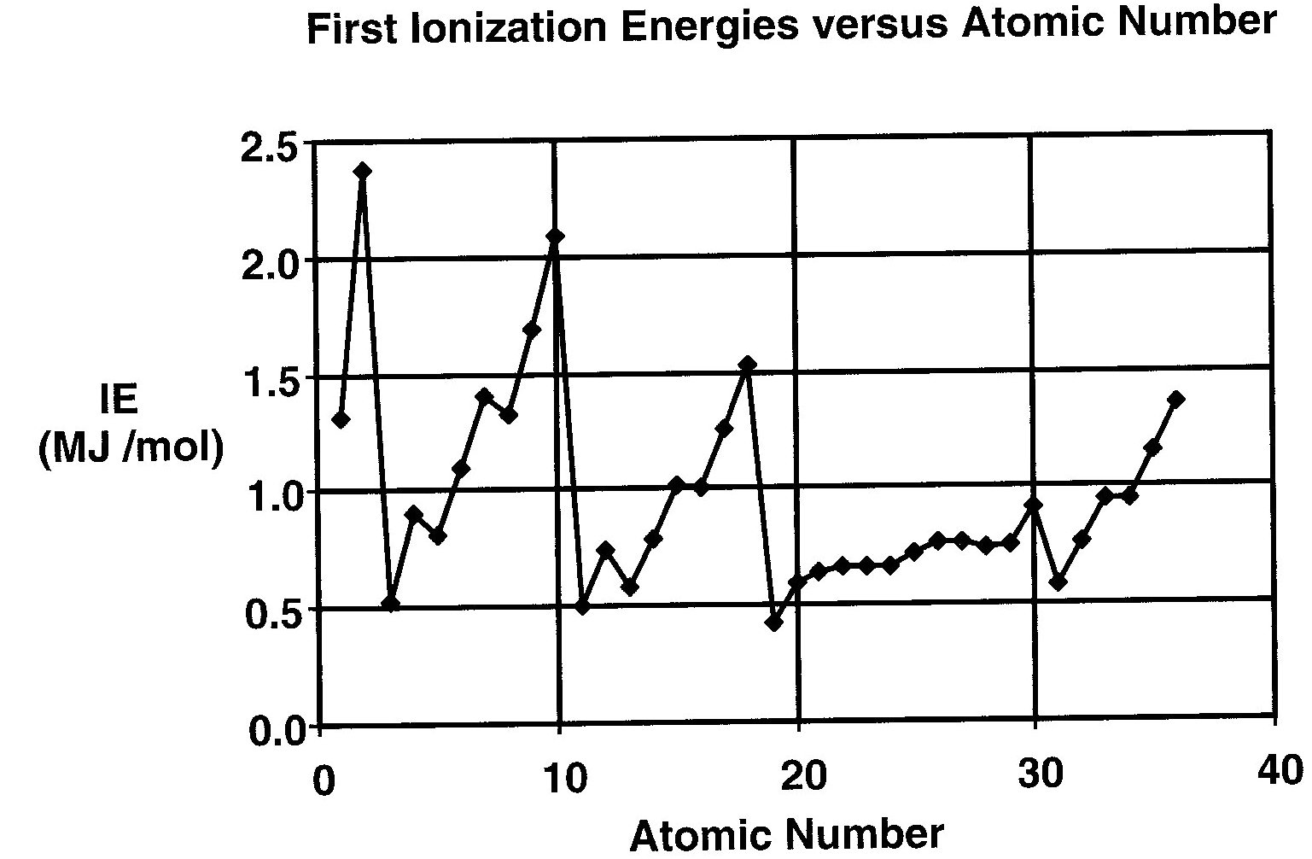
- i. Define the term “first ionisation energy”.
__________________________________________________________________________________
__________________________________________________________________________________
__________________________________________________________________________________
ii. Write an equation to show the first ionisation energy of potassium.
__________________________________________________________________________________
- State and explain the general trend in the first ionisation energies of the Period 3 elements.
_______________________________________________________________________________________
_______________________________________________________________________________________
_______________________________________________________________________________________
_______________________________________________________________________________________
_______________________________________________________________________________________
- Give the electronic configuration, using s p d f notation, for the
Ar atom _____________________________________________________________________________
S^{2–} ion _____________________________________________________________________________
- i. Considering the isotopes argon-39 and potassium-39: comment on the differences in the subatomic particles for the Ar atom compared to the K⁺ ion.
__________________________________________________________________________________
__________________________________________________________________________________
__________________________________________________________________________________
__________________________________________________________________________________
ii. Argon-39 is radioactive and has a half-life of 269 years.
When an atom of argon-39 decays it emits a negative β particle (an electron).
Write the nuclear equation for this process.
__________________________________________________________________________________
- State whether the K⁺ ion is larger, smaller or the same size as a K atom.
Explain your response.
_______________________________________________________________________________________
_______________________________________________________________________________________
_______________________________________________________________________________________
_______________________________________________________________________________________
- The three known isotopes of plutonium, atomic number 94, are ²³⁹Pu, ²⁴²Pu and ²⁴⁴Pu.
All three isotopes are radioactive emitting α particles, He²⁺.
i. State what is meant by the term isotope. Use the element plutonium as an example to explain your statement.
__________________________________________________________________________________
__________________________________________________________________________________
__________________________________________________________________________________
__________________________________________________________________________________
__________________________________________________________________________________
ii. Write the nuclear equation for the α particle emission from plutonium-244.
__________________________________________________________________________________
iii. Why is the relative atomic mass of plutonium shown in brackets on the Data Sheet.
__________________________________________________________________________________
__________________________________________________________________________________
__________________________________________________________________________________
2 + 1 + 2 + [2 + 1] + 2 + [2 + 1 + 1] = 14 marks
Suggested time: 14 minutes

Question 6
The compound Cs₂CoF₆ dissolves in water to form a blue solution containing the CoF₆^{2–} ion.

- Write the electronic configuration, using the s p d f notation, for the cobalt ion in the complex ion, CoF₆^{2–}.
_______________________________________________________________________________________
- State the oxidation numbers of the elements in the compound, Cs₂CoF₆.
Oxidation number
Cs |  |  | Co |  |  | F

- Draw the structure of the CoF₆^{2–} ion and name the shape of the ion.

- Account for the colour of the CoF₆^{2–} ion in aqueous solution.
_______________________________________________________________________________________
_______________________________________________________________________________________
_______________________________________________________________________________________
_______________________________________________________________________________________
_______________________________________________________________________________________
1 + 3 + 2 + 1 = 7 marks
Suggested time: 8 minutes

