2013

VCE
Chemistry
VCAA Sample Examination
Suggested Answers



Kilbaha Multimedia Publishing  PO Box 2227  Kew Vic 3101  Australia | Tel: (03) 9018 5376  Fax: (03) 9817 4334  kilbaha@gmail.com  http://kilbaha.com.au

IMPORTANT COPYRIGHT NOTICE

- This material is copyright. Subject to statutory exception and to the provisions of the relevant collective licensing agreements, no reproduction of any part may take place without the written permission of Kilbaha Multimedia Publishing.
- The contents of this work are copyrighted. Unauthorised copying of any part of this work is illegal and detrimental to the interests of the author.
- For authorised copying within Australia please check that your institution has a licence from http://copyright.com.au. This permits the copying of small parts of the material, in limited quantities, within the conditions set out in the licence.

Reproduction and communication for educational purposes The Australian Copyright Act 1968 (the Act) allows a maximum of one chapter or 10% of the pages of this work, to be reproduced and/or communicated by any educational institution for its educational purposes provided that educational institution (or the body that administers it) has given a remuneration notice to Copyright Agency Limited (CAL) under the Act.

For details of the CAL licence for educational institutions contact
CAL, Level 15, 233 Castlereagh Street, Sydney, NSW, 2000
Tel: (02) 9394 7600
Fax: (02) 9394 7601
Email: info@copyright.com.au

- Web Links have been added to these answers so that teachers and students can explore Chemistry concepts at more depth using the Internet. All Web Links, when created, linked to appropriate sites. Teachers should check these Web Links before using them with their classes. Web Links do not last forever. Kilbaha Multimedia Publishing is not responsible for Web Links that have been altered or that link to inappropriate sites.

- In most cases, the Web Link is to a site from which you can do a simple search for any topic you wish to research.
http://www.chem1.com/chemed/

- While every care has been taken, no guarantee is given that these suggested answers are free from error. Please contact us if you believe you have found an error.

IMPORTANT NOTE:
At the time these detailed answers were produced, the sample examination provided by the VCAA and the answers provided for the multiple-choice questions had a number of errors. These were pointed out to the VCAA Chemistry Examiners and a corrected version of the Sample Examination has been promised for the VCAA website. This may or may not have occurred at the time you are using these answers.

Check this at http://www.vcaa.vic.edu.au/Pages/vce/studies/chemistry/chemindex.aspx

Question 1 Answer C
Identify the longest possible carbon chain. This is always the first thing you must do. Place your pen on the diagram and draw a line through as many carbon atoms as possible without lifting your pen off the paper. You can do this with 6 carbon atoms as shown below.
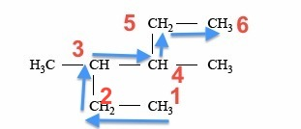

Therefore, the compound must be named after hexane. A CH₃ group is attached to carbon number 3. A CH₃ group is attached to carbon number 4. Hence, the systematic name is 3, 4-dimethylhexane.

Study Design Reference
Structure including molecular, structural and semi-structural formulae, and International Union
of Pure and Applied Chemistry (IUPAC) nomenclature of alkanes, alkenes, amines, haloalkanes,
alkanols (CnH2n+1OH), alkanoic acids (CnH2n+1COOH) and esters up to C10

Web Link
https://www2.chemistry.msu.edu/faculty/reusch/VirtTxtJml/nomen1.htm

Question 2 Answer B
In 2,2-dimethylbutane, we can identify 3 carbon atoms with different environments which have hydrogen atoms bonded to them. They are shown by the arrows and the numbers in the diagram below.
2
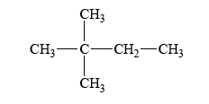
3

1

Hence, when a single hydrogen atom in 2,2-dimethylbutane is replaced by one chlorine atom, there will be three different structural isomers for the compound C₃H₁₃Cl.

Study Design Reference
Structure including molecular, structural and semi-structural formulae, and International Union
of Pure and Applied Chemistry (IUPAC) nomenclature of alkanes, alkenes, amines, haloalkanes,
alkanols (CnH2n+1OH), alkanoic acids (CnH2n+1COOH) and esters up to C10

Web Link
http://www.chemguide.co.uk/basicorg/isomerism/structural.html

Question 3 Answer B
This question asks you to identify the organic reaction that is incorrect.

A correctly shows the substitution reaction of 1-chlorobutane to produce butan-1-ol.

C correctly shows the condensation reaction between methanol and ethanoic acid to form the ester methyl ethanoate.

D correctly shows the addition reaction between propene and water to form propan-2-ol.

B incorrectly shows the addition reaction between but-2-ene and hydrogen chloride. In this reaction, the hydrogen chloride will add across the double bond to produce 2-chlorobutane not
1-chlorobutane as shown in the equation.

Study Design Reference
Common reactions of organic compounds including equations: addition reactions of alkenes (addition of hydrogen halides and water limited to symmetrical alkenes), substitution reactions of alkanes and primary haloalkanes, oxidation of primary alkanols, and esterification

Web Link
http://www2.chemistry.msu.edu/faculty/reusch/VirtTxtJml/Questions/problems.htm

Question 4 Answer B
During addition polymerisation, the double bond in the monomer breaks down to produce a spare electron on each of the carbon atoms. These single electrons readily form carbon-carbon single bonds with other monomers. Hence, the structure of the polymer will maintain the arrangement of atoms in the original monomer. This is shown below.

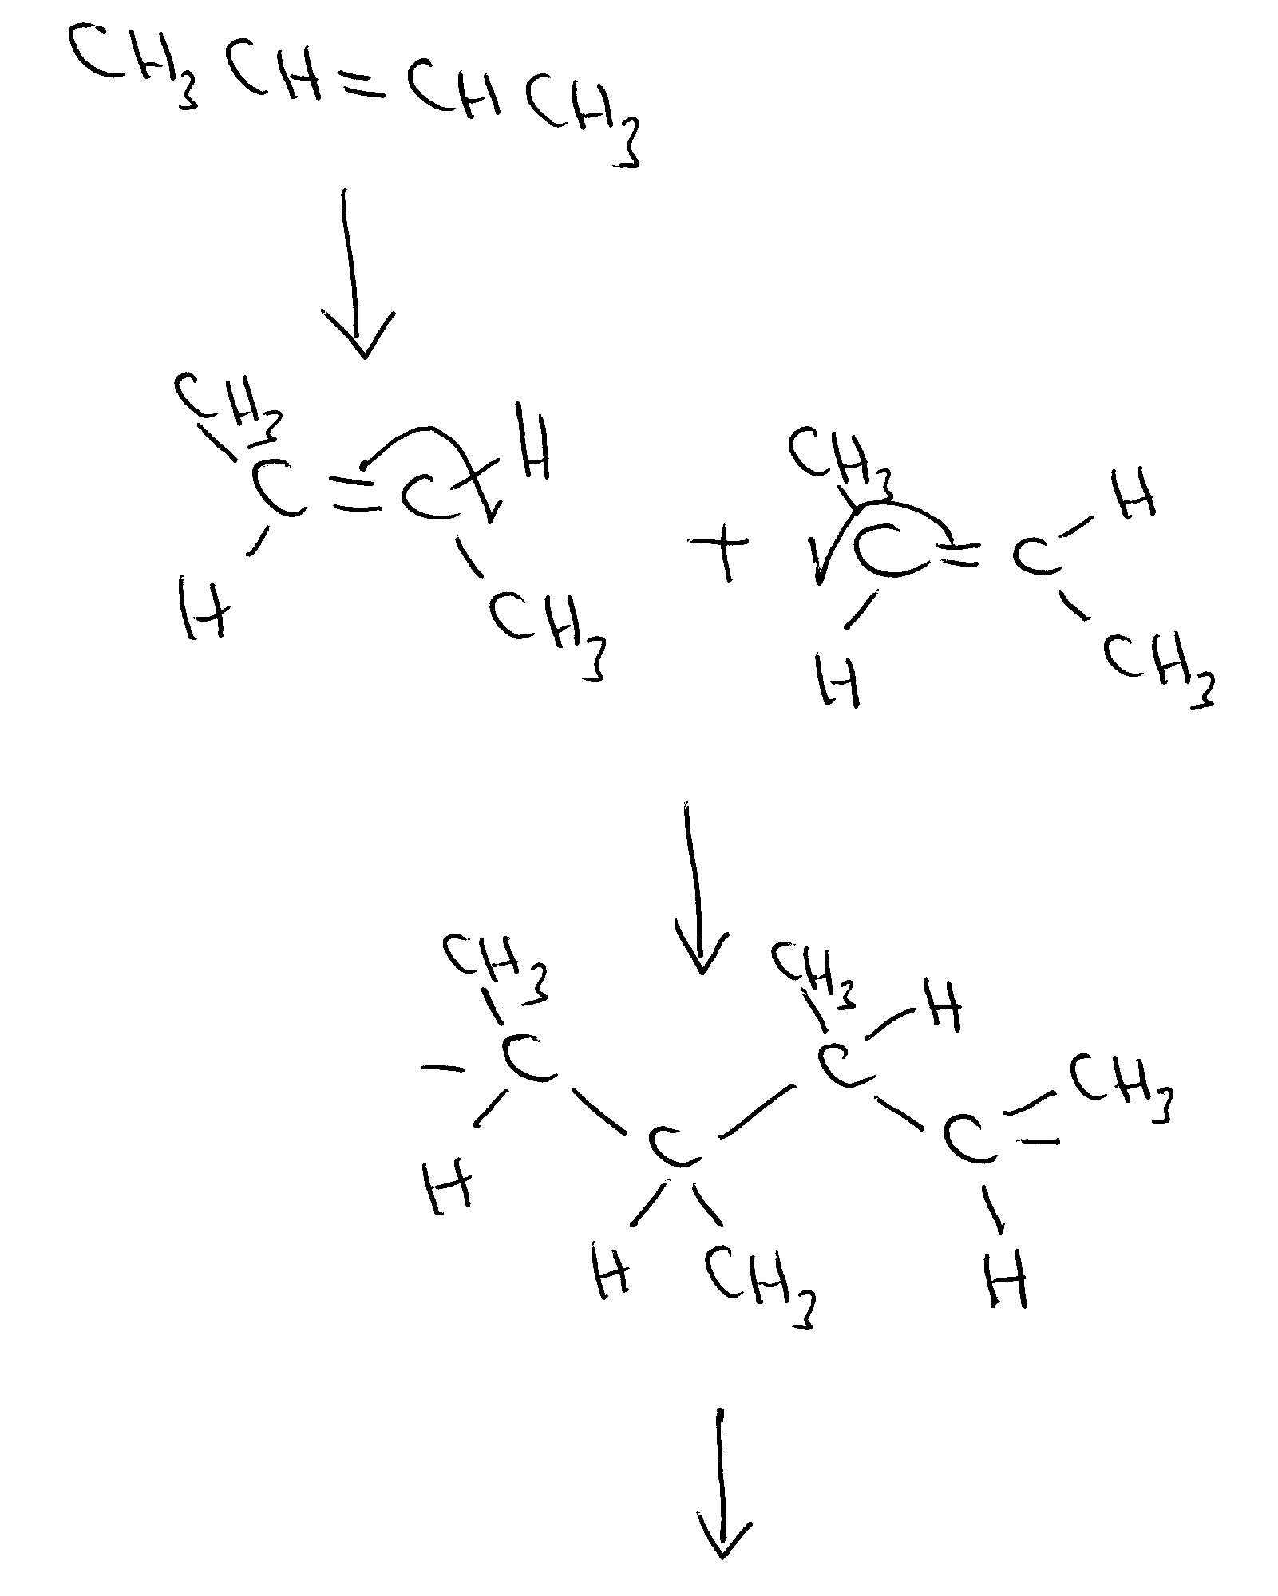

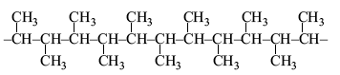

Study Design Reference
Common reactions of organic compounds including equations: addition reactions of alkenes (addition of hydrogen halides and water limited to symmetrical alkenes), substitution reactions of alkanes and primary haloalkanes, oxidation of primary alkanols, and esterification

Web Link
http://www.chemguide.co.uk/organicprops/alkenes/polymerisation.html

Question 5 Answer A
Triglycerides and polysaccharides contain only carbon, hydrogen and oxygen. So not C or D. Proteins contain carbon, hydrogen oxygen and nitrogen but not phosphorus. So not B. DNA contains all five elements. DNA is the only possibility from this selection.

Study Design Reference
Condensation reactions that produce lipids (limited to triglycerides)
Condensation and polymerisation reactions that produce large biomolecules including
carbohydrates, proteins and DNA

Web Link
http://www.chemguide.co.uk/

Question 6 Answer A
Glycerol and three long-chain carboxylic acid molecules react in a condensation reaction in which three ester linkages are formed with the elimination of three water molecules as shown below.
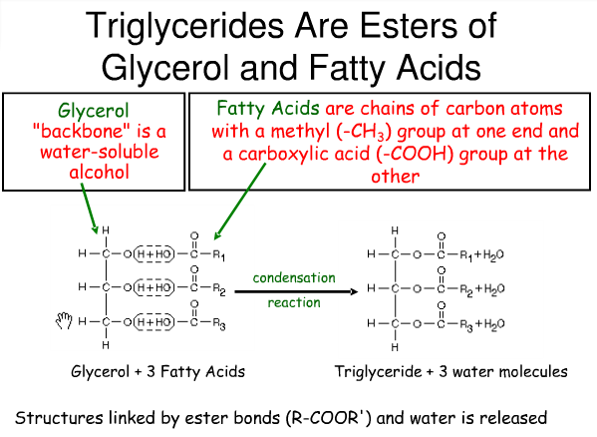
http://bit.ly/12mE3j8

The ester linkage is
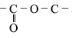

Study Design Reference
Condensation reactions that produce lipids (limited to triglycerides)

Web Link
http://www.chem1.com/chemed/

Question 7 Answer D
The three-dimensional structure of a protein can be destroyed by heat, alcohol, acids, bases, heavy metals and reducing agents.
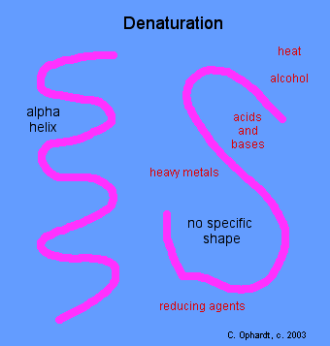
Denaturation of proteins involves the disruption and possible destruction of both the secondary and tertiary structures. Since denaturation reactions are not strong enough to break the peptide bonds, the primary structure (sequence of amino acids) remains the same after a denaturation process. Denaturation disrupts the normal alpha-helix and beta sheets in a protein and uncoils it into a random shape.

Denaturation occurs because the bonding interactions responsible for the secondary structure (hydrogen bonds to amides) and tertiary structure are disrupted. In tertiary structure there are four types of bonding interactions between "side chains" including: hydrogen bonding, salt bridges, disulfide bonds, and non-polar hydrophobic interactions which may be disrupted. Therefore, a variety of reagents and conditions can cause denaturation. The most common observation in the denaturation process is the precipitation or coagulation of the protein.

Heat can be used to disrupt hydrogen bonds. This occurs because heat increases the kinetic energy and causes the molecules to vibrate so rapidly and violently that the bonds are disrupted.

Alcohol denatures proteins by disrupting the side chain intramolecular hydrogen bonding. New hydrogen bonds are formed instead between the new alcohol molecule and the protein side chains.

Salt bridges result from the neutralization of an acid and amine on side chains. The final interaction is ionic between the positive ammonium group and the negative acid group. Any combination of the various acidic or amine amino acid side chains will have this effect.
Acids and bases disrupt salt bridges held together by ionic charges. A type of double replacement reaction occurs where the positive and negative ions in the salt change partners with the positive and negative ions in the new acid or base added. This reaction occurs in the digestive system, when the acidic gastric juices cause the curdling (coagulating) of milk.

Study Design Reference
Primary, secondary and tertiary structures of proteins
The role of the tertiary structure of proteins in enzyme action
Denaturing of proteins: effect of changes in pH and temperature on bonding

Web Link
http://bit.ly/f0iJ6m

Question 8 Answer D
The number of double bonds in a fatty acid can be determined from the ratio between the number of carbon and hydrogen atoms. First of all, rewrite the formulas to show the COOH functional group. For a saturated fatty acid (only single carbon to carbon bonds), the formula for the acid will be C_{n}H_{2n+1}COOH.
Every double bond in the molecule will decrease the number of hydrogen atoms by 2.

Original formula | Extended formula | Number of double bonds | Name from data book (Page 10)
C₁₈H₃₄O₂ | C₁₇H₃₃COOH | 1 | Oleic acid
C₂₄H₄₈O₂ | C₂₃H₄₇COOH | 0 (saturated) | not listed
C₁₈H₃₂O₂ | C₁₇H₃₁COOH | 2 | Linoleic acid
C₂₀H₃₂O₂ | C₁₉H₃₁COOH | 4 | Arachidonic acid

Important: You should label all of the fatty acids on Page 10 of the Data book as either saturated or unsaturated and identify the number of double bonds in each of the unsaturated acids.

Study Design Reference
Structure including molecular, structural and semi-structural formulae, and International Union
of Pure and Applied Chemistry (IUPAC) nomenclature of alkanes, alkenes, amines, haloalkanes,
alkanols (CnH2n+1OH), alkanoic acids (CnH2n+1COOH) and esters up to C10

Web Link
http://www.chem1.com/chemed/

Question 9 Answer B
The primary structure of a protein is the sequence of amino acids in the chain. The amino acids are held together by peptides links (–CONH-). These peptide links are shown by bond C in this diagram. The secondary structure of a protein is the spiral shape caused by hydrogen bonds between peptide links on nearby sections of the amino acid chain. These hydrogen bonds are shown by bond A in this diagram. The tertiary structure of a protein is the three-dimensional structure of the molecule. It is held in place by different kinds of bonding of which one is disulfide bonds. These disulfide bonds are shown by bond B in this diagram.

Study Design Reference
Primary, secondary and tertiary structures of proteins

Web Link
http://www.chem1.com/chemed/

Question 10 Answer A
Enzymes are proteins that act as biological catalysts. Like all catalysts, enzymes increase the rate of reactions. They increase the rate of the forward and reverse reactions identically. They increase the rate at which equilibrium is achieved but they do not change the position of equilibrium. They do not change the equilibrium constants for biochemical reactions.

Study Design Reference
The role of the tertiary structure of proteins in enzyme action

Web Link
http://www.chem1.com/chemed/

Question 11 Answer C
The base pairing in DNA with hydrogen bonds is shown in the diagram below.

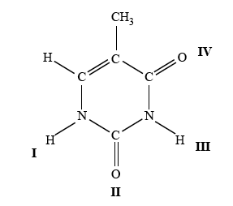 | 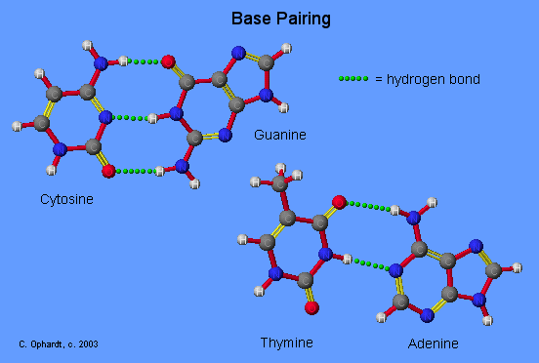
http://bit.ly/16xWOSj

These are positions III and IV in the diagram.

Study Design Reference
Primary and secondary structure of DNA.

Web Link
http://www.chem1.com/chemed/

Question 12 Answer A
Salicylic acid has two functional groups – the hydroxyl group –OH and the carboxyl group -COOH. In aspirin, the carboxyl group remains. The hydroxyl group has been converted into an ester linkage by reacting the salicylic acid with CH₃COOH. D is correct. The other product of the reaction
is H₂O. Aspirin does contain both ester and carboxylic acid functional groups. B is correct. Because aspirin has an acidic functional group, it will react with the base NaHCO₃ to produce a salt, carbon dioxide and water. C is correct. The reaction between salicylic acid and methanol (CH₃OH) will form an ester linkage but the product formed is not aspirin. A is not correct.

Study Design Reference
Function of organic molecules in the design and synthesis of medicines including the production
of aspirin from salicylic acid.

Web Link
http://www.chem1.com/chemed/

Question 13 Answer A
A mass spectrometer will sort isotopes of an element according to the mass to charge ratio of the atoms making up the sample. It will show the isotopic ratio of ²³⁵U to ²³⁸U in a sample of uranium. Gas-liquid chromatography is used to separate molecules (often organic) of different substances in a mixture. Atomic absorption spectroscopy is used to identify trace amounts of metal ions. Nuclear magnetic resonance spectroscopy is used to identify organic molecules.

Study Design Reference
Principles and applications of chromatographic techniques
Principles and applications of spectroscopic techniques

Web Link
http://www.chem1.com/chemed/

Question 14 Answer C
In this gas-liquid chromatography column, the lowest molecular mass molecule butane (C₄H₁₀) will pass through the column most quickly because it will have the least attraction for the stationary phase. The hexane (C₆H₁₄) will have the longest retention time in the column because it forms more temporary bonds with the material in the column and, therefore, spends more time adsorbed onto the column. Hence, the hexane is shown at the 8 minute mark on the graph.
The percentage of hexane =

Study Design Reference
High performance liquid chromatography (HPLC) and gas chromatography (GC) including Rt
and the use of a calibration graph to determine amount of analyte.

Web Link
http://www.chem1.com/chemed/

Question 15 Answer A
A molecular ion must have a charge on it. Therefore, B and D are not correct. The formula mass of CH₄N = 12 + 4 + 14 = 30. The largest reading on the mass spectrum (mass to charge ratio) is 60. A mass spectrum records whole molecules and parts of the molecule. The largest reading usually indicates the whole molecule with a single positive charge. This is C₂H₈N₂⁺ which has a relative molecular mass of 60.
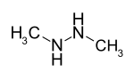
A possible structure of this compound is shown above. (1, 2 dimethyl hydrazine)

Study Design Reference
Mass spectroscopy including determination of molecular ion peak and relative molecular mass,
and identification of simple fragments

Web Link
http://www.chem1.com/chemed/

Question 16 Answer B
The sum of the oxidation numbers must equal the charge on the ion. Therefore,

Study Design Reference
The writing of balanced chemical equations, including the use of oxidation numbers to write redox
equations, and the application of chemical equations to volumetric and gravimetric analyses

Web Link
http://www.chem1.com/chemed/

Question 17 Answer D
For a chemical reaction to occur, particles must collide with sufficient energy to break existing chemical bonds so that new bonds can then be formed. The sufficient energy referred to is called the activation energy of the reaction. When the temperature increases, reactant particles will collide more frequently but many of these collisions will still be “soft” collisions in which the activation energy is not reached. It is the increase in the number of particles that have energy greater than the activation energy that provides the best explanation as to why the observed reaction rate is greater at higher temperature. Increasing the concentration also increases the rate of a reaction by increasing the number of collisions per second but increasing the concentration does not increase the energy of the collisions. The graph showing the increase in the number of particles with energy greater than the activation energy plotted against temperature increase is shown below.
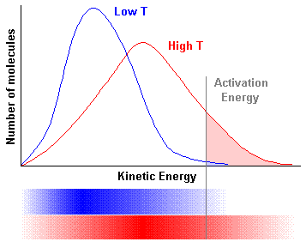

http://bit.ly/11a69GW

Study Design Reference
Collision theory and factors that affect the rate of a reaction including temperature, pressure,
concentration and use of catalysts, excluding: a formal treatment of the Maxwell-Boltzmann
distribution, reaction mechanisms and rate laws.

Web Link
http://www.chem1.com/chemed/

Question 18 Answer D
In an equilibrium mixture, the concentrations of the reactants and the products remain constant. When a catalyst is added to an equilibrium mixture, there is no change in the position of equilibrium. The rates of both the forward and reverse reactions would increase by the same amount. There is no change in ΔH or the temperature of the surroundings. This summarized in the diagram below.
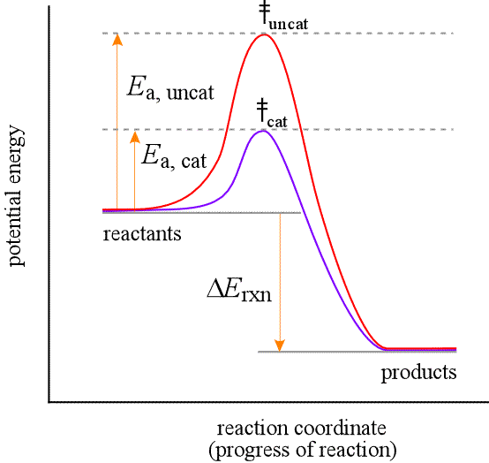
http://bit.ly/16A8cgo

Study Design Reference
Energy profile diagrams and the use of ΔH notation including: activation energy; alternative reaction
pathways for catalysed reactions; and deduction of ΔH for an overall reaction given energy profiles
or ΔH of two related reactions

Web Link
http://www.chem1.com/chemed/

Question 19 Answer B

C(diamond) + O₂(g) → CO₂(g) ΔH = -395 kJ mol⁻¹ . . . (1)

C(graphite) + O₂(g) → CO₂(g) ΔH = -393 kJ mol⁻¹ . . . (2)

Reverse equation (1) and change the sign of ΔH

CO₂(g) → C(diamond) + O₂(g) ΔH = +395 kJ mol⁻¹ . . . (3)

Add equations (2) and (3) and add the ΔH values.

C(graphite) + O₂(g) + CO₂(g) → C(diamond) + O₂(g) + CO₂(g) ΔH = -393 + 395 = +2 kJ mol⁻¹

Study Design Reference
Deduction of ΔH for an overall reaction given energy profiles or ΔH of two related reactions.

Web Link
http://www.chem1.com/chemed/

Question 20 Answer D
The combustion of butane is shown by the equation:

2C₄H₁₀(g) + 13O₂(g) → 8CO₂(g) + 10H₂O(g)

The calibration factor (CF) of the bomb calorimeter is amount of energy required to raise the temperature of the calorimeter and its contents by one degree.

Electrical energy = V × Q
Temperature rise = ΔT₁

A diagram of a bomb calorimeter is shown below.
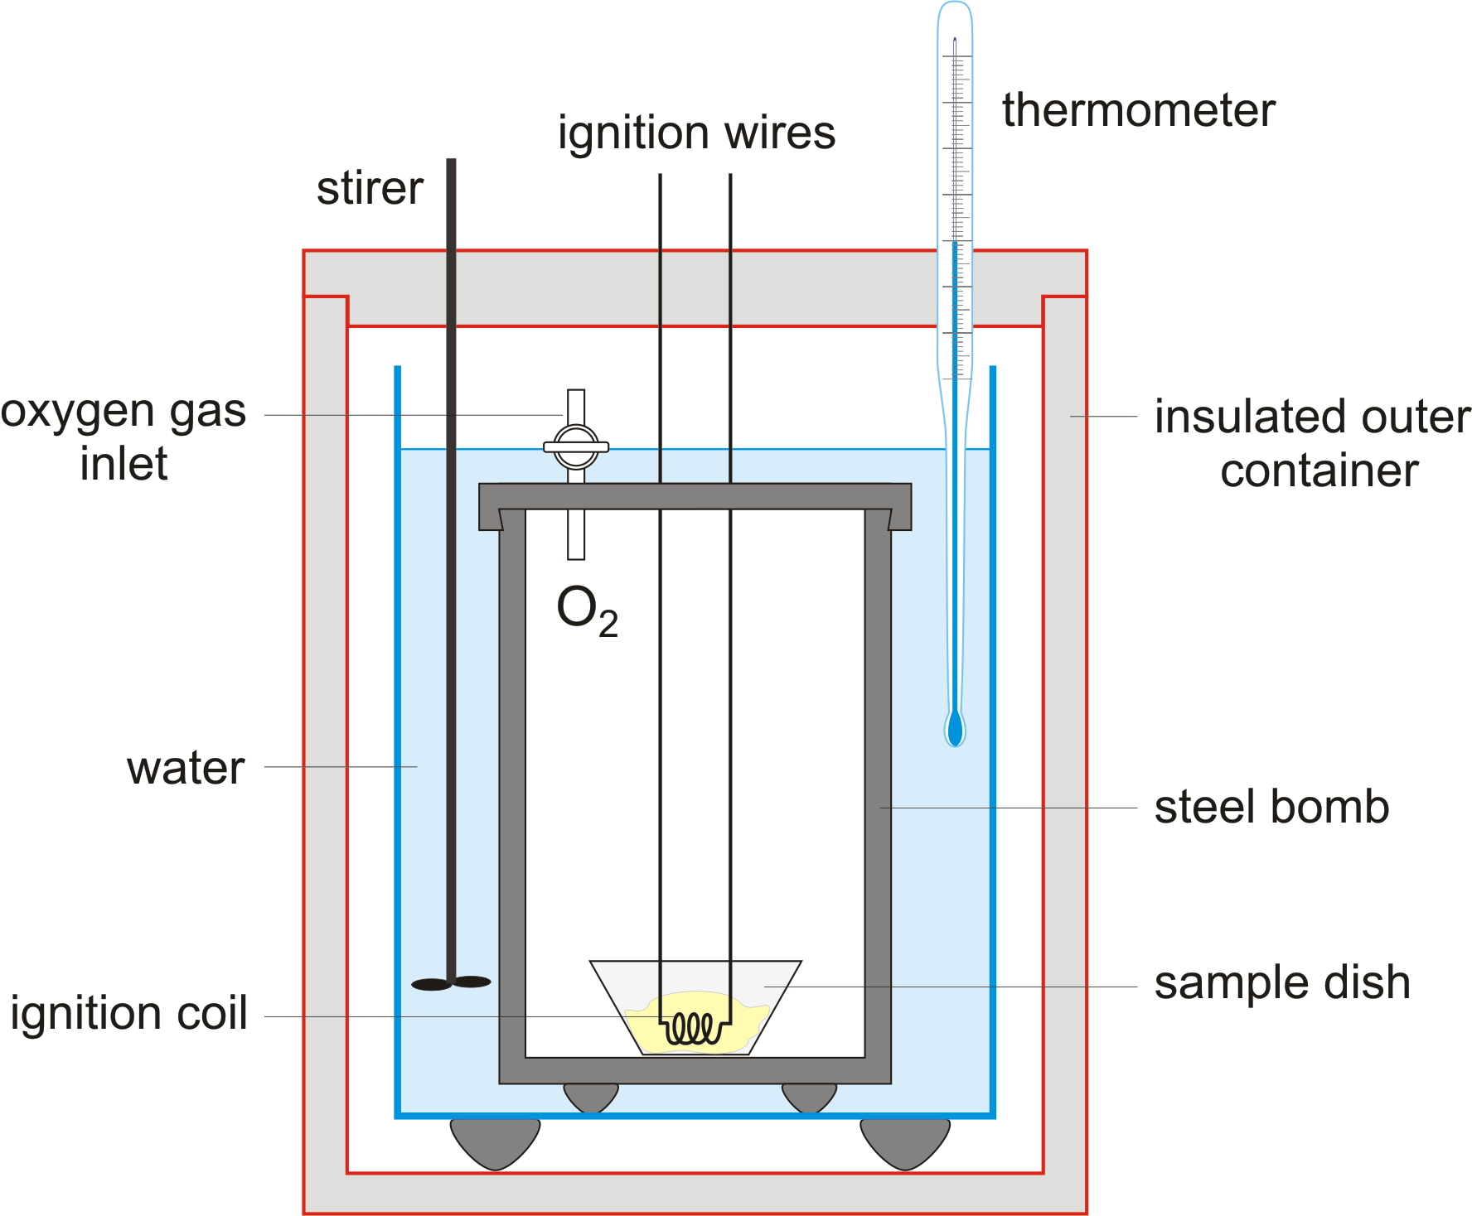

http://bit.ly/13cOnHg

Study Design Reference
Application of calorimetry to measure energy changes in chemical reactions in solution calorimetry
and bomb calorimetry, including calibration of a calorimeter and the effects of heat loss

Web Link
http://www.chem1.com/chemed/

Question 21 Answer A
At high temperatures (700 – 1100 °C) and in the presence of a metal-based catalyst (nickel), steam reacts with methane to yield carbon monoxide and hydrogen. These two reactions are reversible in nature. CH₄ + H₂O ⇌ CO + 3H₂
http://bit.ly/11zNquW

The equation as written in the sample examination is not balanced.
The correctly balanced equation is CH₄(g) + H₂O(g) CO(g) + 3H₂(g) ΔH = +131 kJ mol⁻¹

For every one mole of CH₄ used up, 3 mole of H₂ is produced. Graph D is incorrect because it shows some hydrogen gas present at the beginning. Graph B is incorrect because it shows methane and hydrogen being used up and produced in a ratio of 1 : 1 . The only graphs showing the proportion of 1 : 3 are graphs A and C. After the hydrogen is added at 10 minutes, some of the hydrogen reacts to produce methane. This also occurs in the ratio of 3 : 1 as shown in the balanced equation. Graph C is incorrect because it shows the methane decreasing. Graph A is correct.
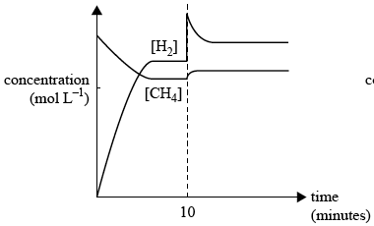

Study Design Reference
Equilibrium: representation of reversible and non-reversible reactions: homogeneous equilibria and
the equilibrium law (equilibrium expressions restricted to use of concentrations), Le Chatelier’s
Principle and factors which affect the position of equilibrium

Web Link
http://www.chem1.com/chemed/

Question 22 Answer B
The equilibrium equation is C₂H₄(g) + H₂O(g) C₂H₅OH(g) ΔH = -46 kJ mol⁻¹

According to Le Chatelier’s Principle “When a chemical system at equilibrium experiences a change in concentration, temperature, volume, or partial pressure, the equilibrium shifts to counteract the imposed change and a new equilibrium is established.” In this equation, 2 mole of reactants produces 1 mole of products. Therefore, high pressure will cause the production of more ethanol at equilibrium. The forward reaction is exothermic, that is, it produces heat. Therefore, a low temperature will cause the production of more ethanol at equilibrium.

Study Design Reference
Equilibrium: representation of reversible and non-reversible reactions: homogeneous equilibria and
the equilibrium law (equilibrium expressions restricted to use of concentrations), Le Chatelier’s
Principle and factors which affect the position of equilibrium

Web Link
http://www.chem1.com/chemed/

Question 23 Answer D
Ba(OH)₂ dissociates according to the equation Ba(OH)₂(aq) → Ba²⁺(aq) + 2OH⁻(aq)

Since the concentration of Ba(OH)₂ = 0.0050 M, the concentration of OH⁻ = 0.0050 × 2 = 0.0100 M

Study Design Reference
pH as a measure of strength of acids and bases.

Web Link
http://www.chem1.com/chemed/

Question 24 Answer C
You need to refer to the Data Book to do this question.
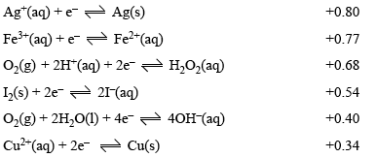

Ag⁺(aq) is a stronger oxidant than Cu²⁺(aq). Therefore, in this galvanic cell, Ag⁺(aq) will be reduced to Ag(s) and Cu(s) will be oxidised to Cu²⁺(aq). This is shown in equations A and C. Equation A is not balanced. Two silver ions and two silver atoms must be used to balance the charge.

Study Design Reference
Use of the electrochemical series in predicting the products of redox reactions and deducing overall
equations from redox half equations.

Web Link
http://www.chem1.com/chemed/

Question 25 Answer A
You need to refer to the Data Book to do this question.


The predicted maximum voltage produced by this cell under standard conditions is the difference between the E⁰ values of the two half-reactions. Predicted voltage = +0.80 - +0.34 = 0.46 V.

Study Design Reference
Use of the electrochemical series in predicting the products of redox reactions and deducing overall
equations from redox half equations. Limitations of predictions made using the electrochemical series, including the determination of maximum cell voltage under standard conditions

Web Link
http://www.chem1.com/chemed/

Question 26 Answer D
The balanced chemical equations needed in this question are:

(1) CH₄(g) + 2O₂(g) → CO₂(g) + 2H₂O(g) ΔH = -900 kJ mol⁻¹

(2) H₂O(l) → H₂O(g) ΔH = +44 kJ mol⁻¹

When one mole of methane is oxidised, 900 kJ of energy is produced.

The conversion of one mole of liquid water to steam requires 44.0 kJ.
Therefore, the number of mole of liquid water that could be converted to steam by 900 kJ = mol. Hence, the maximum mass of liquid water that could be converted =

Study Design Reference
Calculations including amount of solids, liquids and gases; concentration; volume, pressure and
temperature of gases

Web Link
http://www.chem1.com/chemed/

Question 27 Answer D
In a fuel cell based on the oxidation of methane, the equation for the anode half reaction is

CH₄(g) + 2H₂O(l) → CO₂(g) + 8H⁺(aq) + 8e⁻

The corresponding equation for the half reaction at the cathode can be obtained by taking the overall equation and subtracting the anode half reaction as shown below.

Overall equation: CH₄(g) + 2O₂(g) → CO₂(g) + 2H₂O(l)(g) (1)

Anode half reaction: CH₄(g) + 2H₂O(l) → CO₂(g) + 8H⁺(aq) + 8e⁻ (2)

Subtract (2) from (1): 2O₂(g) + 8H⁺(aq) + 8e⁻ → 4H₂O(l)

In simplest form: O₂(g) + 4H⁺(aq) + 4e⁻ → 2H₂O(l)

Study Design Reference
The chemical principles, half-equations and overall equations of fuel cells.

Web Link
http://www.chem1.com/chemed/

Question 28 Answer C

CH₄(g) + 2H₂O(l) → CO₂(g) + 8H⁺(aq) + 8e⁻

When one mole of methane is oxidised, 900 kJ of heat energy is produced. Therefore, the electrical energy is 900 kJ. From the equation, one mole of methane produces 8 mole of electrons. The charge on 8 mole of electrons = 8 × 96500 coulombs (You must use the Data Book Section 3 Physical Constants to obtain this value for the Faraday Constant).
The amount of electric charge, in coulomb, = 7.72 × 10⁵. This is closest to 8 × 10⁵.

Study Design Reference
Application of Faraday’s laws in electrochemistry

Web Link
http://www.chem1.com/chemed/

Question 29 Answer C
The cell reaction for a car battery releasing energy is:

Pb(s) + PbO₂(s) + 4H⁺(aq) → 2SO₄ ²⁻(aq) + 2PbSO₄(s) + 2H₂O(l)

Therefore, the cell reaction when the battery is being recharged is:

2SO₄ ²⁻(aq) + 2PbSO₄(s) + 2H₂O(l) → Pb(s) + PbO₂(s) + 4H⁺(aq)

When the battery is being recharged, the negative electrode is the cathode and this is where reduction is occurring. Hence, the reaction is the reduction of lead(II) sulfate to lead metal. Note that the electrons must be on the right hand side of the half equation.

PbSO₄(s) + 2e⁻ → Pb(s) + SO₄ ²⁻(aq)

Study Design Reference
The chemical principles, half-equations and overall equations of simple primary and secondary
galvanic cells.

Web Link
http://www.chem1.com/chemed/

Question 30 Answer B
The half reactions for the metals being deposited on the cathode in this cell are shown below.

- Cr³⁺(aq) + 3e⁻ → Cr(s)
- Cu²⁺(aq) + 2e⁻ → Cu(s)
- Ag⁺(aq) + e⁻ → Ag(s)

You must know that the nitrate ion has the formula NO₃⁻ so that you can use the correct charges on each of the ions.

The charge on the electrons passing through the solutions = 0.030 faraday.

1 faraday = 1 mole of electrons
0.030 faraday = 0.030 mole of electrons

From equation (1):

Number of mole of chromium metal deposited

From equation (2):

Number of mole of copper metal deposited =

From equation (3):

Number of mole of silver metal deposited =

Study Design Reference
Application of Faraday’s laws in electrochemistry.

Web Link
http://www.chem1.com/chemed/

End of Detailed Answers to 2013 VCAA VCE Chemistry Sample Examination
Multiple Choice Questions

Kilbaha Multimedia Publishing  PO Box 2227  Kew Vic 3101  Australia | Tel: (03) 9018 5376  Fax: (03) 9817 4334  kilbaha@gmail.com  http://kilbaha.com.au

Section B

Question 1 (11 marks)

a. The reactions occurring here are:

(1) (C₆H₁₀O₅)_{n} + nH₂O → nC₆H₁₂O₆

(2) C₆H₁₂O₆ → 2C₂H₅OH + 2CO₂

Molecule A is cellulose. It is called a polysaccharide since it is a condensation polymer formed from the monomer glucose. (1 mark)
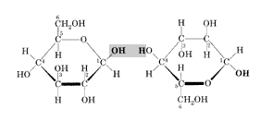

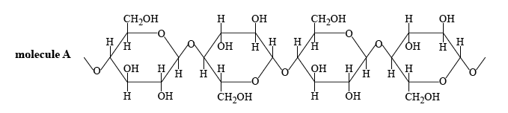

b. The chemical formula for molecule B is C₆H₁₂O₆ (1 mark)

c. Ethanol produced in this way is renewable because the cellulose from which it is produced can be constantly provided by photosynthesis. (1 mark)
(1 mark)
The advantages of using bioethanol are (1) it is renewable, (2) it is available as a liquid,
(3) it can be blended with petrol. (1 mark)

The disadvantages of using bioethanol are (1) it produces the greenhouse gas CO₂, (2) its production uses up land that might be needed for growing food, (3) it is not as good a fuel as oil based liquids. (1 mark)

Question 1 (continued)

d. From the Data Book, the molar enthalpy of ethanol is -1364 kJ mol⁻¹ (1 mark)
The energy released in the bomb calorimeter
= calibration factor × temperature rise
= 12.5 × 13.75 kJ (1 mark)

n(C₂H₅OH) =

m(C₂H₅OH) = (1 mark)

e. If the ethanol is contaminated with water, the actual volume of ethanol will be less than
438 mL. (e.g. 400 mL of ethanol, 38 mL of water). Therefore, the temperature rise of 13.75ºC is for a smaller volume of ethanol. The temperature rise would be greater than
13.75 ºC for pure ethanol. Therefore, the number of mole of ethanol would be greater.
Therefore, the mass of ethanol would be greater. (1 mark)

Hence, the real percentage yield of ethanol is greater than observed percentage yield.
(1 mark)

Study Design Reference
Comparison of the renewability of energy sources including coal, petroleum, natural gas, nuclear
fuels and biochemical fuels. Application of calorimetry to measure energy changes in chemical reactions in solution calorimetry and bomb calorimetry, including calibration of a calorimeter and the effects of heat loss. Make connections between concepts; process information; apply understandings to familiar and
new contexts.

Web Link
http://www.chem1.com/chemed/

Question 2 (8 marks)

a. The balanced half-equation for the cathode reaction is Cu²⁺(aq) + 2e⁻ → Cu(s)
(1 mark)

b. From the balanced half-equation:

c. i. From the graph, an absorbance of 0.80 corresponds to a concentration
of Cu²⁺(aq) of 400 mgL⁻¹ as shown below. (1 mark)

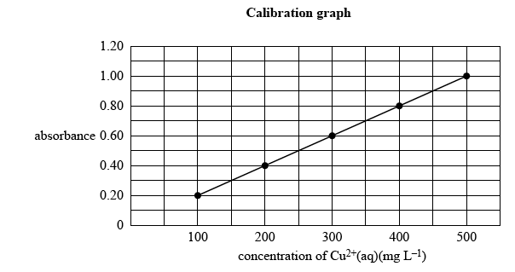

Question 2 (continued))

c. ii. Use this concentration to calculate the mass of copper in the 100.0 mL volumetric
flask. This is the same as the mass of copper in the 25.0 mL solution since this process is simply a dilution with water.

Study Design Reference
Visible and ultraviolet spectroscopy (visible-UV) including electron transitions and use of
calibration graph to determine amount of analyte. Application of Faraday’s laws in electrochemistry

Web Link
http://www.chem1.com/chemed/

Question 3 (8 marks)
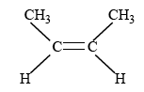
a. The systematic name for compound A shown above is but-2-ene. You must get the longest possible carbon chain. This is 4 carbons. Then you must specify the position of the double bond.
(1 mark)

b. i. The structure of 2,3-dibromobutane is shown below.

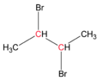

In this molecule, there are only 2 different carbon environments.
(1 mark)

The ¹³C NMR spectrum of compound C shows 4 different carbon environments.
(1 mark)
Therefore, compound C cannot be 2,3-dibromobutane

ii. The structure of 2-bromobutane is shown below.

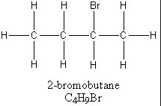
(1 mark)

iii. In order to produce 2-bromobutane from but-2-ene, a hydrogen atom and a bromine atom must add across the double bond. Reagent D is hydrogen bromide (HBr)
(1 mark)

Question 3 (continued)

c. i. A catalyst changes the rate at which equilibrium is achieved but does not alter the
position of equilibrium. Hence, in this reaction C₄H₈(g) + H₂(g) C₄H₁₀(g), with a catalyst, the graph will be steeper at the beginning and will reach the same constant value as shown below.
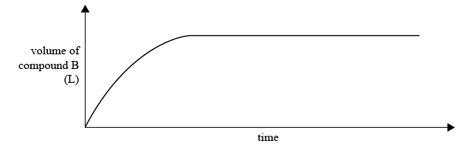
(1 mark)

ii. A catalyst changes the rate of a reaction by providing a substrate on its surface to bring the reactants closer together.
(1 mark)

This lowers the activation energy and increases the number of effective collisions per unit time.
(1 mark)

Study Design Reference
Carbon-13 nuclear magnetic resonance spectroscopy (NMR) including spin, the application of carbon-13 to determine number of equivalent carbon environments. Common reactions of organic compounds including equations: addition reactions of alkenes (addition of hydrogen halides and water limited to symmetrical alkenes). Factors which affect the position of equilibrium.

Web Link
http://www.chem1.com/chemed/

Question 4 (18 marks)

a. HA is a weak monoprotic acid with the molecular formula C₄H₈O₂.
There are 2 possible structures for this compound. These are shown below.

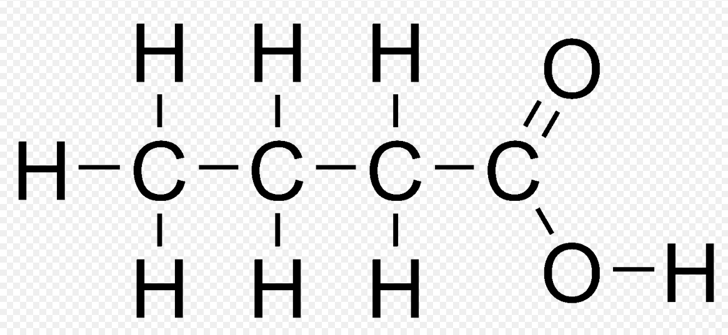  butanoic acid | 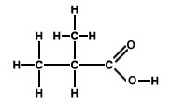  methylpropanoic acid

In the proton NMR spectrum for HA there are 3 main peaks which indicates 3 unique hydrogen environments. See diagram below.
(1 mark)

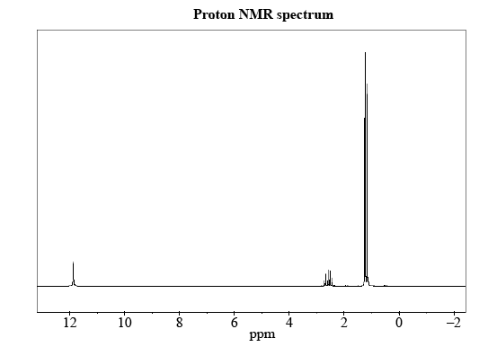

C-H
O-H

The IR spectrum clearly shows the C-H , C=O and C-O bonds in the molecule. See below.

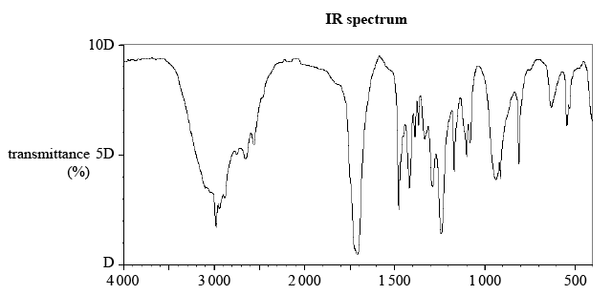

C=O
C-H
C-O

Question 4 (continued)

b. At 2.6 ppm, the signal is split into 7 peaks. Therefore, the number of C-H bonds on the neighbouring carbon atoms = 7 – 1 = 6.
(1 mark)

c. From the Data Book, the group of atoms responsible for the absorptions at

- 3000 cm⁻¹ is C-H
(1 mark)

- 1700 cm⁻¹ is C=O
(1 mark)

d. The structure of HA must be
(1 mark)
(1 mark)


e. ¹³C must be used because ¹²C has a spin quantum number of zero and, therefore, is not magnetically active like ¹³C.
(1 mark)

A ¹³C NMR spectrum would provide the following information about the structure of HA:

(1) 3 peaks indicating 3 different carbon environments
(1 mark)
(1 mark)

(2) Since butanoic acid has 4 different carbon environments, the ¹³C NMR spectrum would provide sufficient information to choose between the two possible structures for HA as long as the molecular formula is known and the compound has been identified as a monoprotic acid.
(1 mark)

Question 4 (continued)

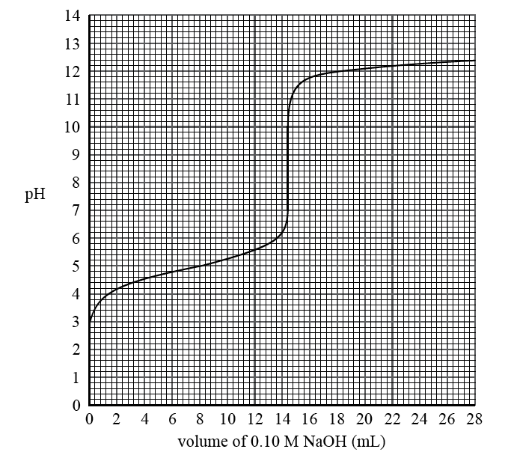
f. In a titration between a weak acid and a strong base, the pH is greater than 7 at the equivalence point as shown in the graph below.

- The volume of NaOH used to neutralize the solution of HA is 14 mL.
(1 mark)

ii. The balanced equation is: HA(aq) + NaOH(aq) → NaA(aq) +H₂O(l)

From the balanced equation, n(HA) = n(NaOH)

- From the graph, the pH of HA before it was reacted with the NaOH = 3.
(1 mark)
Therefore, the concentration of hydronium ions (H₃O⁺) = 10⁻³ M
(1 mark)

Question 4 (continued)

iv. The equation showing HA acting as a weak, monoprotic acid is:
HA + H₂O H₃O⁺ + A⁻

Study Design Reference
Proton and carbon-13 nuclear magnetic resonance spectroscopy (NMR) including spin,
the application of carbon-13 to determine number of equivalent carbon environments; and
application of proton NMR to determine structure: chemical shift, areas under peak and
peak splitting patterns (excluding coupling constants), and application of n+1 rule to simple
compounds. Titration curves: simple titrations

Web Link
http://www.chem1.com/chemed/

Question 5

a. The methionine residue is circled below. “Residue” means “left over”. Note that the residue has fewer atoms than the actual amino acid. This is because atoms are lost when the peptide link is formed. Get the formula for methionine amino acid from the Data Book.
(1 mark)

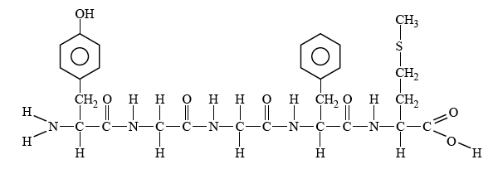

b. In the diagram, the solvent front is at 29 cm when the methionine is at 17.5 cm. Let x = the distance of the methionine spot when the solvent was at 20 cm. Therefore,

c. The different amino acids form bonds of different strengths with the stationary phase and the solvent.
(1 mark)

Hence, separation occurs as bonds form and break while the amino acids are carried along the strip.
(1 mark)

Question 5 (continued)

d. From the Data Book, find the formula for glycine. It is H₂N – CH₂ – COOH. When the pH is low, the concentration of hydrogen ions (H⁺) is high. The formula for glycine in this low pH environment is ⁺H₃N – CH₂ – COOH. The structural formula is shown below.
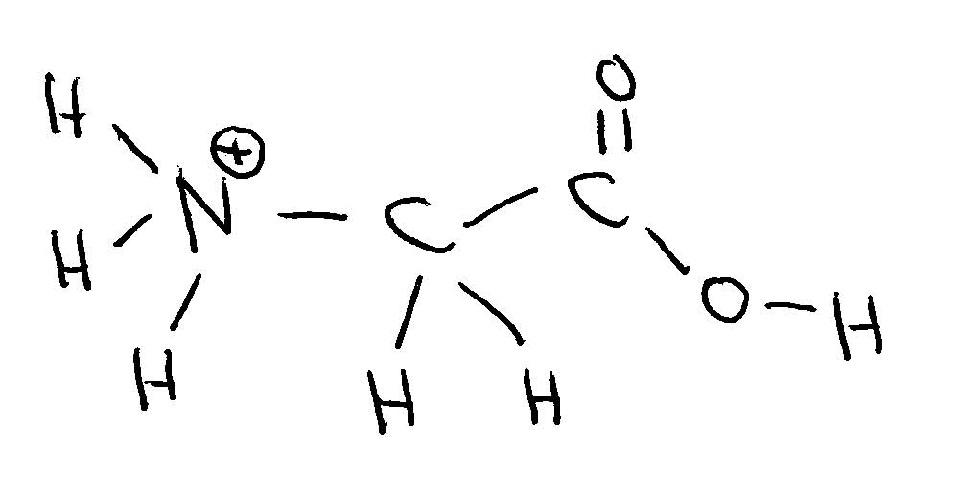
(1 mark)

Study Design Reference
Thin layer chromatography (TLC), including calculation of Rf
Primary, secondary and tertiary structures of proteins.

Web Link
http://www.chem1.com/chemed/

Question 6

a. The balanced equation is 2CH₃OH(g) CH₃OCH₃(g) + H₂O(g)
The expression for the equilibrium constant, K₁, at 350 ºC is shown below.

(1 mark)
b. The new balanced equation is the reverse of the equation in a.
CH₃OCH₃(g) + H₂O(g) 2CH₃OH(g)

(1 mark)

c. It is very important to distinguish between initial states and equilibrium states in equilibrium calculations. Use the subscript i for initial states and the subscript e for equilibrium states.

i. The equilibrium concentration of methanol, [CH₃OH]_{e}
(1 mark)

ii. From the balanced equation, the concentration of dimethyl ether formed equals the concentration of water formed. Hence,

Question 6 (continued)

c. iii. The initial number of mole of methanol
= number of mole of methanol at equilibrium + number of mole of methanol reacting

n(CH₃OH)_{i} = n(CH₃OH)_{e} + n(CH₃OH)_{reacting}
(1 mark)
From the balanced equation, 2 mol of methanol produces 1 mol of dimethyl ether. Therefore,

n(CH₃OH)_{e} = n(CH₃OH)_{e} + 2 × n(CH₃OCH₃)_{e}

n(CH₃OH)_{e} = 0.340 + 2 × 5.74 = 11.82 mol
(1 mark)

Study Design Reference
Equilibrium: representation of reversible and non-reversible reactions: homogeneous equilibria and
the equilibrium law (equilibrium expressions restricted to use of concentrations).

Web Link
http://www.chem1.com/chemed/

Question 7

a. In the Data Book, hydrogen peroxide is listed both as an oxidant and as a reductant.
A reductant donates electrons, so you must use the equation
O₂(g) + 2H⁺(aq) + 2e⁻ H₂O₂(aq) E⁰ = +0.68 V
(1 mark)

H₂O₂(aq) will react with any oxidant with a more positive E⁰ value than +0.68. You can choose any oxidant from F₂(g) down to Fe³⁺(aq). For example,

Br₂(l) + 2e⁻ 2Br⁻(aq)

H₂O₂(aq) O₂(g) + 2H⁺(aq) + 2e⁻

Balanced overall equation is H₂O₂(aq) + Br₂(l) 2Br⁻(aq) + O₂(g) + 2H⁺(aq)
(1 mark)

b. Since Cu²⁺(aq) acting as an oxidant has a more positive E⁰ value than H₂(g) acting as a reductant, the prediction is for a chemical reaction to occur. However, the electrochemical series predicts only the position of equilibrium for a chemical reaction but not the rate at which the reaction occurs. Apparently, this reaction is very slow.
(1 mark)

Study Design Reference
Use of the electrochemical series in predicting the products of redox reactions and deducing overall
equations from redox half equations.

Web Link
http://www.chem1.com/chemed/

Question 8

a. A primary galvanic cell such as the lithium button cell cannot be recharged. A secondary galvanic cell such as a lithium ion cell can be recharged.
(1 mark)

b. In the Data Book, the electrochemical series shows that Li(s) is the strongest reductant with an E⁰ value of -3.02 V. Hence, when Li(s) is used in a galvanic cell with a strong oxidant, the cell potential will be large. Cell potential = E⁰(oxidant) – E⁰(reductant)
(1 mark)
c. The balanced equation for the reaction is: 2Li(s) + 2H₂O(l) → H₂(g) + 2LiOH(aq)

From the balanced equation, n(H₂) produced = n(Li) reacting.
(1 mark)

Since excess water is used, all of the Li will react.

Question 8 (continued)

d. The electrode equations as the lithium ion cell is discharged are the reverse of the equations for when the cell is being recharged. The discharge equations are:

CoO₂ + Li⁺ + e⁻ → LiCoO₂

LiC₆ → 6C + Li⁺ + e⁻

Therefore, the electrons and Li⁺ ions are moving as shown in the diagram below. The LiC₆ electrode is producing electrons and so this is the negative electrode. The LiCoO₂ electrode is accepting electrons and so this is the positive electrode.
(1 mark)
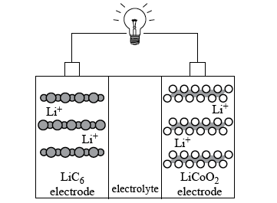
e⁻
e⁻
e⁻

positive
electrode
negative
electrode

Study Design Reference
The chemical principles, half-equations and overall equations of simple primary and secondary
galvanic cells. Calculations including amount of solids, liquids and gases; concentration; volume, pressure and temperature of gases.

Web Link
http://www.chem1.com/chemed/

Question 9

a. You must calculate the initial and final masses of carbon dioxide and then subtract.
(1 mark)
b. The balanced equation for the burning of coal (assumed to be pure carbon) is
C(s) + O₂(g) → CO₂(g) ΔH = - 394 kJ mol⁻¹

First, calculate the number of mole of carbon and then calculate the energy released.
Don’t forget to use only half the mass of carbon!

c. The first equilibrium is CO₂(g) CO₂(aq)
According to Le Chatelier’s Principle, increasing the concentration of atmospheric carbon dioxide will shift the first equilibrium to the right, thereby increasing the concentration of dissolved carbon dioxide at the ocean surface.
(1 mark)
The second equilibrium is CO₂(aq) + H+O(l) H⁺(aq) + HCO₃⁻(aq)
Increasing the concentration of dissolved carbon dioxide will then shift the second equilibrium to the right, thereby increasing the concentration of hydrogen ions in sea water.
(1 mark)

Increasing the hydrogen ion concentration lowers the pH of seawater
because pH = -log₁₀[H⁺]
(1 mark)
Study Design Reference
Calculations including amount of solids, liquids and gases; concentration; volume, pressure and
temperature of gases. Le Chatelier’s Principle and factors which affect the position of equilibrium.

Web Link
http://www.chem1.com/chemed/

Question 10

Note: in two of the structures drawn on this page (in the original sample exam posted on the VCAA website), the carbon atoms are incorrectly shown connected to the sides of the benzene ring instead of the vertices. The structure of the original compound should be drawn as shown below. The carbon atoms occur where lines join. The hydrogen atoms have been omitted.

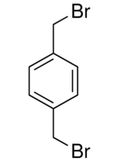

a. Reagent A is sodium hydroxide – NaOH. This is a substitution reaction in which the bromide functional group has been replaced by the hydroxyl functional group. The other product in the reaction is sodium bromide (NaBr). Note that, in organic chemistry, the by-products of chemical reactions are frequently omitted.
(1 mark)

b. The structure of compound 1 is shown below. The carbon atoms occur where lines join.
The hydrogen atoms have been omitted everywhere except on the functional group.

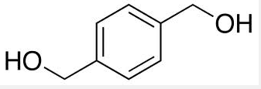
(1 mark)

c. Dichromate ions in an acidic environment are commonly used in organic chemistry to carry out oxidation reactions. The balanced half-equation for the reduction of dichromate ions (Cr₂O₇ ²⁻) to chromium(III) ions (Cr³⁺) is shown below.

Cr₂O₇ ²⁻(aq) + 14H⁺(aq) + 6e⁻ → 2Cr³⁺(aq) + 7H₂O(l)

(1 mark)

Question 10 (continued)

d. The dichromate ions have oxidised the hydroxyl functional group (OH) to the carboxyl functional group (COOH). The reaction of this dicarboxylic acid with compound 2 produces a condensation polymer with links containing the atoms NHCO. Compound 2 must contain the amine functional group (NH₂) as shown below. The carbon atoms occur where lines join.
The hydrogen atoms have been omitted everywhere except on the functional group.

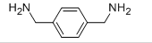

(1 mark)

e. The functional group shown below is known as amide or peptide.
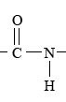
(1 mark)

Study Design Reference
Organic reaction pathways including appropriate equations and reagents:

Web Link
http://www.chem1.com/chemed/

Question 11

Lots of reading here but you need to find the important stuff. All of the phosphorus has been precipitated as MgNH₄PO₄.6H₂O. Notice that there is one atom of phosphorus in this formula. When the P₂O₅ in the fertiliser is converted to MgNH₄PO₄.6H₂O, two molecules of precipitate are formed from one molecule of P₂O₅. You could write a balanced equation for the reaction with all of the other information given in the question, but this is unnecessary. You just need the ratio between the P₂O₅ and the MgNH₄PO₄.6H₂O.

Here is the simple calculation for what looks like a very difficult problem!
When in doubt, start with a calculation of the number of mole of something!

m(MgNH₄PO₄.6H₂O) = 4.141 g

n(MgNH₄PO₄.6H₂O) =
(1 mark)
One mole of P₂O₅ produces two mole of MgNH₄PO₄.6H₂O

n(P₂O₅) = n(MgNH₄PO₄.6H₂O) =
(1 mark)
m(P₂O₅) in the 3.256 g sample of fertiliser =
(1 mark)
m(P₂O₅) in the 1 kg (1000 g) of fertiliser = = 368.1 g
(1 mark)

Study Design Reference
Gravimetric analysis. Calculations including amount of solids.

Web Link
http://www.chem1.com/chemed/

Question 12

a. Make up a number (say 10) solutions of X of different, known concentrations.
(1 mark)
Measure the absorbance of each of these solutions using electromagnetic radiation of wavelength 290 nm.
(1 mark)
Plot a graph of absorbance (Y axis) against concentration (X axis).
The straight line graph of best fit for these data will have a gradient of 4.15
(1 mark)

b. When the absorbance becomes constant after about 120 seconds, equilibrium has been established and the concentration of X does not change.
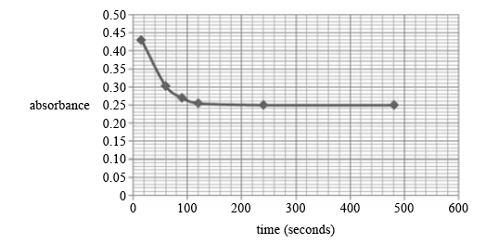

i. At equilibrium, the absorbance = 0.25
Therefore, from the given relationship, 0.25 = 4.15 × [X]_{e}
Hence, [X]_{e} =
(1 mark)

ii. [X]_{initial} =
Hence, absorbance at the instant that X was dissolved in the water
= 4.15 × [X]_{initial}
= 4.15 × 0.110 = 0.457
(1 mark)

Question 12 (continued)

b. iii. n(X) that has been converted into Y at equilibrium = n(X) reacting
n(X) reacting = n(X) initially present - n(X) at equilibrium
= 0.110 – 0.0602
= 0.0498
= 0.05 mol
(1 mark)

% conversion =
(1 mark)

Study Design Reference
Visible and ultraviolet spectroscopy (visible-UV)

Web Link
http://www.chem1.com/chemed/

Question 13

A critical evaluation of the student’s proposal.

- The equation as given in the experimental design is not balanced and so any calculations based on this equation will be wrong.

The correct balanced equation is CaCO₃(s) + 2HCl(aq) → CaCl₂(aq) +CO₂(g) +H₂O(l)

- The variables in the experiment have not been controlled.
- the mass of the calcium carbonate is different in each flask.
- the surface area of the calcium carbonate in each flask is different.
- the volume of hydrochloric acid used in each flask is different.
- the temperature in each flask is different.

- No valid conclusion can be reached about the effect of concentration of acid on the rate of reaction between calcium carbonate and hydrochloric acid.

- In order to achieve the aim of the experiment, the student must use the same mass of calcium carbonate in each flask, must have particles with the same surface area, must use the same volume of acid and must keep the temperature constant.

- The basic rule of experimental design is to test for only one variable at one time.

Study Design Reference (Key Skills)
Conduct investigations that include collecting, processing, recording and analysing qualitative
and quantitative data; draw conclusions consistent with the question under investigation and the
information collected; evaluate procedures and reliability of data. Construct questions (and hypotheses); plan and/or design, and conduct investigations; identify and address possible sources of uncertainty.

Web Link
http://www.chem1.com/chemed/

End of Detailed Answers to 2013 VCAA VCE Chemistry Sample Examination
Short Answer Questions

Kilbaha Multimedia Publishing  PO Box 2227  Kew Vic 3101  Australia | Tel: (03) 9018 5376  Fax: (03) 9817 4334  kilbaha@gmail.com  http://kilbaha.com.au

