Chemistry exam Name: ________________

SECTION A – Multiple-choice questions

Instructions for Section A
Answer all questions.
Choose the response that is correct or best answers the question.
A correct answer scores 1, an incorrect answer scores 0.
No mark will be given if more than one answer is completed for any question.
Marks will not be deducted for incorrect answers.

Question 1
The use of hydrogen as a fuel in cars involves
A. replacing the petrol tank of a conventional car with a hydrogen tank.
B. using hydrogen gas to generate electricity that is used to charge a bank of batteries.
C. using hydrogen gas as a reactant in a fuel cell.
D. reacting hydrogen gas as a reactant in a bank of lithium batteries.

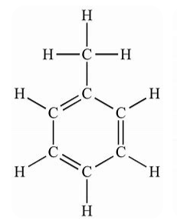
Question 2
The molecule shown in this question is toluene.
It is an important solvent in the rubber and tyre industry.

The degrees of unsaturation in a toluene molecule is
A. 2
B. 3
C. 4
D. 5

Question 3
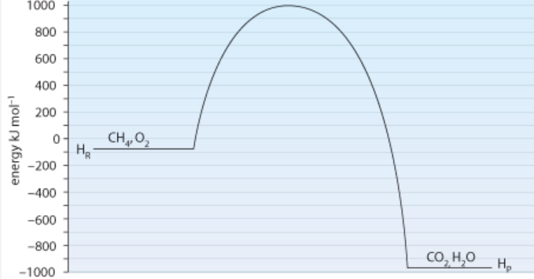
The energy profile diagram shows the energy changes when methane undergoes complete combustion.
energy kJ

The activation energy and ΔH values for the reverse reaction will be, respectively,
A. -890 kJ and -1090 kJ
B. 1090 kJ and -890 kJ
C. -1980 kJ and -890 kJ
D. 1980 kJ and 890 kJ
Question 4
The complete combustion of 3 mole of an alkane produces 149 L of CO₂ at SLC. The alkane is
A. methane
B. ethane
C. butane
D. octane

Question 5
The industrial process used to separate ethanol from water to produce a fuel
A. uses a solvent that will dissolve ethanol but not water.
B. is chromatography where the alcohol and water move at different speeds through a column
C. is an oxidation reaction where the ethanol is converted to ethanoic acid.
D. is fractional distillation.

Use the following information to answer Questions 6 to 7
The diagram below shows an iron-air cell and the half-equations occurring at the iron electrode. The half-equation is represented in two stages.
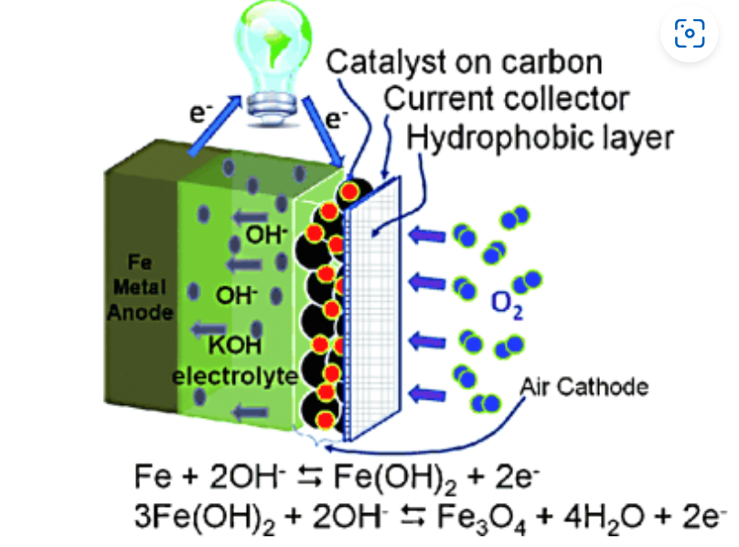

Question 6
When the two half-equations shown are combined the overall half-equation obtained will be
A. 3Fe + 8OH⁻ Fe₃O₄ + 4H₂O + 8e
B. 3Fe + 4H₂O + 4e Fe₃O₄ + 4H₂O
C. Fe + 2OH⁻ Fe₃O₄ + 4H₂O
D. Fe + 6OH⁻ Fe₃O₄ + 2H₂O + 2e

Question 7
The overall equation for the discharge reaction in this cell will be
A. 3Fe + 2O₂(g) Fe₃O₄
B. 3Fe + 2O₂(g) + 8OH⁻ Fe₃O₄ + 4H₂O
C. 2Fe + 4OH⁻ Fe₃O₄ + 4H₂O
D. 2Fe + 2H₂O Fe₃O₄ + 8OH⁻

Question 8
Hydrogen gas can be produced in a PEM cell and used in a hydrogen fuel cell. The polarity of the hydrogen electrode in each cell will be
 | PEM cell | Fuel cell
A. | positive | positive
B. | positive | negative
C. | negative | positive
D. | negative | negative

Question 9
Sulfate ions can be converted to peroxysulfate ions (S₂O₈²⁻)in a redox reaction. A balanced half equation for this reaction is
A. 2SO₄²⁻(aq) S₂O₈²⁻(aq) + 2e⁻
B. SO₄²⁻(aq) + 4H₂O(l) S₂O₈²⁻(aq) + 8H⁺(aq) + 2e⁻
C. 2SO₄²⁻(aq) + 4H₂O(l) 2S₂O₈²⁻(aq) + 8H⁺(aq) + 2e⁻
D. 2SO₄²⁻(aq) + 2e⁻ 2S₂O₈²⁻(aq)

Question 10
The reaction between hydrogen and iodine gases is a reversible one.

H₂(g) + I₂(g) ⇌ 2HI(g) ΔH < 0

The temperature of an equilibrium mixture of the above gases is increased. The value of Q, just after the increase in temperature, will
A. be unchanged because K will not change.
B. not change as the system will move to bring the value of K back to the value of Q.
C. now be higher than the new value of K.
D. now be lower than the new value of K.

Use the following information to answer Questions 11 and 12
The reaction between Fe³⁺ and SCN⁻ ions forms a complex with a deep red colour. The equation for this reaction is

Fe³⁺(aq) + SCN⁻(aq) ⇌ FeSCN²⁺(aq)
deep red

Question 11
Which of the following changes will not increase the intensity of the red colour?
A. Evaporation of some water from the solution.
B. Addition of a few drops of KSCN solution.
C. Addition of a few drops of Fe(NO₃)₃ solution.
D. Addition of a few drops of water.

Question 12
A few drops of AgNO₃ is added to an equilibrium mixture of the above chemicals. The Ag⁺ ions form an AgSCN precipitate. As a result of this addition, the concentration of SCN⁻ is lower when equilibrium is re-established.
When equilibrium was re-established, the value of K
A. will be higher as the concentration of SCN⁻ dropped.
B. will be lower as the concentration of SCN⁻ dropped.
C. will be unchanged.
D. will be higher as the concentration of FeSCN²⁺ has dropped.

Use the following information to answer Questions 13 and 14
The cell below shows the electrolysis of a dilute solution of NaCl.
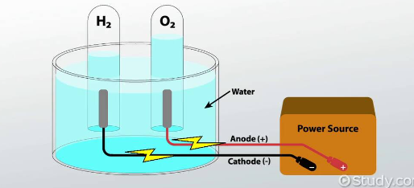

Question 13
Select the alternative that is a correct statement about this cell.
A. The electrodes need to porous and to act as catalysts.
B. Electrolysis of 0.1 M sulfuric acid will produce the same products at a lower voltage.
C. Electrolysis of 0.1 M NaOH will produce the same products and require the same voltage.
D. The half-equation producing oxygen gas is a reduction reaction.

Question 14
The number of mole of oxygen gas produced in this cell will
A. equal the number of mole of hydrogen gas produced.
B. equal the number of mole of electrons passing through the cell.
C. be one quarter the number of mole of electrons passing through the cell.
D. be four times the number of mole of electrons passing through the cell.

Question 15
A chemistry student sends a method for vitamin C determination of Fanta to her pen-pal in Tokyo to test. The Australian student found a vitamin C level of 8.4 ppm, while the Japanese student found the level to be 2.8 ppm. At this point, the students
A. can conclude that the Japanese student’s result is not valid.
B. have found the repeatability of the experiment is poor.
C. have found the reproducibility of the experiment is low.
D. have found the resolution of the method is low.

Question 16
What is the systematic name of this molecule?
A. 3,4-dibromo-2,5-dimethylheptane
B. 3,4-dibromononane
C. 4,5-dibromo-3,6-dimethylheptane
D. 3,6-dimethyl-4,5-dibromoheptane

Question 17
Which of the following molecules is likely to have the highest viscosity?
A. hexane
B. nonane
C. 1-chlorooctane
D. octanoic acid

Question 18
Consider the following categories to answer this question
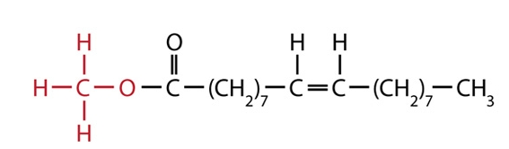
I fatty acid
II biodiesel
III ester
IV triglyceride

The molecule shown can be described as
A. I and III only.
B. II and IV only.
C. I and II only.
D. II and III only.

Question 19
Consider the molecule drawn below.
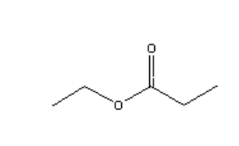
This molecule could be formed from the reaction between
A. ethanoic acid and propan-1-ol.
B. ethanol and propanoic acid.
C. ethanol and ethanoic acid.
D. ethane and propanoic acid.

Question 20
A high-resolution proton-NMR is shown below.
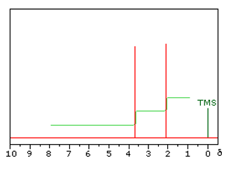

This molecule is likely to be
A. ethanol
B. propan-1-ol
C. methyl propanoate
D. methyl ethanoate

Question 21
An organic compound is reacted with K₂Cr₂O₇ in acid conditions. The pH of the product is tested and found to be around 7. Which of the following compounds could be the compound tested?

A. B.

C. D.

Question 22
Refer to the mass spectrum below to answer this question.
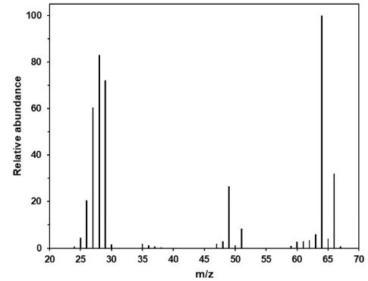

The mass spectrum is of a compound that
A. contains a chlorine atom.
B. has a very small proportion of an isotope present.
C. is a primary alcohol.
D. is an isomer of butane.

Question 23

The molecule shown is tested in both proton-NMR and carbon-NMR.
It will have

 | Hydrogen environments | Carbon environments
A. | 2 | 2
B. | 3 | 2
C. | 2 | 3
D. | 3 | 3

Question 24
The charge on a molecule of aspartic acid at pH 11 will be
A. 0 (neutral)
B. +1
C. -1
D. -2

Question 25
Refer to the HPLC printout below to answer this question. A non-polar solvent is used and a polar stationary phase.
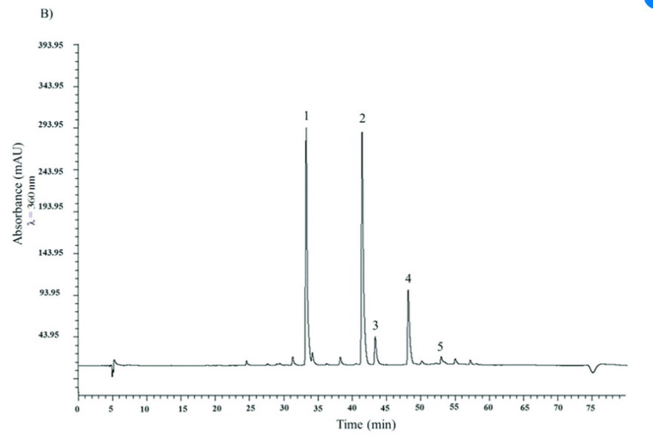
A carbon

Question 22
An impure
A. 5.5
B. 11
C. 22
D. 55

Question 23
The mass spectrum of a molecule is shown below.

The components of the mixture are ethanol, hexane, octane and hexan-1-ol. The compound causing peak 5 on the chromatogram will be
A. octane
B. hexane
C. ethanol
D. hexan-1-ol

Question 26
The presence of folic acid in the body, increases the rate of cancer cells multiplying. Methotrexate is a drug used to limit the effect of folic acid.
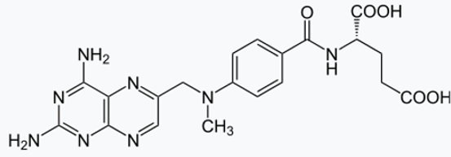
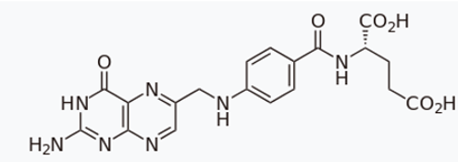

folic acid methotrexate

A conclusion that can be formed from studying these two molecules is that
A. both molecules act as catalysts for reactions taking place in the body.
B. folic acid and methotrexate are optical isomers.
C. folic acid is an enzyme and methotrexate fits its active site.
D. methotrexate can block the active site that catalyses folic acid.

Question 27
20 mL of 0.10 M KMnO₄ is added to a flask under a burette. A solution of Fe(NO₃)₂ is added from the burette and the titre is found to be 15.6 mL. The concentration of the iron solution is
A. 0.026 M
B. 0.13 M
C. 0.26 M
D. 0.64 M

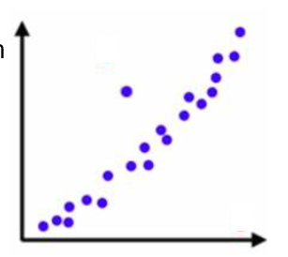
Question 28
A student’s measurements from an experiment are shown
in this graph.
A. The graph contains an outlier that should be investigated further.
B. The data will not be valid due to the presence of an outlier.
C. The experiment needs to be repeated to eliminate outliers.
D. The experiment is not reproducible.

Question 29
The diagram below shows a measuring cylinder containing an aqueous solution.
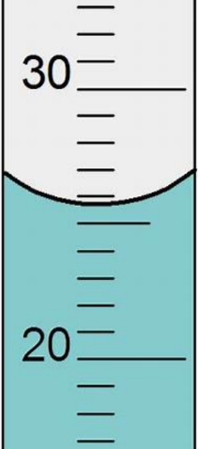

From the diagram the measuring cylinder can be seen to have a

 | Resolution (mL) | Reading (mL)
A. | 0.1 | 34.2
B. | 1.0 | 25.8
C. | 1.0 | 25.5
D. | 2.0 | 25.5

Question 30
Which of the following best describes the presentation of data on a scientific poster?
A. All measurements taken need to be shown for the reader to evaluate for themselves.
B. Only data that supports the hypothesis should be shown.
C. All measurements must be shown but they should be presented in tables or graphs.
D. Data should be presented in an appropriate format to highlight trends or relationships

Section A 30 marks ____

Total Section B 96 marks ____

Total exam 126 marks ____

SECTION B - Short-answer questions
Instructions for Section B
Questions must be answered in the spaces provided in this book.
To obtain full marks for your responses you should
- give simplified answers with an appropriate number of significant figures to all numerical questions; unsimplified answers will not be given full marks.
- show all workings in your answers to numerical questions. No credit will be given for an incorrect answer unless it is accompanied by details of the working.
- make sure chemical equations are balanced and that the formulas for individual substances include an indication of state; for example, H₂(g); NaCl(s)

Question 1 (9 marks)
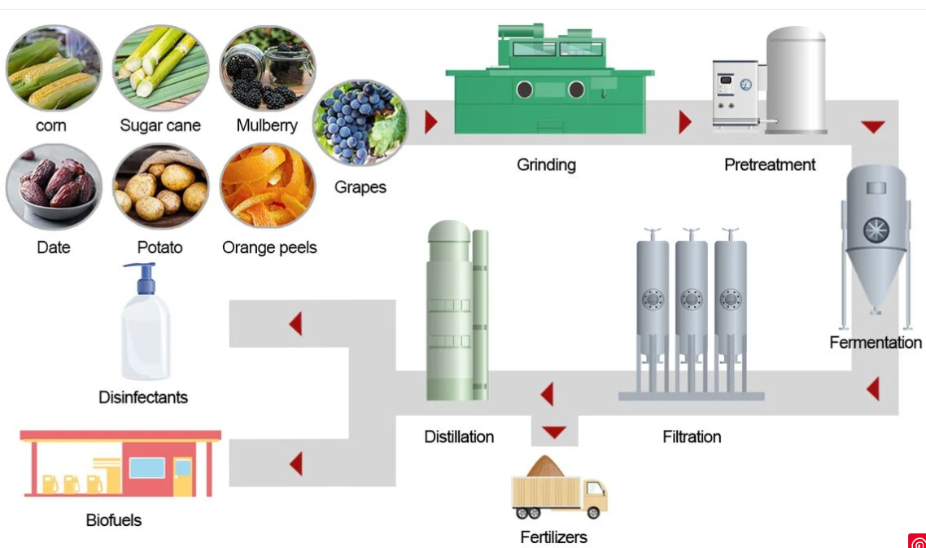
The flowchart below represents the process at a NSW bioethanol facility.

a. The flowchart shows that the plant uses more than one raw material.
i. Suggest a reason for the use of multiple raw materials. 2 marks

__________________________________________________________________________

__________________________________________________________________________

ii. The amount of pretreatment varies for each type of raw material. Refer to the chemical
structure of the raw materials to discuss the reasons. 2 marks

__________________________________________________________________________

__________________________________________________________________________

__________________________________________________________________________

b. i. Write an equation for fermentation. 1 mark

__________________________________________________________________________

ii. Why is filtration required? 1 mark

__________________________________________________________________________

c. i. Explain what is happening in the distillation phase. 2 marks

__________________________________________________________________________

__________________________________________________________________________

ii. The bottom of the flowchart shows an extra sustainability aspect. Identify this step. 1 mark

__________________________________________________________________________

__________________________________________________________________________

Question 2 (8 marks)
The cell shown below is a fuel cell using ethanol solution and oxygen gas as reactants. The reaction produces CO₂ gas, which in turn forms carbonate ions in the solution. The half-equation and potential for the reaction of the ethanol is

C₂H₅OH(aq) + 16OH⁻(aq) 2CO₃²⁻(aq) + 11H₂O(l) + 12e⁻ -0.74 V
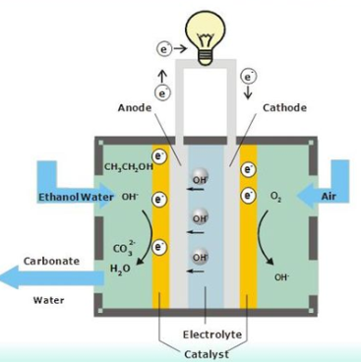

a. i. Use the circles provided on the diagram to indicate the polarity of the electrodes. 1 mark

ii. One half-equation is provided for you. Write the other half-equation occurring in this cell.
1 mark
________________________________________________________________________

iii. Write the overall equation for the reaction occurring in this cell. 2 marks

_________________________________________________________________________

b. Determine the likely cell voltage for this cell. _____________________ 1 mark

c. i. Discuss the sustainability impact of the CO₂ produced in this cell reacting further to form
carbonate ions. 2 marks

_________________________________________________________________________

_________________________________________________________________________

_________________________________________________________________________

ii. Identify the energy conversion occurring in this cell. 1 mark

_________________________________________________________________________

Question 3 (10 marks)
The diagram below is a representation of the cell used in the production of aluminium. A current is passed through molten alumina, Al₂O₃. The alumina is dissolved in a substance called cryolite. The cryolite does not show in the reactions occurring.
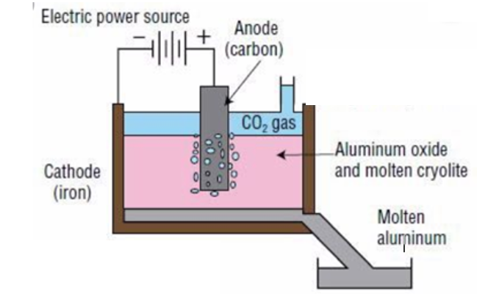

a. i. Refer to the diagram to identify the two main products of this cell. 2 marks

______________________________________________________________________

ii. Write a half-equation for the reaction occurring at the cathode. 1 mark

______________________________________________________________________

iii. The reactant at the anode reacts with the carbon electrode itself. Write a half-equation for
this reaction. 1 mark

_______________________________________________________________________

iv. Write an overall equation for the cell reaction. 1 mark

_______________________________________________________________________

b. Calculate the current required to produce 1 tonne of aluminium in 24 hours.
(1 tonne = 1000 kg) 3 marks

_______________________________________________________________________

_______________________________________________________________________

_______________________________________________________________________

_______________________________________________________________________

c. List two ways the production of aluminium has a detrimental impact on the environment.
2 marks
_______________________________________________________________________

_______________________________________________________________________

Question 4 (11 marks)
a. The two molecules shown are structural isomers. They are both colourless liquids.

___________________ _________________

i. Use the lines provided to name each molecule. 2 marks

ii. Describe a chemical test or reaction that could be used to distinguish between the two
liquids. Explain briefly how your test works. 2 marks

____________________________________________________________________

____________________________________________________________________

iii. Which spectrum should easily distinguish the two molecules? 1 mark

____________________________________________________________________

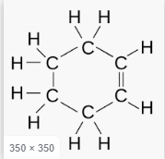
b. The two molecules shown are both fuels and are both colourless liquids.
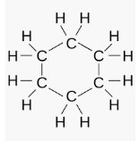

Describe carefully a chemical test that will distinguish the two liquids. Explain briefly
how your test works. 2 marks

____________________________________________________________________

____________________________________________________________________

c. The two molecules shown are both colourless liquids

Describe carefully two chemical tests that could be used to distinguish between the two
liquids. Explain briefly how your test works. 4 marks

Test 1: ____________________________________________________________________

____________________________________________________________________

Test 2: ____________________________________________________________________

____________________________________________________________________

Question 5 (12 marks)
A molecule of an organic compound is known to contain carbon, hydrogen and one oxygen atom. All spectra in this question refer to this compound.

a. The mass spectrum of the compound is shown below.
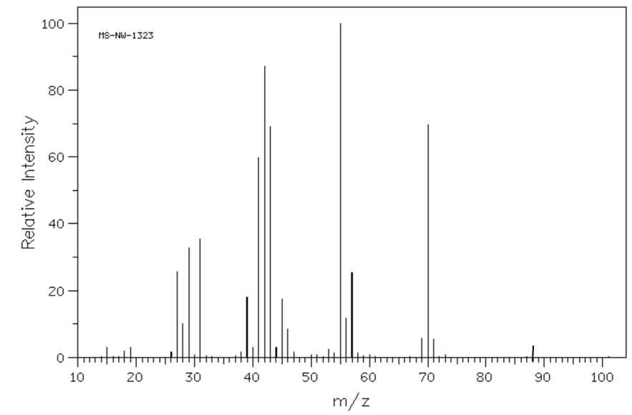
i. Use the mass spectrum to provide a likely molecular formula for the molecule. Justify
your answer. 2 marks

_______________________________________________________________________

_______________________________________________________________________

ii. There is a significant peak with a m/z ratio of 31. Suggest a fragment that might cause
this peak. 1 mark

_______________________________________________________________________

b. The infrared spectrum of the compound is shown below.
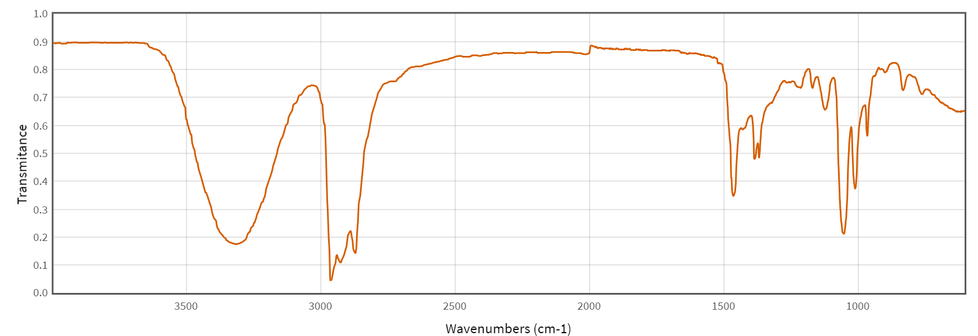
State two conclusions you can draw from this spectrum. 2 marks

Conclusion 1: _________________________________________

reason: _________________________________________

Conclusion 2: ________________________________________

reason: ______________________________________________

c. The C-NMR and proton-NMR for this compound are both shown below.
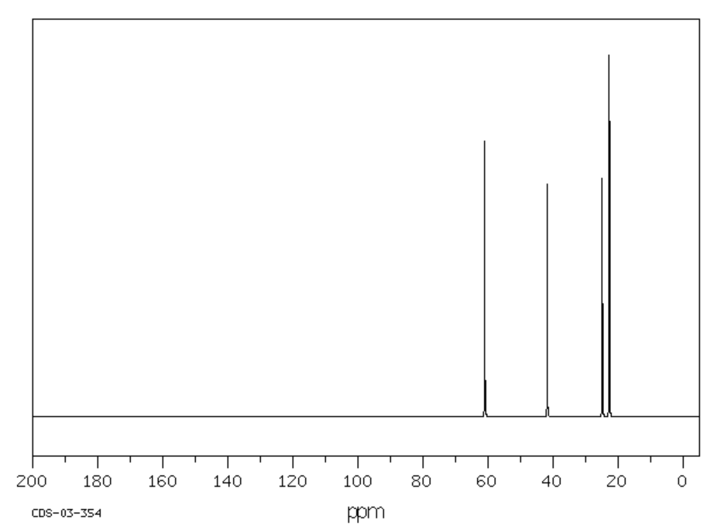

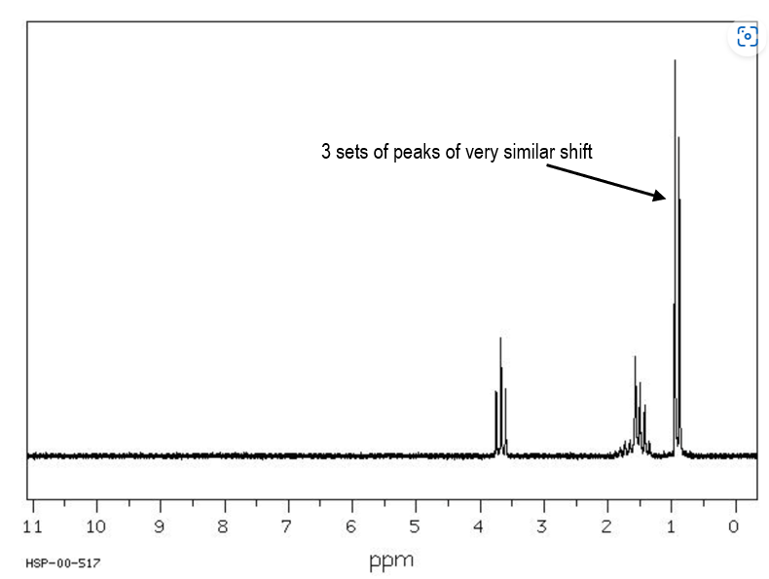

one of which is a singlet

i. The number of carbon environments in the compound is _________? 1 mark

ii. The C-NMR just over 60 could be due to ___________? 1 mark

iii. The number of hydrogen environments is ____________? 1 mark

d. Draw the structure of this compound and justify your answer. 4 marks

____________________________________________________________________

____________________________________________________________________

____________________________________________________________________

____________________________________________________________________

____________________________________________________________________

____________________________________________________________________

Question 6 (12 marks)
The molecule below is salicylic acid. An early method used to make aspirin was to react salicylic acid with ethanoic acid, forming aspirin 2-acetyloxybenzoic acid
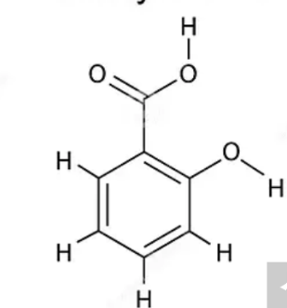

a. Use the space beside the salicylic acid molecule to draw a molecule of ethanoic acid and to
draw aspirin, the ester formed from the reaction between the two reactants. 3 marks

b. i. Suggest a suitable catalyst for this reaction. _________________ 1 mark

ii. Write a balanced equation for the reaction. 2 marks

_______________________________________________________________________

c. In a particular reaction a 4.00 g sample of salicylic acid yields a 4.55 g yield of aspirin.
i. Determine the atom economy of the reaction producing aspirin. 2 marks

_______________________________________________________________________

________________________________________________________________________

ii. Calculate the %yield of aspirin. 2 marks

_______________________________________________________________________

________________________________________________________________________

d. Describe a simple laboratory test you could perform to check the purity of the aspirin produced
and how you interpret the result. 2 marks

_______________________________________________________________________

________________________________________________________________________

Question 7 (8 marks)
a. The molecule below can be made from 2-amino acids.

i. Identify the 2-amino acids used. _____________________________ 2 marks

ii. Circle and name the bond that joins the amino acids. 1 mark

iii. Describe the process of hydrolysis of this molecule. 2 marks

___________________________________________________________________

____________________________________________________________________

_____________________________________________________________________

b. A flowchart from a medicinal journal is shown below.
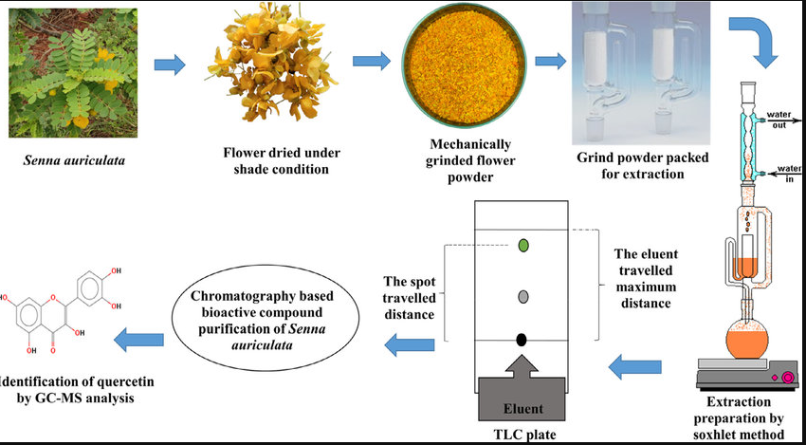

Identify three observations you can draw from this flowchart that relate to your Unit 4 chemistry
course. 3 marks

___________________________________________________________________

____________________________________________________________________

_____________________________________________________________________

___________________________________________________________________

Question 8 (8 marks)
Hydrogen peroxide decomposes slowly over time to water and oxygen gas. The equation for the reaction is
2H₂O₂(l) 2H₂O(l) + O₂(g)

Catalase is an enzyme that can act to increase the rate of this reaction. In some living things catalase is too effective, so researchers have investigated ways of limiting the rate of this reaction. The results from one investigation are outlined below, where the researcher has trialled the use of copper sulfate solutions to impact the reaction rate.
Copper sulfate investigation
Hypothesis: There will be a linear relationship between rate of reaction and copper sulfate concentration.

Method
A set volume of H₂O₂ is added to a flask.
The flask is placed on a balance.
5 drops of catalase solution is added.
The time required for the mass to become constant is recorded.
The procedure is repeated many times with additions of copper sulfate solution as well as catalase.

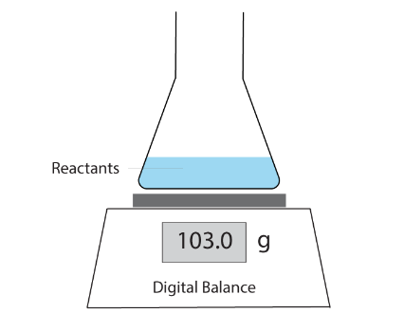
Results

CuSO₄ conc  M | Run 1  s | Run 2  s | Run 3  s
0.00 | 16 | 16 | 16
0.001 | 25 | 24 | 24
0.005 | 122 | 120 | 121
0.025 | 605 | 600 | 604
Experimental set-up

a. Identify the following:

- independent variable ___________________________ 1 mark

- dependent variable ___________________________ 1 mark

b. i. Explain why the mass is changing in this experiment. 1 mark

______________________________________________________________________

ii. Comment on the repeatability of the data obtained. 1 mark

_______________________________________________________________________

c. What conclusion do you draw on whether the hypothesis has been validated or not? 2 marks

________________________________________________________________________

_________________________________________________________________________

_________________________________________________________________________

d. Explain the likely mechanism by which copper sulfate affects the reaction rate. 2 marks

________________________________________________________________________

_________________________________________________________________________

_________________________________________________________________________

Question 9 (12 marks)
Methanol is a useful commercial solvent produced worldwide in large quantities. The traditional method for the manufacture is from the reaction between carbon monoxide and hydrogen gas. The equation for the reaction and the conditions used are:

CO(g) + 2H₂(g) ⇌ CH₃OH(l) ΔH = -91 kJ

Conditions: 10 MPa pressure: temperature 250 ºC: copper/zinc oxide catalyst

a. Refer to Le Chatelier’s Principle to explain the choice of reaction conditions:

i. Temperature: ______________________________________________ 2 marks

________________________________________________________________

ii. Pressure: ________________________________________________ 2 marks

_________________________________________________________________

b. A catalyst generally improves the sustainability of a process. Explain how. 2 marks

______________________________________________________________________

______________________________________________________________________

Like many production processes, industry is moving to produce ‘green methanol’.
Methanol production can be considered to be ‘green’ if green hydrogen is used.

c. Explain how green hydrogen is produced. 2 marks

______________________________________________________________________

______________________________________________________________________

d. A new line of research in the production of green methanol is to use microorganisms. The
anaerobic fermentation of biomass produces methane as biogas. The methane can then be
reacted with oxygen to produce methanol:

2CH₄(g) + O₂(g) 2CH₃OH(l)

Discuss the relative sustainability of this new process. In your answer, refer to either green
chemistry principles or UN sustainability goals. 4 marks

______________________________________________________________________

______________________________________________________________________

______________________________________________________________________

______________________________________________________________________

______________________________________________________________________

______________________________________________________________________

Question 10 (6 marks)
Green tea leaves have been used as a form of medicine in Morocco for many centuries. One of the active ingredients that has been extracted from these leaves is catechin. The structure of catechin is drawn below and it is known to be effective in reducing the rate of cancer cell propagation.

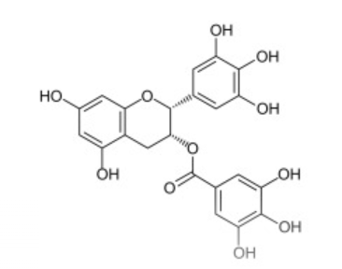

Catechin is a chiral molecule and only one enantiomer is effective in humans. The plants contain a mixture of enantiomers.

Use catechin to discuss the use of chiral plant extracts. Your answer should
- identify the chiral carbon atom(s)
- include an explanation of why only one enantiomer might be effective
- consider the significance to catechin drug manufacturers of this chirality of this molecule and
- comment on the relative sustainability of producing a medicine in this way.

___________________________________________________________________________

___________________________________________________________________________

___________________________________________________________________________

___________________________________________________________________________

___________________________________________________________________________

___________________________________________________________________________

___________________________________________________________________________

___________________________________________________________________________

END OF EXAM

