VT Center for Geographic Information
VT GIS Parcel Data Standard
Version 2.3, Adopted on October 20, 2016

Updates

Date | Notes
March 2012 | Version 1.0
November 2013 | Version 1.1
August 19, 2016 | Version 2.0, Draft posted for public comment
October 12, 2016 | Version 2.1, Intermediate revised draft
October 16, 2016 | Version 2.2, Intermediate revised draft
October 20, 2016 | Version 2.3, Adopted by Vermont Enterprise GIS Consortium (EGC)

Statutory Authority and Standard Review/Approval

The Vermont Center for Geographic Information (VCGI) has the statutory authority to craft and adopt VT GIS standards and guidelines. Over the past 20 years, VCGI has worked with the VT GIS community to carefully craft these standards and guidelines, helping to ensure that Vermont GIS (VGIS) data is compatible with and useful to others in the VT GIS community.

The VT GIS Parcel Data Standard was adopted following the procedure established in VCGI’s “Adoption of VT GIS Standards and Guidelines” Version 1.0. A draft of the standard was released for public comment on August 19th, 2016 and the State’s Enterprise GIS Consortium (EGC) voted to approve the standard on October 20th 2016.

Introduction

GIS (geographic information system) parcel data is the digital geographically-referenced data used to model the locations of parcel boundaries and unlanded buildings, along with associated attribute information, for input to geospatial analysis and production of municipal tax maps. Although GIS parcel data cannot replace detailed ground surveys, the data does assist municipal officials with functions such as accurate property tax assessment, economic development, conservation, planning, zoning, and public safety. Towns can link their GIS parcel data to their electronic municipal Grand List data and display local information. Officials can show tax-payers how proposed development or changes in municipal services and regulations will affect them and their neighbors. In many towns, parcel data also helps to provide public notices, plan bus routes, and carry out other municipal services.

Definitions

Real Estate - Land, improvements to the land, and certain buildings.

Grand List - As of April 1st of any given year, a list that contains a brief description and the listed valuation of each separate piece or parcel of taxable real estate.

Parcel – State statute defines a parcel as "all contiguous land in the same ownership, together with all improvements thereon" (32 V.S.A. § 4152(a)(3)). Though not specifically stated above, the accepted interpretation is that division of a tract by a road does not create two parcels. The Vermont GIS Parcel Data Standard requires that each parcel or unlanded building of the Grand List be modeled in GIS data. Examples of parcels and unlanded buildings that are modeled in GIS data per this standard include but are not limited to:

- lot within a subdivision
- condominium unit
- condominium common land
- mobile home on leased land
- camp on leased land

Unlanded Building – Condominium unit, mobile home, camp, or other building that is a unit of real estate which is separate from the underlying land surface. In some cases, the underlying land is rented.

Active Parcel and Inactive Parcel – Sometimes, when two or more abutting parcels have the same owner, one of those parcels is considered the main parcel, or active parcel, to which a single collective tax bill is associated for all of the parcels. The other parcels are inactive. In these cases, all of the parcels are collectively modeled as one parcel with attribution of the active parcel in the active parcels data layer per this standard; Inactive parcels are modeled in a separate data layer. When the owner of one of the inactive parcels becomes different, that parcel becomes active. Both active and inactive parcels have SPAN numbers.

SPAN - School Property Account Number - A unique, state-assigned identification number for each parcel / unlanded building. SPAN number information is critical to database synergy between Vermont GIS parcel data and Grand List data.


Multi-part Non-contiguous Parcel – Sometimes, a non-contiguous geometry object (multi-part polygon) is required in order to model one Grand List record as one record in the GIS data.

Public Right-of-Way – An area that is legally dedicated to public right-of-way purpose. Ingress/egress easements or “private right-of-way easements” that overlay underlying parcels are NOT considered to be public right-of-ways and are NOT considered to be parcels. Public right-of-way areas do not have SPAN numbers.

Ingress-Egress Easement / Private Right-of-Way – Ingress-egress easements or “private right-of-way easements” are arranged for access to locations by traversing one or more parcels. Ingress-egress easements that overlay underlying parcels are NOT considered to be public right-of-ways and are NOT considered to be parcels.

Map ID - Unique parcel identifier, determined by the municipality, which is distinct from the unique identifier in the Grand List.

Discrepancy List - List of properties with ownership or area conflicts/uncertainty above a threshold agreed upon by municipality and map consultant.

Shapefile – A GIS data format that is widely used in proprietary and open source realms of GIS software. The shapefile format allows data layers to be created with geometry types that include points, lines, and polygons.

dBASE (.dbf) – A tabular data format in which tabular information is stored, either as a component of a shapefile and or as a stand-alone table.

Geodatabase – A data storage format that is based on relational database concepts. The geodatabase format can store spatial and non-spatial data types and supports complex data object relationships. The geodatabase format is scalable from the file-based “file geodatabase” (.gdb) implementation to an enterprise implementation within enterprise-oriented DBMS systems. The geodatabase format allows data layers to be created with geometry types that include points, lines, and polygons; The geodatabase format also allows creation and storage of annotation data layers.

Feature Class – Feature classes stored within a geodatabase and shapefiles are both considered to be feature classes.

Metadata - Documentation about the data, including date, source, and provider.

Objectives of this Data Standard

- Define technical requirements for municipalities to utilize when creating or updating GIS parcel data. Separate levels of this standard will allow municipalities to pick a level suitable for procurement, budget, and resource considerations and ensure that high quality and reliable parcel information products are developed. This standard provides an extensible framework that serves as a foundation for production of supersets of the standard levels for particular municipal business needs.

- Establish common data elements and ensure consistency between different municipal GIS parcel data sets to ensure that all delivered municipal GIS parcel datasets can be merged into a single statewide dataset without translation. The common data elements and data consistency provide a framework that yields efficient exchange of parcel data and parcel data aggregation.

Applicability of this Data Standard

The Transportation Bill of 2016 (Act 158) created the Statewide Property Parcel Mapping Program by which a statewide digital parcel data layer (data set) will be developed, maintained, and made available to state government, regional planning commissions, municipalities, and the public.

Compliance with this standard is required for any contracts or arrangements for creation of GIS parcel data through the Statewide Property Parcel Mapping Program.

GIS parcel data is a recommended source for municipal tax maps. Municipal tax maps are for tax assessment purposes and, unlike areas outside New England, are not the legal (cadastral) record of property ownership. While property boundaries on assessor maps often serve as a proxy for ownership, any authoritative representation of property ownership must be based on records from the municipality and/or work by a licensed professional land surveyor. Please note that this standard is NOT a general purpose standard for traditional printed parcel map sheets.

This standard applies to development of digital versions of municipal parcel maps for use in planning, property assessment, and graphic map display.

Templates are Available

VCGI provides shapefile, .dbf table, geodatabase, and metadata templates that can help in the conversion to, or creation of, data that meets levels of the Vermont GIS Parcel Data Standard. Go to vcgi.vermont.gov or call 802-882-3005 for more information.

Explanation of Levels

Level 1 is meant to describe the minimum components and characteristics of GIS parcel data that are required in order to meet the objectives identified above. Level 2 provides a framework for developing an extended and/or enhanced GIS parcel data set.

Municipal-Level Database Schema Dependencies

Some municipalities have technical applications and business processes that require the existence of certain database schema elements in their GIS parcel data assets. Those schema dependencies can vary from the feature class and table specifications that are articulated in the requirement levels of this standard. In these cases, VCGI encourages municipalities and/or their mapping contractors to enhance and add value to those parcel data assets by providing extract-transform-load (ETL) utilities that use field-mapping to generate “publishing” data sets that are on accord with a requirement level of this standard.

Data Format Requirement

For each municipality, all geospatial and tabular data are delivered as either a single version 10.x or higher file geodatabase (.gdb) or a set of shapefiles and dBASE (.dbf) files. Each file geodatabase or set of shapefiles and dBASE files must be accompanied by a metadata file in FGDC CSDGM XML format.

Top-Level Deliverable File Naming Requirement

If a municipality’s data is delivered in geodatabase format, then all geospatial and tabular data must be within a single version 10.x or higher file geodatabase that is named VTPARCELS_<town name>_<YYYY>.gdb, where YYYY represents the Grand List year (year of April 1st Grand List) to which the data is current. For example:

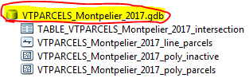

If a municipality’s data is delivered as a set of shapefiles and dBASE (.dbf) files, then all geospatial and tabular data must be within a single compressed file, in .zip format, that is named VTPARCELS_<town name>_<YYYY>.zip, where YYYY represents the Grand List year (year of April 1st Grand List) to which the data is current. For example:

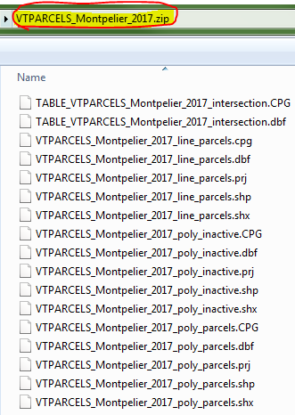

All deliveries must be accompanied by a stand-alone FGDC CSDGM metadata file in XML format that is named VTPARCELS_<town name>_<YYYY>.xml, where YYYY represents the Grand List year (year of April 1st Grand List) to which the data is current. For example:

Metadata Content Requirement

For each municipality, a single metadata file, in FGDC CSDGM XML format, is required. All feature classes (or shapefiles) and non-spatial tables are documented in that metadata file. Content is required for the following core metadata elements:

- Identification_Information/Citation/Citation_Information/Title
- Identification_Information/Citation/Citation_Information/Originator
- Identification_Information/Citation/Citation_Information/Publication_Information/Publisher
- Identification_Information/Description
- Identification_Information/Time_Period_of_Content
  - The Grand List year to which the data is current, using the format YYYY. The date of Grand List export for use in parcel data development shall be noted.
- Identification_Information/Spatial_Domain
- Identification_Information/Use_Constraints
  - Populate this attribute with the following disclaimer: “This data layer is not a legal survey. It is not a legal conveyance or description of property and is intended for planning purposes only. VCGI and the State of VT make no representations of any kind, including but not limited to the warranties of merchantability or fitness for a particular use, nor are any such warranties to be implied with respect to the data.”
- Data_Quality_Information
  - Include Lineage with Source_Information and Process_Step(s).
- Entity_and_Attribute_Information
  - Include an individual Detailed_Description for every feature class (or shapefile) and non-spatial table. Provide Attribute information for all fields.

Coordinate System and Datum Requirement

All geospatial data must be in Vermont State Plane Meters, NAD 83 (National Spatial Reference System (NSRS) or most current)).

Level 1: GIS Parcel Data Standard Requirements

- Feature Classes and Tables – The delivery includes feature classes and tables that are described in the following tables.

Feature Class Name = VTPARCELS_<Town Name>_<YYYY>_line_parcels
- Description = A line counterpart to the VTPARCELS_<Town Name>_<YYYY>_poly_parcels feature class. Boundary geometries of the VTPARCELS_<Town Name>_<YYYY>_poly_parcels feature class are sourced from this feature class. This feature class only includes lines related to parcels that have active SPAN numbers.
- This feature class can be used for symbolizing parcel boundaries by type.
- Geometry Type = line
Field Name | Description | Field Type | Allowed Values
PLTYPE | Line type | Text, length of 9 | No Null values or empty strings. See Appendix D for valid values.
PARCBOUND | A Boolean-like field to indicate if the line is part of a parcel boundary | Text, length of 1 | No Null values or empty strings. Enter Y for yes (line is part of a parcel boundary) or N for no.
YEAR | Grand List Year that mapping data represents | Short Integer | Year as represented by 4 digits. No Null values or zeros.
TOWN | Name of the town, city, gore, or grant | Text, length of 30 | No Null values or empty strings. See Appendix E for valid values.
SOURCENAME | Name of the source information | Text, length of 80 | Entry is optional. Null values or empty strings are allowed.
SOURCETYPE | Type of source information | Text, length of 19 | See Appendix C. No Null values or empty strings.
SOURCEDATE | Date of the source information | Text, length of 8 | No Null values or empty strings. Use an eight-character string that follows the YYYYMMDD pattern. If MM and/or DD are not known, then fill those portions with zeros. If the source date is not known, enter UNKNOWN.
EDITMETHOD | The method of capturing the feature’s geometry | Text, length of 20 | No Null values or empty strings are allowed. See Appendix F for valid values.
EDITOR | Name of editor that added or modified the feature | Text, length of 50 | No Null values or empty strings. If the editor is unknown, such as in the case of pre-existing GIS data, enter UNKNOWN.
EDITDATE | The date on which the feature was added or modified | Text, length of 8 | No Null values or empty strings. Use an eight-character string that follows the YYYYMMDD pattern, or, if the edit date is not known, enter UNKNOWN.
EDITNOTE | Stores additional helpful information on the feature | Text, length of 254 | Entry is optional. Null values or empty strings are allowed. Text, up to the length of the field.

Feature Class Name = VTPARCELS_<Town Name>_<YYYY>_poly_parcels
- Description = Active parcels (excluding unlanded structures), public right-of-ways, trail right-of-ways (for trails identified on the VTrans General Highway Maps, AKA Town Highway Maps), and surface water areas that serve as property boundaries. This feature class should consist of polygon features for all active parcels (excluding unlanded structures) listed in the municipality’s Grand List.
- Ingress/egress easements or “private right-of-way” easements that overlay underlying parcels are NOT considered to be public right-of-way and are NOT considered to be parcels. Easement data is NOT required for Level 1 of this standard. If easements are included in the delivery, they should be modeled within additional separate feature class(es).
- Geometry Type = polygon
- Each Grand List record must only be modeled as one record in the GIS data. A single non-contiguous geometry object (multi-part polygon) should be used to model a non-contiguous multi-part parcel. The SPAN field must not contain duplicate SPAN numbers.
- Mapping parcels to the public right-of way line rather than to the road centerline is a suggested best practice.
Field Name | Description | Field Type | Allowed Values
SPAN | Unique number assigned by VT Dept. of  Taxes | Text, length of 13 | SPAN number of the parcel as listed in the Grand List (nnn-nnn-nnnnn), or, if the feature represents an area to which a SPAN would not be assigned, such as a public right-of-way or water area, value is Null or empty string.  Only 1 record can be attributed with a particular SPAN number (no duplicate SPAN numbers).  If the feature is condominium common land that has no SPAN number, then populate this field with a combination of the FIPS6 code of the municipality and the next available integer as specified in Appendix A.  Otherwise, if the SPAN number of the parcel is not known, a presumed/predicted SPAN number can be entered (which will be flagged as non-matching via the TABLE_VTPARCELS_<Town Name>_<YYYY>_intersection table).
MAPID | Unique identification of the parcel assigned by town | Text, length of 80 | Text up to length of field
PROPTYPE | Type of property/area | Text, length of 9 | See Appendix B for valid entries. No Null values or empty strings.
YEAR | Grand List Year that mapping data represents | Short Integer | Year as represented by 4 digits. No Null values or zeros.
TOWN | Name of the town, city, gore, or grant | Text, length of 30 | No Null values or empty strings. See Appendix E for valid values.
SOURCENAME | Name of the source information | Text, length of 80 | Entry is optional. Null values or empty strings are allowed.
SOURCETYPE | Type of source information | Text, length of 19 | See Appendix C. No Null values or empty strings.
SOURCEDATE | Date of the source information | Text, length of 8 | No Null values or empty strings. Use an eight-character string that follows the YYYYMMDD pattern. If MM and/or DD are not known, then fill those portions with zeros. If the source date is not known, then enter UNKNOWN.
EDITMETHOD | The method of capturing the feature’s geometry | Text, length of 20 | See Appendix F for valid entries. No Null values or empty strings.
EDITOR | Name of editor that added or modified the feature | Text, length of 50 | No Null values or empty strings. If the editor is unknown, such as in the case of pre-existing GIS data, enter UNKNOWN.
EDITDATE | The date on which the feature was added or modified | Text, length of 8 | No Null values or empty strings. Use an eight-character string that follows the YYYYMMDD pattern, or, if the edit date is not known, enter UNKNOWN.
MATCHSTAT | The status of matching/relating the Grand List to this feature by SPAN number | Text, length of 9 | No Null values or empty strings. Enter MATCH if the record’s SPAN number can be matched/related to an active SPAN number in the Grand List. Enter EXEMPT if the record models a feature that should be exempted from the match, such as condominium common land which has no SPAN number, public right-of-way, or water. Otherwise, enter UNMATCHED.
EDITNOTE | Stores additional helpful information on the feature | Text, length of 254 | Entry is optional. Null values or empty strings are allowed. Text, up to the length of the field.

Table Name = TABLE_VTPARCELS_<Town Name>_<YYYY>_intersection
- Description = An intersection table that relates records of the municipality’s Grand List which have active SPAN numbers to records in the VTPARCELS_<Town Name>_<YYYY>_poly_parcels feature class which represent parcel features (PROPTYPE = ‘PARCEL’). Supports bi-directional matching/reconciliation between the municipality’s Grand List and the parcels feature class.

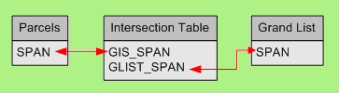

- Can be used to identify Grand List records of unlanded buildings (condominium units, unlanded mobile homes, unlanded camps, etc.) which are located on a particular land parcel.
- Can be used to identify the land parcel on which a particular unlanded building, as listed in the Grand List, is located.
- Can be used to identify mismatches between the municipality’s Grand List and the GIS parcel data.
- Use a .dbf file if submitting data in shapefile format. Otherwise, use a geodatabase table.
Field Name | Description | Field Type | Allowed Values
GIS_SPAN | The SPAN number exactly as attributed in the SPAN field of the VTPARCELS_<Town Name>_<YYYY>_poly_parcels feature class.  All unique SPAN entries of the VTPARCELS_<Town Name>_<YYYY>_poly_parcels feature class that represent parcel features (PROPTYPE = ‘PARCEL’) must be reflected in this field. | Text, length of 13 | Duplicate SPAN numbers are valid in cases where there is a one-to-many relationship between the parcel feature and Grand List records. For example, if the parcel feature is condominium common land on which unlanded buildings are located, then the SPAN of that common land parcel would be entered multiple times in this column, once for each unlanded building and sometimes once again for the common land parcel itself (if the common land has a SPAN in the Grand List). Continued on next page…  Null values or empty strings are allowed when the GIS counterpart of an active SPAN number is not known.
GLIST_SPAN | SPAN number exactly as listed in the municipality’s Grand List as an active SPAN. Corresponds to the value of the GIS_SPAN field.  All active SPAN numbers of the municipality’s Grand List must be reflected in this field. | Text, length of 13 | No duplicate entries, except for Null values or empty strings that occur when the Grand List counterpart of the GIS_SPAN field entry is unknown.
YEAR | Grand List Year that mapping data represents | Short Integer | Grand List year as represented by 4 digits. No Null values or zeros.
TOWN | Name of the town, city, gore, or grant | Text, length of 30 | No Null values or empty strings. See Appendix E for valid values.

Feature Class Name = VTPARCELS_<Town Name>_<YYYY>_poly_inactive
- Description = Inactive parcels and their related Active parcels. This feature class should consist of features for all Inactive parcels listed in the municipality’s Grand List and their related Active parcels.
- A cluster of inactive parcels and their related active parcel are modeled as individual parcels in this feature class while collectively modeled as one all-encompassing active parcel in the VTPARCELS_<Town Name>_<YYYY>_poly_parcels feature class.

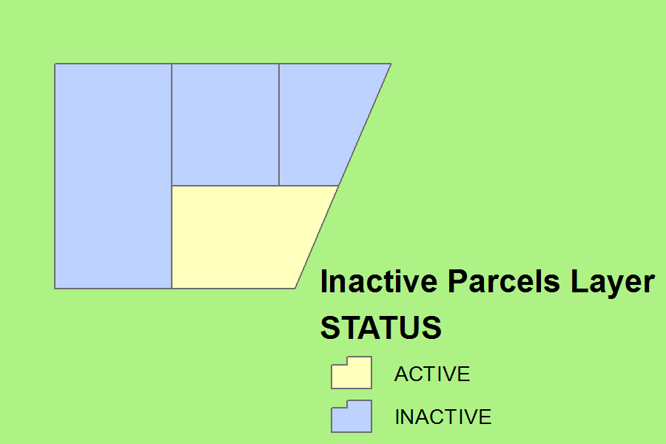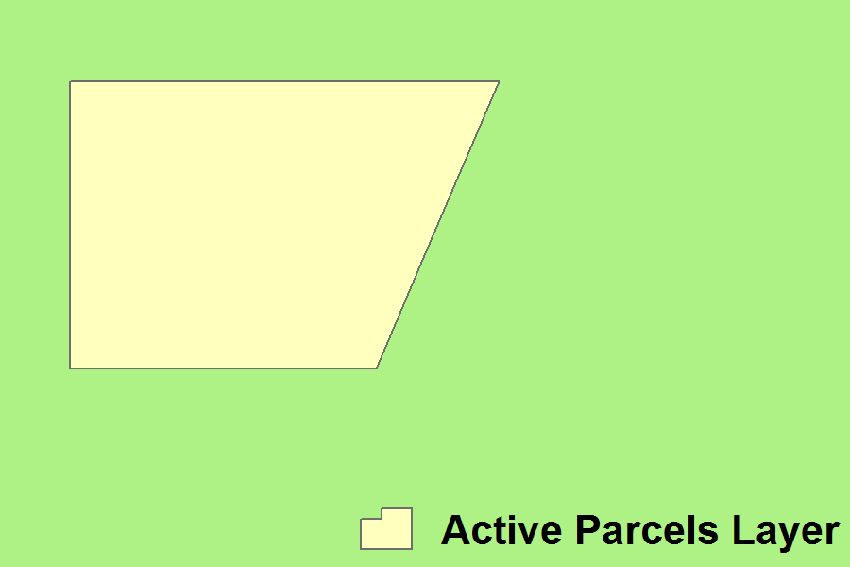

- Geometry Type = polygon
- Each Grand List record must only be modeled as one record in the GIS data. A single non-contiguous geometry object (multi-part polygon) should be used to model a non-contiguous multi-part parcel.
- Mapping parcels to the public right-of way line rather than to the road centerline is a suggested best practice.
Field Name | Description | Field Type | Allowed Values
STATUS | Indicates if the parcel is an Active parcel or an Inactive parcel | Text, length of 8 | Allowed values are ACTIVE and INACTIVE.  No Null values or empty strings.
PARENTSPAN | Unique number assigned by VT Dept. of  Taxes | Text, length of 13 | Only populate this field if the parcel is an Inactive parcel.  SPAN number of the Active parcel which is related to the Inactive parcel. Enter the SPAN number as listed in the Grand List (nnn-nnn-nnnnn).
SPAN | Unique number assigned by VT Dept. of  Taxes | Text, length of 13 | SPAN number of the parcel as listed in the Grand List (nnn-nnn-nnnnn). Only 1 record can be attributed with a particular SPAN number (no duplicate SPAN numbers).
MAPID | Unique identification of the parcel assigned by town | Text, length of 80 | Text up to length of field
PROPTYPE | Type of property/area | Text, length of 9 | Enter PARCEL. If using a geodatabase, the default entry can be set to PARCEL. No Null values or empty strings.
YEAR | Grand List Year that mapping data represents | Short Integer | Year as represented by 4 digits. No Null values or zeros.
TOWN | Name of the town, city, gore, or grant | Text, length of 30 | No Null values or empty strings. See Appendix E for valid values.
SOURCENAME | Name of the source information | Text, length of 80 | Entry is optional. Null values or empty strings are allowed.
SOURCETYPE | Type of source information | Text, length of 19 | See Appendix C. No Null values or empty strings.
SOURCEDATE | Date of the source information | Text, length of 8 | No Null values or empty strings. Use an eight-character string that follows the YYYYMMDD pattern. If MM and/or DD are not known, then fill those portions with zeros. If the source date is not known, enter UNKNOWN.
EDITMETHOD | The method of capturing the feature’s geometry | Text, length of 20 | See Appendix F for valid entries. No Null values or empty strings.
EDITOR | Name of editor that added or modified the feature | Text, length of 50 | No Null values or empty strings. If the editor is unknown, such as in the case of pre-existing GIS data, enter UNKNOWN.
EDITDATE | The date on which the feature was added or modified | Text, length of 8 | No Null values or empty strings. Use an eight-character string that follows the YYYYMMDD pattern, or, if the edit date is not known, enter UNKNOWN.
MATCHSTAT | Only applicable if the parcel is an Inactive parcel (STATUS=‘INACTIVE’).  The status of matching the Inactive SPAN number to an Inactive SPAN number in the Grand List. | Text, length of 9 | Entry is optional. Null values or empty strings are allowed.  Enter MATCH if the record’s SPAN number can be matched to an inactive SPAN number in the Grand List.  Otherwise, enter UNMATCHED.
EDITNOTE | Stores additional helpful information on the feature | Text, length of 254 | Entry is optional. Null values or empty strings are allowed. Text, up to the length of the field.

- Topology/Geometry Requirements

- Lines of VTPARCELS_<Town Name>_<YYYY>_line_parcels Must Not Overlap. Lines cannot share segments.
- Lines of VTPARCELS_<Town Name>_<YYYY>_line_parcels Must Not Intersect. Lines cannot cross one another. Lines can share the same endpoints.
- Lines of VTPARCELS_<Town Name>_<YYYY>_line_parcels Must Not Self-Intersect. Lines cannot cross themselves.
- Polygons of VTPARCELS_<Town Name>_<YYYY>_poly_parcels Must Not Overlap. Polygons can share edges or vertices.
- For polygons of VTPARCELS_<Town Name>_<YYYY>_poly_parcels, Boundary Must Be Covered By lines of VTPARCELS_<Town Name>_<YYYY>_line_parcels.
- Polygons of VTPARCELS_<Town Name>_<YYYY>_poly_parcels Must Not Have Gaps. No void areas are allowed within polygons or between polygons.
- Polygons of VTPARCELS_<Town Name>_<YYYY>_poly_inactive Must Not Overlap. Polygons can share edges or vertices.
- For VTPARCELS_<Town Name>_<YYYY>_poly_inactive, edges of a cluster of polygons must share edges of a polygon in VTPARCELS_<Town Name>_<YYYY>_poly_parcels.
- Polygons are closed at the town boundary.
- Polygon feature classes do not have sliver polygons.
- For VTPARCELS_<Town Name>_<YYYY>_poly_inactive, the aggregated polygon areas of an active parcel and its related inactive parcels must equate to the area of the active parcel as modeled in VTPARCELS_<Town Name>_<YYYY>_poly_parcels (all pieces add up to the whole).
- No feature classes may contain any Null/empty geometry objects whatsoever.

- Requirement for SPAN Match

At least 99% of records with active SPAN numbers in the municipality’s Grand List can be joined to SPAN field entries of the VTPARCELS_<Town Name>_<YYYY>_poly_parcels feature class via the following three steps. First, the TABLE_VTPARCELS_<Town Name>_<YYYY>_intersection table is joined to the municipality’s Grand List (records with active SPAN numbers only) by SPAN number via its GLIST_SPAN field. Second, the VTPARCELS_<Town Name>_<YYYY>_poly_parcels feature class is joined to the result of the first join by SPAN number via the GIS_SPAN field of the TABLE_VTPARCELS_<Town Name>_<YYYY>_intersection table. Third, in the result of joining in the second step, if at least 99% of Grand List records have a joined SPAN number from the VTPARCELS_<Town Name>_<YYYY>_poly_parcels feature class, then the requirement for SPAN match is met.

Level 2: GIS Parcel Data Standard Requirements

Level 2 includes Level 1 requirements and the following requirements. It provides a framework for an enhanced parcel data set.

- Feature Classes and Tables – The delivery includes feature classes and tables that are described in the following tables.

Feature Class Name = VTPARCELS_<Town Name>_<YYYY>_poly_easements
- Description = This feature class is optional, unless specified as required in contract. Easements, such as ingress/egress and access easements. Contracts should specify particular easement types to be modeled.
- Ingress/egress easements or “private right-of-way” easements that overlay underlying parcels are NOT considered to be parcels. Those easements can be modeled within this feature class.
- Geometry Type = polygon
- Each multi-part non-contiguous easement is modeled by one multi-part feature.
Field Name | Description | Field Type | Allowed Values
ESMTTYPE | Easement type | Text, length of 20 | See Appendix G. Otherwise, Null values or empty strings are allowed.
SOURCENAME | Name of the source information | Text, length of 80 | Entry is optional. Null values or empty strings are allowed.
SOURCETYPE | Type of source information, such as plat | Text, length of 19 | No Null values or empty strings.
SOURCEDATE | Date of the source information | Text, length of 8 | No Null values or empty strings are allowed. If the source date is not known, enter UNKNOWN.  Otherwise, use an eight-character string that follows the YYYYMMDD pattern. If MM and/or DD are not known, then fill those portions with zeros.
EDITMETHOD | The method of capturing the feature’s geometry | Text, length of 20 | No Null values or empty strings are allowed. See Appendix F for valid values.
EDITOR | Name of editor that added or modified the feature | Text, length of 50 | No Null values or empty strings. If the editor is unknown, such as in the case of pre-existing GIS data, enter UNKNOWN.
EDITDATE | The date on which the feature was added or modified | Text, length of 8 | No Null values or empty strings. Use an eight-character string that follows the YYYYMMDD pattern, or, if the edit date is not known, enter UNKNOWN.
EDITNOTE | Stores additional helpful information on the feature | Text, length of 254 | Text, up to the length of the field. Null values or empty strings are allowed.

- Additional Requirement for SPAN Match (in addition to SPAN Match required by Level 1)

At least 99% of records in the VTPARCELS_<Town Name>_<YYYY>_poly_parcels feature class which represent parcels (PROPTYPE = ‘PARCEL’) can be joined to records with active SPAN numbers in the municipality’s Grand List via the following three steps. First, the TABLE_VTPARCELS_<Town Name>_<YYYY>_intersection table is joined to records of the VTPARCELS_<Town Name>_<YYYY>_poly_parcels feature class that have a PROPTYPE field entry of PARCEL (PROPTYPE = ‘PARCEL’) by SPAN number via its GIS_SPAN field. Second, the municipality’s Grand List (records with active SPAN numbers only) are then joined to the result of the first join by SPAN number via the GLIST_SPAN field of the TABLE_VTPARCELS_<Town Name>_<YYYY>_intersection table. Third, in the result of joining in the second step, if at least 99% of VTPARCELS_<Town Name>_<YYYY>_poly_parcels feature class records have a joined SPAN number from the Grand List, then the requirement for additional SPAN match is met.
Appendix A

Use of FIPS6 Code and Integer to Assign a Unique Identifier to Condominium Common Land

In some instances, a deed specifies a percentage of common land ownership to each condominium unit and the common land does not have a SPAN number. In other instances, a deed does not allocate the common land and the common land does have a SPAN number.

In cases when the common land does not have a SPAN number, the SPAN field of the VTPARCELS_<Town Name>_<YYYY>_poly_parcels feature class should be populated with a unique value in lieu of a SPAN number per the following pattern:

C-<FIPS6 code of the locality>-<next unused integer, starting with 1>

For example, the first instance of common condominium land with no SPAN number in Williston would have a SPAN value of:

C-7085-1

The second instance would be assigned the following value for the SPAN number:

C-7085-2

The purpose of these SPAN value “fillers” is to provide common land with a unique identifier that can be used to relate the common land to unlanded condo units entered from the Grand List within the TABLE_VTPARCELS_<Town Name>_<YYYY>_intersection table.

Appendix B

Valid PROPTYPE Values

Value | Description
PARCEL | Parcel
ROW_ROAD | Public road right-of-way
ROW_RAIL | Railroad right-of-way
ROW_TRAIL | Legal trail right-of-way as defined on the VTrans General Highway Maps
WATER | Surface water area that serves as property boundary

Appendix C

Valid SOURCETYPE Values

Value | Description
SURVEY/PLAT | Survey or plat
DEED | Deed
LINES OF OCCUPATION | Boundary, such as a stone wall, that is not very visible on the ground but might be detected by technologies such as lidar or ortho imagery.
SCANNED TAX MAP | Scanned tax map
NON-SCANNED TAX MAP | Non-scanned paper tax map
UNKNOWN | Unknown, such as pre-existing parcel GIS data
MULTIPLE | Multiple sources

Appendix D

Valid PLTYPE Values

Code | Description
PARCEL | Parcel boundary only
ROW_ROAD | Edge of public road right-of-way
ROW_RAIL | Edge of railroad right-of-way
ROW_TRAIL | Edge of legal trail right-of-way as defined on the VTrans General Highway Maps
WATER | Edge of surface water area that serves as property boundary
VILLAGE | Village boundary
TOWN | Town boundary
STATE | State boundary
COUNTRY | International boundary
BREAKLINE | Division of status or name (not for map display)
DISPUTE | Parcel boundary whose location is disputed
HOOK | Parcel hook for cartographic presentation

Appendix E

Valid TOWN Values

Use the name of the locality as specified in the COMMNAME field of the commcode.dbf table of VCGI’s Lookup tables with codes corresponding to the VGIS Geographic Area Codes Standard (GEOCODES) data product. For more information on Vermont’s geographic area names, see the VGIS Handbook – Geographic Area Codes. Must be in all capital letters, with quotes removed (for example, ST. JOHNSBURY and BUELS GORE).

Appendix F

Valid EDITMETHOD Values

Code | Description
HEADS UP DIGITIZING | Capturing geometry into a layer that is superimposed to underlying source data, such as aerial imagery
COORDINATED COGO | COGO line work placed in real-world coordinates
NON-COORDINATED COGO | COGO line work placed by best fit to other evidence
COORDINATED CADD | CADD line work placed in real-world coordinates
NON-COORDINATED CADD | CADD line work placed by best fit to other evidence
GIS GRADE GPS | GIS-grade GPS collection
RTK GPS | High-precision GPS collection conducted with Real-Time Kinematic (RTK) positioning
OTHER
UNKNOWN

Appendix G

Valid ESMTTYPE Values

Code | Description
ACCESS | ACCESS EASEMENT
ROW | RIGHT OF WAY EASEMENT
RAILROAD | RAILROAD EASEMENT
CONSERVATION | CONSERVATION EASEMENT
FLOOD | FLOOD EASEMENT
SEWER | SEWER EASEMENT
WATER | WATER EASEMENT
DRAINAGE | DRAINAGE EASEMENT
GAS | GAS EASEMENT
OIL | OIL EASEMENT
ELECTRIC | ELECTRIC EASEMENT
UTILITY | UTILITY EASEMENT
LAND USE RESTRICTION | LAND USE RESTRICTION
ZONING RESTRICTION | ZONING RESTRICTION
MISC | MISC EASEMENT
UNKNOWN | UNKNOWN EASEMENT

http://legislature.vermont.gov/statutes/fullchapter/10/008
In some instances, a deed specifies a percentage of common land ownership to each condominium unit and the common land does not have a SPAN number. In other instances, a deed does not allocate the common land and the common land does have a SPAN number.
http://legislature.vermont.gov/bill/status/2016/H.0876
Federal Geographic Data Committee Content Standard for Digital Geospatial Metadata. See https://www.fgdc.gov/metadata/csdgm/ .
Federal Geographic Data Committee Content Standard for Digital Geospatial Metadata. See https://www.fgdc.gov/metadata/csdgm/ .
FIPS6 code according to the VGIS Handbook – Geographic Area Codes, http://vcgi.vermont.gov/sites/vcgi/files/standards/partii_section_e.pdf
http://vcgi.vermont.gov/warehouse/products
http://vcgi.vermont.gov/sites/vcgi/files/standards/partii_section_e.pdf

