Include a textual narrative that summarizes the steps of the python code – textually explain how all of the data values are derived

Abstracts
The Vermont Community Resilience Index (VT CRI) is an interactive health disparities tool. This tool aids public official officials examine community resilience among populations throughout Vermont. Community resilience is the capacity of a population to mitigate and recover from a public health crisis or personal health emergency in a manner that sustains physical, social, and mental health. The VT CRI tool consists of three components: composite index, indicator displays, and population reference maps. The composite index integrates 11 socioeconomic and housing indicators into a single value assigned to each Census tract and municipality. There is a unique composite index for each geographic frame, including statewide and each specific VDH district, hospital service area, and county. The community resilience composite index serves as a model to explore the social conditions which influence a community’s ability to efficiently recover from a health crisis.

Contents
Abstract 1
Contents 1
Introduction 2
What is a Composite Index? 3
Key Definitions 3
Composite Index 4
Indicator Definitions 4
Indicator Weighting 5
Index Construction Steps 5
Step 1 – Identify Variables 6
Step 2 – Preprocess Indicators 7
Step 3 – Calculate Index 7
Step 4 – Postprocess Index 8
Geometric Mean 8
Indicator Displays 9
Standard Mean Difference 9
Step 1 – Area Frame Indicator Means 9
Step 2 – Difference Mean 10
Step 3 – Standard Deviation 10
Step 4 – Standard Mean Difference 10
Disaggregated Indicator Values 10
Data Appendix 11
References 11

Introduction
The Vermont Community Resilience Index (VT CRI) is a multifaceted tool that seeks to inform public health officials on the distribution of community resilience across the state. Resilience is a term that has numerous definitions across disciplines, but it is generally considered the ability of a subject to respond to, mitigate, and effectively recover from stressors with minimal assistance from external sources (Manyena, 2006). There is a wide variety of common subjects in a resilience framework including individual persons, societies, and whole environmental systems (Glonti et al., 2015; Holling, 1973; Masten et al., 2009). Common example stressors of these subjects include infectious disease, mental health status, large-scale natural disasters, and environmental change (Cutter et al., 2010; Davydov et al., 2010; Nelson et al., 2007; Rutter, 1993).
In a public health domain, community resilience means the numerous expressions of on-the- ground daily reality that promote physical, social, and mental well-being (World Health Organization; Wulff et al., 2015). This resilience enables people to build vitality and the adaptability necessary to recover from a health crisis (Wulff et al., 2015). Informed by this understanding, the VT CRI views community resilience as the socioeconomic and housing capacity of a population to mitigate and recover from a public health crisis or personal health emergency in a manner that sustains physical, social, and mental health.
The final form of the VT CRI is a public-facing application hosted on ArcGIS Online Experience Builder with three main components: composite index, indicator displays, and population reference maps. The primary component of the tool is the composite index. This composite index combines multiple input indicators related to community resilience into a single geometric mean value. Each input indicator in the VT CRI is an accumulation of population variables derived from the Census Bureau’s American Community Survey (ACS) 5-year estimate datasets. Secondly, the indicator display component of the tool further examines the data of each input indicator by using the statistic standard mean difference accompanied by race and ethnicity disaggregation. The third component of the tool is a series of population reference maps that provide further contextual information about the population of the state but are not themselves indicators used in the calculation of the composite index. The data for each of these three components are presented at the Census tract and municipality geography units.

What is a Composite Index?
A composite index is a highly distilled output that attempts to measure the overarching trends among large, multi-dimensional macro processes (Nardo et al., 2005). Examples of large macro processes include resilience, environmental change, and economic conditions. A composite index draws together numerous measurements that relate to the specific macro process and combines them together to create a single value (OECD Committee on Statistics, 2004). Composite indices are useful because they enable a user to measure the performance of a macro process across time and across geographies (OECD et al., 2008).

Key Definitions
- Community resilience - the capacity of a population to mitigate and recover from a public health crisis or personal health emergency in a manner that sustains physical, social, and mental health.
- Composite index - the compilation of individual indicators into a single metric to measure a multi-dimensional concept (OECD Committee on Statistics, 2004).
- Indicator – the data measures compiled together that create a composite index.
- Geography unit – a spatial unit of measurement. The geography units used in VT CRI include Census tracts and municipalities.
- Census tract – a geography unit that is a small, relatively permanent statistical subdivision of a county or statistically equivalent entity that generally has a population size between 1,200 and 8,000 people, with an optimum size of 4,000 people (US Census Bureau, 2022).
- Municipality – a geography unit that is equivalent to the county subdivision unit of the US Census Bureau and are most familiarly known as towns and cities. The VT CRI follows the municipality definition that includes 256 (255 prior to 2022) administrative units in Vermont.
- Area frame – an area of focus that determines the geographic extent to measure and present geography units. The area frames used in the VT CRI include the entire state and specific VDH districts, hospital service areas, and counties. Each area frame is a unique combination of geography units. As such, each area frame presents a unique measurement of relative calculations including the composite index and standard mean difference.
- Percentile rank - the proportion of values in a distribution that a specific value is greater than or equal to (Flanagan et al., 2011).
- VDH district – the 12 Vermont Department of Health local administrative units which carry out statewide public health initiatives and services at the local level.
- Hospital service area – the 13 Vermont local health care markets for hospital care measured by collections of zip codes whose residents receive most of their hospitalizations from the hospitals in that area (Law Insider).
- Theme – the thematic grouping of indicators. The Overall Theme represents all indicators of a selected year. The Socioeconomic Theme and Housing Theme represent two subsets of indicators of a selected year.

Composite Index
The Vermont Community Resilience Index (VT CRI) draws together 11 population measures about the distribution of social and economic conditions across the state. These indicators were identified based upon their thematic relation to the community resilience definition. The selection of these indicators follows the precedent set by the CDC Social Vulnerability Index in considering social and economic indicators for public health purposes. In fact, of the 11 indicators integrated into the VT CRI, the CDC model influenced 8 of the VT CRI indicators in some capacity.
The composite index can be analyzed along 3 different themes: Overall Theme, Socioeconomic Theme, and Housing Theme. Themes are the assortment of indicators used in the calculation of the composite index. The primary theme of the VT CRI is the Overall Theme which represents the combination of all available indicators per year. All indicators used in the calculation of the Overall Theme are thematically categorized as either socioeconomic data or housing data.
The two thematic categorizations of the indicators are interpreted as two additional VT CRI themes: Socioeconomic Theme and Housing Theme. When the composite index is viewed through the lens of the Socioeconomic Theme or Housing Theme, the resulting composite index value is only reflective of the selected theme’s assortment of indicators. The composite index for all 3 themes is calculated directly from the indicators. Each theme is simply a different assortment of those indicators.

Indicator Definitions
- Socioeconomic Theme – this theme reflects aspects of economic and material conditions of the population.
  - Supportive Income – the percentage of the population with income greater than 200% of the Federal poverty level.
  - Employment - the percentage of the adult population currently employed.
  - Without Public Assistance – the percentage of households that have not received public assistance in the past 12 months.
  - Median Household Income – median household income adjusted for inflation.
  - High School Education – the percentage of adult population with a completed high school degree.
  - Health Insurance – the percentage of the population with health insurance.
  - Manageable Housing Costs – the percentage of housing units with housing costs less than 30% of household income.
- Housing Theme – this theme reflects aspects of housing quality and household composition of the population.
- Broadband Internet Subscription – the percentage of the population with access to a computer and broadband internet.
- Owner-Occupied Homes – the percentage of owner-occupied housing units.
- English Proficiency – the percentage of the population that speaks English “well” or better.
- Vehicle Access – the percentage of housing units with a vehicle available.

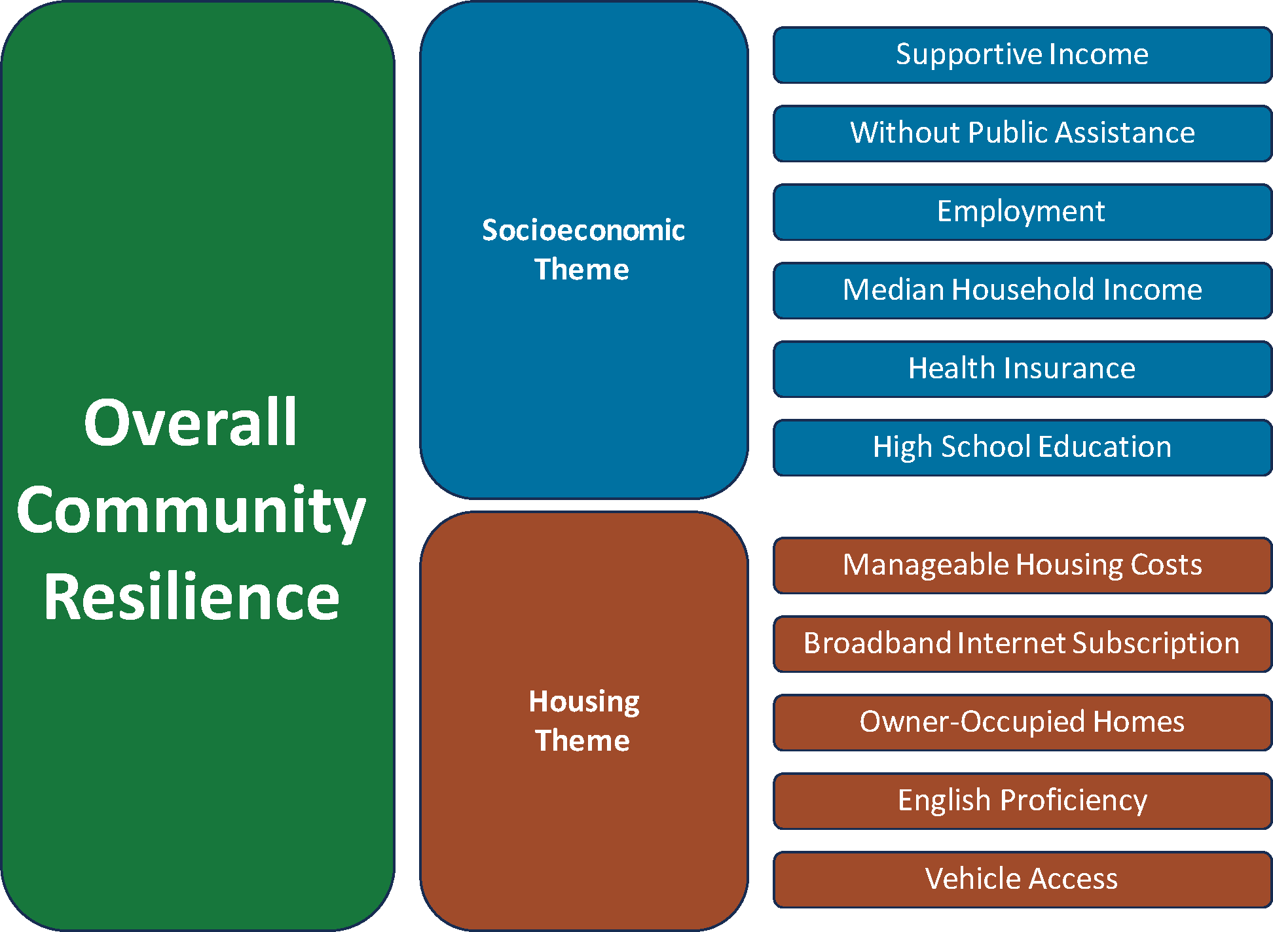
Figure 1. A visual representation of the 11 indicators and how they are thematically grouped by the Socioeconomic Theme and Housing Theme. The Socioeconomic and Housing Themes each contain their assortment of indicators while the Overall Community Resilience theme contains all indicators.

Indicator Weighting
Every index requires the combination of different indicators. Combining indicators requires a decision of how to weigh them. Intentional indicator weighting determines the relative influence the value of an indicator has on the final composite index. As the ‘Index Construction Steps’ section of this document demonstrates, all indicators of the VT CRI are equally weighted.
This means that all 11 indicators of the VT CRI have the same potential to influence the final value of the composite index. In other words, no indicator is purposefully weighted to have more influence than other indicators. Equal weighting is the most common weighting method used to aggregate indicator values in a composite index (Beccari, 2016).

Index Construction Steps
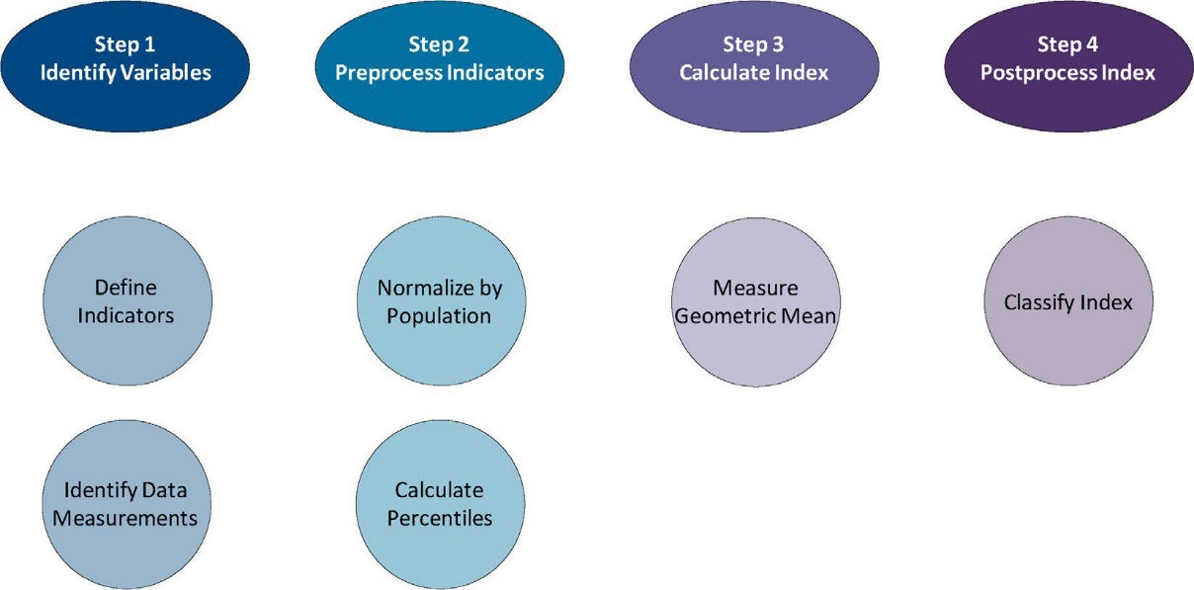
Figure 2. A visual representation that demonstrates the sequence of steps required to construct the VT CRI.

Step 1 – Identify Variables
First, we conducted a thorough review of local, state, and national social disparity indices throughout the United States. Among these indices, the CDC Social Vulnerability Index is the most prominent. We then evaluated the range of indicators used by these indices for their potential ability to contribute to a meaningful aspect of community resilience in the context of Vermont. We identified a total of 11 indicators from these sources to serve as inspiration for the construction of the VT CRI indicators.
With a general understanding of our 11 indicators, we identified plausible data measurements of US Census Bureau American Community Survey (ACS) 5-year estimates data tables that overlapped with the indicators. We considered the full extent of available measurements that aligned with our general indicator ideas, and then determined which to specifically use for the indicators. Through this process, we simultaneously identified the required ACS data measurements and created precise definitions for our indicators. For nearly all the 11 indicators, our final definitions are different from the definitions used by the indices we reviewed. These adjustments reflect the changes necessary to ensure that the indicators better capture the objectives of the VT Community Resilience Index. You can review these definitions in the ‘Indicators’ section of this document.
We then used a US Census Bureau API to pull the ACS data variables into a python script. We acquired the data of the variables for all Census tracts and municipalities in the state. Additionally, we acquired the data across multiple years, starting with 2008-2012 5-year estimate data and completing at the most recent 2018-2022 5-year estimate data. Refer to the ‘Data Appendix’ section of this document to review the specific ACS variables used in the construction of the indicators and the available years for each indicator.

Step 2 – Preprocess Indicators
In the python script, we aggregated the numerous ACS variables to create a single value for each indicator. The values are aggregated simultaneously for each individual geography unit. These aggregated values are in the form of a fraction. The numerator of the fraction represents the total number of people measured by the indicator’s definition per geography unit. The denominator of the fraction is the total population of the geography unit. It’s important to recognize that the variables supporting each indicator are acquired from different ACS tables, which in turn are based on different original survey questions. As such, not all survey questions will contain the same response rates. This means that the reported total population of a given geography unit may vary across different ACS tables, and thus between different indicators. To compare the values of indicators within the same geography unit, we normalized the fraction indicator values. To do this, we divided the aggregated sum numerator by the total population denominator.
This normalized indicator value represents the proportion of a geography unit’s population represented by the defined indicator. At this point, each geography unit has 11 normalized values assigned to it – one for each indicator. Based on these normalized values, we calculated the percentile rank values of each indicator. The percentile rank output assigns a value of 0-100 to each geography unit and for each indicator. A percentile value of 0 signifies that the given geography unit has a lower normalized indicator value than all other geography units. A percentile value of 100 signifies that the given geography unit has a higher normalized indicator value than all other geography units.
We calculated percentile rank of indicators numerous times in different manners. Firstly, we processed the normalized indicator values separately for Census tract and municipality geography units. Secondly, we calculated the percentile rank at each area frame. For Census tracts, this means we measured the percentile rank of normalized indicators at a statewide frame and at each of Vermont’s 14 counties. For municipalities, this means we measured the percentile rank of normalized indicators at a statewide frame and at each of Vermont’s 12 VDH districts, 13 hospital service areas, and 14 counties. The ability to calculate a different percentile rank for each area frame reflects that percentile rank is a relative calculation. This means that the percentile value calculated from a geography unit’s normalized indicator depends on what other geography units are included in the calculation. Since each area frame is a unique combination of geography units, each corresponding percentile rank is also unique.

Step 3 – Calculate Index
To construct the composite index, we used the geometric mean method to combine the 11 percentile rank values at each geography unit. We first multiplied the percentile rank values of each indicator by each other. Then, we acquired the nth root of that product. The n represents the number of values used in the calculation of the product, which for the Overall Theme is 11. This root value is the final Overall Theme of the composite index. We repeated this geometric mean method for the Socioeconomic Theme and Housing Theme subsets of indicators. Additionally, just like the percentile ranks from the Preprocess Indicators step, we repeated the geometric mean calculation at each area frame.
The final output of the geometric mean is a scale of 0-100. A geography unit with a value of 0 indicates that it has the lowest community resilience among the geography units of that area frame. A value of 100 indicates that the geography unit has the highest community resilience among the geography units of that area frame. You can review more about the logical implications of the geometric mean in the ‘Geometric Mean Discussion’ section of this document.

Step 4 – Postprocess Index
At this stage, we have the Overall Theme, Socioeconomic Theme, and Housing Theme values across both geography units and all area frames. We exported this data from the python script to ArcGIS Pro. In this program, we join the Census tract and municipality data to their respective maps. For each map, we then classified the range of 0-100 theme values into a quantile classification, which created 4 classes with the same number of features per class. We classified theme values of 75 – 100 as “High Resilience”. We classified theme values of 50 – 75 as “Medium-High Resilience”. We classified theme values of 25 – 50 as “Medium-Low Resilience”. We classified theme values of 0 – 25 as “Low Resilience”.

Geometric Mean
The geometric mean is a non-compensatory index construction method. This means that each percentile rank value has a direct influence on the final index calculation. In other words, a high percentile value in one indicator does not compensate for a low percentile value in a different indicator. Conversely, a compensatory method such as measuring the sum of percentile values and then dividing that sum by the count of percentile values would result in high and low indicator values to effectively cancel each other. There are two observed characteristics that non-compensatory methods have on the index value:
  - A geography unit where all indicators are ranked around the middle could perform better than a geography unit with low extreme indicator values, even if the arithmetic mean of indicators for the latter geography unit is higher than the former (Munda and Nardo, 2005).
  - An increase in low indicator values has a greater influence on the index value than an increase in high indicator values (Munda and Nardo, 2005).

The implication of these two characteristics of non-compensatory methods such as the geometric mean are defensible in the topical context of the Community Resilience Index. For example, let’s imagine two Census tracts. In Census tract A, the percentile value of all indicators is 50. In Census tract B, one indicator has a percentile value of 95 while the remaining indicators have a percentile value below 40. It’s likely that a non-compensatory geometric mean method to calculate the composite index will have a higher index value for Census tract A. On the other hand, it’s likely that a compensatory arithmetic mean method will result in a higher index value for Census tract B. Ultimately, a final composite index value should reflect the socioeconomic and housing conditions of the entire population, rather than favoring only the population represented by an indicator with a high percentile value. With this consideration, a non-compensatory geometric mean method better reflects the anticipated outcome of the VT CRI.

Indicator Displays
After the composite index, the indicator displays is the second main component of the VT CRI. This section allows a user to drill down into the data of each specific indicator used in the construction of the composite index, including the standard mean difference and disaggregated race and ethnicity demographic data for each indicator.

Standard Mean Difference
The statistic standard mean difference is used to display the spatial distribution of the 11 normalized indicator values. To do this, standard mean difference standardizes the distance of each geography unit’s normalized indicator value from the area frame’s normalized indicator mean.
The standard mean difference is represented by an output at each geography unit for each indicator that ranges from -1 to 1. A geography unit with a standard mean difference of 0 indicates that the geography unit’s normalized indicator value is equivalent to the normalized indicator mean of the selected area frame. A negative value from the standard mean difference indicates that the geography unit’s normalized indicator value is below the area frame’s normalized indicator mean. Conversely, a positive value indicates that the geography unit’s normalized indicator value is above the area frame’s normalized indicator mean. Furthermore, the greater the absolute value of the output, the farther that geography unit’s normalized indicator value is from the area frame’s mean. In other words, values near the extremes of either -1 or 1 indicate greater difference from the area frame’s normalized mean than values closer to 0. The display of these values on a map enables a user to quickly identify the distribution of an indicator across an area frame.

Standard Mean Difference
Area Frame Normalized Indicator Mean
Geography Unit Normalized Indicator Value
Standard Deviation
Figure 3. A visual representation of calculating the standard mean difference.

Step 1 – Area Frame Indicator Means
At each area frame, determine the area frame’s normalized indicator mean. This is completed in two different ways. For the statewide and individual county area frames, the normalized indicator mean is determined in the same manner as the normalized indicator values of specific Census tracts and municipalities. This means acquire the specific variables from the US Census Bureau ACS data tables necessary to construct each indicator, and then process those variables in a python script to create the normalized indicator. The ‘Index Construction Steps’ section of this document outlines this processing step in more detail.
The normalized indicator means for the area frames of VDH districts and hospital service areas require a different approach since ACS data tables do not directly provide data for these geographies. However, the boundaries of these area frames are determined by the boundaries of municipalities. This means that each municipality belongs to a single VDH district and hospital service area. As such, to determine the normalized indicator average for VDH Districts and hospital service areas, take the normalized indicator average of the municipalities that belong to each of these area frames.

Step 2 – Difference Mean
At each geography unit, subtract the normalized indicator value from the area frame’s normalized indicator mean. This results in the normalized difference between the area frame mean and the geography unit’s value.

Step 3 – Standard Deviation
Calculate the standard deviation of the normalized indicator values of all geography units for each area frame.

Step 4 – Standard Mean Difference
Divide the mean difference by the standard deviation to determine the standard mean difference of each geography unit’s normalized indicator value compared to the area frame’s standardized indicator mean.

Disaggregated Indicator Values
Disaggregated race and ethnicity demographic data of indicators is a second aspect of the indicator displays component of the VT CRI. The definitions for the race and ethnicity groups are derived from the US Census Bureau. Due to limited data availability across the ACS variables, only 8 out of the 11 indicators include disaggregated data. In all cases, the provided scale of disaggregated data is not an individual geography unit, but rather the entire area frame. That means when a user reviews the data for a geography unit, the disaggregated demographic data is the mean for the area frame and is not the data of that specific geography unit. The presentation of disaggregated data as the area frame’s mean accommodates the small population values present among some demographic groups at the individual geography unit. Refer to the ‘Data Appendix’ section of the document to review the ACS variables used to construct the disaggregated indicator values.

Data Appendix
- View the VT CRI indicator table of ACS variables and associated metadata used to construct each indicator.
- View the disaggregated race and ethnicity indicator table of ACS variables and associated metadata used to disaggregate each VT CRI indicator.

References
Beccari, B. (2016). A comparative analysis of Disaster Risk, vulnerability and resilience composite indicators. PLoS Currents. https://doi.org/10.1371/currents.dis.19f9c194f3e3724d9ffa285b157c6ee3
Cutter, S. L., Burton, C. G., & Emrich, C. T. (2010). Disaster resilience indicators for benchmarking baseline conditions. Journal of Homeland Security and Emergency Management, 7(1). https://doi.org/10.2202/1547-7355. 1732
Davydov, D. M., Stewart, R., Ritchie, K., & Chaudieu, I. (2010). Resilience and Mental Health. Clinical Psychology Review, 30(5), 479–495. https://doi.org/10.1016/j.cpr.2010.03.003
Flanagan, B. E., Gregory, E. W., Hallisey, E. J., Heitgerd, J. L., & Lewis, B. (2011). A social vulnerability index for disaster management. Journal of Homeland Security and Emergency Management, 8(1). https://doi.org/10.2202/1547-7355.1792
Glonti, K., Gordeev, V. S., Goryakin, Y., Reeves, A., Stuckler, D., McKee, M., & Roberts, B. (2015). A systematic review on health resilience to economic crises. PLOS ONE, 10(4). https://doi.org/10.1371/journal.pone.0123117
Holling, C. S. (1973). Resilience and stability of Ecological Systems. Annual Review of Ecology and Systematics, 4(1), 1–23. https://doi.org/10.1146/annurev.es.04.110173. 000245
Hospital service area definition. Law Insider. (n.d.). Retrieved September 19, 2022, from https://www.lawinsider.com/dictionary/hospital-service-area
Manyena, S. B. (2006). The concept of Resilience Revisited. Disasters, 30(4), 434–450. https://doi.org/10.1111/j.0361-3666. 2006. 00331.x
Masten, A. S., Cutuli, J. J., Herbers, J. E., & Reed, M.-G. J. (2009). Resilience in Development. In C. R. Snyder & S. J. Lopez (Eds.), The Oxford Handbook of Positive Psychology (2nd ed., pp. 117–131). essay, Oxford University Press.
Nardo, M., Saisana, M., Saltelli, A., & Tarantola, S. (2005). Tools for Composite Indicators Building. European Commission Joint Research Centre. Retrieved 2022, from https://publications.jrc.ec.europa.eu/repository/handle/JRC31473.
Nelson, D. R., Adger, W. N., & Brown, K. (2007). Adaptation to Environmental Change: Contributions of a Resilience Framework. Annual Review of Environment and Resources, 32(1), 395–419. https://doi.org/10.1146/annurev.energy.32.051807. 090348
OECD Committee on Statistics. (2004). Composite indicator. OECD Glossary of statistical terms - composite indicator definition. Retrieved 2022, from https://stats.oecd.org/glossary/detail.asp?ID=6278
OECD, European Union, European Commission Joint Research Centre. (2008). Handbook on Constructing Composite Indicators: Methodology and User Guide. OECD Publications. Retrieved 2022, from https://www.oecd.org/sdd/42495745.pdf.
Rutter, M. (1993). Resilience: Some conceptual considerations. Journal of Adolescent Health, 14(8), 626–631. https://doi.org/10.1016/1054-139x(93)90196-v
US Census Bureau. (2022, April 11). Glossary. Census.gov. Retrieved September 19, 2022, from https://www.census.gov/programs-surveys/geography/about/glossary.html
World Health Organization. (n.d.). Constitution of the World Health Organization. World Health Organization. Retrieved September 13, 2022, from https://www.who.int/about/governance/constitution
Wulff, K., Donato, D., & Lurie, N. (2015). What is health resilience and how can we build it? Annual Review of Public Health, 36(1), 361–374. https://doi.org/10.1146/annurev- publhealth-031914-122829

