What is the Vermont Community Resilience Index (VT CRI)?
- The VT CRI is a planning tool designed to help public health officials examine the question: What is the capacity of communities throughout Vermont to mitigate and recover from a public health crisis or health emergency?

How is the VT CRI measured?
- Assigned to each Census tract and municipality in the state is a composite value which represents the respective population’s generalized capacity to address the impacts of a public health crisis.
- The index value draws together 11 indicators about the distribution of social conditions across the state which contribute to an aspect of community resilience.
- All data is from US Census Bureau American Community Survey 5-year estimates.
- The 11 indicators are grouped into 3 themes: Overall; Socioeconomic; Housing.
Figure 1. A visual representation of the 11 indicators and how they are thematically grouped by the Socioeconomic Theme and Housing Theme. The Socioeconomic and Housing Themes each contain their assortment of indicators while the Overall Community Resilience theme contains all indicators.
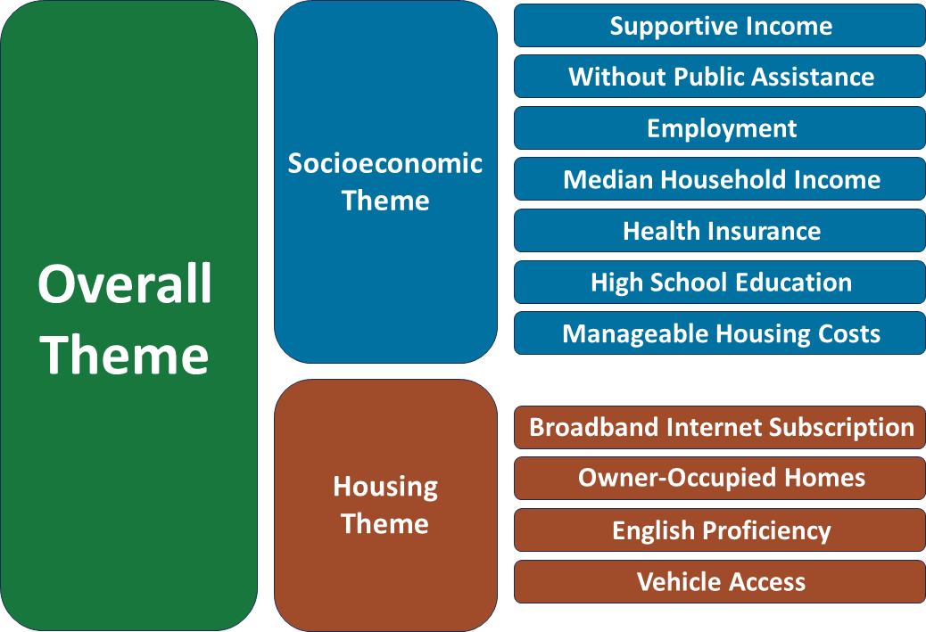

What are the VT CRI indicators?
- Socioeconomic Theme – this theme reflects aspects of economic and material conditions of the population.
  - Supportive Income – the percentage of the population with income greater than 200% of the Federal poverty level.
  - Employment - the percentage of the adult population currently employed.
  - Without Public Assistance – the percentage of households that have not received public assistance in the past 12 months.
  - Median Household Income – median household income adjusted for inflation.
  - High School Education – the percentage of adult population with a completed high school degree.
  - Health Insurance – the percentage of the population with health insurance.
  - Manageable Housing Costs – the percentage of housing units with housing costs less than 30% of household income.
- Housing Theme – this theme reflects aspects of household composition of the population.
- Broadband Internet Subscription – the percentage of the population with access to a computer and broadband internet.
- Owner-Occupied Homes – the percentage of owner-occupied housing units.
- English Proficiency – the percentage of the population that speaks English “well” or better.
- Vehicle Access – the percentage of housing units with a vehicle available.

How is the index calculated?
  - Step 1 – Identify Variables
- Define the indicators integrated into the index.
- Review data tables of American Community Survey 5-year estimates to identify the specific data variables necessary to construct the indicators.
  - Step 2 – Preprocess Indicators
- Take the individual data variables and aggregate them to determine the population represented by each indicator. Complete for each geography unit.
- Normalize the aggregated values. For each geography unit, divide the aggregated sum by the total. Now, each geography unit has a normalized value for each indicator. These values represent the proportion of a unit’s population represented by an indicator.
- Within each indicator, convert normalized values to a percentile rank. This means that for each indicator, values of 0-100 are applied to all geography units.
- A rank of 0 indicates that the geography unit has the lowest normalized value for that indicator compared to all other units. A rank of 100 signifies the inverse, that the geography unit has the highest normalized value for that indicator compared to all other units.
  - Step 3 – Calculate Index
- At each geography unit, multiply percentile rank values by each other.
- Take the nth root of this product, with n representing the number of values used in the calculation of the product. For the Overall Theme value, that is 11.
- This root value is the final Overall Theme value. This methodology is repeated for the indicators of the Socioeconomic and Housing Themes, providing 2 sub-indices to complement the Overall Theme.
  - Step 4 – Postprocess Index
- Classify index values into quantile values representing Low Resilience, Medium-Low Resilience, Medium-High Resilience, and High Resilience. Symbolize the index maps with these quantile values.
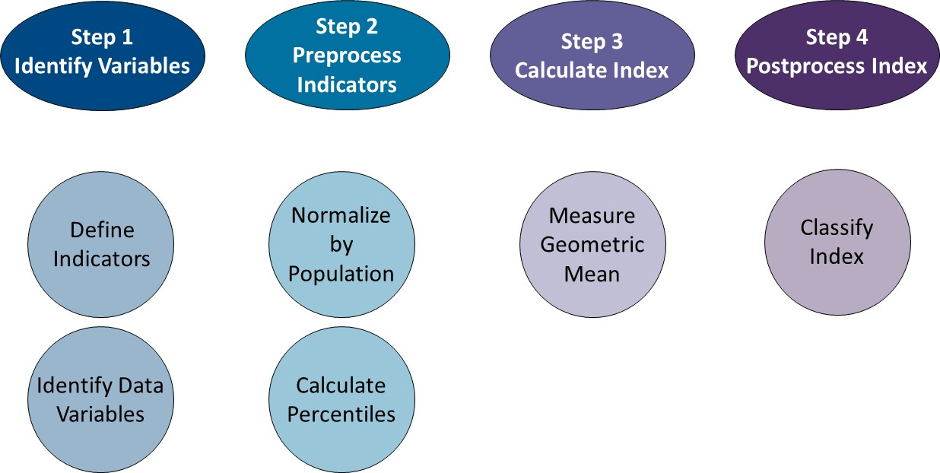
Figure 2. A visual representation that demonstrates the sequence of steps required to construct the VT CRI.

