# ReadMe

# GitHub

Link

<https://github.com/VCPTA/hmaw1-imad5112-written-on-campus-practicum-ST10484735>

# App Screenshots

Screenshot 1

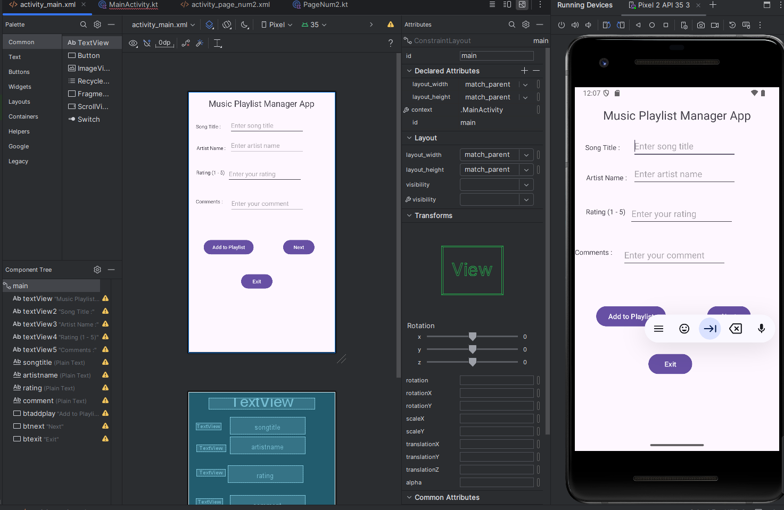

This the main page were all the information must be filled before the user moves to the next page.

Screenshot 2

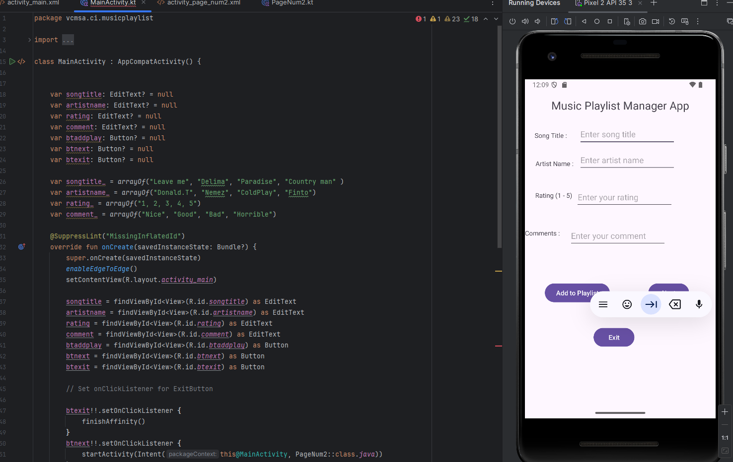

This is the code that I have written or typed that helps the app run and also gives out instructions on how the user should go about adding playlist, typing the right information in order to get certain songs added onto his/her playlist

Screenshot 3

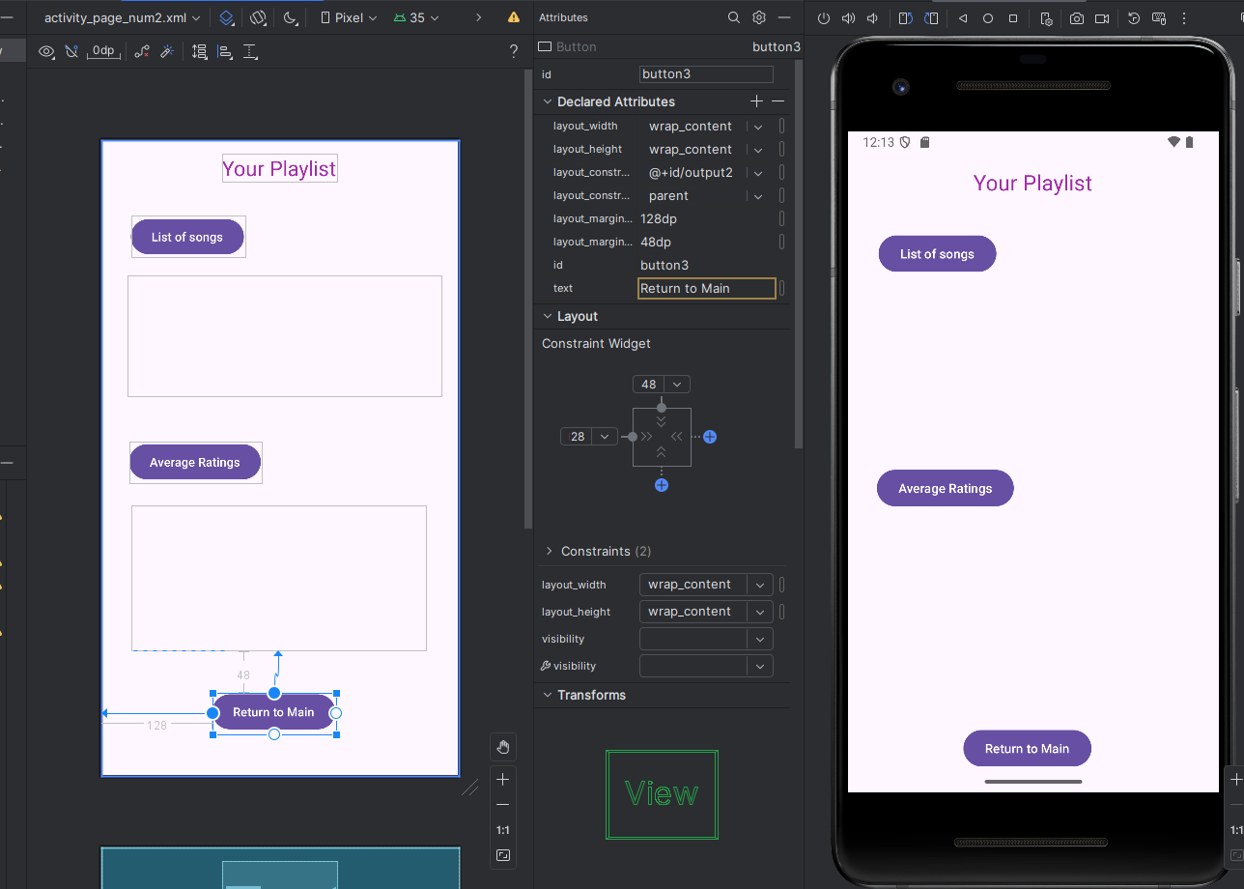

This the second page where the person information comes out or we can say results.

The buttons provided are for the user to click and get the information or results that he/she is looking for regarding the playlist. The return button is a button that takes you all the way to the beginning just in case the user is not happy with his/her results or probably made a mistake when choosing her playlist, so the can press the button and do the correct thing

Screenshot 4

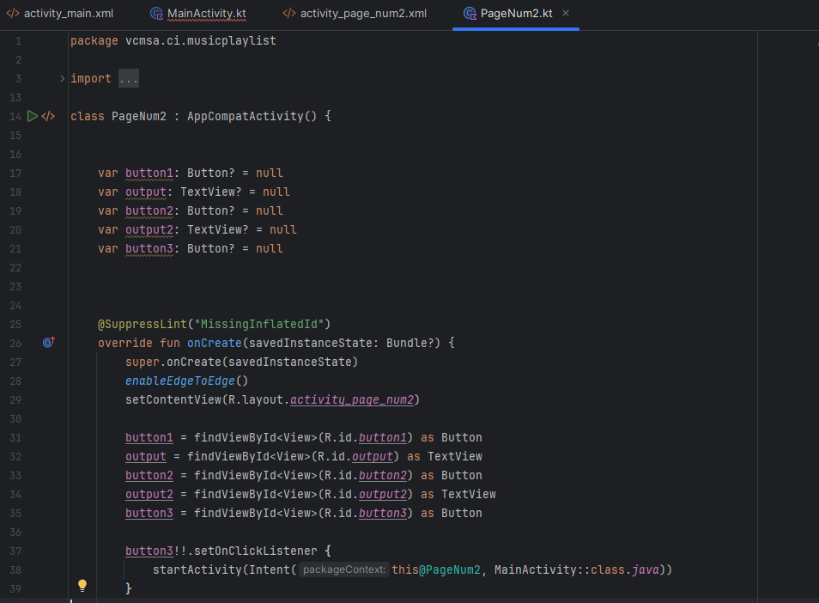

This is the code that initialises the code to work on the app. This code that you see her is what is being code so that the results of the user will come out with the user having any trouble trying to find information or results to his playlist or music. The code that you see here also helps the user to return back to the main page to selected the music that he wants to have in his playlist