|  |  |
| --- | --- |
| UNISAFE MOBILE APP USER MANUAL | Prepared by  Jasmin Kisten, Imaan Ebrahim, Zakariyya Adams, Ryan Khan, Gregory Mbiya, Kyle Govender -  XBCAD7319  VC SANDTON |

Table of Contents

Mobile Application User Manual Overview2

Registration Screen2

Functionality Overview2

Design3

Login Screen4

Functionality Overview4

Design4

Emergency Panel5

Functionality Overview5

Design5

Parking Indicator5

Functionality Overview5

Design6

Map6

Functionality Overview6

Design7

Carpooling Options7

Functionality Overview7

Design8

Complaints Tab8

Functionality Overview8

Design9

**MOBILE APPLICATION OVERVIEW**

The **UniSafe** web application is a feature-rich platform designed for college students that offers individualized user experiences, smooth navigation, improved parking logistics, increased safety, and encouragement of environmentally responsible modes of mobility. This manual serves as a comprehensive guide, detailing the app's functionalities and design principles to help users maximize its potential. The handbook is organized into design explanations that describe how the interface and system architecture function to provide a smooth and effective user experience, as well as functionality overviews that describe the features and goals of each module.

**REGISTRATION SCREEN**

**Functionality**

The purpose of the Registration Page is to make it easier for new users to get started. By entering basic details such their complete name, university ID, email address, and phone number, students can create an account. Creating a unique password and verifying its accuracy are examples of security features. The page also streamlines safety setting by allowing users to add optional emergency contacts during the registration process. Users receive a confirmation email or SMS with an account activation link after successfully registering.

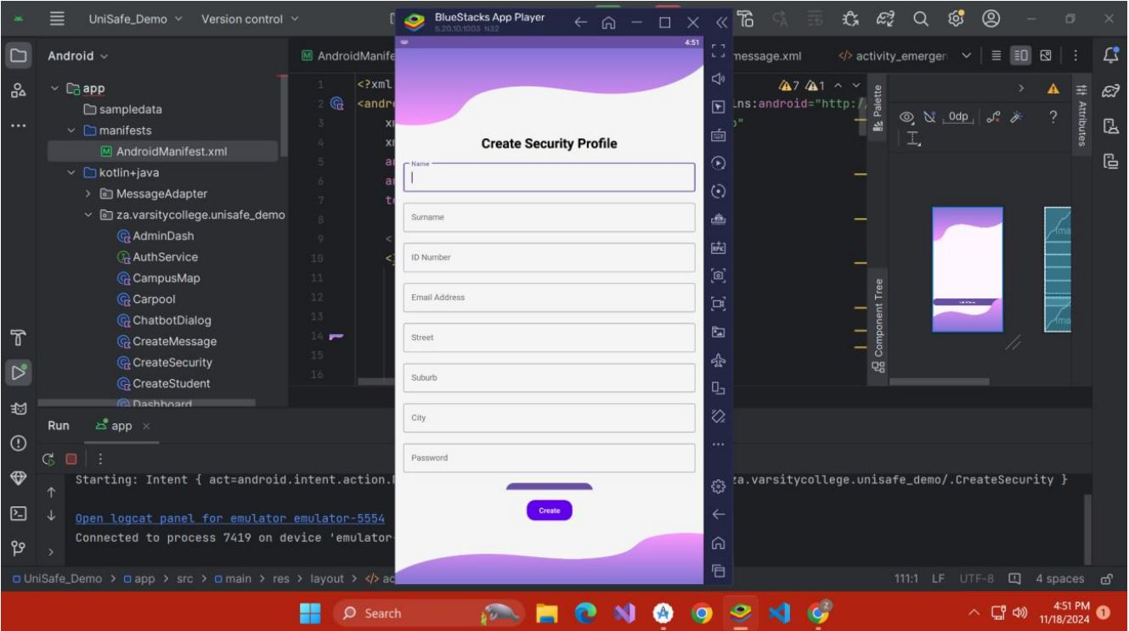

**Design**

To reduce errors, the Registration Page features input areas with clear labelling and a simple, easy-to-use structure. To assist users, real-time error prompts, like "invalid email" or "password mismatch," are shown. When appropriate, checkboxes and drop-down options make data entry easier (e.g., selecting university departments). Screen reader compatibility is guaranteed by the page's adherence to accessibility guidelines. Secure encryption algorithms preserve confidentiality and adhere to data privacy regulations by safeguarding user data while it is being transmitted.

**LOGIN SCREEN**

**Functionality**

The application can be accessed securely using the Login Page. To obtain access, users enter their password and registered email address. The student is then taken to the next page which allows them to navigate to options such as complaints, carpooling options, account, explore and recent messages.

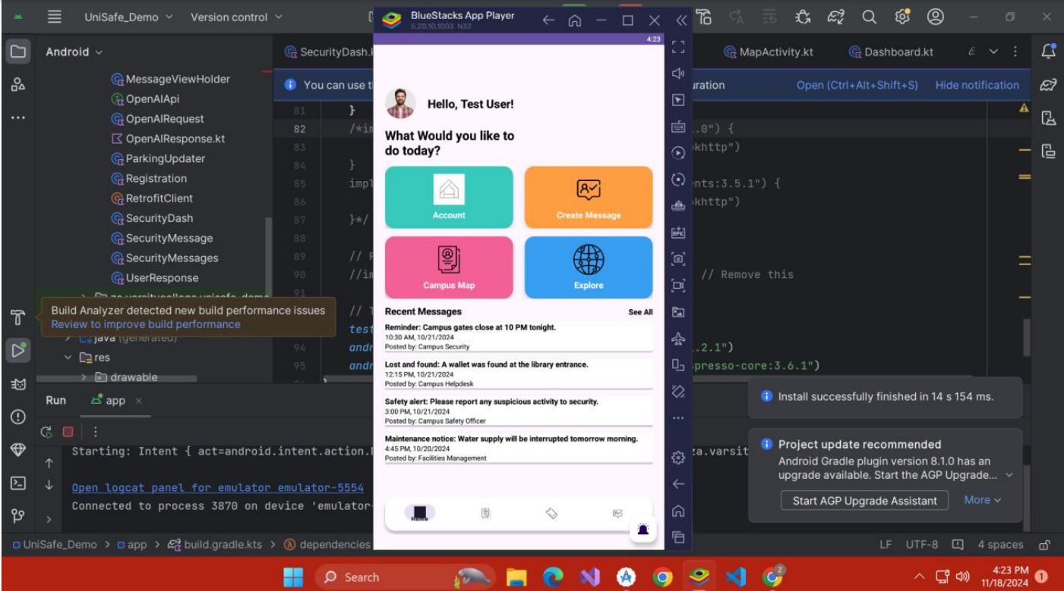

**Design**

To guarantee speedy access, the Login Page has a simple layout. To make the interface user-friendly, it employs visual clues such icons for the password and email fields. Responsiveness is given top priority in the design to guarantee smooth operation on both desktop and mobile platforms. Strong encryption guards against unwanted access by securing login credentials during authentication.

**EMERGENCY PANEL**

**Functionality**

The Emergency Panel provides a quick and efficient way for students to report emergencies and immediately alert campus security. Instead of managing contacts, this panel focuses solely on facilitating real-time communication between students and the campus security team.

Students can access the Emergency Panel from the dashboard or navigation menu. The panel includes a dropdown menu or predefined options for selecting the type of emergency, such as “Medical Emergency,” “Fire,” “Suspicious Activity,” or “Other.” Users can also provide additional details in a text field if necessary.

**Design**

The Emergency Contact Panel shows newly added contacts in a straightforward list format, with user-friendly icons for updating or removing each entry. The Emergency Panel is designed for clarity and speed, ensuring students can submit alerts without confusion.

**PARKING INDICATOR**

**Functionality**

The Parking Indicator displays available parking spots throughout the campus using real-time data streams. It provides real-time information about occupied and open spaces, including restricted areas, through dynamic updates. Users can also utilize this functionality to filter parking alternatives by kind, such as accessible, reserved, or general. Users are notified when new areas in their desired zones become available.

**Design**

To show parking availability visually, the Parking Indicator is integrated with an interactive map. Parking spaces are denoted by color-coded markers: yellow for restricted access, red for occupied, and green for availability. Additionally, the map has zoom and pan features that let users concentrate on particular regions. Toggle switches are used to display filters for easy customisation. Users can locate parking lots by name or address using a search box. By synchronizing with IoT sensors in parking lots, the technology guarantees accuracy in real time.

**MAP**

**Functionality**

An interactive tool that offers thorough navigation around the campus is the Campus Map. It contains comprehensive details about structures, amenities, and sites of interest, including cafeterias, libraries, and emergency stations. Users can enter their destinations to get detailed directions, including alternatives for driving or walking routes. Building accessibility details and operating hours are also included on the map.

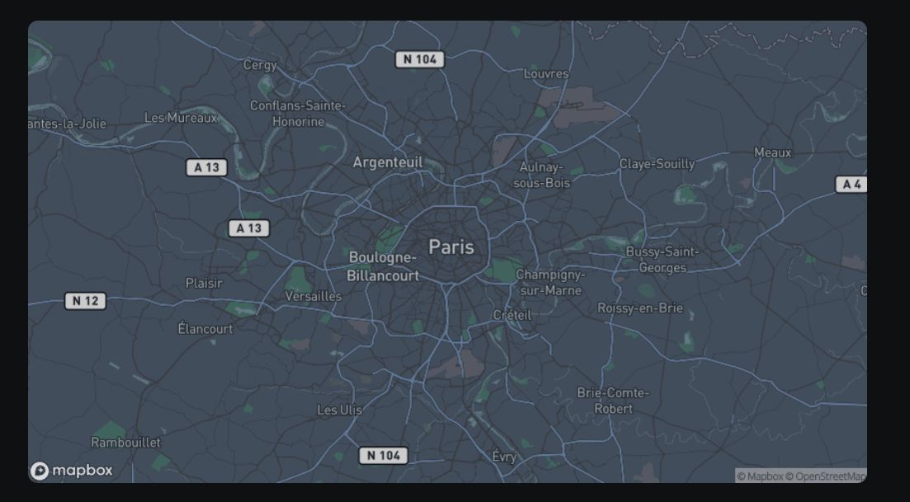

**Design**

Using color-coded markers for distinct place categories, the Campus Map boasts an eye-catching style. For convenience, icons stand in for amenities like first-aid stations, ATMs, and bathrooms. To alter the map view, users can change between layers to highlight particular departments or hide parking spaces. The map is user-friendly across all screen sizes thanks to responsive design. Based on real-time traffic or construction updates, the route planner makes dynamic adjustments.

**CARPOOLING OPTIONS**

**Functionality**

By connecting students going to similar locations, the carpooling option encourages environmentally friendly transportation. Based on common routes, timetables, and interests, users can start their own carpool groups or join ones that already exist. Ride-matching algorithms are part of the function, and they recommend matched partners based on availability and location.

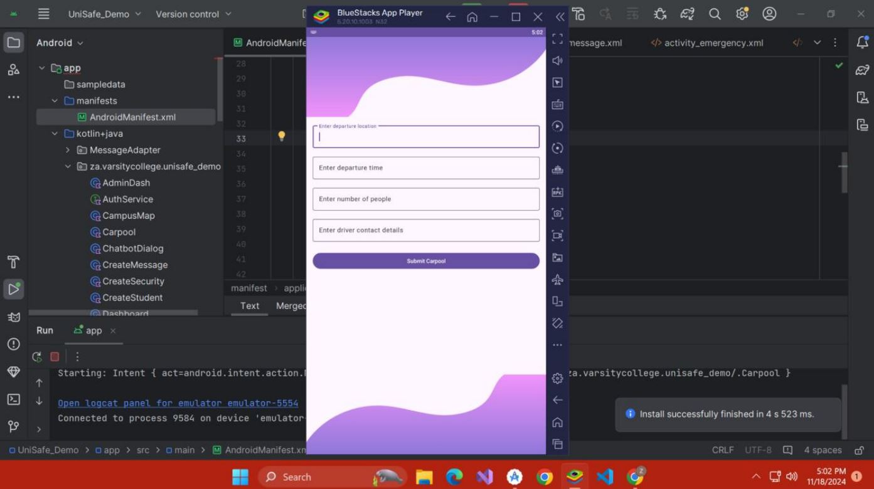

**Design**

The Carpooling interface is simple and intuitive, featuring a tab for "Carpooling". Filters allow users to narrow down options by departure time, route, and carpool size. Profiles of potential carpool partners display relevant information, such as their name, and locations ensuring transparency.

**Complaints Tab**

**Functionality**

The Complaints Tab allows students to submit complaints directly to the campus administration, ensuring their concerns are heard and addressed promptly. Students can fill out a simple form where they specify their complaint, provide details in a message field, and include their email address for follow-up communication.

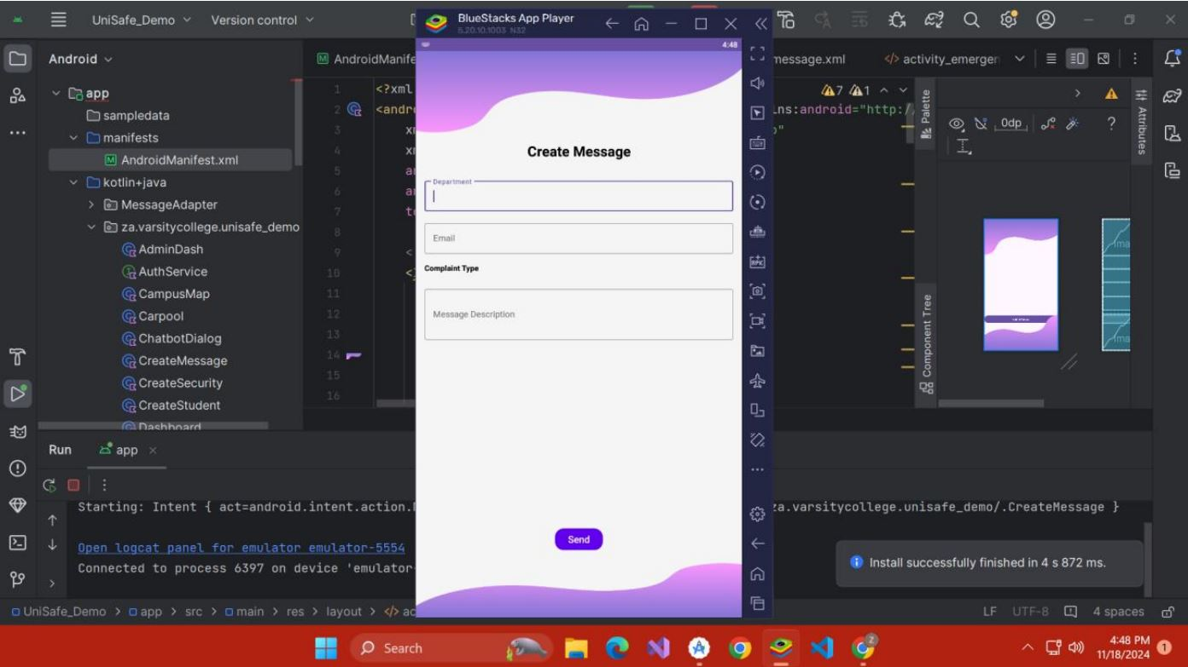

**Design**

The Complaints Tab is designed with clarity, accessibility, and user-friendliness at its core. The layout is minimalistic yet functional, ensuring that students can quickly and easily submit their complaints without any distractions. The tab is displayed as a separate, clearly labelled section within the app, typically placed in the navigation menu or as part of the user’s dashboard for quick access. When users open the tab, they are immediately presented with a simple form comprising three essential fields: Complaint Subject, Complaint Message, and Email Address.

**END**