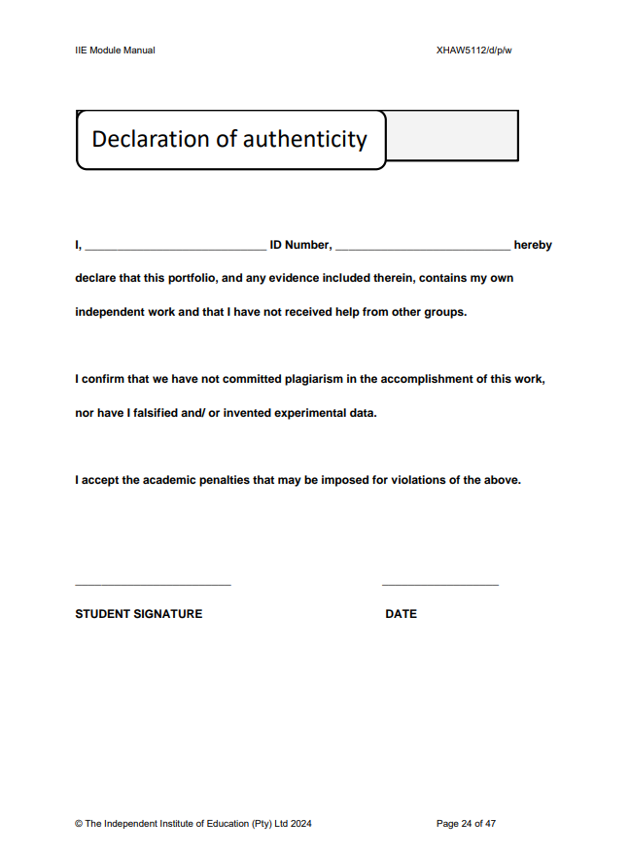

0206045092080

Mohammed Ebrahim kadir

2024/10/18