DCC - Production Deployment Guide

DCC Portal
Date: 25 February 2026
BY: SURESH PRAJAPATI - VCERP

1. Software Requirements
Ensure the following packages are installed on the server:
- Python 3.13.7
- pip & virtualenv
- Gunicorn
- poppler-utils
- libzbar0t64

2. Deployment Steps

Step 1: Server Preparation
- Install base dependencies:
- sudo apt install python3.13 python3.13-venv python3-pip -y
- apt-get download libzbar0
- apt-get download poppler-utils

Step 2: Application Setup
- Create the application directory:
- sudo mkdir /dcc-portal

Step 3: Virtual Environment Setup
- Navigate into the project directory /dcc-portal and run:
- python3.13 -m venv .venv
- source .venv/bin/activate
- pip install -r requirements.txt

Step 4: Environment Configuration

- Create a .env file inside the project directory for sensitive configurations:

- The .env file is included

Step 5: Gunicorn Configuration
- Test Gunicorn:
- gunicorn --workers 1 --timeout 120 --bind 127.0.0.1:7000 api:app
Step 6: Systemd Service Configuration
- Create the service file:
- /etc/systemd/system/dcc-portal.service

- Service File Content:

[Unit]
Description="DCC API Python"
After=network.target

[Service]
WorkingDirectory=/dcc-portal
Environment=PATH=$VIRTUAL_ENV/bin:$PATH
ExecStart=/dcc-portal/.venv/bin/gunicorn --workers 1 --timeout 120 --bind 127.0.0.1:7000 api:app
Restart=always
RestartSec=10
KillSignal=SIGINT
SyslogIdentifier=dcc-api-python
User=root

[Install]
WantedBy=multi-user.target

- Enable & Start Service:
- sudo systemctl enable dcc-portal
- sudo systemctl start dcc-portal
- sudo systemctl status dcc-portal

3. Nginx Configuration

- Below is the Nginx file for reverse proxy & SSL:

server {
listen 443 ssl http2;
server_name dcc-portal.torrentgas.in;

# SSL
ssl_certificate /etc/ssl/torrent.in/wildcard_torrrentgas.in.crt;
ssl_trusted_certificate /etc/ssl/torrent.in/CACert.crt;
ssl_certificate_key /etc/ssl/torrent.in/_torrentgas_in.key;

# Logging
access_log /var/log/nginx/dcc-portal.torrentgas.in.access.log;
error_log /var/log/nginx/dcc-portal.torrentgas.in.error.log;

# Buffer limits
client_body_buffer_size 16k;
client_header_buffer_size 1k;
client_max_body_size 8M;

root /dcc-portal;
charset utf-8;

# Static Assets
location ~* \.(css|js|img|ico|eot|woff|woff2|ttf|svg|otf)$ {
try_files $uri $uri/ =404;
expires 30d;
add_header Cache-Control "public, max-age=2592000";
}

# Proxy Pass
location / {
proxy_pass http://localhost:7000;
proxy_set_header Host $host;
proxy_set_header X-Real-IP $remote_addr;
proxy_set_header X-Forwarded-For $proxy_add_x_forwarded_for;
proxy_set_header X-Forwarded-Proto $scheme;
proxy_set_header X-Forwarded-Host $server_name;
proxy_http_version 1.1;
proxy_set_header Upgrade $http_upgrade;
proxy_set_header Connection "upgrade";
proxy_cache_bypass $http_upgrade;
proxy_read_timeout 300s;
proxy_connect_timeout 300s;
}
}

3. .env File Content

- AZURE_API_KEY : here define the azure document intelligence api key
- AZURE_ENDPOINT= define the azure resource end point
- AZURE_OPENAI_ENDPOINT= define the azure open ai service end point
- AZURE_OPENAI_KEY= define the secret key of azure open ai service
- AZURE_OPENAI_DEPLOYMENT= here define the deployment name
- CLIENT_SECRET= / CLIENT_ID = / TENANT_ID = >> define the all key for read the email from azure cloud
- SCOPES = ["https://graph.microsoft.com/.default"]
- SCOPES_URL = https://graph.microsoft.com/.default
- AT_EMAIL_PAGES = here set the limit of page read from pdf like this “1-2” top 2 page read only from pdf but those pdf which process from email
- AT_MANUAL_PAGES = here set the limit of page read from pdf like this “1-5” top 5 page read only from pdf but those pdf which uploaded manually from the portal
- SAP_BASE_URL = here define the base url of Fiori app
- SAP_CLIENT = define the client of sap application
- SAP_USERNAME = / SAP_PASSWORD = define the sap application username and password
- USER_ID = here define that email id from read the invoice like dcctest@torrentgas.com
- IMAGE_EXTS=["jpeg","png","jpg"]
- Z_TABLE_DATA_STORE_ENTETY_SET_NAME="ZFI_DCC_HEADERSet"
- DMS_DOCUMENT_SAVE_ENTETY_SET_NAME="AttachmentSet"
- GET_PAN_NUMBERS_ENTETY_SET_NAME="PanNo_DetailsSet"
- GET_PO_NUMBERS_ENTETY_SET_NAME="PoCheckSet?$filter="

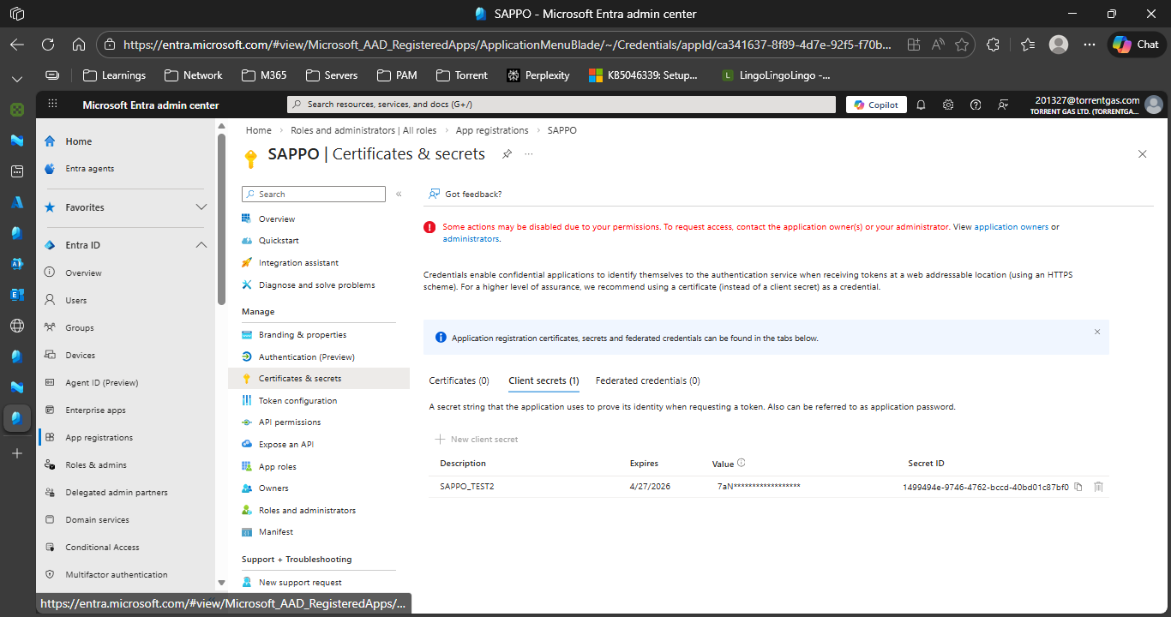
CLIENT SECRET ID

