# 1.0 Executive Summary

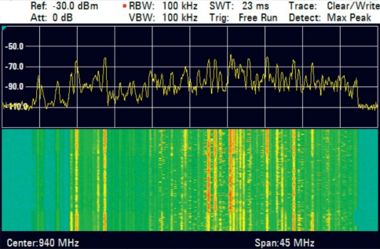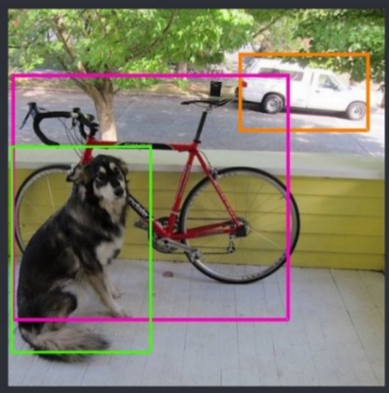

2 YOLO Single Shot MultiBox Detector

2 Classic RF Spectrum Views

Radio Signals Classification and identification are complex activates requiring significant experience. QRC wants to evaluate the utility of image classification for Signals Classification. This extends the QRC Wideband Transcorder product line features. QRC thinks the technology of a YOLO-like image classifier could act as a technician training tool, reference guide or “RF Google” to the analysis of some RF displays.

This project will utilize open source computer vision pattern recognition software and train its classification engine to identify signals in a radio frequency spectrum display. As a stretch goal the classification software may run in the WBT environment as installed software.

# 2.0 Statement of Work

Students will demonstrate and test a real-time object detection software system based on Convolutional Neural Network technology. Students will select the software technology (such as that found within the open source You Only Look Once “YOLO” project). Students will train the classifier with provided RF signal data files. **The project goal is to provide a proof of concept demonstration, instructions for reproducing the results and a lessons learned report to QRC on time.**

**Risk Reduction in Software and Hardware Scope:**

QRC thinks the value of this capstone is application of YoLo-like software to signal recognition. We suggest teams may run YoLo on student accessible hardware attached to WBT by ethernet. WBT can use SSH X11 Forwarding to put the RF Spectrum Analysis app into the YoLo host environment. This approach leaves the WBT environment a ‘black box’ for the YoLo teams and reduces the complexity of achieving a strong demo. The WBT 200 will run in Single Tuner Mode, a maximum of 40 MHz displayed bandwidth. The teams will select a single configuration of the visual output of the RF Spectrum Analysis app to whatever is most helpful for the classifier. The independent variable in this project should be limited to center frequency of the WBT playback.

**Proposed Deliverables:**

* Early consults with QRC Liaison for student research and selection of a classifier appropriate for the project.
  + ~~Has this been done before?~~
  + ~~Is there configured software to build upon?~~
  + ~~System integration block diagram for the project~~
* Early delivery of a proof of concept demonstration that identifies:

|  |  |
| --- | --- |
| **Team 1** | **Team 2** |
| Cellular LTE from other wide bands | Cellular WCDMA from other wide bands |
| Frequency Hopping ISM Band 900 MHz recognition | FM simple and Side Band FM from others |
| DMR from P25 | P25 from DMR |

* This demo has priority on the schedule and should be delivered to the QRC Liaison in some form no later than the **middle of April 2018**.   
  (QRC engineers will learn and use the demo for an early May conference event.)
* Later Delivery; Instructions or video walk thru which should be sufficient to guide to QRC engineers in:
  + Use of the final demonstration,
  + Understanding how to extend the training to attempt other signals,
  + ~~Must include the ability to reproduce the installation steps on other WBT devices.~~
    - ~~A video (or document) guide for step by step installation and training of a classification set produced from the provided signals. Details should be sufficient to act as a manifest for reproducing this demo from scratch.~~
* Final Delivery; A “Corporate Top Management” brief (4-6 slides deck) of the overview, limitations and risks encountered with suggested improvements for future student work is required. Briefly describe successful and false positive identification behavior of the classifier for these signals from some real live signals environments. We expect the classifier to be ‘pretty good’ with the recorded signals, and less effective with real signals in a live environment. This is due after the Demo date.
* The final report and poster board presentation for the class.

# 3.0 Objectives/Technical Specifications

Objective 1

* ~~Figure out how to integrate a trained image classifier into the Lubuntu Linux versions 12.04 or 16.04 environment of the WBT software.~~
* Complete the demo and deliver it about mid-April 2018.

Objective 2

* Determine if it’s feasible to integrate a classifier into the WBT Linux environment.
* Make the final deliverables.

# 4.0 Customer Provided Equipment

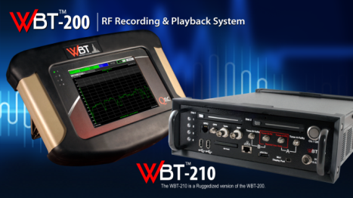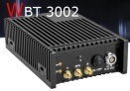

A WBT 200 model will be provided.

Each team member will be provided with a copy of the WBT development environment virtual machine image for use on any student accessible 64bit computer with 8Gig or more of RAM.

## Handling Requirements for QRC Software:

Team members should recognize that software and technical data authored and provided by QRC are not intended for distribution other than among team members and Major Design Experience (MDE) faculty.

QRC is showing team members sensitive information that is important to the Company. Team members must agree to protect QRC software with due care to prevent it from being publically distributed or hacked. Team members shall use the same care with QRC Software as they would use to protect their own most valuable personal information.

The team members agree to follow these software handling requirements for the “WBT Dev-Kit” and any other QRC authored software (collectively “QRC Software”):

1. A team member shall not provide copies of or analysis from any provided QRC Software outside of the team. Any QRC Software contained in the virtual machine image initially provided by QRC for the project shall be considered Company Private, for team use only.
2. Team members shall not will not reverse engineer, decompile, decode, decrypt, disassemble, or in any way derive source code from any QRC Software.
3. Upon request of the QRC Liaison (after receipt of the final project software deliverables to QRC) each team member shall remove all copies of any QRC Software from all information systems that contain QRC Software. (Human readable code developed in the project may be retained by team members for educational purposes.)

## Introduction to the WBT Software Development

<https://youtu.be/YmY1vrubMIY>

Suggested Intro to signals recognition

<http://www.sigidwiki.com/wiki/Database>

## Suggested Reading on Computer Vision YOLO:

<https://pjreddie.com/darknet/yolo/>

<http://guanghan.info/blog/en/my-works/train-yolo/>

<https://timebutt.github.io/static/how-to-train-yolov2-to-detect-custom-objects/>