Clinical Structure Naming Tool

Description

A series of scripts have been written to assist the creation of structures in Pinnacle and conform to the AAPM TG-263 naming conventions. This system should also remove some of manual work required to add multiple structures in the Pinnacle Treatment Planning System.

Pinnacle Scripts
A number of scripts have been created to assist the process of adding TG-263 approved structure names in the Pinnacle Treatment Planning System. Below is the current list of scripts:

Script Name | Description
Abdomen.Script | Auto-populates the ROI list with pre-specified Abdomen site structure names
CNS.Script | Auto-populates the ROI list with pre-specified CNS site structure names
HeadNeck.Script | Auto-populates the ROI list with pre-specified HeadNeck site structure names
Lung.Script | Auto-populates the ROI list with pre-specified Lung site structure names
Prostate.Script | Auto-populates the ROI list with pre-specified Prostate site structure names
remove_structures.Script | Removes all structures from the ROI list if no curves have been added. All structures added by the above scripts will start without curves as they have not been manually contoured.
load_structure_naming.Script | Opens the Structure Naming program
add_structures.Script | Loads into the ROI list structures names saved from the Structure Naming program
innerscript.Script | Internal script used by the add_structures.Script
add_single_roi.Script | Internal script used by the add_structures.Script
empty.Script | Placeholder file

The scripts for site specific names can be modified to add or remove structure names if the default lists are not what you want to use. You can also follow the format of these scripts to add other scripts to load structure names for other disease sites or user specific lists. Added names should be from the TG-263 approved list.
The load_structure_naming.Script and add_structures.Script will need to be added to your HotScripts list if you want to use the Structure Naming tool with the graphical interface. The remove_structures.Script can be useful with or without any of the other scripts included in this project. The remove_structures.Script will remove all structures from your HotScript list if they are empty (no curves exist).

Structure Naming Tool
This tool allows the user to create a list of structures from the TG-263 approved master list and load them in an open Pinnacle plan.

Basic Operation
The basic steps for using this program are:
- Load load_structure_naming.Script
- Create a list of needed structure names
- Save list of structures names
- Run add_structures.Script to populate the Pinnacle region of interest list
- (Optional) Run remove_structures.Script to remove any uncontoured structures

Structure Naming User Guide
After running the load_structure_naming.Script script you should see the window below.
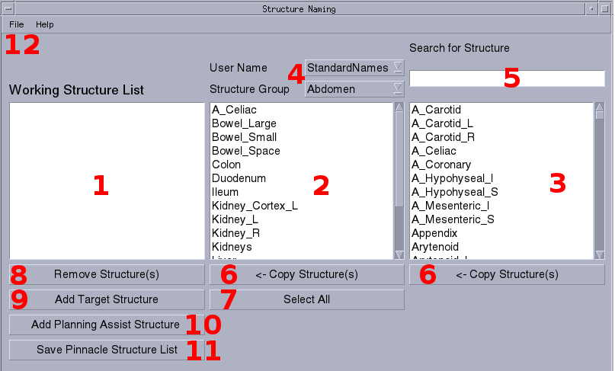
- Working Structure List
The working structure list shows all of the structures that are intended to be loaded in Pinnacle. This list will be empty when the program is first loaded as no structures have been selected.
- Structure Group List
To make the process of adding structures quicker, users can select from a predesignated list of structures using the pull-down boxes shown in Item 4 below.
- Master AAPM TG-263 Structure List
Not all of the default site specific structure lists will have all of the names that might need to be used. To solve that problem a master list of structures as specified in AAPM TG-263 has been added. These structures can be added to the working list of structures that will be loaded in Pinnacle.
- Selection of User Name and Structure Groups
The default User Name is the one called Standard Names which is a group of structures for treatment sites as specified by people in the Department. In addition to the Standard Names, specific users can have their own group of structures. For this example only two other users exist in the system: fsleeman, jdoe. Instructions to add or remove users can be found in the “Modify User List” later in this document. Below are a few screenshots showing the user and structure group selection:
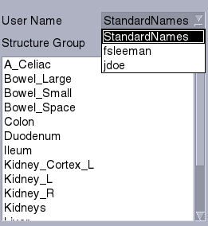  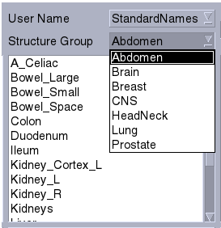  User Selection | Group Selection

Search Tool
The list of structures that might be useful from the AAPM TG-263 list is in the hundreds which can make it difficult to find a specific name in the master list. To make this process easier there is search box above the master structure list. Typing into the search list will automatically filter the master list. The search text is not case sensitive and will filter the master list for any structure that contains the search text anywhere in the structure name. See an example below.

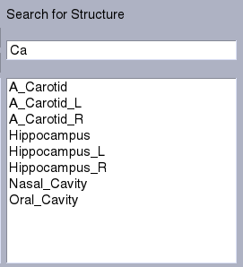

- Copy Structures
Structures must be copied from the Structure Group List or the Master AAPM TG-263 List to the Working Structure List before they can be loaded in Pinnacle. This can be done by manually selecting on structures of interested in either the Structure Group List or the Master AAPM TG-263 List. You can either CTRL-click to select multiple items one by one or Shift-click to selecting a group of contiguous items, the same way you would in popular program like Excel. Once items are selected, you can press the <- Copy Structure(s) buttons to copy to Working Structure List on the left of the window. If the structure name is already in the Working Structure List, the selected item will be ignored to prevent duplicates.

- Select All
This selects all structures in the Structure Group list so they can be copied to the Working Structure List.
- Remove Structures
If there are structure names you no longer want in the Working Structure List they can be removed using the Remove Structure(s) button. Multiple items can be selected in the same manner as in the Master AAPM TG-263 List and Working Structure List. Removing these items has no impact on the Master AAPM TG-263 List and Working Structure Lists.
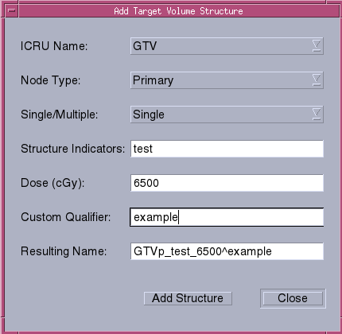
- Add Target Structure
Target structures are not listed in the Master AAPM TG-263 List and Group Structure List but can be manually added. Clicking on the Add Target Structure button will open this window:
This window contains several pull down boxes and text fields that can be filled or left blank. The Resulting Name is dynamically generated based on the values in the fields above according to the target nomenclature of TG-263. Clicking on Add Structure will add the resulting name to the Working Structure List. The form will be cleared so it could be filled again if there is another structure to be added.
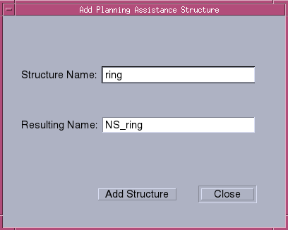
- Add Planning Assist Structure
Structures like rings are not in the lists used in the program but the Add Planning Assist Structure button will open a new window that allows user specified planning structures.
These structure names will be appended with NS_ . Adding these structures to the Working Structure List is the same as with the targets.
- Save Pinnacle Structure List
Once you are happy with the list of structures in the Working Structure List you can click on the Save Pinnacle Structure List button. This will create a session specific, temporary file that can be loaded using the add_structures.Script hotscript. Close the Structure Naming Tool and click on the add_structures.Script script in Pinnacle that the new names should populate the ROI list. The load script will ignore structure names if they exist in current plan's ROI list.
- Main Menu
The top main menu of program is shown below and the has the following items:
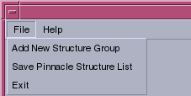

Add New Structure Group:
Each user listed in the User Name list (see Item 4 above in this document) can have multiple, custom structure groupings. Clicking on the Add New Structure Group button will open this window which allows new groups to be added:
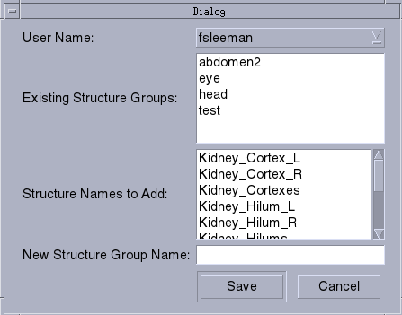
Save Pinnacle Structure List: Saves the Working Structure List to disk, same as item 11 above in this document. Exit: Closes the program. Do this after saving the Pinnacle structure list you want to load in the planning system.

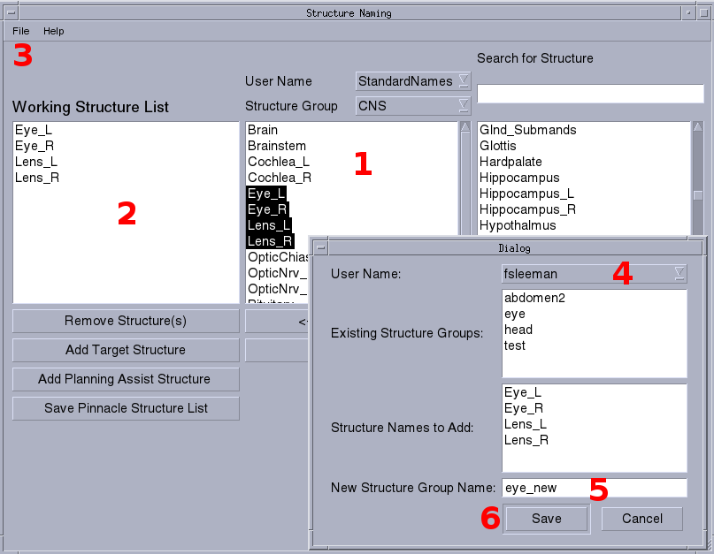
Adding New Structure Groups

You can add new user specific structure groups by:
- Select structures you want to add to the group.
- Copy desired structure names to the Working Structure List
- Open the Add New Structure Group window from the main menu.
- Select the username, for this example it is fsleeman. After selecting the user you will see the list of existing structure groups for Structure names from the Working Structure List will be shown in the Structure Names to Add . This list of structures will be added to the new structure group.
- Write in the name of the new structure group. The program will not allow a name that already exists.
- Save the new structure group. This will now be available from the main window Structure Group drop down box for this sessions and all following sessions.

Modify User List
Users that show up in the User Names list (item 4) are loaded based on directories and files in the structures directory under the installed location of the Structure Naming tool. In this directory is a list of users (as sub-directories) and the Master AAPM TG-263 List (as structure_dictionary.txt). Each user sub-directory contains .txt files, each containing the list of structures for the structure group.
Adding a new user is a simple as creating a new sub-directory with the new user name. When the Structure Naming tool is opened next the new user name can be used to add structure groups. Users can be removed by deleting the corresponding sub-directory. The department/clinic level StandardNames structure groups add be modified by adding, removing, or modifing the text files under the StandardNames directory. Right now modifying the StructureNames and the user list is not supported in the main user interface to provide some level of access control. Unwanted individual structure groups can be removed by deleting the corresponding text file.

Known Issues
While the Structure Naming Tool will allow the user to add structures with names including special characters, such as - and ^, the Pinnacle Treatment Planning System version 9.8 will refuse to add them. Right now the only work around is to use structure names that do not include those characters although that may exclude some structure names specified in the AAPM TG-263 list. Future versions of Pinnacle may allow these characters.

