**LB – 09**

Cp

**Line**

array([ 0.258525, 68.825 ])

array([146.3825 , 159.30875, 172.235 , 185.16125, 198.0875 , 211.01375,

223.94 , 236.86625, 249.7925 , 262.71875, 275.645 , 288.57125,

301.4975 , 314.42375, 327.35 ])

**Exp**

array([1.10000000e+02, 1.11828973e-03])

array([153.84833598, 162.69573053, 172.0519144 , 181.94614666,

192.40936901, 203.47430248, 215.17554984, 227.54970374,

240.63546119, 254.47374456, 269.10782952, 284.58348046,

300.9490935 , 318.25584793, 336.5578662 ])

**Pow**

array([2.92436537, 0.68084799])

array([142.09364534, 157.81753039, 172.83788509, 187.26906212,

201.19627271, 214.68517592, 227.78772804, 240.54594106,

252.99440103, 265.16201484, 277.07325735, 288.74908414,

300.20761373, 311.46464728, 322.53407069]

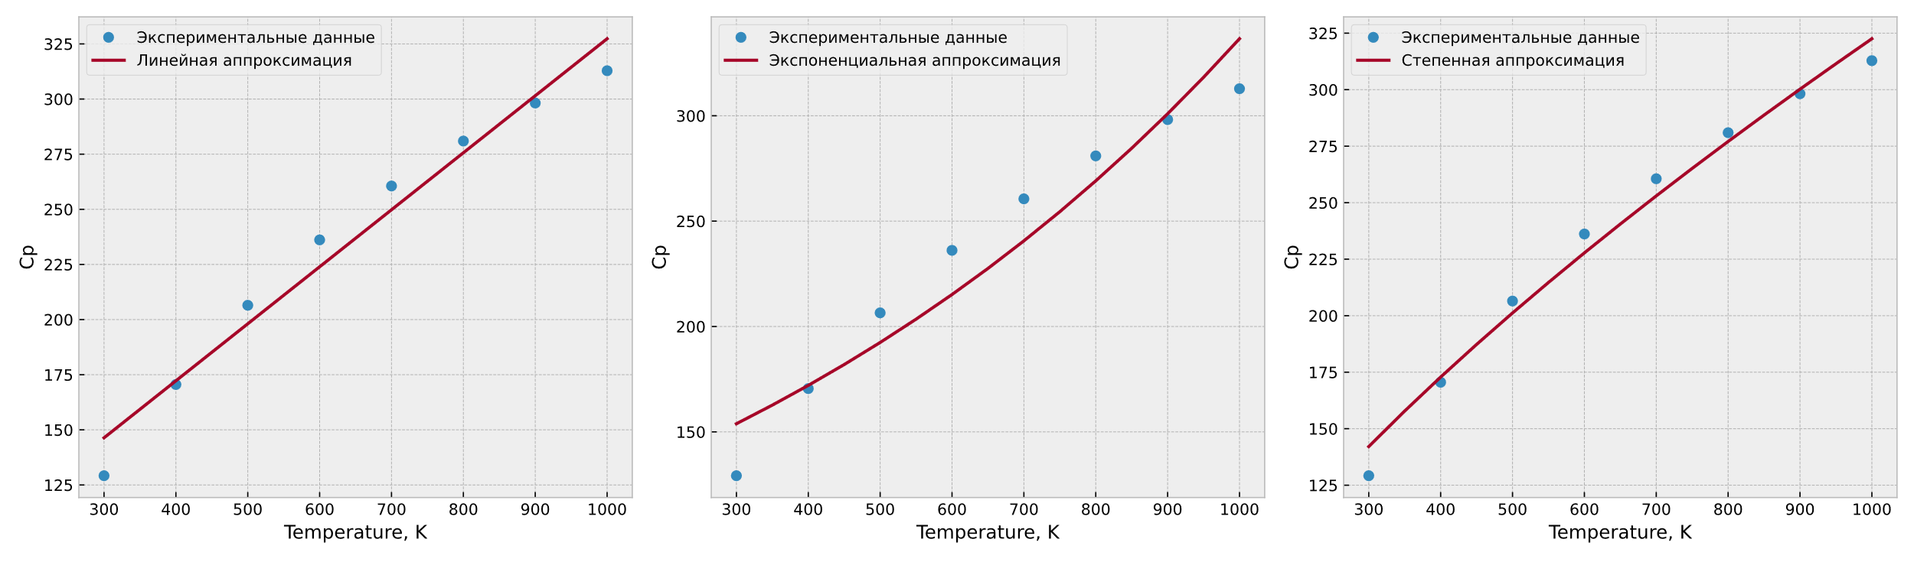

∆H

**Line**

array([-0.04167976, 38.15309524])

array([25.64916667, 23.56517857, 21.48119048, 19.39720238, 17.31321429,

15.22922619, 13.1452381 , 11.06125 , 8.9772619 , 6.89327381,

4.80928571, 2.72529762, 0.64130952, -1.44267857, -3.52666667])

**Exp**

array([ 9.45640301e+05, -1.80645235e+00])

array([30.74759244, 25.31425319, 20.84102734, 17.15825536, 14.12625789,

11.63003801, 9.57491964, 7.88295671, 6.48997681, 5.34314732,

4.39897154, 3.62163898, 2.98166715, 2.45478332, 2.02100397])

**Pow**

array([ 9.45640301e+05, -1.80645235e+00])

array([31.69016199, 23.98768149, 18.84640782, 15.23435215, 12.59404567,

10.60208668, 9.05999829, 7.8402882 , 6.85791235, 6.05431196,

5.38805774, 4.82914525, 4.35539599, 3.95011888, 3.60055062])

