Links

<https://data.cso.ie/product/VSBO>

<https://data.cso.ie/table/VSA19>

<https://data.cso.ie/table/VSA14>

<https://data.cso.ie/table/VSA36>

Birth Rate Analysis –

<https://data.worldbank.org/indicator/SP.DYN.TFRT.IN?locations=IE>

<https://getinthepicture.org/sites/default/files/resources/7.%20Births.pdf>

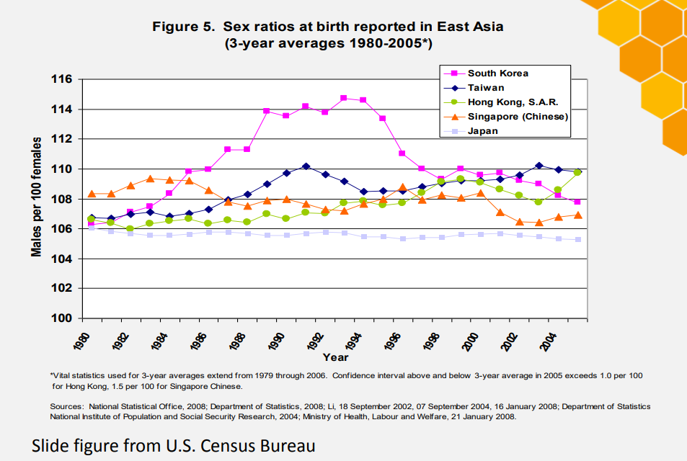

* <https://ourworldindata.org/fertility-rate>
* <https://pubmed.ncbi.nlm.nih.gov/12281339/>
* <https://paa2015.princeton.edu/papers/150351>
* <https://bmjopen.bmj.com/content/3/8/e002920>
* <https://www.macrotrends.net/countries/IRL/ireland/birth-rate>
* <https://www.rte.ie/brainstorm/2021/0519/1222517-ireland-birth-rates-falling/>
* s