

CAPSTONE PROJECT REPORT
Report 1 – Project Introduction

– Hanoi, September 2026 –
Table of Contents
I. Record of Changes 3
II. Project Introduction 4
1. Overview 4
1.1 Project Information 4
1.2 Project Team 4
2. Product Background 4
2.1. Background & Problem Statement 4
2.2. Proposed Solution & Objective 4
3. Existing Systems 5
3.1 System name1 5
3.2 System name2 5
4. Business Opportunity 6
5. Software Product Vision 6
6. Project Scope & Limitations 6
6.1 Major Features 6
6.2 Limitations & Exclusions 7

I. Record of Changes
Date | A*  M, D | In charge | Change Description
12/09/2026 | A | ThuNTM | Add 2.1, 2.2
12/09/2026 | A | AnNT | Add 5 , 6.2
12/09/2026 | A | HungVD | Add 3.2 6.1
12/09/2026 | A | TuHA | Add 6.1, 3.1
12/09/2026 | A | LinhPM | Add 4
*A - Added M - Modified D - Deleted

II. Project Introduction

1. Overview

1.1 Project Information
- Project name: Web-Based Japanese Practice Support Application for IT Students at FPT University
- Project code: J-Tech
- Group name: SEP490_G24
- Software type: Web-Base Application

1.2 Project Team
Full Name | Role | Email | Mobile
Bui Dinh Chien | Lecturer | kiennt@fe.edu.vn | 0912656836
Vu Dinh Hung | Leader | hungvdhe181369@fpt.edu.vn | 0867278738
Hoang Anh Tu | Member | tuhahe182111@fpt.edu.vn | 0965564577
Nguyen Thi Minh Thu | Member | thuntmhe180810@fpt.edu.vn | 0368846874
Phung Mai Linh | Member | linhpmhe187215@fpt.edu.vn | 0387198622
Nguyen Truong An | Member | annthe173189@fpt.edu.vn | 0796096270

2. Product Background

2.1. Background & Problem Statement
At FPT University, Software Engineering (SE) students often encounter significant friction and barriers in assimilating and retaining Japanese language knowledge following classroom lectures. Through domain analysis and observation, the primary root causes have been identified as follows:
- Heavy Academic Workload & Subject Prioritization: The SE academic curriculum is inherently rigorous, demanding substantial cognitive effort and time. Consequently, students naturally prioritize core technical disciplines - such as software construction, algorithms, and system design - leaving inadequate focus and study time for foreign language acquisition.
- Classroom Constraints & Low In-class Engagement: Large class sizes pose a challenge for instructors in tracking individual learning curves and monitoring real-time comprehension. Additionally, psychological hesitation (fear of asking) prevents students from proactively seeking clarification on complex language concepts during lectures.
- Over-reliance on Generative AI Tools: While generative AI adoption accelerates task completion, students increasingly rely on it to finish assignments passively without achieving actual comprehension or long-term retention of core language competencies.

2.2. Proposed Solution & Objective
To mitigate these operational and learning inefficiencies, the FPT BIT Japanese Practice Platform is proposed.
The system aims to provide a personalized, adaptive self-study and revision environment. By tailoring learning paths, practice exercises, and pacing to individual performance, the platform reduces learning friction, enhances retention, and fosters an engaging, stress-free Japanese learning experience tailored specifically to the schedule and characteristics of software engineering students.

3. Existing Systems

3.1 Nhai Kanji
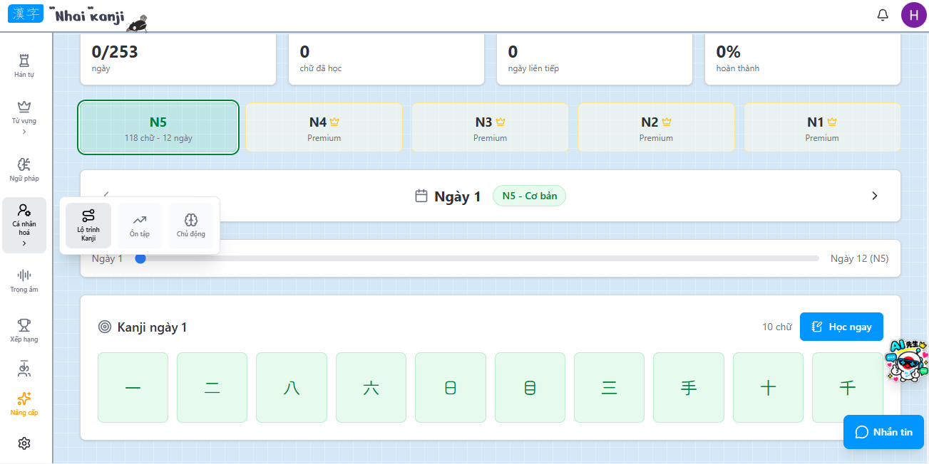Nhaikanji.com is a platform designed for learning Kanji through personalized features, helping users customize their learning paths and focus on forgotten characters. It offers an interactive learning experience tailored to individual progress.
However, Nhaikanji.com does not provide specialized practice exercises aligned with the Dekiru Nihongo curriculum taught at FPT University. Consequently, FPTU students may find it difficult to review their specific academic subjects effectively using only this platform.

3.2 DungMori
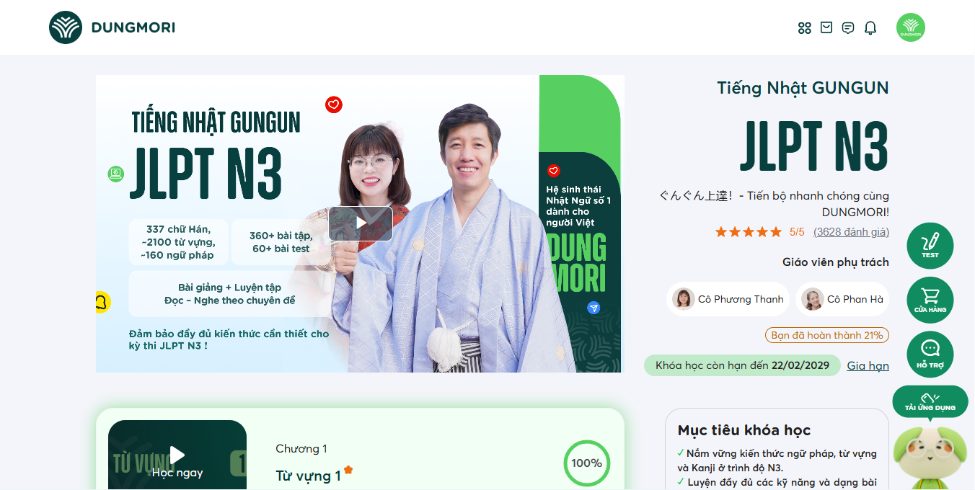
Dungmori.com is a well-known online platform for learning Japanese, providing comprehensive video courses, grammar lessons, and JLPT preparation materials. It offers structured learning paths suitable for various proficiency levels from basic to advanced.

However, Dungmori.com does not offer specialized practice content tailored specifically to the Dekiru Nihongo curriculum taught at FPT University. Therefore, FPTU students may find it difficult to review and master their university-specific course materials effectively through this platform.

4. Business Opportunity
Currently, at FPT University, Software Engineering students are required to study Japanese alongside their major courses. However, many students do not have a strong foundation in Japanese and have difficulty balancing their study time. A web-based Japanese learning support system will help students easily access vocabulary, grammar, and exercises while allowing them to study independently anytime and anywhere.
Compared to using multiple separate learning resources, the system consolidates learning materials into a single platform, saving time and reducing costs. The product also aligns with the trend of online learning, helping improve students’ Japanese learning effectiveness and supporting them in meeting the requirements of the training program.

5. Software Product Vision
For Software Engineering students who need to practice Japanese as part of their curriculum but struggle to find time between dense programming coursework, the FPT BIT Japanese Practice Platform is a free, web-based Japanese practice platform that accepts self-paced vocabulary drills, writing exercises, listening comprehension tasks, and AI-assisted conversation practice with adaptive learning paths that personalize content difficulty and pacing to each student's current proficiency level.
Unlike the current classroom-only schedule, where all students follow the same lesson pace regardless of individual strengths and weaknesses, students who use FPT BIT Japanese Practice Platform will receive exercises targeting their specific weak areas - spending less time on kanji they already know and more time on grammar points they struggle with which maximizes every minute of their limited study time and helps them maintain consistent progress alongside their engineering coursework.

6. Project Scope & Limitations
Approached by all BIT students at FPT University, the system will not reach students outside of FPT University because the subjects developed in the system are exclusive subjects of FPT University.

6.1 Major Features
FE-01: Access the FPT BIT Japanese Practice Platform (FBJPP) through the Internet to use the system's learning and practice services.
FE-02: View and modify personal profile information.
FE-03: Create, update, and delete tests used to assess learners' Japanese knowledge and skills.
FE-04: Manage user accounts, approve accounts, change account status, and configure system settings.
FE-05: Identify learners' weaknesses, track individual learning progress, and provide personalized learning support based on their performance.
FE-06: Practice Japanese vocabulary, grammar, Kanji, listening, reading, and speaking; watch learning videos; and use AI-supported reading and speaking practice.
FE-07: Send notifications and reminders via text messages about learning activities, schedules, progress, and other important information.
FE-08: Upload, edit, and delete learning documents to support the management and moderation of learning materials.
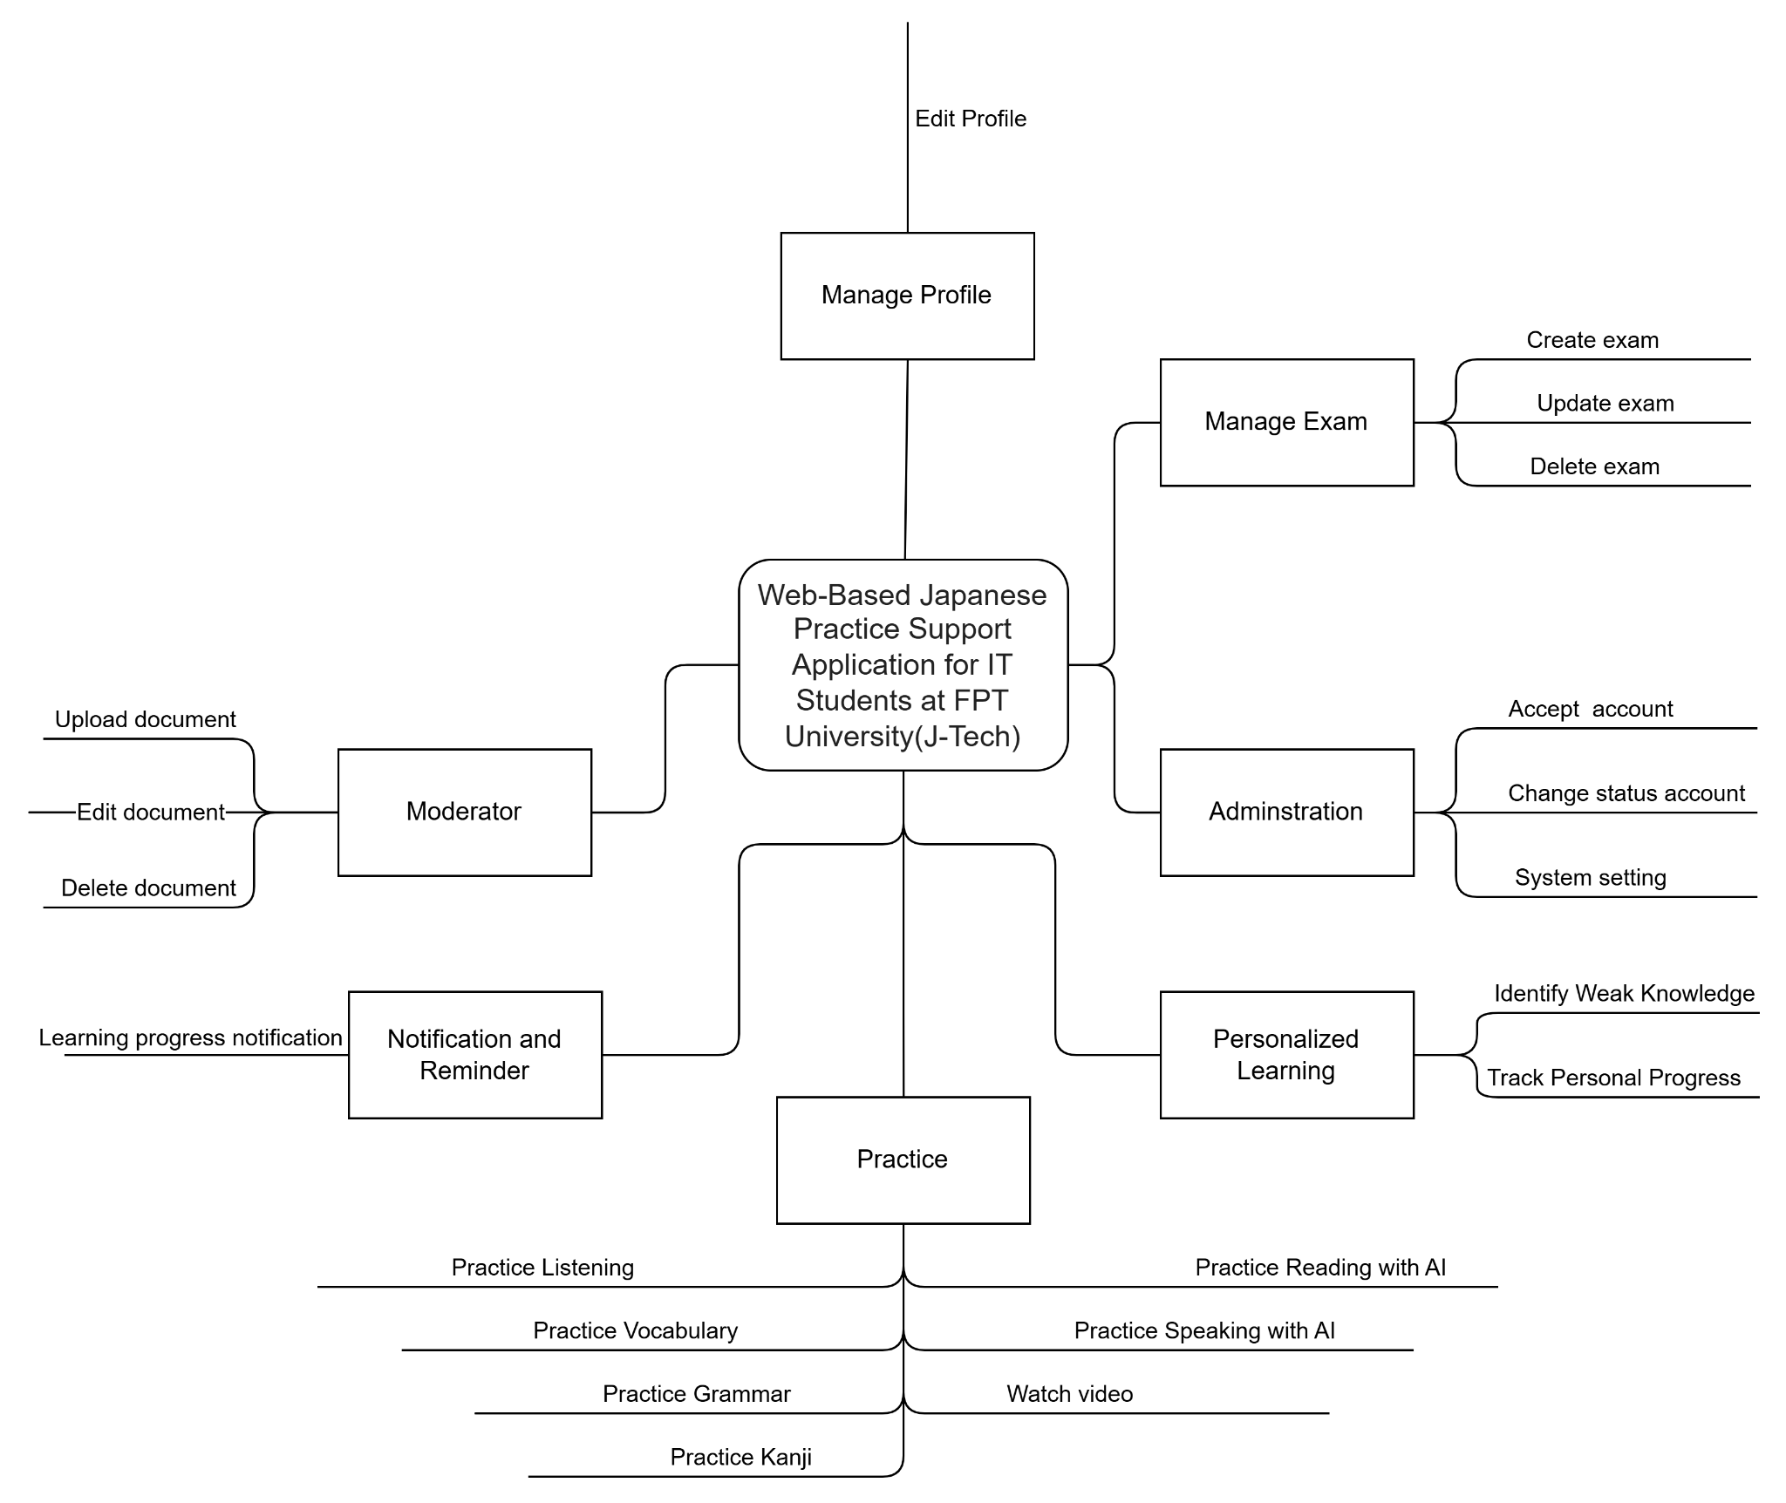
6.2 Limitations & Exclusions
LI-1: AI-assisted practice features (speaking conversation partner and reading comprehension) only support pre-designed scenario categories and curated curriculum topics (daily life, campus, job interview). Free-form conversation or text generation on arbitrary, highly specialized domains (e.g., medical, legal, advanced engineering) is not supported.
LI-2: AI-generated study recommendations are based solely on the student's performance history within this platform — off-platform knowledge or JLPT exam results are not factored in.
LI-3: The product is designed exclusively for BIT students — students from other majors or institutions are not the target users.
LI-4: Stroke-order feedback for kanji writing is limited to the Jōyō kanji set required by the curriculum — advanced or rare kanji are not evaluated.
LI-5: Pronunciation assessment provides accuracy scoring only — it does not produce phonetic transcription, IPA notation, or detailed articulatory feedback.
LI-6: The product is available in Vietnamese, English and Japanese only — no other language UI at launch.
LI-7: Offline access is not supported — all features require an active internet connection.
LI-8: The platform does not support live instructor-led sessions, grading, or direct pedagogical review. Lecturers or instructors do not monitor individual study sessions in real-time.

