VirtualDJArtnet
VirtualDJArtnet is an addon to enable VirtualDJ to send control instructions to lighting controllers such as QLC+. While it has only been tested on QLC+ it should also work on other DMX software that can take an artnet input.

Installation

Windows
Unzip the addon ZIP file to the VirtualDJ plugin Autostart folder (C:\Users\YOURUSER\Documents\VirtualDJ\Plugins\Autostart)

MAC
Unpack the bundle to the VirtualDJ plugin Autostart folder
(<VirtualDJ>\Plugins\AutoStart\)

How to use the VirtualDJArtnet Plugin
Once the plugin is installed it has to be enabled in order to work.
In VirtualDJ 8, go to the MASTER tab. In the centre ‘Master Effect’ dropdown select & click on the ‘Auto start’ folder.
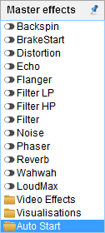

Find & click on the switch to enable VirtualDJartnet.
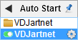

Clicking the settings icon will load a sidebar into VirtualDJ to allow you to configure the plugin.

Configuring the VirtualDJartnet plugin
The plugin comes with its own config editor. The editor itself includes a number of predefined presets for commonly used functions.

Config editor fields
The main window of the config editor features a number of text entry areas. The first of these, Dest IP is for entering the IP address of the device which will be intended to receive Artnet packets. In cases where the light control program is on the same machine as VirtualDJ the IP address should be set to 127.0.0.1
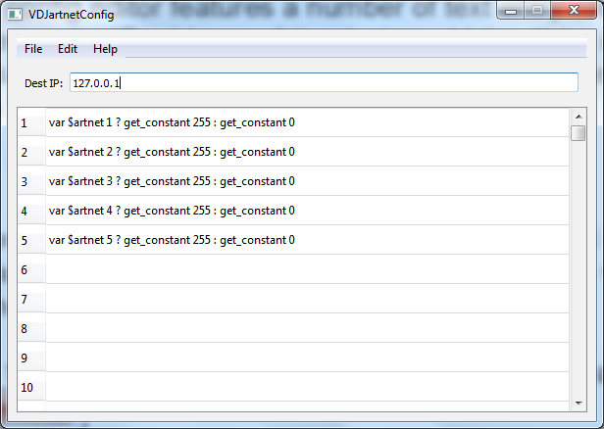
In the 512 lines that follow is a number in the left hand column followed by an area to enter a VirtualDJScript. The number signifies the Artnet DMX address which will be controlled by the result output by the VirtualDJScript.

Presets can be dragged from the smaller window into the text entry area.
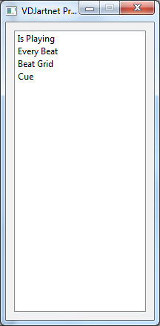
Double click the VDJScript textarea to edit the text.
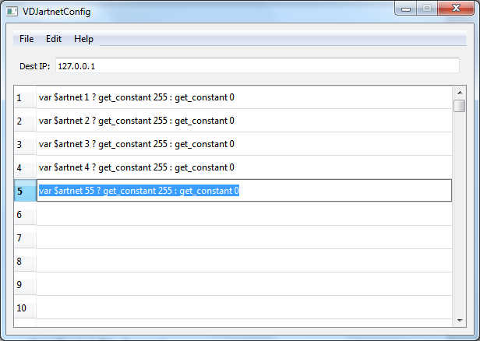

Config.txt file format
The format of the config.txt file is straightforward. The first line of the file should always be the destination IP address of the Artnet device to be controlled. The lines which follow are for Artnet DMX channel assignments & are of the format:
DMXADDRESS~ VDJSCRIPT
e.g.
1~ var $artnet 50 ? get_constant 255 : get_constant 0
The above example will check the variable called $artnet. If its value is 50, Artnet DMX channel 1 will be set to a value of 255. If not, Artnet DMX channel 1 will be set to a value of zero.

Preset.txt file format
PresetName~VDJSCRIPT
e.g.
IsPlaying~play ? get_constant 255 : get_constant 0

