Somnia Agents Notes

1. Introduction to Decentralization & Somnia Agents
Decentralization: Transfer of control and decision-making from a central entity (individual, company, government) to a distributed network.
Somnia Agents: Removing the trade-off between decentralization and what you can achieve. They are decentralized, isolated computing agents.
- They use powerful smart contracts but can reach outside the blockchain to:
- Interact across a web3 website
- Send an email
- Call any API or webhook
- Call any model
- Why, when, and where it runs on each node is verifiable and auditable.
- Uses consensus mechanisms (Proof of Work or Proof of Stake).
- Allows running an AI model on-chain and getting the entire network to agree on a particular thing.
- Easier to test, debug, and use in production like traditional software.
Deterministic LLM Models: Configured to produce the exact same output every time you give the same input/prompt (uses a fixed seed, Temperature = 0, and strict rules for output like JSON). It is easier to test, debug, and use in production code.
Simpler Explanation of Decentralized AI: Moving AI out of private cloud servers (like OpenAI's data centres) and running it across public, decentralized blockchain networks. Instead of trusting one company to run an AI honestly, thousands of independent computers run the AI together and must all agree on the final answer.

2. Blockchain & Onchain AI Concepts
Blockchain: A shared digital record book (ledger). Exact copies are distributed across a massive global network of computers. Transactions are grouped into a "block" and securely chained together in chronological order, making the records virtually impossible to alter.
Onchain AI: The AI's code and decision-making logic lives inside a blockchain's smart contracts.
Isolated Computing: The AI agent operates in a secure sandbox where its internal code cannot be tampered with by outsiders.
Network Agreement: Multiple independent computers (nodes) run the exact same deterministic model. They compare results, vote, and only commit the answer to the blockchain if they all reach a consensus.

3. Key Benefits
- Tamper-proof Honesty: No hackers can secretly alter the AI's prompt or data.
- Zero Trust Required: No trust is needed towards an AI tech giant to protect our data or keep the AI unbiased. The blockchain enforces fairness.
- Guaranteed Uptime: Because the AI runs on a global network of computers, it cannot be shut down, censored, or suffer from single-server outages.
- Audit Trails: Every decision the AI makes, along with the data it used, is permanently recorded on the blockchain for anyone to see.

4. Workflow & Consensus Logic
Simple Workflow: The AI agent does not just run on a single computer and upload the answer to the network.
- A specific condition or user request triggers the blockchain network.
- This causes multiple independent nodes to run the AI model simultaneously.
- They agree on the exact same answer (AI logic consensus).
- They write that consensus to the blockchain and the state is updated on-chain.
The "Deterministic" Doubt: "Why is there a need for multiple nodes running the same AI and a need for consensus if the AI is deterministic? Won't every node have the exact same answer?"
- If the model is deterministic, every honest node will get the exact same answer.
- Reality: There could be a hacker or a node that got hacked in a decentralized network. The motto is you cannot trust the human or hardware running the code.
- Therefore, consensus is mandatory even with deterministic AI.
- If only one node ran the AI, that node could easily cheat, have a hardware glitch, or do prompt injection.
- The person owning a single node could modify their local code to skip the AI entirely and type "Output = denied".
- By forcing more nodes to run the AI, if Node A and Node B output "Approved" but Node C outputs "Denied", the network automatically catches the liar (Node C), ignores their answer, and punishes them.

5. Where Does the AI Model Sit?
Remember that Somnia agents are "isolated computing agents". It depends on how the blockchain network is designed. The AI agent's logic sits in one of two places:
1) Directly inside the smart contract (Fully Onchain)
- The AI's entire code and weights are written directly into the blockchain's smart contract storage.
- When triggered, the nodes execute the AI logic directly within their virtual machines (like the Ethereum Virtual Machine).
- Drawback: This is incredibly expensive and slow. LLMs require gigabytes of data. Storing and running that inside a smart contract is not feasible, so this is usually reserved for very small models (SLMs).
2) In Isolated Node Environments (Hybrid Approach)
- Off-chain execution with on-chain consensus.
- Blockchain acts as the Manager. AI logic is outside the core chain.
- The AI model sits inside a TEE (Trusted Execution Environment) or Sandbox. This is a specialized, unhackable, isolated chip built directly into the physical hardware of each validator node.
- The instructions to trigger the AI and the final agreement rules always sit inside the "smart contract" on the blockchain. But the heavy AI logic and weights sit inside highly secure, isolated hardware chips owned by individual nodes running the network.

6. How to Build on Somnia
Somnia agents are decentralized, sandboxed compute containers, invoked by smart contracts, with results verified by node runner consensus.
- They utilize the standard ABI (Ethereum Virtual Machine).
- The application broadcasts a request to the blockchain -> Agent is invoked on multiple nodes (e.g., Node A, Node B) -> Receipts are generated -> Consensus is reached -> ABI response is returned.

7. The Base Agents (Phase 1)
1) JSON API Requests (6 methods)
- Fetches JSON data from public API endpoints.
- Extracts specific values using selector paths.
2) LLM Inference (4 methods)
- No GPU required (uses CPU).
- A simple String-in-String-out LLM inference agent using Qwen-3B.
- Features structured outputs and tool calls.
3) LLM Parse Website (2 methods)
- Search a domain or scrape a URL.
- Extract unstructured data using AI.

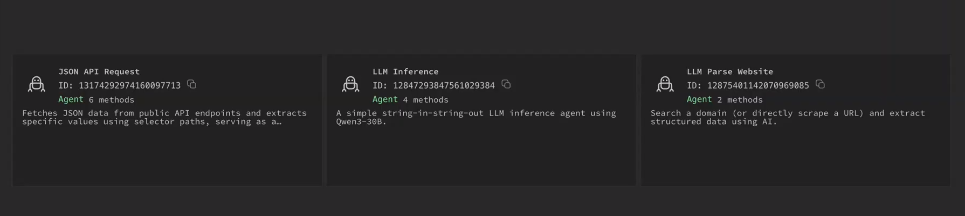

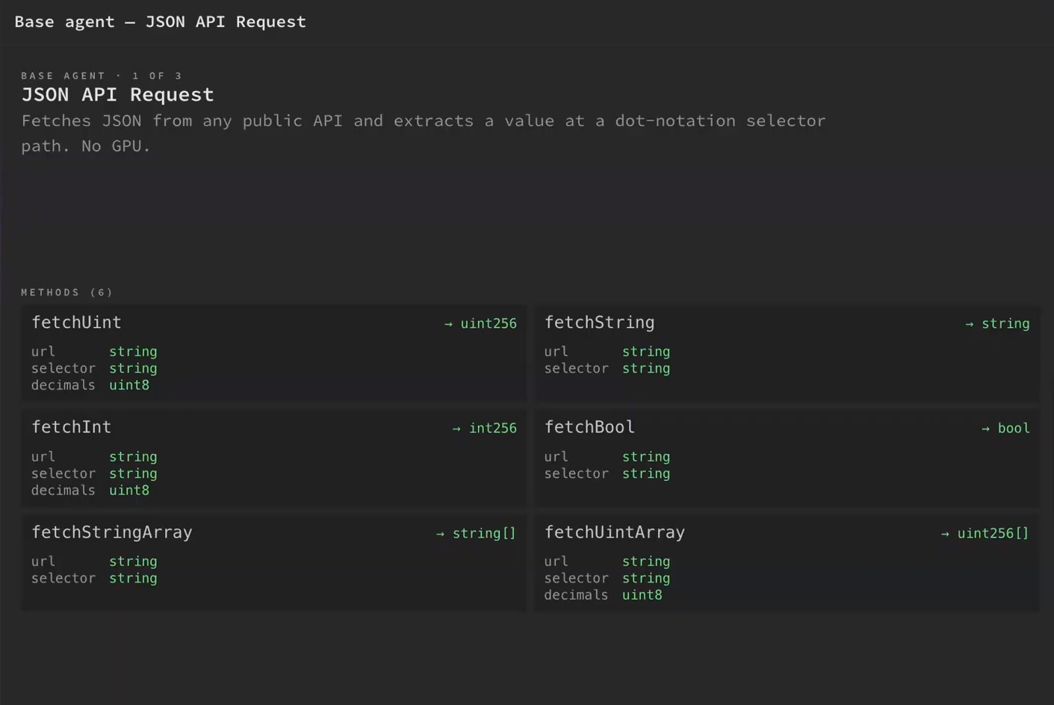
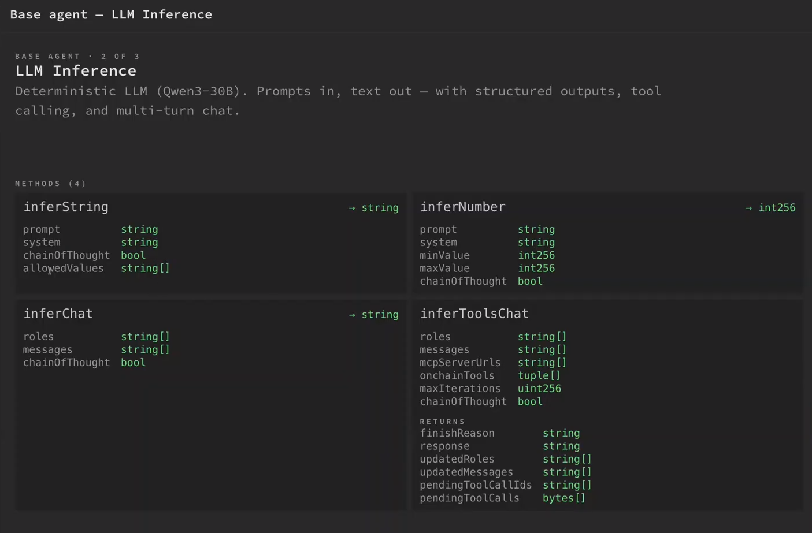
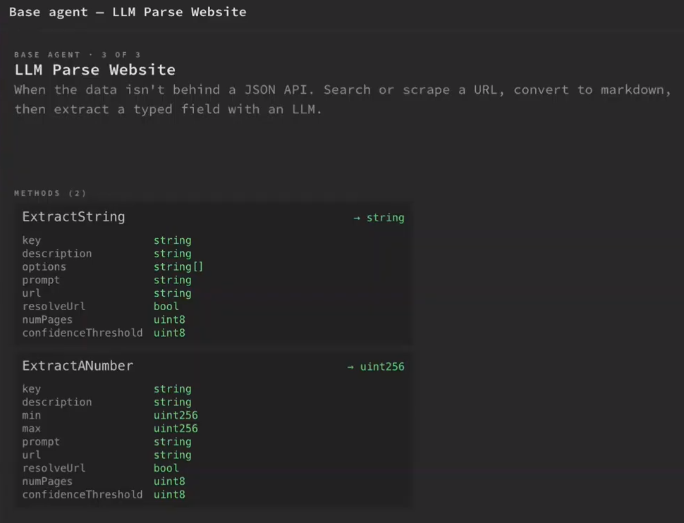

8. Use Cases by Agent Type
Agent 1 Use Cases:
- Price feeds (Crypto, equities, FX)
- Sports scores and match outcomes
- Weather for Parametric Insurance (e.g., an on-chain AI can ingest weather API data, agree that a hurricane hit an area, and automatically trigger insurance payouts to victims with no human delay)
Agent 2 Use Cases:
- Content moderation/classification
- On-chain text generation (NFT bios, summaries)
- Tool-using agents calling on-chain functions
- MCP servers: Lets the LLM drive decision-making, but the output execution actually happens inside the contract
Agent 3 Use Cases:
- Extract news from news pages
- Prediction-market resolution from articles
- Extract any data behind a website but not an API

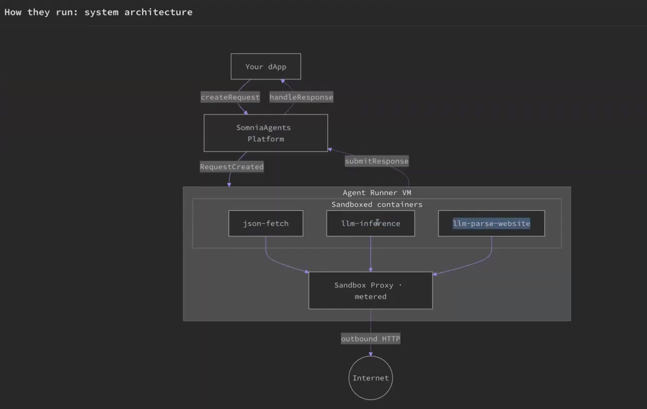

9. Examples of Applications

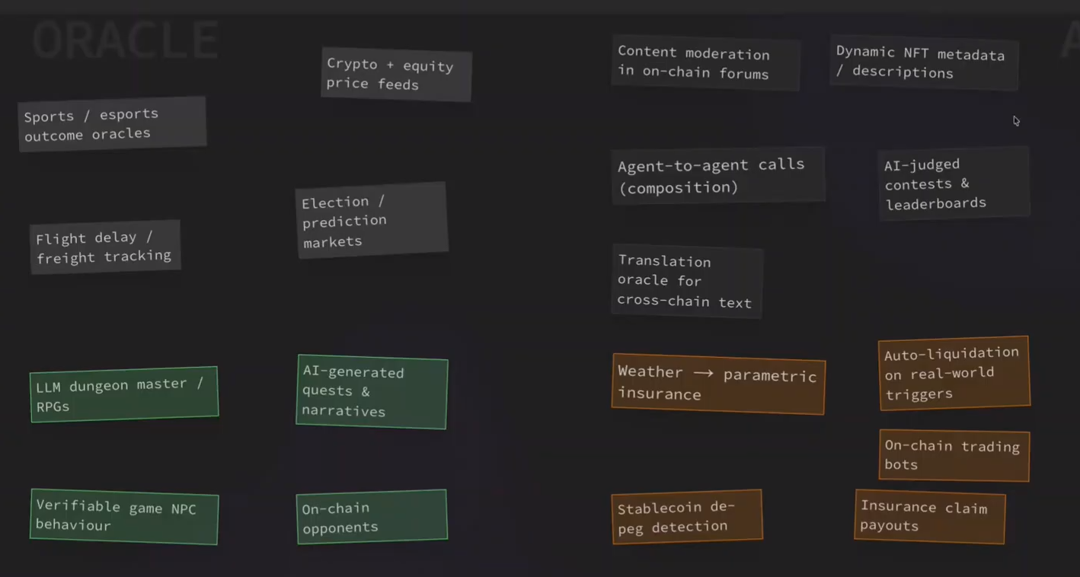

10. PROJECT: ON-CHAIN TRADING BOT
A verifiable, news-reactive autonomous trading vault ("the trustless quant fund")
Users deposit into a vault. An on-chain agent strategy runs the full loop: JSON API pulls price/funding data → LLM Parse Website reads news/headlines for the asset → inferToolsChat decides position sizing and emits the swap calldata, which the contract executes against an on-chain DEX (Somnia has on-chain order books, e.g. dreamDEX).
The killer feature — and your differentiator from Somnia's generic "agentic DeFi bot" example — is auditable reasoning: every decision the agent made and the exact data it read is an on-chain receipt. Depositors get a tamper-proof, public track record. It's a fund whose strategy literally cannot lie about why it traded. That "trust-minimized, provably-honest strategy" framing is the real-world utility judges reward, and it maps one-to-one onto the Demo Engineer JD.
Why it wins: uses all three base agents + on-chain execution; sub-second finality and sub-cent fees make a real-time loop viable; the verifiability angle is novel and impactful.
Scope discipline: one asset, one DEX pair, a simple but real strategy (e.g., trend + news-sentiment gating with position caps). Hard-code risk guardrails in the contract (max position, daily loss limit, circuit breaker) — this also scores you Autonomous Performance / stability points, which most teams forget.
The ambitious version (merges both your loves): a multi-agent trading desk
A fund-manager agent coordinates specialist analysts — a technicals agent (JSON API price/indicators), a news agent (Parse Website), and a risk-officer agent (inferString veto: ["approve","block"]) — that vote before any trade executes. This fuses Priority 1 (agent-to-agent) and Priority 2 (trading), which is probably the single most winning concept on the table and a phenomenal portfolio centerpiece. The honest tradeoff: it's the riskiest to ship reliably in the program window. My advice — build the single-agent vault first as your guaranteed-working core, then layer the risk-officer veto agent as your "composability" flourish. That gives you a demo that works and shows multi-agent autonomy.
This pairing (vault + agent-to-agent desk) is my overall recommendation for you specifically: it sits exactly where your trading interest, your agentic interest, and the Somnia job description all intersect.

