Nowcasting using physics-informed diffusion models

DEFINITIONS:
- Nowcasting: Forecasting a few hours ahead based on a set of previous observations.
- Advection: Figuring out how wind pushes weather systems around the map. Basically, the transfer of heat or matter by the flow of a fluid in the atmosphere or the sea. Think of it like a leaf floating down a river (River current being the wind, and the leaf being the storm system).
- Receptive Field (Field of Vision): The specific patch of an input image that a NN can see to make its prediction

GAPS:
- CNN and RNN architectures have shown promise for nowcasting applications such as predicting rainfall or thunderstorms. However, they can often produce blurry forecasts/outputs which can be unphysical. It is due to Mean Squared error limitations. Means, AI gets penalized for bring wrong.
  - The way it's penalized encourages it to play it safe, to average things out. If the model isn't sure if a storm cloud will be here or maybe a little over there, its safest bet is to just create a fuzzy averaged out blob right in the middle.
  - It's statistically correct, sure, but you lose all the sharp realistic details that are absolutely vital for a good forecast.
- Traditional nowcasting uses optical flow to extrapolate the past movement of rain/thunderstorms into the future, but this method cannot generate or decay thunderstorms.

SOLUTION:
- Generative methods such as diffusion can produce realistic looking output, potentially overcoming the blurring issue from neural networks and the inability of traditional methods to generate/decay thunderstorms. They generate sharp, realistic imagery by iteratively transforming noise into structured data.
- Diffusion models are starting to be used for nowcasting by using a conditional diffusion model to generate the next frame from an input sequence that contains meteorological data (rainfall radar or satellite observations).

AIM:
- This project would attempt to create nowcasts with diffusion models conditioned on previous observations and optical-flow based nowcasts.

PAPER: Physical Scales Matter: The Role of Receptive Fields and Advection in Satellite-Based Thunderstorm Nowcasting with Convolutional Neural Networks, arXiv:2504.09994v2

Brief Description:
Overview:
Explores integrating classical advection physics into Machine Learning to improve satellite-based thunderstorm nowcasting.
Training:
- By training ResU-Nets with satellite and lightning data, the authors demonstrate that adding Lagrangian persistence as an input significantly enhances forecast accuracy for lead times exceeding two hours
- Introduced a scale argument explaining that standard neural networks struggle when storm patterns move beyond their receptive field, or "field of vision"
Conclusion:
- The study confirms that Advection-Informed Neural Networks outperform baseline models, particularly during high-speed atmospheric motion and extended forecast intervals
- The work highlights the necessity of aligning neural network architectures with the underlying physical scales of meteorological phenomena

Explanation:
- DL techniques like CNN and RNN looks at the last 30 minutes of satellite pictures and lightning strikes and makes its best guess.
- The Advection-Informed Neural Network, or AINN gets the exact same data as the CNNs (its also another CNN), but its forecast is based on the laws of advection that predicts where the current weather is probably going to drift.
- On paper, the AINN should crush it, but when averaging everything out, AINN was only 1.25% better than the standard NNs.

Question: Why would an AI that was handed a massive head start, a cheat sheet based on the fundamental physics of our atmosphere, perform so normally?
The answer isn’t just about the data!! It’s how the AI architecture is built up.

Problem:
CNNs processes images in layers. When AI want to predict the weather for one single spot on the map, it can only look at the limited number of pixels from the current image right around that spot. That box is its Receptive Field, AI’s Field of Vision.
- This Receptive Field is a massive potential blind spot.
- If a big storm that's going to hit a town in two hours is currently outside that field, the standard NN model is completely and totally blur into it. Has no idea that the danger is on the way, because it can only see what’s happening in its immediate little neighbourhood.
- So, researchers realised that its not about which AI is smarter. It was all about a fundamental relationship between speed, time, and the AI's limited vision. And this is called “SCALE ARGUMENT”
Advection laws are only useful integration to an AI when a fast-moving storm, over a long forecast time, travels a distance that is bigger than the AI's own receptive field. If you're doing a short-term forecast or the storm is moving slowly, the important weather is probably already inside the receptive field. In that case, both AIs see it just fine (the standard NNs can learn patterns on its own, so no benefit of Advection laws here). So, the AINN only gets a real leg up when you ask it to predict fast-moving storms far into the future.

Testing:
Instead of averaging everything (lumping all scenairios: every forecast simulation – long and short term forecasts) together, they sliced the data, sorting every forecast based on how fast the storm is moving and how far out they were predicting.
Results? For short forecasts of 30, 60, and 90 mins, the AINN prediction was normal compared to standard NN. But for 180 minute (3hr) forecast, as the storm’s speed picks up, the AINN’s advantage skyrockets
- For slow storms, the AINN’s advantage is just tiny of 5%
- For medium speed storms, its 30% better.
- High speed storms, over 25m/s, the AINN is 80% more skilful than standard CNN
In action, over the Adriatic sea, the standard NN model couldn’t predict the storm that was outside its receptive field two hours earlier. But the AINN nailed it as it had the foresight to see what was coming from way outside its own little box.

Takeaway:
- More data isn’t always better for AI. Architecture matters.
- Blind spots can be overcome by directly embedding human knowledge, the laws of physics, principles of biology, right into its design – Hybrid Intelligence

PAPER: How to use score-based diffusion in earth system science: A satellite nowcasting example, https://arxiv.org/pdf/2505.10432

Brief Description:
Overview:
Introduces Score-based diffusion models as a superior alternative to traditional ML for satellite-based cloud nowcasting.
Training:
- Three specific architectures: Diff, CorrDiff, and LDM.
- Found that the CorrDiff approach performs best by refining a preliminary U-Net prediction.
Conclusion:
- Beyond improving visual clarity, these models successfully simulate complex atmospheric processes like convective initiation and cloud decay.
- Provided a practical framework to help earth scientists implement these advanced generative techniques in their own environmental research.

Explanation:
Working of Diffusion Models:
- Forward Process - Systematically add Gaussian noise to an image until only static remains.
- Backward Process – Train an AI to reverse the steps (anywhere from the noisy space), restoring the image from noise.
AI isn’t just memorizing the pictures. It is being trained to become a master denoiser. Forced to learn the deep structure of the data by getting good at moving noise in the image space. It compares its output to the original clean image. From random noise, the model iteratively takes small steps, following learned paths to a realistic image.
The model is guided by a Score Function, pointing the way to a more realistic image.

Forecasting with AI:
We don't want just any weather pattern. We want the specific weather pattern that's gonna happen three hours from now. We use Conditioning for this.
Instead of just giving the model a noisy image and telling it to clean it up, we give it that noisy image plus a little hint. And in this case, that hint is the real satellite images from the last hour or so.
- Now it won’t just generate like another satellite image. Instead, it uses logic to generate a realic forecast. Past is conditioning the future.
Diffusion Model Versions:
- DIFF: Standard approach
- CorrDIFF: Lets a conventional AI takes a first quick shot at the forecast, which ends up a bit blurry, then it uses the diffusion model to come in and correct that guess, adding all the realistic sharp details. Turned out to be a top performer.
- LDM (Latent Diffusion Model): It is super fast and efficient. Running the whole diffusion process on big, high-resolution image over and over again takes a ton of computing power. So the LDM uses a separate AI to first compress the big image into a much smaller, data-packed version of itself (Dimensionality reduction) which is called the Latent Space. It then runs the entire diffusion process (from noise to clean image) in this space. At the end, it uses another AI to get the original dimensions of the image.

Testing (South America off coast):
Skies had low-level clouds, high-level wispy clouds, and even brand new storms starting to bubble up.
CorrDIFF predicted the forecast with cloud textures, the sharp edges, and incredible clarioty. But it got a huge compute power. With LDMs, this can be reduced.

PAPER: Four-hour thunderstorm nowcasting using a deep diffusion model for satellite data, arXiv:2404.10512 (Dec 2025)

Brief Description:
Overview:
- Introduces Deep Diffusion Model for Satellite data (DDMS), a new AI system designed for high-res thunderstorm nowcasting.
- Utilizes FengYun-4A geostationary satellite data, the model effectively simulates the complex life cycles of convective clouds, including their rapid growth and dissipation.
Training:
- The architecture features three primary components: a data process module, a satellite nowcasting module based on diffusion processes, and a convection detection module guided by expert knowledge.
- Rigorous testing indicates that DDMS provides planetary-scale coverage and maintains high resolution, making it a powerful tool for disaster emergency response.
Conclusion:
- This system achieves a four-hour lead time with remarkable accuracy, significantly surpassing traditional physical models, even the physics-based numerical weather prediction and existing deep learning methods.
- The study highlights the transformative potential of diffusion models in capturing the stochastic nature of severe atmospheric events.

Explanation:
- NWP methods are great for figuring out the weather a few days from now, but they kind of struggle with these super-fast local storms.
- PySteps models (simpler ones) looks at where a storm is moving and guess where it’s going to go next. They can’t tell if a storm is about to blow up. Fails to accurately capture the complex motion patterns of clouds, resulting in large deviations from observations
- Classic CNN, RNN models would get blurry after 2 hours.
Neither of these approaches could reliably crack that crucial four-hour window.

DDMS:
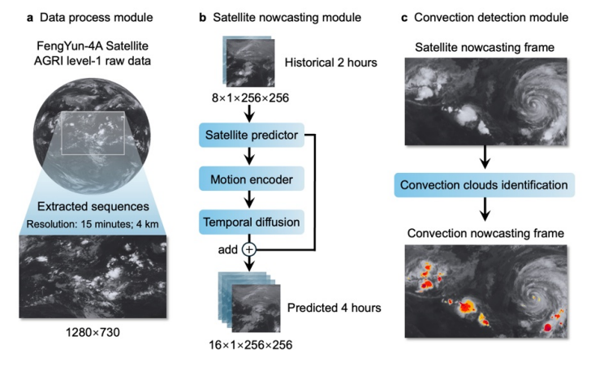
- Takes 4 years worth of images, taken every 15 minutes.
- Looks at the last two hours of satellite imagery and then generates a prediction of what the satellite will see for the next four hours.
- Scans those future images and flags the specific cloud shapes that signal a dangerous storm.

Testing against established forecasting models:
Critical Success Index (CSI) Chart -
This is a standard way to grade a forecast, measuring the nowcasting accuracy of convective clouds.
- DDMS consistently outperforms traditional methods Persistency and PySTEPS. Compared with the baselines, DDMS maintains a clear superiority across all scales.
- This advantage is evident at all evaluated scales and is generally more pronounced at shorter lead times, although the performance gap narrows at coarser scales (16- and 48-km) during the longer forecasting hours.
- NowcastNet produces competitive results over a short period (from about 120 minutes to 210 minutes), particularly at the 4-km scale. but it performs considerably worse outside this interval.
- PredRNN-v2 performance declines at longer lead times and at coarse scales
- At 4 km scale, NowcastNet and PredRNN-v2 generally outperform Persistency and PySTEPS, which highlights the advantages of AI techniques in modelling high-resolution convective systems. In contrast, Persistency and PySTEPS exhibit relatively improved performance at the 48-km spatial scale, indicating that advection-based approaches can effectively capture large-scale cloud patterns

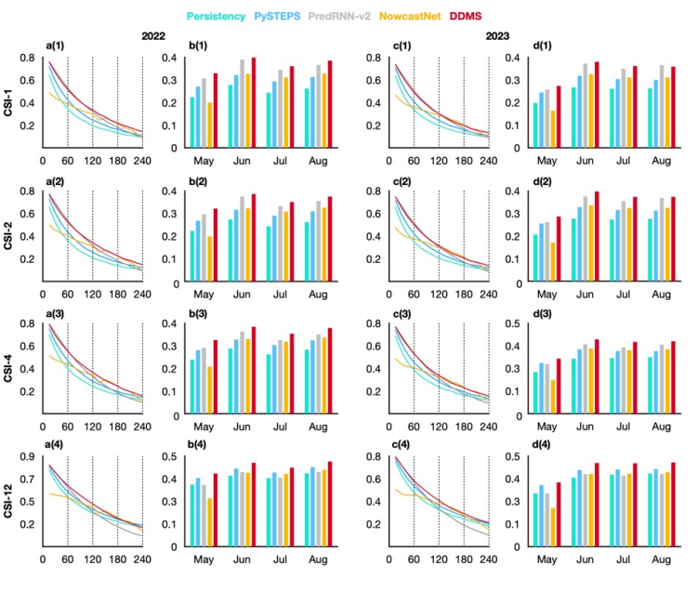
Test case (Convection event with an extreme rainstorm in South China, accompanied by Flood warnings):
- NowcastNet and PredRNN-v2 significantly overestimates the growth of the two convective cloud formations, which is actually disspating. In the last 2 hours, they fail to capture the disspation of the convective cloud.
- PySTEPS is unable to predict either the growth or dissipation of the convective clouds
- The three methods fail to deliver satisfactory 4-hour convection nowcasting, while the proposed DDMS produces much more accurate nowcasting results.

PAPER:

Brief Description:
Overview:
Training:
Conclusion:

Explanation:

PAPER:

Brief Description:
Overview:
Training:
Conclusion:

Explanation:

