**REPORT ON LAB-02 EXERCISE**

**DATA COLLECTION FROM SENSOR AND UPLOADING THE DATA INTO HBASE**

*TASK-1: Data Collection from the BLE Sensor Tag device through Android Mobile Device*

I have imported the given application “app1-app3-GPS” into my local eclipse and tried to analyze the code given through it. The given working code is used to write about the accelerometer data from sensor along with the date and location from the android device we connect. The work model of each sensor and its related methods for enabling and reading the data are clearly understood. With the same ease, I have tried developing code to read humidity and temperature values from the Sensor Tag device. I tried for reading pressure values which encountered a problem with the sensor device on which I’m working on.

Here is a screenshot of my working code.

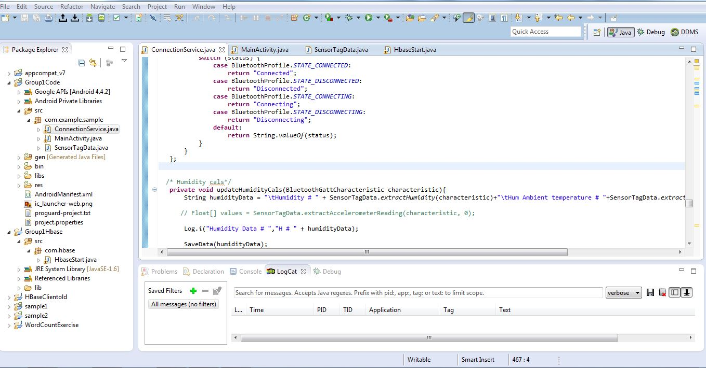

Logcat Showing the sensor data reading

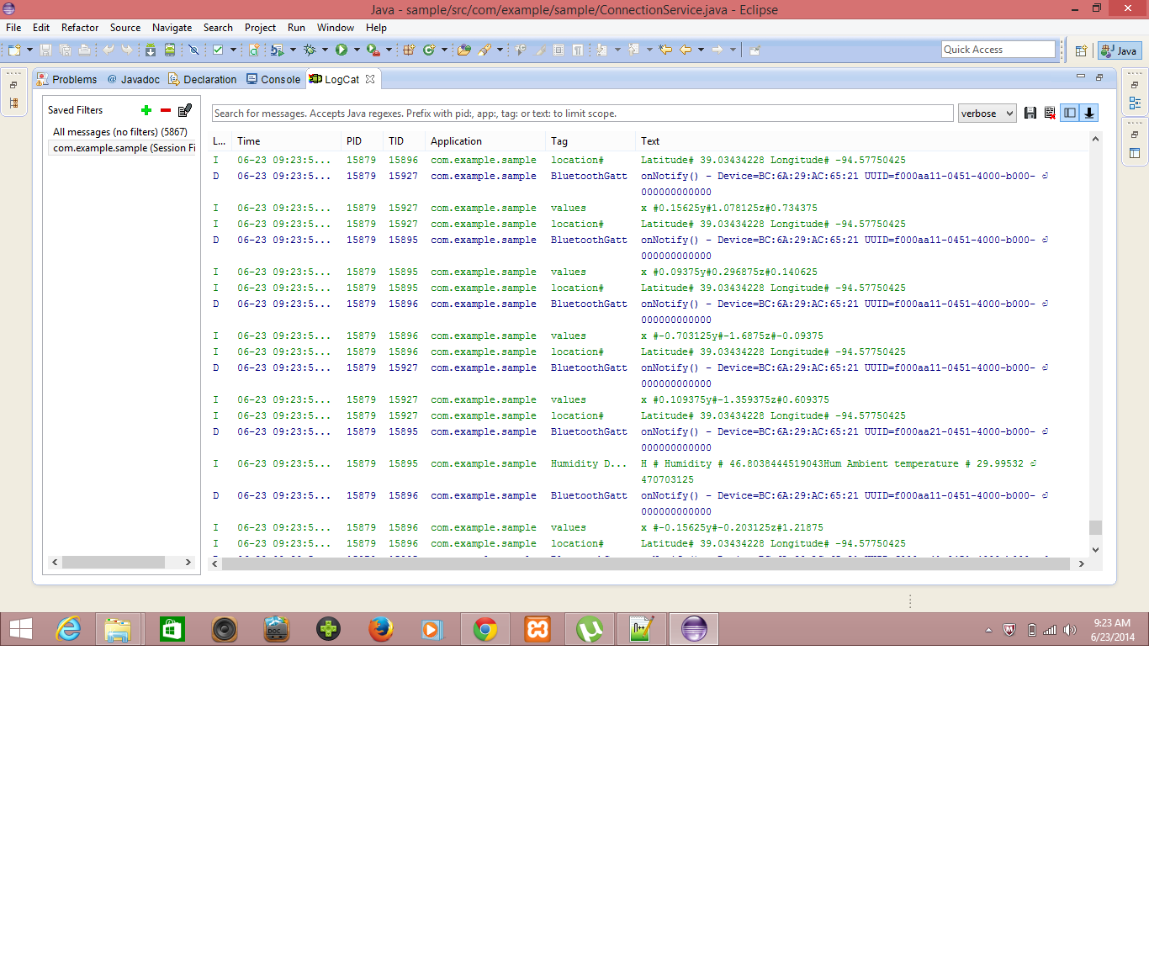

*TASK-2: Uploading the data into HBase*

I collected the sensor data into a file of text format and uploaded into HBase which is named as Group1Table with several column families. I modified the table structure given to match with my pattern of data model and categorized the data accordingly to their families, such as Accelerometer data includes values of x, y and z axes.

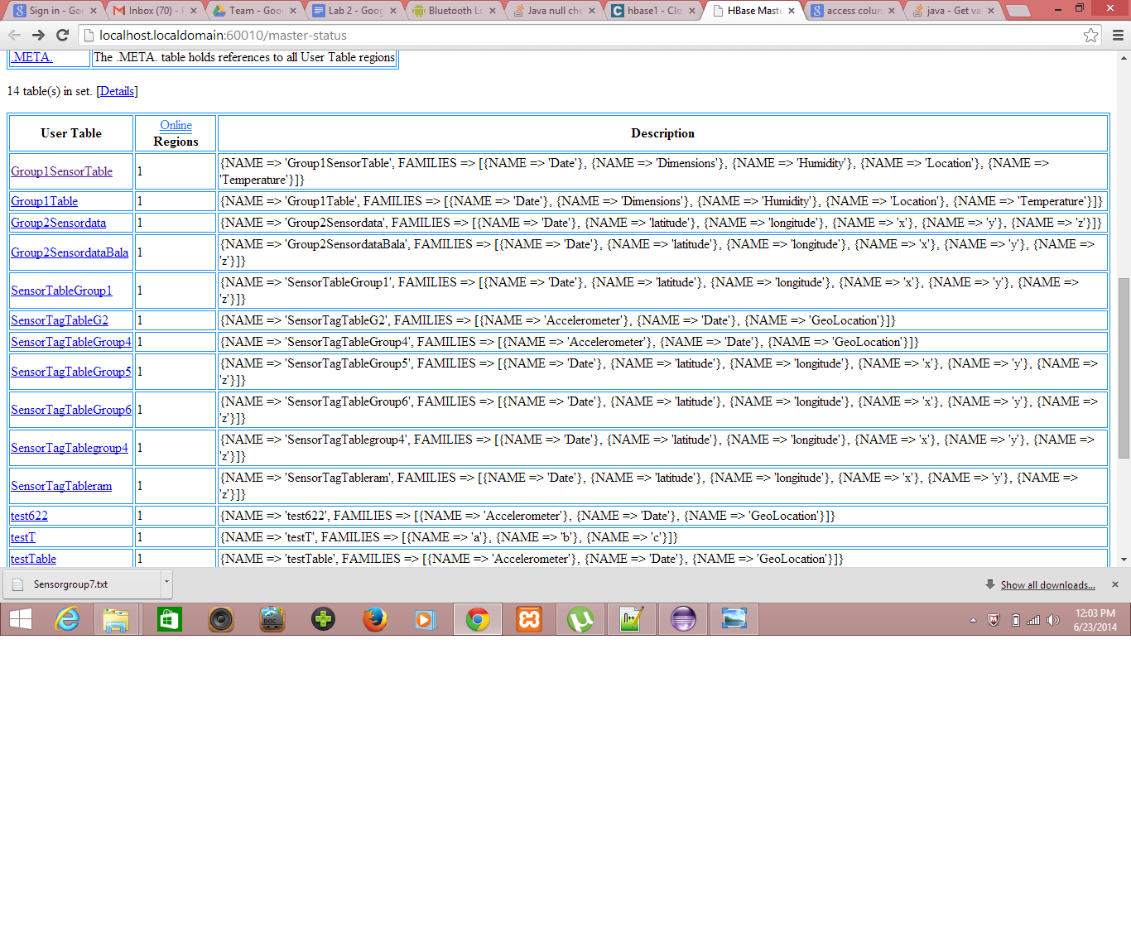

*TASK-3: Retrieving the Data from HBase*

I modified the given code a bit to retrieve the data from my table in HBase in a proper order. I’m able to retrieve the data as row wise. The entire table data is also retrieved by the given HBaseClient application as a tutorial. I retrieved the data from HBase into sample text files using the functions provided in the application.

Here are some screenshots of retrieval of data.

Getting row data

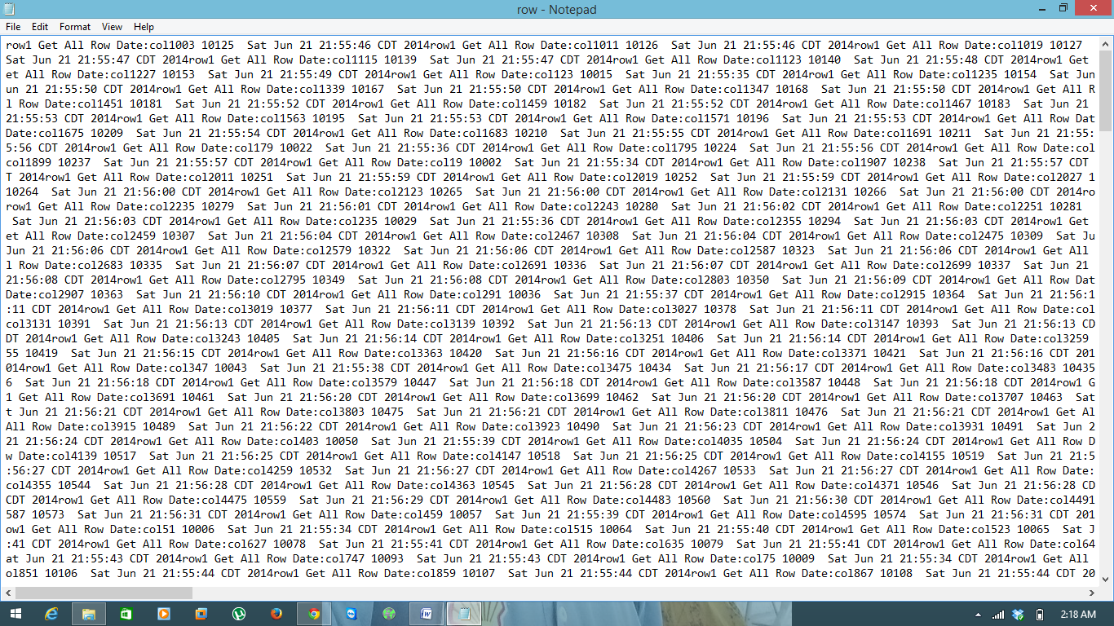

Getting table data

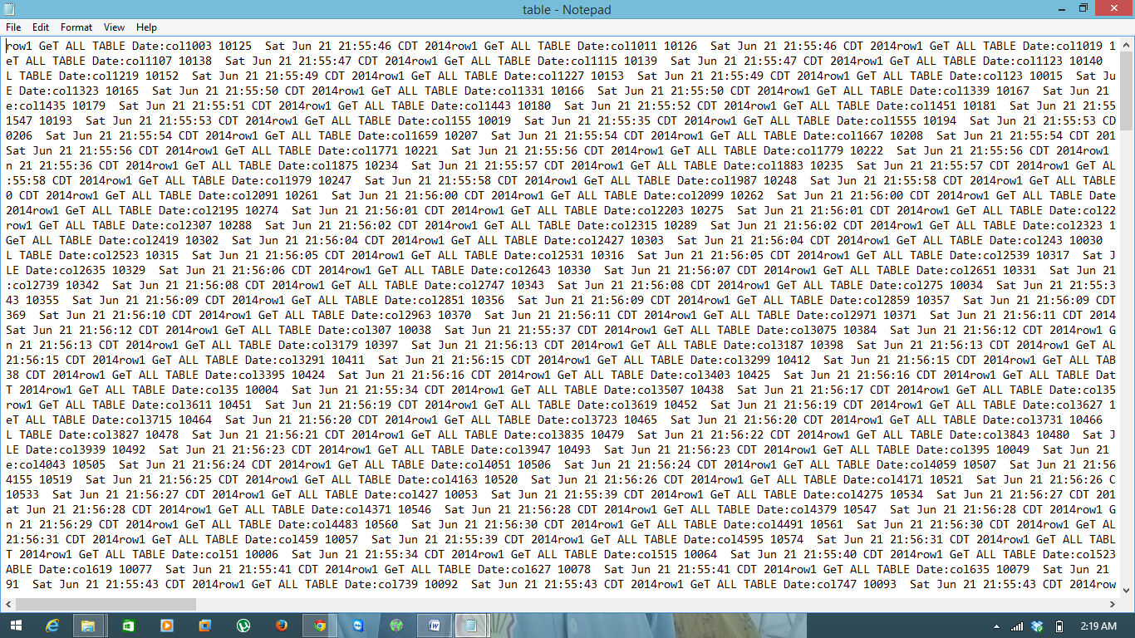

Displaying the data on console

