CHALLENGE # 1

1. DESIGN:

We designed an online grocery store where users can view all the available grocery items in a categorical approach. The user can select his/her required items to purchase. Once the purchase is complete, the bill is generated by the system and payment options are given to the user. This is a mobile application where users can shop from their mobile devices using this application.

Here is the Architectural Diagram of the application.

This is a class diagram implementation of the application.

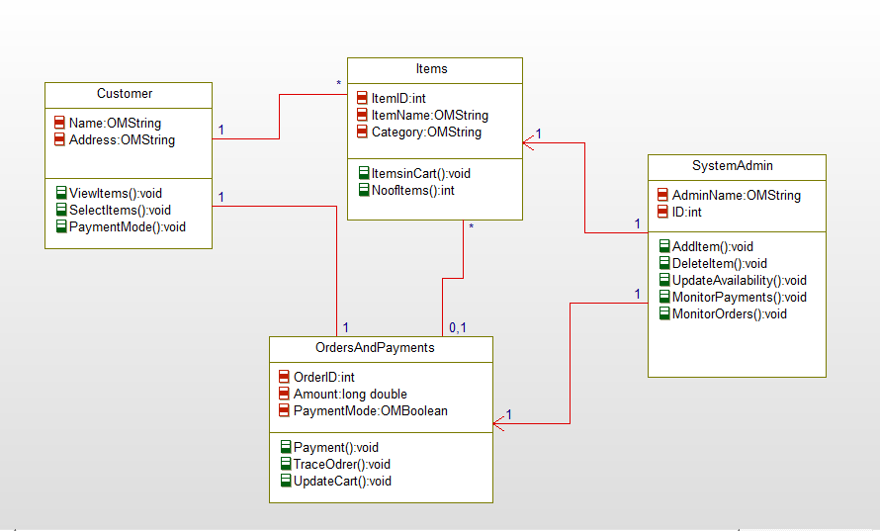

**Features Implemented:-**

1. **web services:-**

We use the eclipse to develop a android application for the grocery store to select the grocery items and we connected to the google maps if customers want to know the directions for the grocery stores. We just created an application with the several items in grocery store customers can access. Customers can access to the nearby grocery store accordingly suggested by the database search. Customers can view the price of the products and add to their cart.

Existing: The existing web service provide the details of the product and their price. It connects the main database of the store. As per our choice we buy the products from the store.

1. Database :

The project deals with the web services and the way of accessing the web service.

Existing: The database web server displays the products of the corresponding store if they are available, and is removed from the database if we find no stock of the product.

1. Mobile user Interface:

In the era of technology, one can use the web services using their mobile devices too. Shopping using mobile devices made easy on the go.

Existing: The existing mobile user interface is closely same as the database search, we can access the product if they are available and we may not get access to the products as per our choice, when they are out of stock.

This is the home page for the application. Customer can select the options what he want.

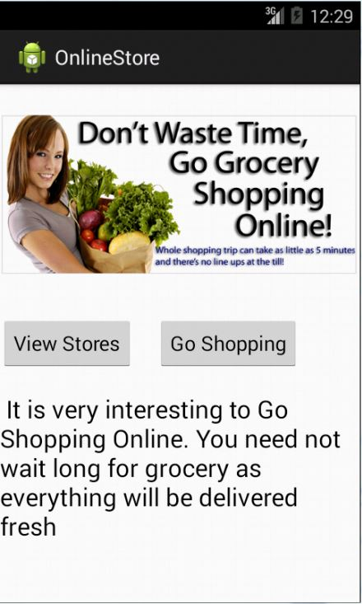

In this customer can choose the products and can know the prices of the products.

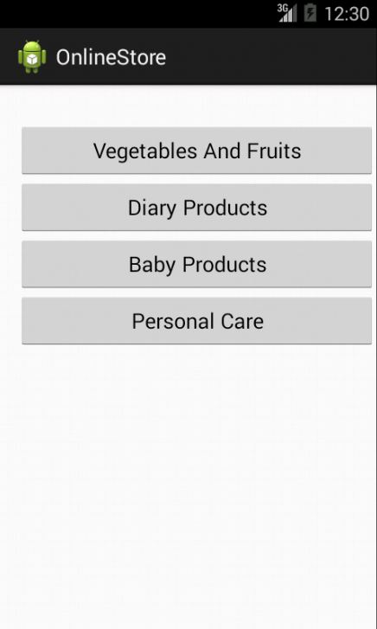

List of vegetables with prices.

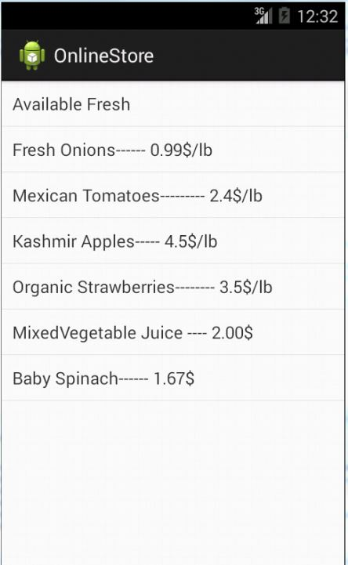

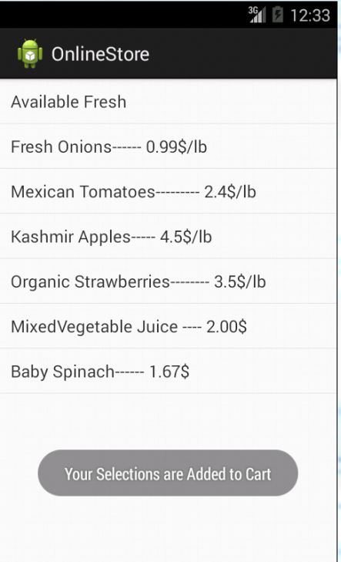

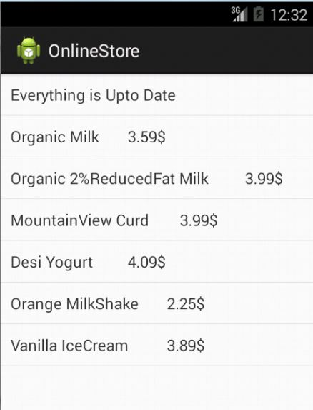

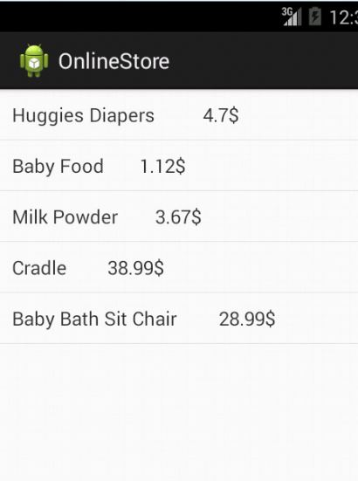

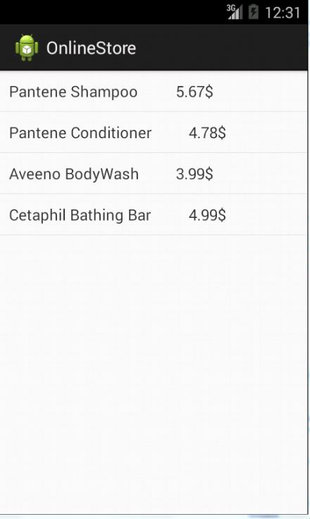

<http://github.com/VDivya/ASE1>

**Limitations:-**

1. People need a android mobile devices to access this online shopping.
2. Not applicable for the people who are illiterate.
3. Not completely secured to do the payments through this application.
4. Whole sale merchants cannot use this application. This only for small purchase people.

**References**:-

Amazon’s UPC/Product Database

http://docs.aws.amazon.com/AWSECommerceService/latest/DG/EX_LookupbyUPC.html

Barcode Scanner API

<http://www.programmableweb.com/api/barcode-scanner>

Camera API

https://developer.mozilla.org/en-US/docs/Web/Guide/API/Camera

Supermarket API

http://www.supermarketapi.com/

Grocery Server API

http://developer.groceryserver.com/

http://www.programmableweb.com/api/smartpea-grocery

Nutrition API https://developer.edamam.com/