**CHALLENGE-2**

Sai Praneeth Paruchuri(30)

Mounika karampudi(17)

Divya Sree Vintha(45)

Sivaji Ganesh Kandimalla(16)

This is a part of our project which we have submitted for the challenge -2.

***DEAL-ME!!***

Application Features:

* This app can be used to either get the places nearby and also the deals near you. There are a bunch of place types like restaurants, cafe, shopping from which you can choose multiple.
* These places are displayed as markers on the map. On clicking the info box of a marker, another activity is opened displaying the complete details of the place.

**SCREENSHOTS:**

This is the start screen of the app, where you have to have a username and password to login. If you do not have the login credentials you can register by clicking the text below asking you to register.

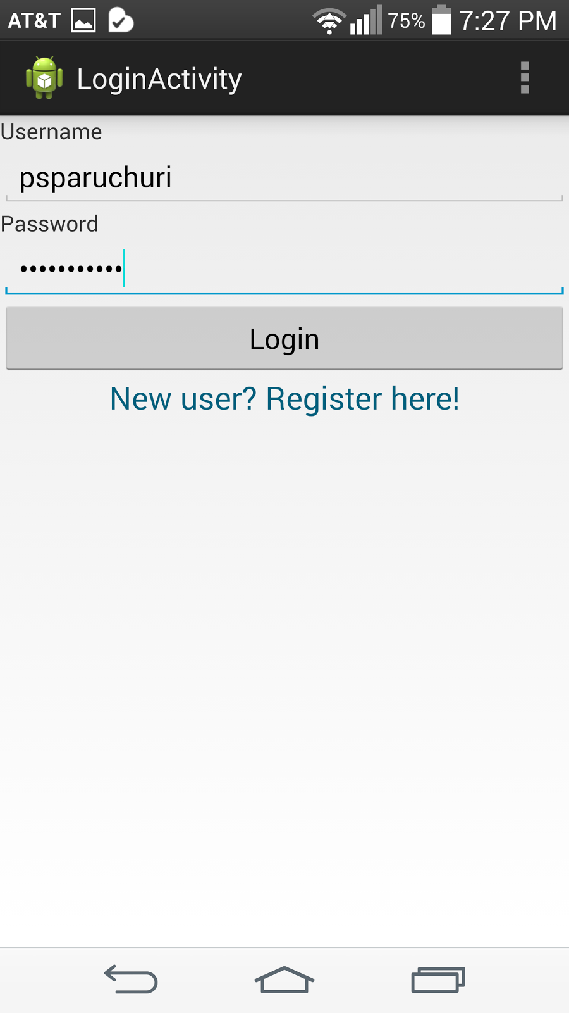

This is the registration screen.

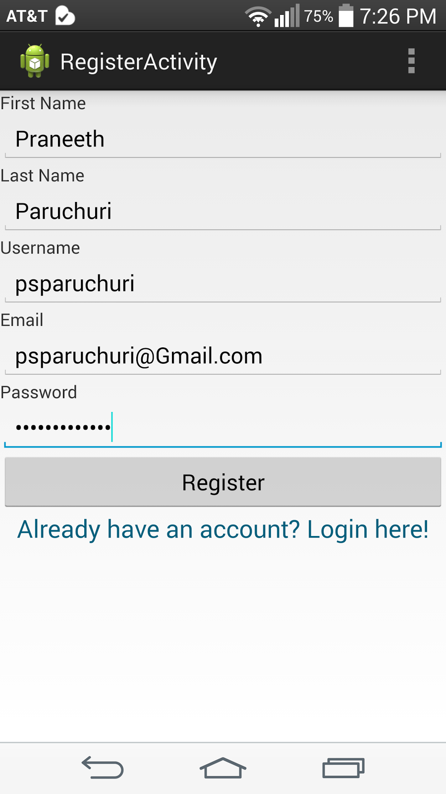

If you have successfully registered you’re diverted back to the login screen where you’re asked to login again. On successful attempt, a toast is displayed and the main activity is called. We’ve written our own web services for the registration and login pages.

In the Main Activity, you can see four buttons.

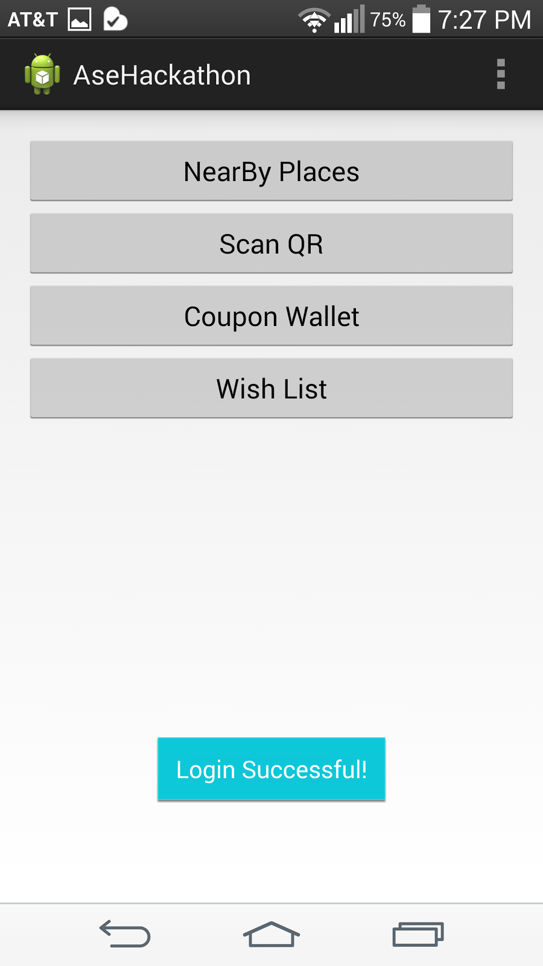

When you click the NearBy Places button, a list of place types is displayed. Here, you can choose more than one place types to be displayed near you.

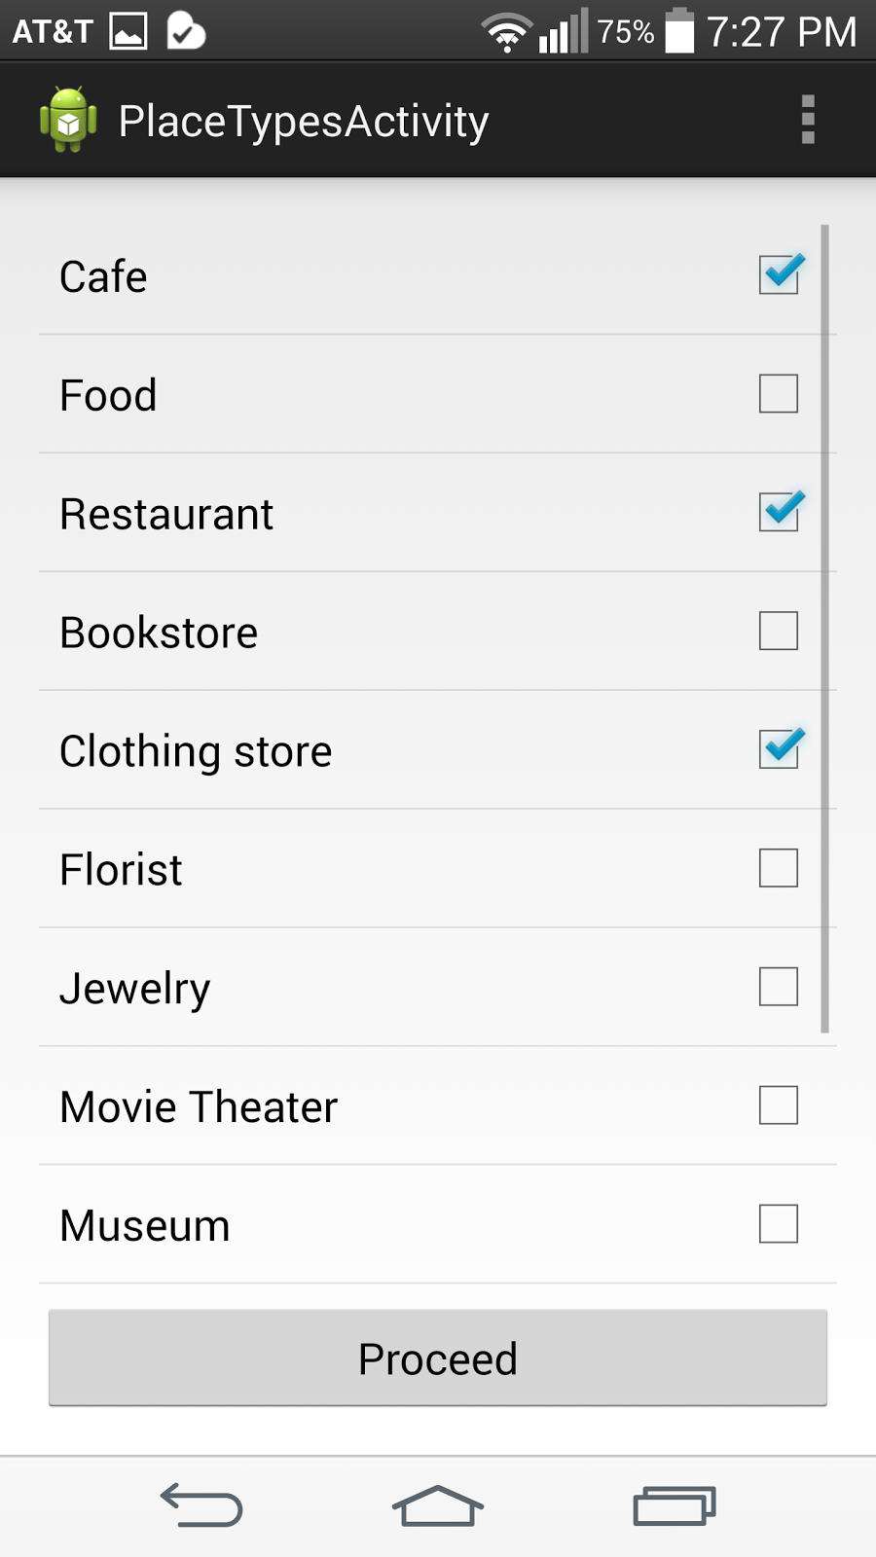

Suppose I pick the above three, these places are displayed as pointers on the map.

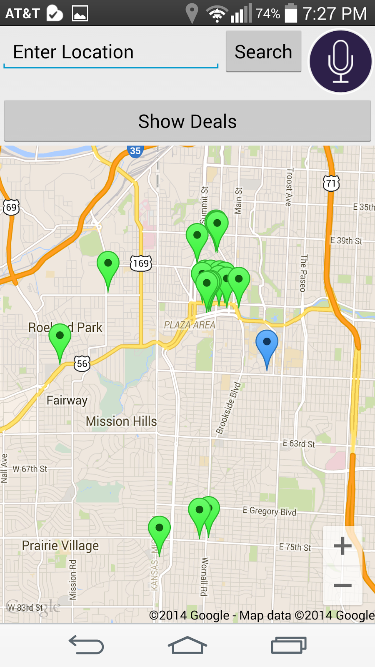

The blue pointer on the map shows your location and the green pointers are the selected place types.

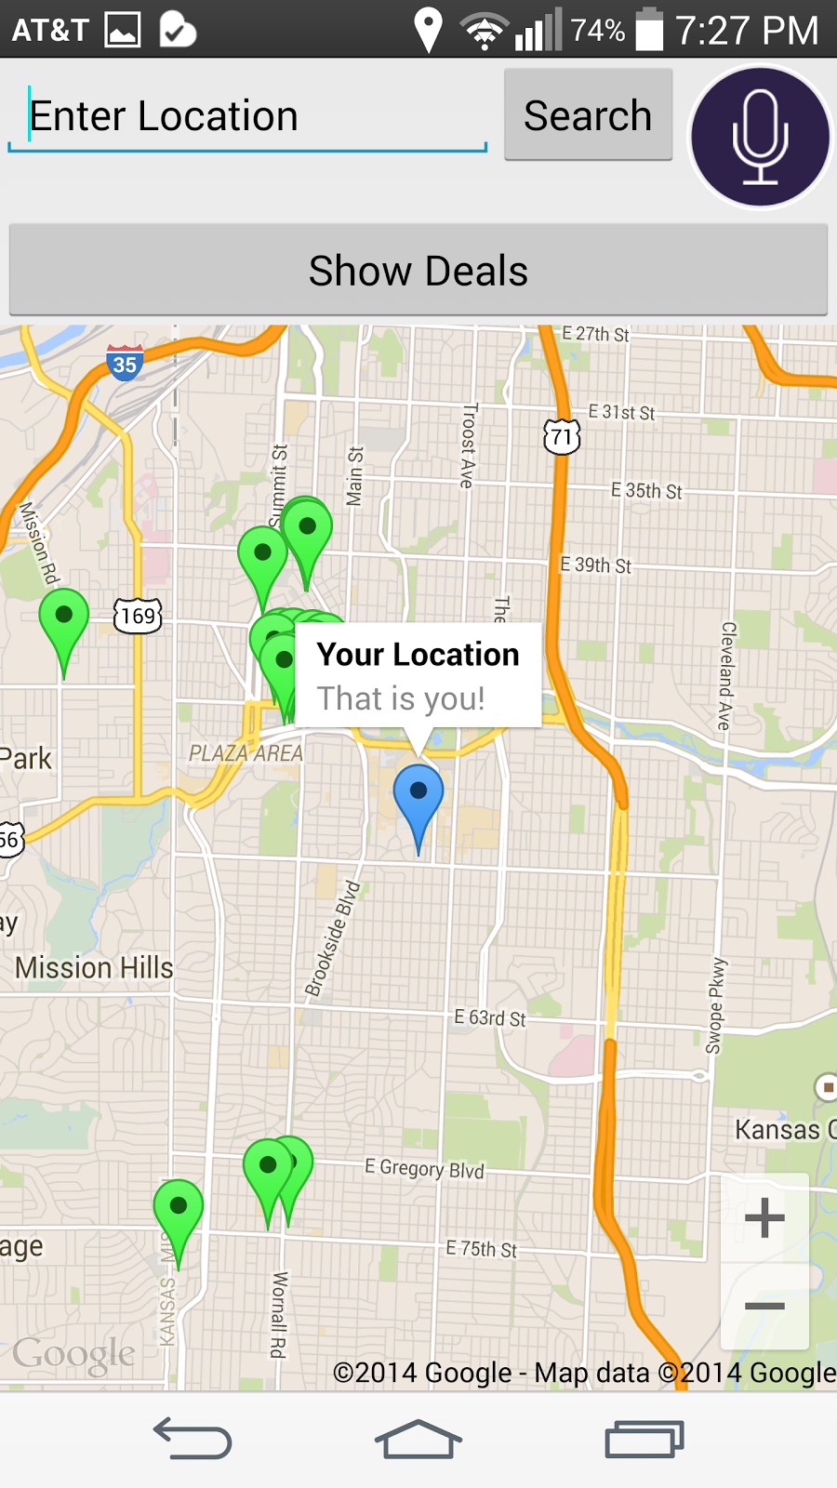

When you click a pointer on the map it displays the place name, like the name of the restaurant or a coffee shop, and the address of the place.

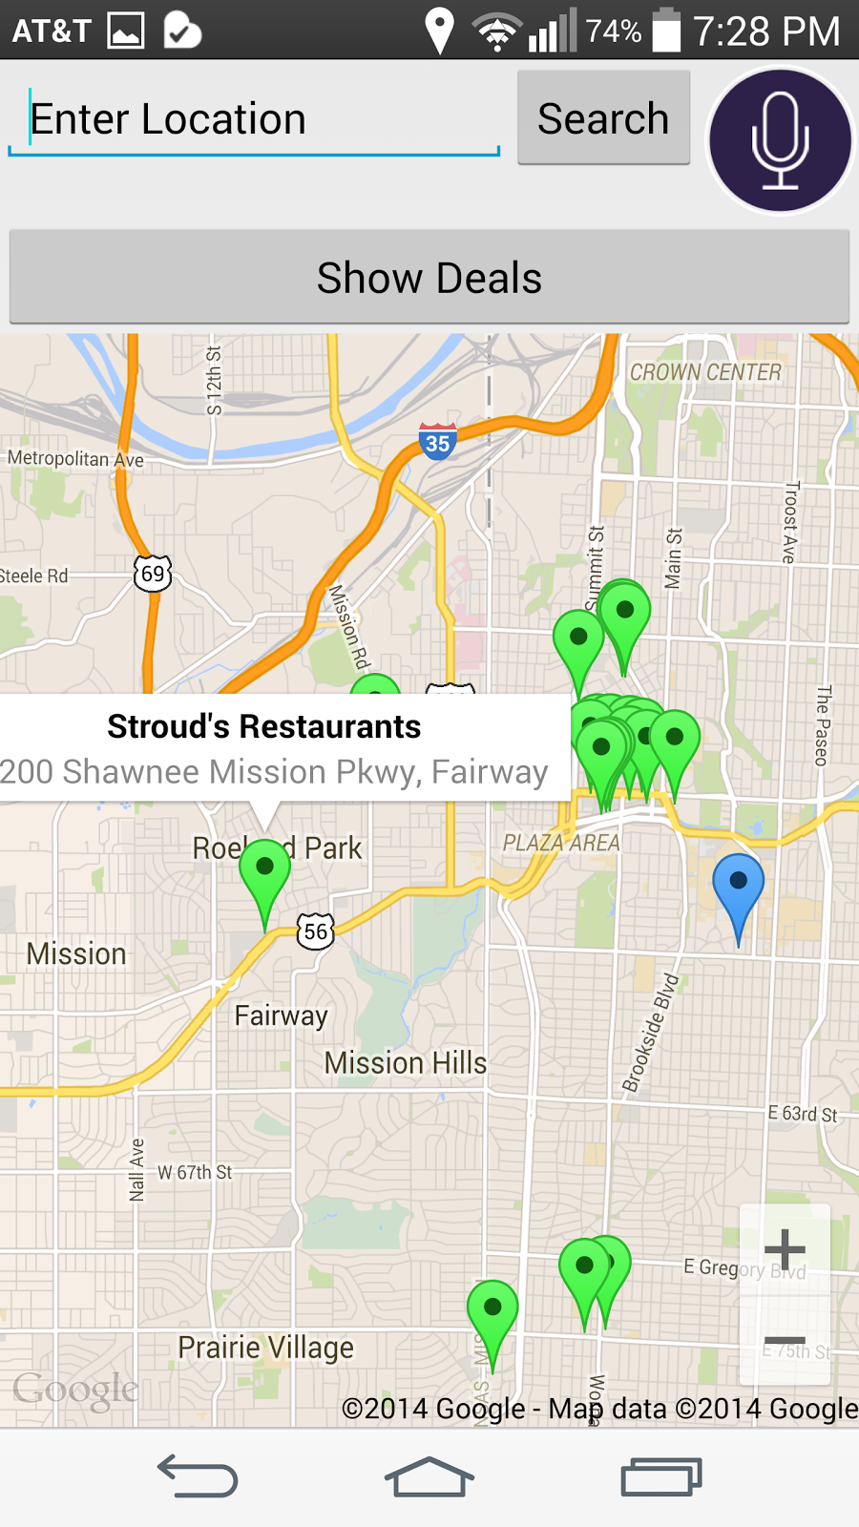

When you click the show directions button, this gives the directions from your location to the place location.

