DEAL ME!!!

**Increment 1**

**Praneeth Paruchuri**

**Mounika Karampudi**

**Divya Sree Vintha**

**SivajiGanesh Kandimalla**

1. Login Page:You can either login using facebook or If you’ve already registered, you can use your login credentials to login to your account of the application. If you are a new user, click on the “New User? Register now!” text to goto a registration page, which we have kept basic, since this isn’t a really big part of the application.

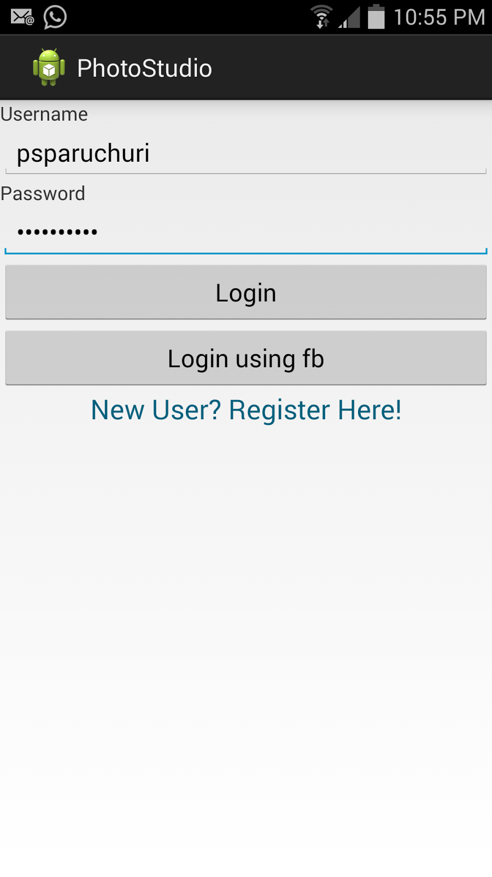

1. Registration Page: If you are a new user to the application, you can register using your email id, a new username and password. All of this is done using SQLite as the database. If needed we plan to write a web service for the login and registration part.

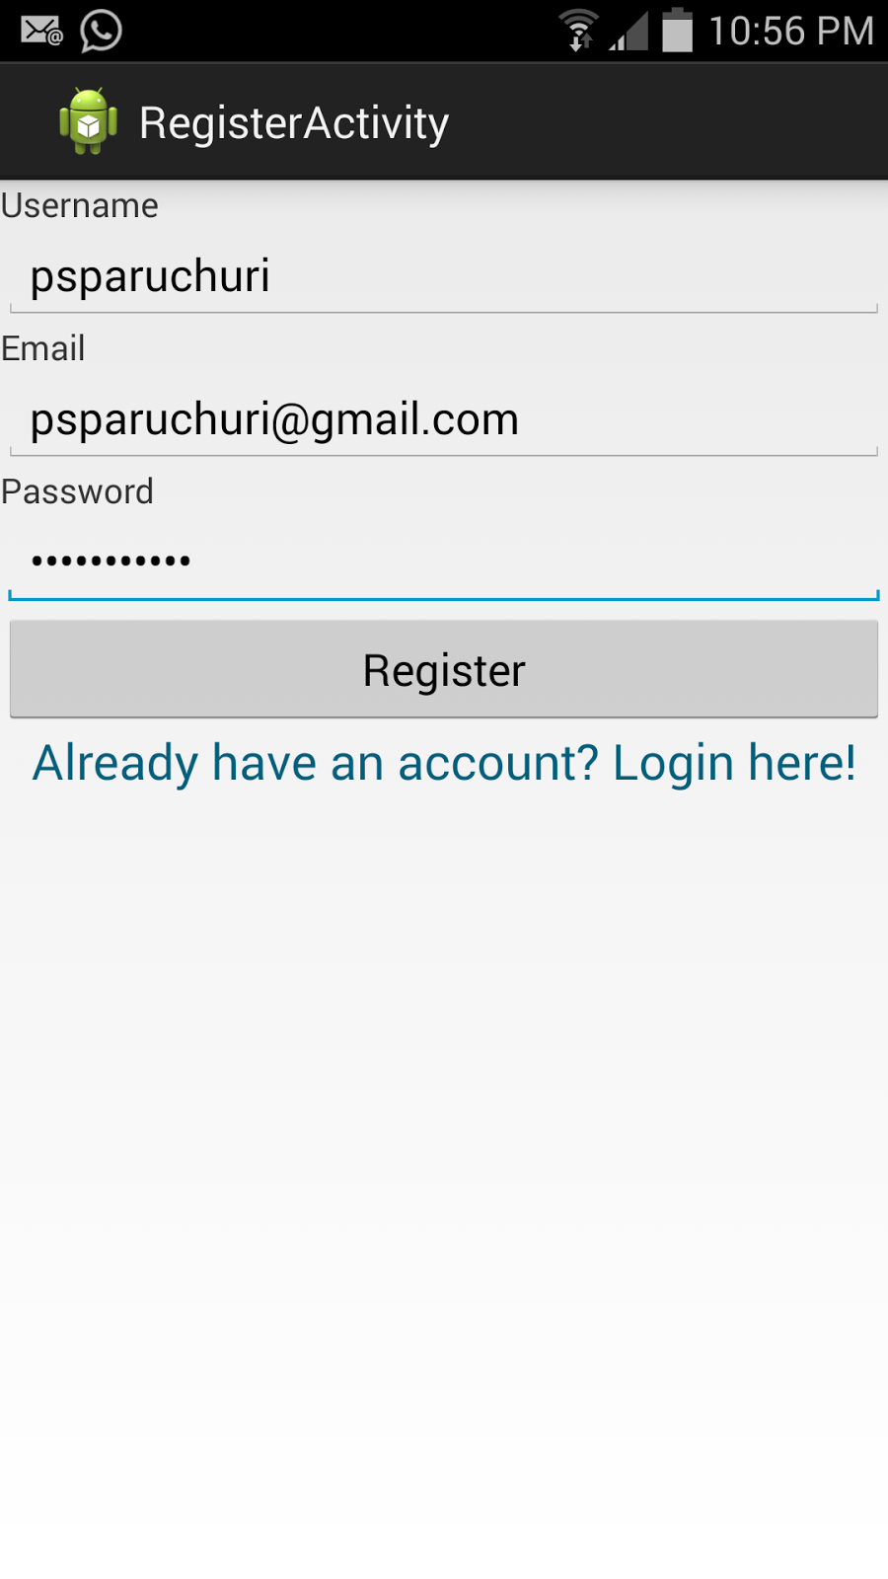

1. This is our main part for this increment, We’ve experience with the text in an info box before, but adding an image is a totally different issue. We created a hashMap to keep track of the markers on the map and the path of the image associated with it. When we load the markers, we stored the Marker ID in the HashMap with the path to the image associated with the marker. We designed a custom InfoWindowAdapter and override its two methods, 1) getInfoContents(Marker marker) and 2)getInfoWindow(Marker marker). Currently, we have used the location of a particular place of to get the following output. This isn’t done dynamically and we plan to move forward in the next increment. We have tried to provide the user with routing options using Google Maps and Google Places. .

.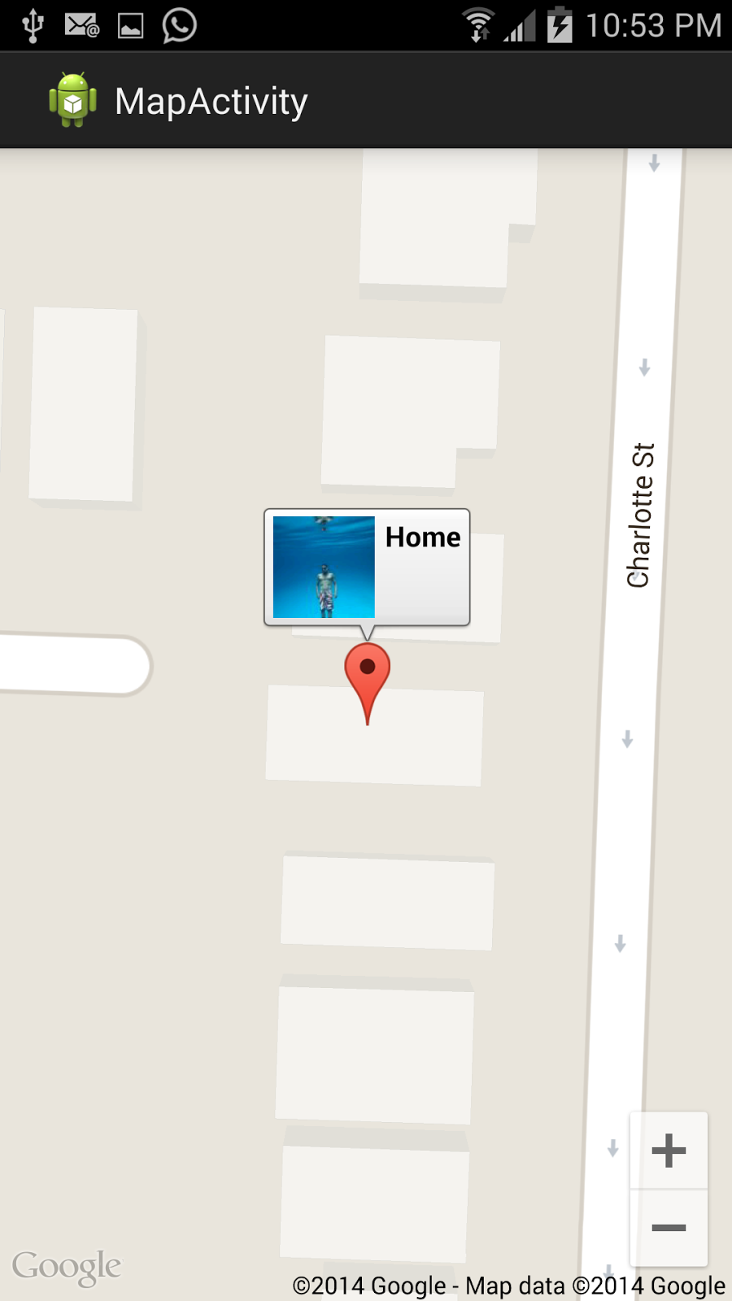

1. We have also studied the different API and REST services we plan to use in the coming increments, fb’s graph API, google plus API, Instagram API.

References

[**http://androidfreakers.blogspot.com/2013/08/display-custom-info-window-with.html**](http://androidfreakers.blogspot.com/2013/08/display-custom-info-window-with.html)

[**http://devlearning.blogspot.com/2014/05/android-custom-info-window-with.html**](http://devlearning.blogspot.com/2014/05/android-custom-info-window-with.html)

[**http://viralpatel.net/blogs/pick-image-from-galary-android-app/**](http://viralpatel.net/blogs/pick-image-from-galary-android-app/)

[**https://developers.facebook.com/docs/android/getting-started**](https://developers.facebook.com/docs/android/getting-started)

[**https://developers.google.com/maps/documentation/android/marker#info_windows**](https://developers.google.com/maps/documentation/android/marker#info_windows)

**GitHub:**

<https://github.com/spp64/ASE-Project>