# Project Management Report

As part of our Project Management, We had used ScrumDo Website for planning our tasks among our team mates.

**Increment 01:**

We had completed the following Tasks for our Increment 01 in ScrumDo

1. Praneeth - Identify all the required APIs and Plan

2. Divya sree - Design of User Interface

3. Mounika – Google Maps

4. Sivaji Ganesh – Document and google APIs

**Scrumdo:**

We used scrumdo for planning our tasks for increments as below.

**Scrumdo Url**

https://www.scrumdo.com/projects/project/deal-me/iteration/116761

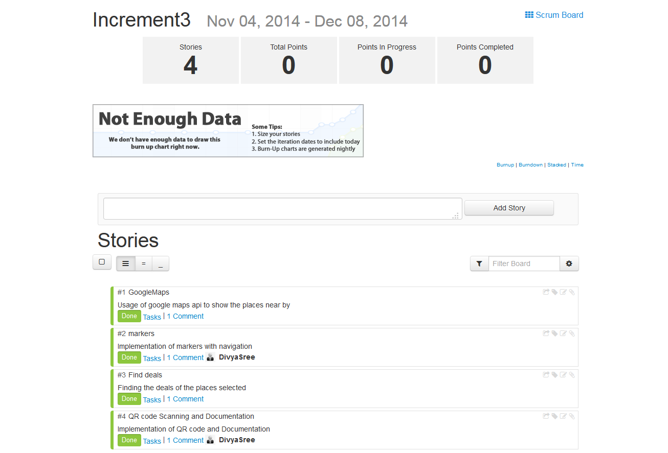

**Increment 02:**

We had completed the following Tasks for our Increment 02

1. Praneeth – Google Places API and Integration.

2. Divya sree – Speech to Text and WebServices

3. Mounika – Google Maps API

4. Sivaji Ganesh - Documentation and Google Services

**Increment 03:**

We had completed the following Tasks for our Increment 03

1. Praneeth – FourSquare API and integration.

2. Divya sree –Video Production and QR Scanning.

3. Mounika – Video Production and Markups for places.

4. Sivaji Ganesh - Final documentation and presentation.

# Final Project Evaluation

### Discuss how well your project satisfies your original requirement specification.

We successfully retrieved deals located at a particular location of chosen categories. We also used speech to text module which makes user more comfortable in handling locations. We are very satisfied with our project as we had done all the things that we had planned at beginning.

**Were you satisfied with your design process?**

Yes, we had covered all the activities that we had planned to do in our project.

### How helpful was the agile process?

The agile process was helpful in planning an overall project’s requirements.

**How would you do the agile process next time?**

Until an employer leverages performance requirements against production work, we would continue to perform as needed to accomplish necessary academic gains. That is to say, timelines and workloads are whatever and wherever we are comfortable having them so long as we are productive in meeting our end goal using reasonable time and resources to get there. Nevertheless, agile process is a good exercise to build awareness.

### Did you stick to your project plan schedule?

Communication among active participants was regular. At the beginning of every new increment, we had clearly defined goals and expectations. Who was working on what, and when it could be expected was always clear. Any delay was properly communicated. There were regular setbacks or delays in the project ultimately resulting in unfinished components, but these were always made clear to the invested contributors. At the end of every increment, contributors always met to update documents and realign our goals and activities.

### What was the real management structure within your group?

We used online collaborative tools courtesy of the Google Drive and Google Plus platforms to communicate remotely and share documents and data. We incrementally scheduled meetings and we were fortunate that our schedules aligned in such a way as to meet on critical deadlines whether in person or online. Anyone that expressed a project need or concern was accommodated by others. Dr. Lee was clear in her expectations of project deliverables and our group was responsible in producing deliverable works. The workload was evenly distributed among those who chose to participate.

### Does it bear any resemblance to structure that you had planned?

We informally planned everything after increment one. In spite of lacking formality, our planning did evolve a precise structure. For every increment, we would identify work previously completed based on our original plan. During the increment reporting process, we would identify the next segment of work to be completed by each person in preparation for the following increment. In between increments, we met after class to share progress and demonstrate working contributions to our project.

### Did you have any problems getting each member to do his/her share of the work?

No problems.

### Do you have any suggestion on how this could have been handled better?

No.

### Discuss what you might have done differently if this were a real world project?

If this were a real world project, we would have to work harder and produce more work hours to accomplish our original objectives.. A fully realized work flow would have to be produced to handle the constant stream of data. From back to front, it is possible to build a system that does all we wanted to do.