**CS-5551: Advance Software Engineering**

**Project plan**

**Praneeth Paruchuri(30)**

**Mounika karampudi(17)**

**Divya Sree Vintha(45)**

**Sivaji Ganesh Kandimalla(16)**

**DEAL ME!!**

**Introduction:**

In general, travelling is a hobby for many people in this world. While travelling we are more likely to check out the new places around that area to plan our visit accordingly. It is always interesting to check on available deals of the places nearby which makes our visit more economical. While travelling people are more likely to use their smart phones for navigation as well as checking out the places for visiting purposes. Smart phones nowadays plays major role in travelling, acting like a guide for the routes and explore the places nearby.

Using these features of smartphone, we tried to implement a new mobile application where we can explore our places of interest along with the available deals at those particular places with more ease

**Project Goal And Objectives:**

**Goal:**

Our Aim is to design a mobile application in which we can explore all the places of our choice and deals available at a given location or city. The application should be flexible enough to handle the smart cash through e-wallets and also save their places of future visit as wishlist.

**Specific Objectives**:

The application should direct the user from his/her location to their selected place.

The user should be able to give the location input either directly by GPS (tracing their current location) or give the desired location by text or voice modes of input. The application should be flexible with QR code scanning where they can scan the QR codes of coupons they have. The application should be flexible enough to get the deals within the customized range of user so that sorting the deals would be much easier.

**Significance**:

This application allows the user to get the deals nearby after choosing his categories of deals he/she wants. The user gets all the deals, coupons available near their place and can save these coupons to their wallets. This wallet can be used when he is in the place acquiring the deal. The user can also get navigation by getting the directions to the location he wishes to visit from his current position.

**Proposed System**

**Requirements:**

1. Google Map API V2 for Maps and markers
2. Google Places API for searching relevant places
3. Google Places Autocomplete API
4. zxing api for QR code scanner
5. 8coupons Rest Web service
6. Our own Web services for login and registration.

**Features:**

* User can pick their choice of places to explore nearby.
* The user can explore the places related to their interest at a given place and also at their current location.
* The user can find the available deals and coupons of the chosen places nearby their location.
* The user can save places for their future visit as a wish list.
* The user have the privilege of scanning the coupons which are readily available with him/her.
* The user can also navigate to the particular place of their choice from their current location.

**System Specifications:**

**Existing Services**:

We have seen many applications which shows routes to places and Deals in a location. These all services can be integrated through API’s into a single service where users can share and search particular places and deals.

**New Services to be built:**

We are using google maps services to find places at a particular location, Google Places API for searching relevant places. We used ZXING API for QR code scanning. Use FourSquare and Groupon API for getting the places to show user and their corresponding deals in that locations with navigation of routing options.

**Design of Mobile Client:**

Most of the work will be done as a Native Android app using various famous API’s and RestFul Web Services.

**Plan By SCRUMDO**

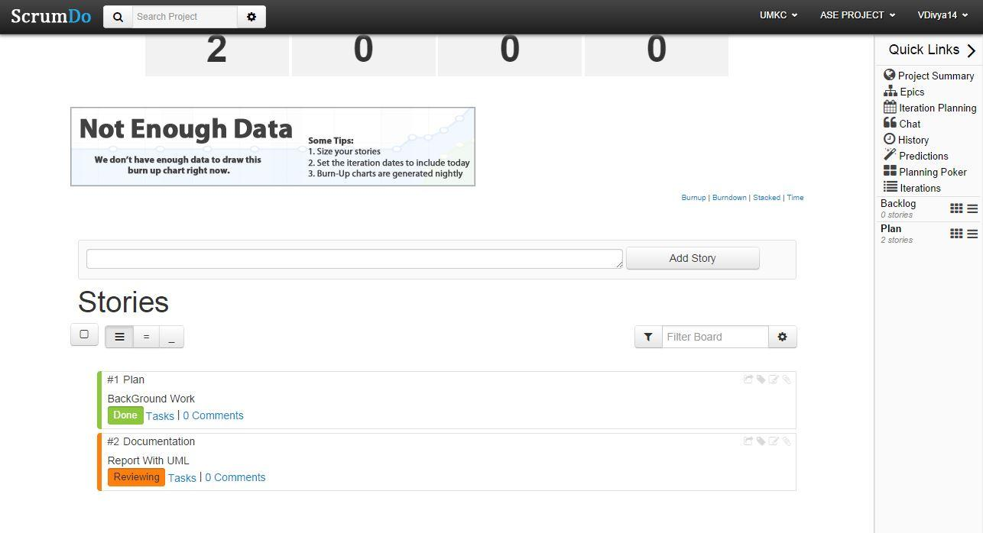

**GITHUB URL**

<https://github.com/VDivya/ASEProject>