Screen Project: TV Set Software Installation

1. Connect pc to the TV set
2. Adjust display settings and the display resolution
3. Copy the software to the computer
4. Create a shortcut with Maximized parameters at desktop for this screen
5. Give permission to access this pc at port 80
6. Make the program run automatically upon pc booting
7. Disable automatic running upon startup for other programs
8. Check that your computer will not go to sleep after some time of inactivity
9. Run the program (or better, reboot the computer to check automatic running)

**Details:**

1. CONNECT PC TO TV SET

You should have a keyboard and mouse temporarily connected to the pc (when the process completed, you can take them away)

Find (or buy) HDMI to HDMI cable, which fits the sockets at both TV and Pc, and connect this cable (this is not the only options, any other video cables are also ok, but mainly current TV sets support only this option to be connected from a computer.

Adjust settings of the TV to get the input from that HDMI source.

1. ADJUST DISPLAY SETTINGS AND DISPLAY RESOLUTION

You can start by clicking the right button of the mouse at the empty space on the desktop and choose «Screen Settings» («Skjerminnstillinger»). Use windows manual to adjust video settings. It would be good to have resolution of 1600 x 900 at all computers, but it is not always supported. Try to adjust video so that the tv shows exactly the desktop`s screen (it is also not always possible).

1. COPY SOFTWARE TO COMPUTER

Copy the original «skjerm» folder to your flash stick, and then insert the flash stick into your mini pc and copy «skjerm» folder to the root folder of your mini pc. (So, you will have the folder C:\Skjerm, but any other place and name are also possible)

You can also immediately can learn the name of this computer. For this purpose, click on the «Folder» icon at the bottom bar and find «This PC» («Denne PCen»). Right-click on it and select «Properties» («Egenskaper»)

Here you will find the name of the PC, you can add it immediately to the list of your computers at the frontend part.

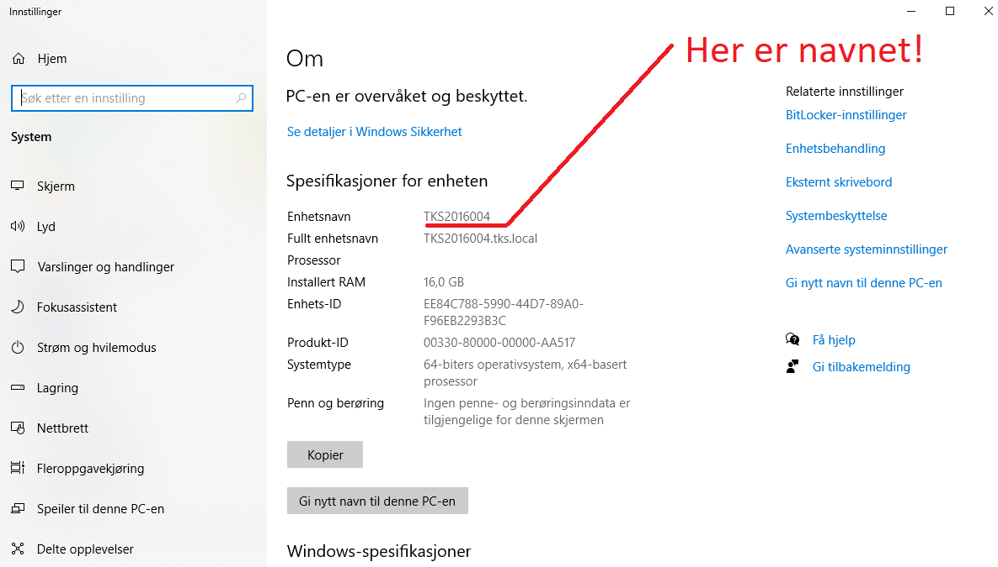

1. CREATE SHORTCUT FOR THE PROGRAM AT DESKTOP

At the desktop, right click at any empty place. In the menu, choose New, then Shortcut («Ny», «Snarvei»)

Click the button «Browse» («Bla gjennom»), and find the file at «Denne PCen» 🡪 «Lokal disk C:» 🡪 «Skjerm» 🡪 «tvport». So, the full path must be C:\Skjerm\tvport.exe. Click Next («Neste»), then click Finish («Fullfør»).

Then, again right click this shortcut (snarvei), and choose Properties (“Egenskapen”).

And in the field Run («Kjor»), select Maximum (“Maksimert”), and click OK.

1. GIVE PERMISSION TO ACCESS THIS PC AT PORT 80

Control Panel\System and Security\Windows Firewall then Advanced settings then Inbound Rules->From right panel choose New Rule-> Port-> TCP and type in port number 80 then give a name in next window, that's it.

Details:

Click Windows Icon , then click Settings (“Innstillinger”) Icon 

Choose Update and Security (Oppdatering og sikkerhet), as shown below

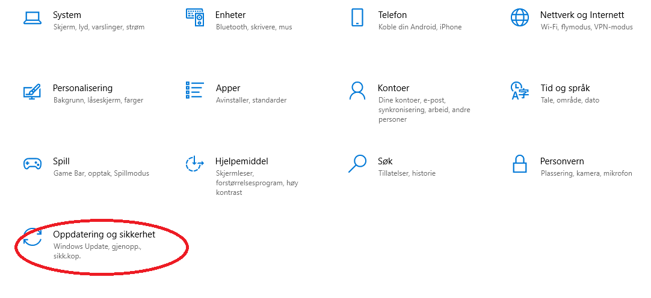

Then, at the left panel choose Windows Security (Windows Sikkerhet), and then on the right panel choose Firewall and Network Protection (Brannmur og nettverkbeskyttelse)

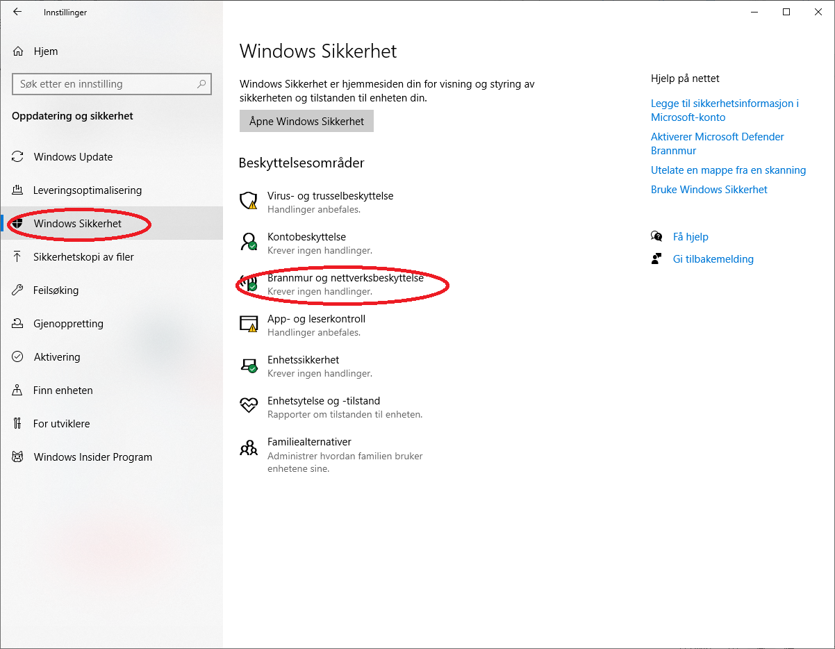

On the next screen, click Advanced Settings (Avanserte innstillinger)

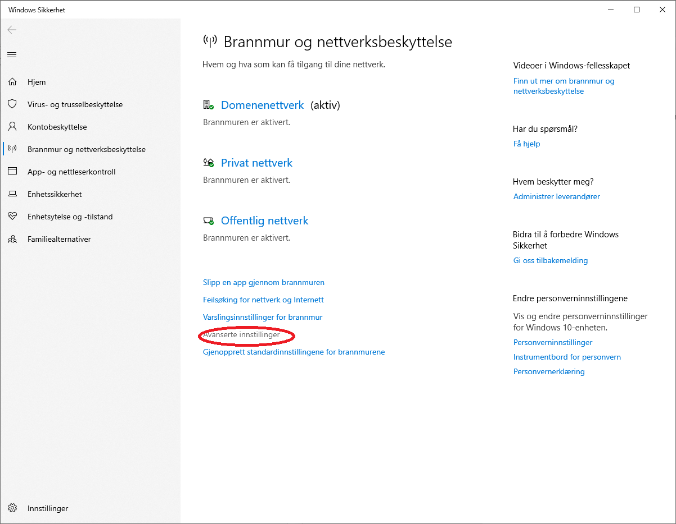

On the next screen, click Inbound Rules (Innkommende regler)

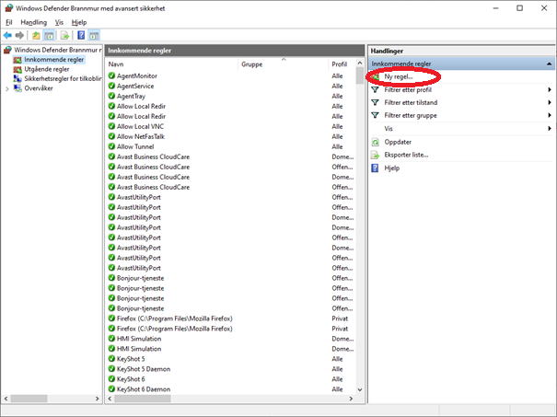

Let us suggest the name for this rule is “WWW service at port 80”. Look through the list, whether this rule has not been created yet. If it was created before, then it is done. If not, create it. For this purpose click on New Rule (Ny regel) at the right panel.

In the next window, choose Port, and then click on the button Next (Neste)

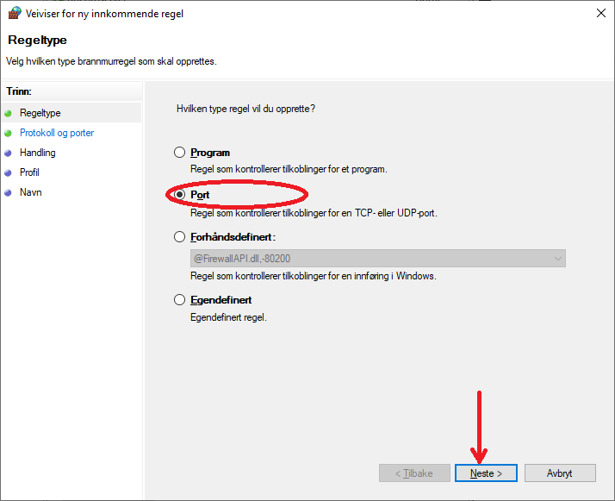

In the next screen, type “80”, and then click Next (Neste)

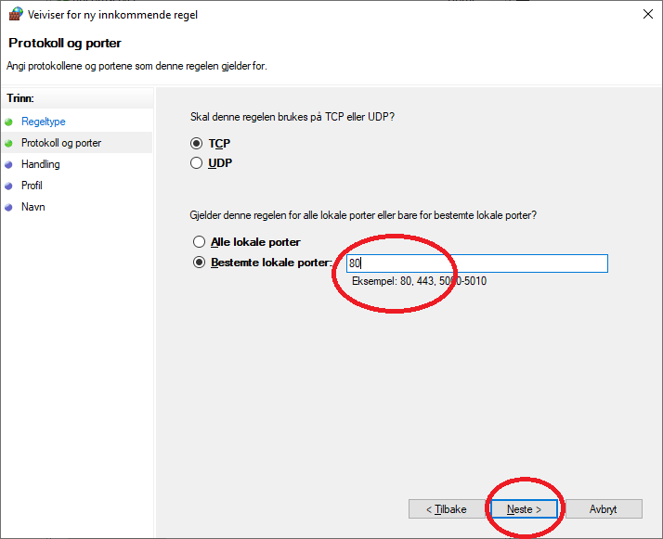

On the next screen, choose Allow Connection (Tillat tilkoblingen), and click Next (Neste)

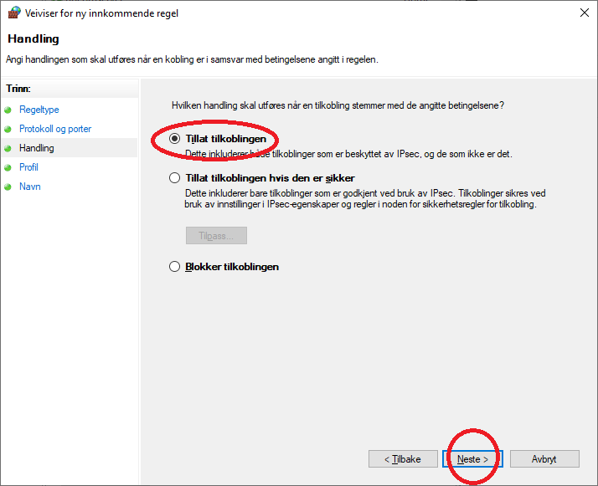

On the next screen, keep all checked and click Next (Neste)

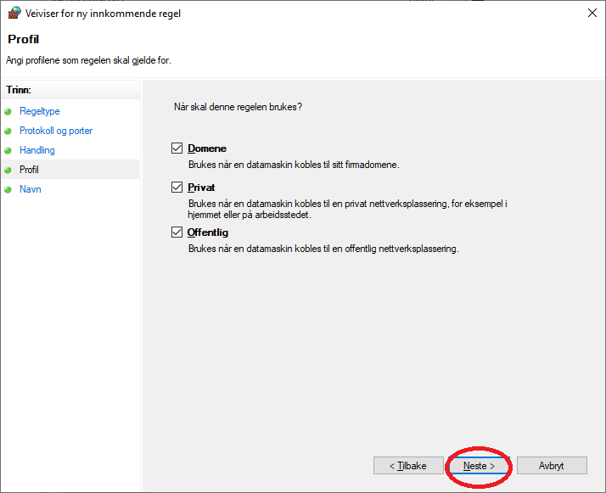

On the next screen, you can give any name and description. We can suggest the name “WWW server at port 80”. And then click Finish (Fullfør).

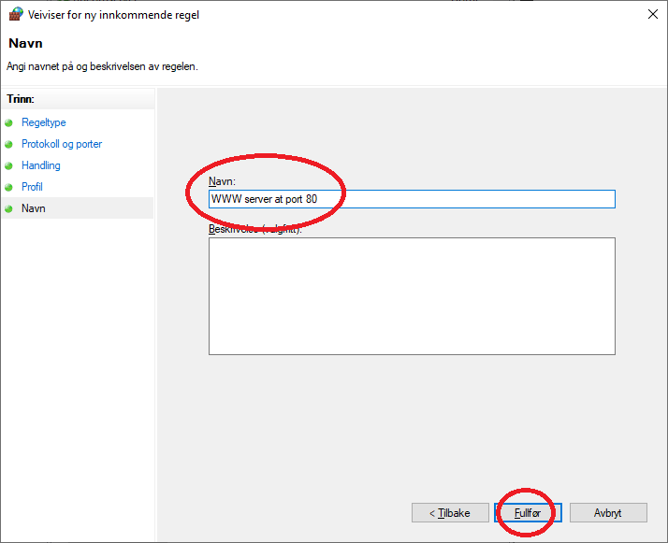

It has been done. That’s all.

1. MAKE PROGRAM RUN AUTOMATICALLY UPON REBOOTING

Click  + R on the keyboard. Type “shell:startup” and click Ok.

A folder will appear. Create the same shortcut once more at the desktop, as you did in IV (see Create Shortcut For Program at Desktop above), and copy this shortcut to that folder. If you wish, reboot the computer to check that it works. Sometimes you need to wait for about half minute, until the program starts upon startup.

1. DISABLE AUTOMATIC RUNNING ON STARTUP FOR OTHER PROGRAMS

This step is optional, but some software can show additional unwanted messages, reboot the tv computer and so on. So, in general this software can make unhappy experience, for this reason it is desirable to turn them off.

When you reboot the computer, pay the attention, whether there are some other programs which also start up automatically upon rebooting. You should consider them and in many situations it is quite reasonable to disable their automatic running. At first, you pay attention to the names of the programs, which started automatically.

If we have some programs, first we should check that they are not present in the folder for automatic running. For this purpose, I do the same as above (WINDOWS + R, type “shell:startup”, press ok, and check that only our program is there. If you find another program there, remove it immediately. You have also the option to uninstall them from Settings 🡪 Programs.

ONLY FOR EXPERIENCED IT GUYS: If they are not there, again click WINDOWS+R, and type “regedit.exe”, and inside Register Editor (Registerredigering), I should find those programs and delete them. One of the opportunities to do it, is to click F3, give any name for the search, and try to find it. You should find them in sections called Run, having Microsoft software path.

Notifications: It is also better to disconnect notifications in Settings (varslinger).

1. CHECK YOUR COMPUTER WILL NOT SLEEP DUE TO INACTIVITY

To adjust power and sleep settings in Windows 10, go to **Start**, and select **Settings**> **System** > **Power & sleep**. (Strøm og hvilemodus)

* Under **Screen (Skjerm)**, select Never (Aldri)
* Under **Sleep (Hvilemodus)**, select Never (Aldri)

To adjust power and sleep settings in Windows 11, select **Start**> **Settings** > **System** > **Power & battery**>**Screen and sleep**.

* Screen: Select Never.
* Sleep: Select Never.

1. RUN THE PROGRAM

If you make all steps above, it will run automatically upon the reboot. You can stop it by clicking on the picture screen, and pressing ESC. Then you will see a black console screen with message, click on it and press several times Ctrl + C. It will stop. If you want to run it again click on the shortcut at the desktop that you already created.