Evidence Of Tool Usage
Group 12

Document, source code, and team management: GitHub | 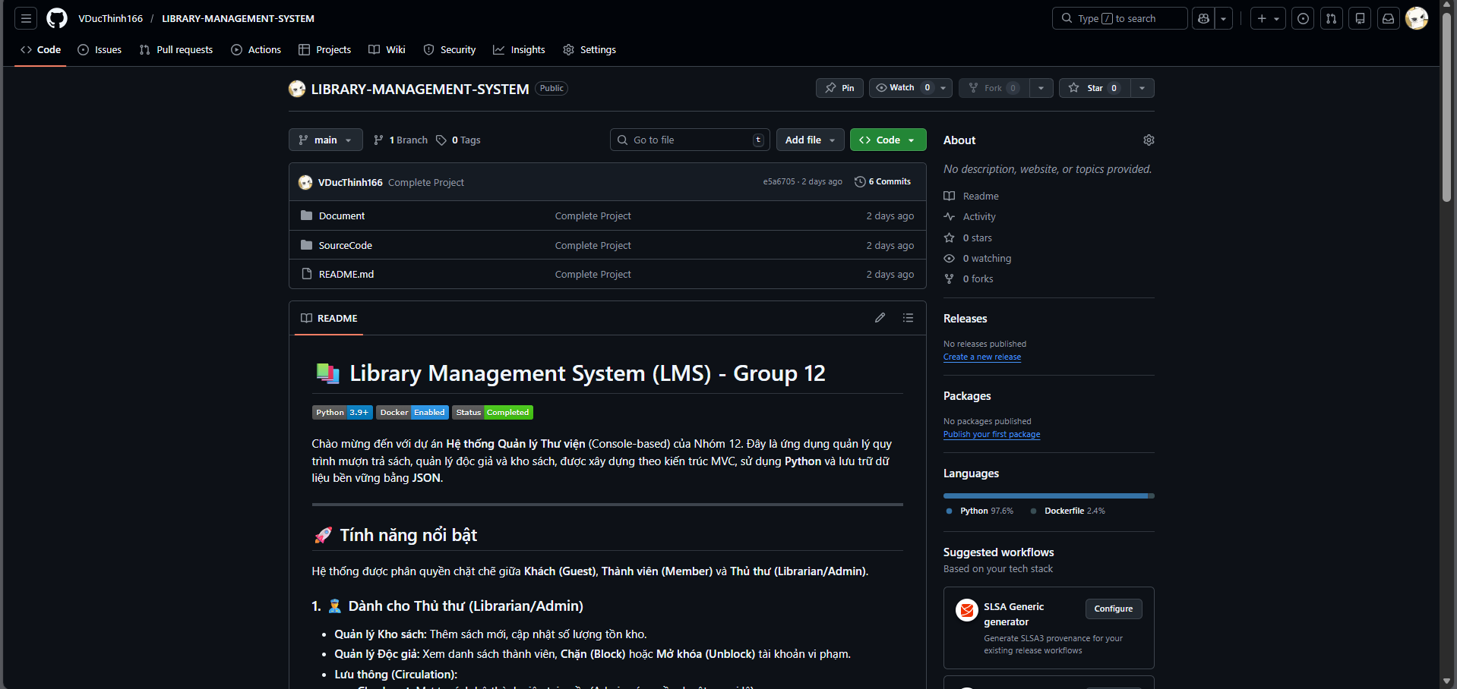
Drawing DFD, Use Case, Class Diagram, and Database Schema: Draw.io | https://drive.google.com/file/d/13TzUIsyIqz_aBCUBohv_0nBGtaBpwEW_/view?usp=sharing
Programming IDEs: VS Code | 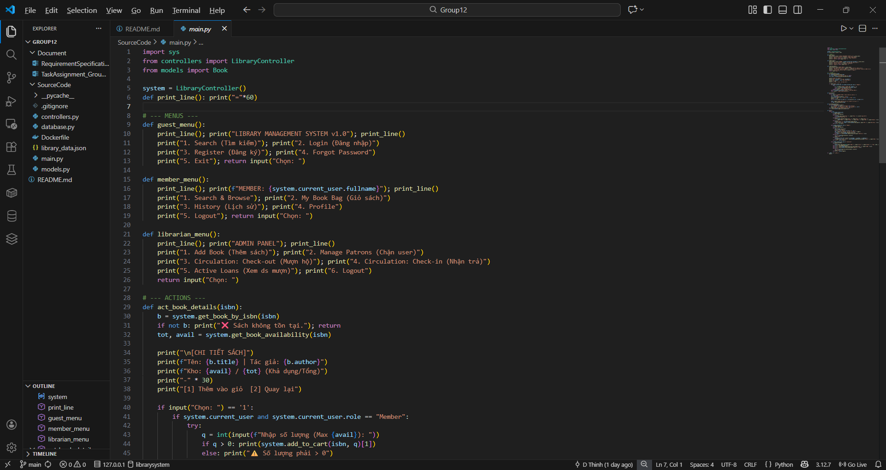
Creating test cases: Excel

Bug tracking tools:
Packaging and deployment: Docker | 