Library Management System Specification

GROUP 12

I. FUNCTIONAL REQUIREMENT
The Library requires a centralized management system to automate circulation processes (borrowing/returning) and manage facility resources, replacing the existing manual operations. The system comprises the following key functional modules:
- Search and Browse Materials:
+Browsing: Patrons can view materials by Category (e.g., IT, Literature, Economics). The list of materials can be sorted (ascending or descending) by criteria such as Title or Publication Year.
+Searching: Patrons can search for materials by entering keywords. The system will return a list of books whose names or authors contain the keyword. The result list can also be sorted by Title or Publication Year.
+ Display: Each book item displays full details: Cover image, Title, Author, Publisher, Shelf Location, and Availability Status (e.g., "Available" or "Out of Stock").

- Select and Borrow Materials:

+Book Details: Each book has a title, ISBN (distinct), cover image, summary description, detailed information, and availability status (Available or Checked Out), and the number of copies in stock. Each book belongs to a specific Category
+Cart Management (Book Bag): When viewing or searching for products, patrons can add the selected book to their current Book Bag (similar to a shopping cart) or view detailed information. While viewing details, patrons can also add the book to the bag .
+Update Bag: During the selection process, patrons can view the list of books in the bag and update it (remove books from the bag).
+Borrowing Request: Patrons select the "Request Loan" function after selecting the books to officially register for borrowing.
+Borrowing Process (Workflow):
-The system requires the patron to Log in if they have not already done so.
-The system validates the patron's status (e.g., checking for overdue items or blocked accounts).
-If the patron is eligible, the system records the loan request, including details of the selected books, patron information, borrowing date, and due date (calculated automatically, e.g., 14 days from borrowing).
- Register and Update Account:
+Registration: New users (Students/Staff) can register for an account in the system.
+Information: Patron information includes: Full Name, Date of Birth, Gender, Address, Phone Number, Password, and Email Address (used as the username and for receiving notifications or password recovery).
+Update Profile: Patrons can update all their personal information except for the username (Email).
+Password Recovery: In case patrons forget their password, they can use the "Forgot Password" function. The system will generate a new password and send it to the patron's email.
- View Transaction History:
+View History: Patrons can review past loan transactions and booking history, along with their status (e.g., Active, Returned, Overdue, Cancelled).
+Cancellation: Patrons can cancel a room booking or a book request if the status is still "New" or "Pending".
- Book Borrowing/Returning Management:
+ The librarian manages the borrowing and returning of books: approving borrowing requests, rejecting borrowing requests (with accompanying reasons), confirming book returns, and handling overdue cases (penalty regulations: if a book is returned more than 3 days late, the account will receive a warning; if it is more than 7 days late, a fine must be paid — direct payment method).
- System Administration:
+Manage Books: Add, edit, delete book information and stock quantity.
+Manage Users: Manage student/staff accounts and permissions.
+Manage Loans/Returns: Process check-out and check-in transactions, handle overdue fines.

II. NON-FUNCTIONAL REQUIREMENT

1. Usability Requirements
- The system shall be operated entirely through a text-based console interface.
- All system functions shall be accessed through numbered menus.
- Each menu option shall display a clear instruction message before user input.
- Invalid input shall result in a clear error message and require the user to re-enter data.

2. Performance Requirements
- For normal usage, all operations (search, add book, borrow, return) shall produce results immediately after user input.
- The system is designed for single-user operation at a time.

3. Reliability Requirements
- The system shall not terminate unexpectedly during normal operation.
- When an error occurs (invalid input, invalid menu choice), the system shall continue running and return to the appropriate menu.
- All data entered during a session shall remain valid until the program terminates.

4. Security Requirements
- Patrons and librarians shall log in using email and password.
- Passwords shall be encrypted (hashed) before storage to ensure security.

5. Data Management Requirements
- The system shall store data using a Relational Database Management System (e.g., MySQL, SQLite).
- Each book shall have a unique ISBN.
- Each loan record shall include:
  - Patron ID
  - Book ISBN
  - Borrow Date
  - Due Date
  - Status (Active / Returned / Overdue)
- Data shall be loaded from files when the program starts and saved back to files when the program ends.

6. Business Rules
- The maximum borrowing duration is 14 days.
- If a book is returned:
  - More than 3 days late → warning status
  - More than 7 days late → fine required
- Patrons with overdue books cannot create new borrowing requests.

7. Operational Constraints
- The system shall be developed as a console-based application.
- The system shall be implemented using the Python programming language.
- GitHub shall be used for source code management and version control.
- Visual Studio Code (VS Code) shall be used as the development environment (IDE).
- Test cases shall be documented and managed using Microsoft Excel.
- The system shall be packaged and deployed using Docker.
- No graphical user interface is required.
III. DATA FLOW DIAGRAM
1.1. Data Flow Diagram Level 0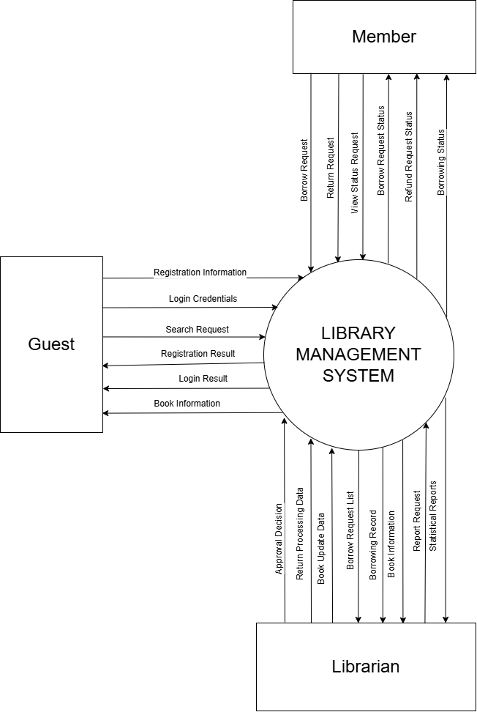

1.2. Data Flow Diagram Level 1
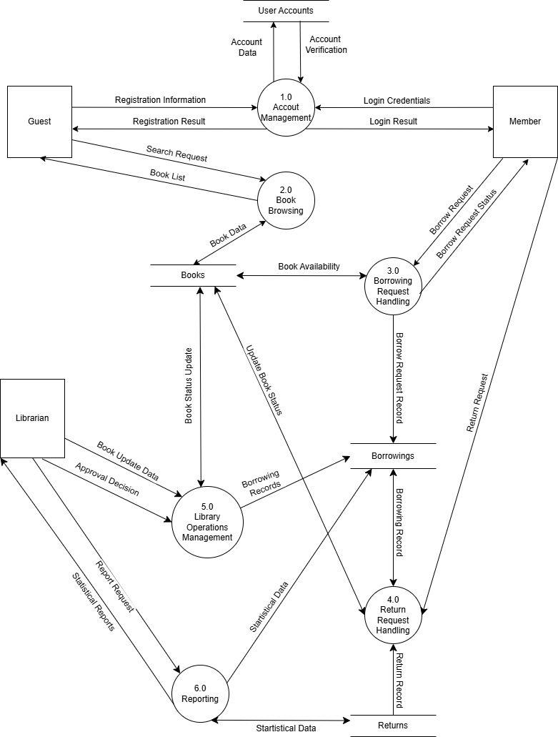

IV. USE-CASE DIAGRAM
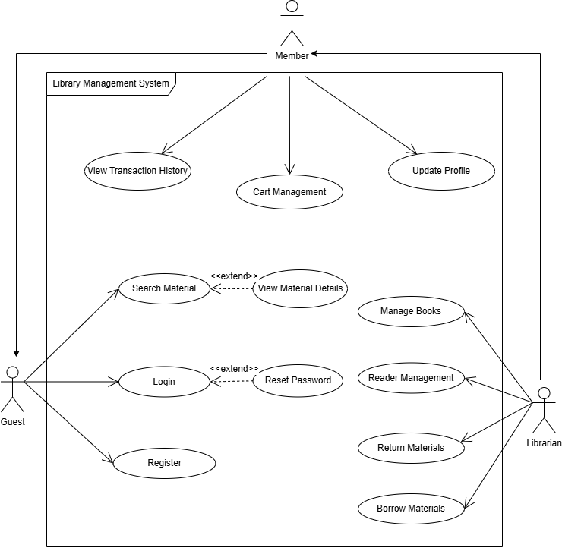

1.1. List of Actors
No. | Use-case | Meaning
1 | Guest | User who is not logged in and can only search and view books.
2 | Member | Logged-in user who can borrow books, manage book cart, view transaction history, and make reservations.
3 | Librarian | Manages books and users, handles book borrowing/returning, and approves reservations.

1.2. List of Use-case
No. | Use-case | Meaning | Note (Group)
1 | Search Materials | Search for books by keywords | Guest/Member
2 | View Book Details | View detailed info of a book | Guest/Member
3 | Login | Log into the system | All
4 | Register | Register a new account | Guest
5 | Borrow Materials | Process loan transactions (Check-out) | Librarian
6 | Return Materials | Process return transactions (Check-in) | Librarian
7 | Manage Books | Add, Edit, Delete book info | Librarian
8 | Manage Patrons | Manage user accounts | Librarian
9 | View Transation History | Review information about previous orders | Member
10 | Cart Management | Manage item in the Book Bag | Member
11 | Update Profile | Update personal information | Member

2. Use-case Search Materials
2.1. Summary This use-case allows users to search for materials by entering keywords (Title, Author, or ISBN).
2.2. Flow of Events
2.2.1. Main Flow The use-case begins when the user selects the "Search" function.
- The system displays a search form for the user to enter keywords.
- The user enters keywords and selects search criteria (Title, Author, Year).
- The system searches the database and lists materials containing the keyword.
- The system displays the list of results, showing: Cover image, Title, Author, Shelf Location, and Availability Status.
- Users can sort the list by Title or Publication Year.
2.2.2. Alternative Flows
2.2.2.1. No Results Found If no materials match the keyword in Step 3, the system displays a message "No materials found" and suggests the user try different keywords.
2.3. Special Requirements The search function must return results within 2 seconds.
2.4. Pre-conditions None.
2.5. Post-conditions None.
2.6. Extension Points Use-case View Material Details: If the user selects a specific book to view.

3. Use-case View Book Details
3.1. Summary This use-case allows Guest or Patron to view detailed information of a specific book.
3.2. Flow of Events
3.2.1. Main Flow The use-case begins when the user selects a book from the "Search Results" or "Browse List".
- The system retrieves the book's data from the database.
- The system displays the Material Detail Page containing: Bibliographic Info, Physical Info, Status Info, and Visual Info.
- If the user is logged in as a Patron, the system displays an "Add to Book Bag" button.
3.2.2. Alternative Flows None.
3.3. Special Requirements None.
3.4. Pre-conditions None.
3.5. Post-conditions None.
3.6. Extension Points Use-case Login: If the user wants to add items to the bag but is not logged in.

4. Use-case Login
4.1. Summary This use-case describes how a user logs into the Library Management System.
4.2. Flow of Events
4.2.1. Main Flow The use-case begins when an unauthenticated user wants to access restricted features.
- The system requests the user to enter their Username (Email) and Password.
- The user enters the credentials and submits.
- The system verifies the Username and Password. If valid, grants access.
4.2.2. Alternative Flows
4.2.2.1. Invalid Credentials If in Step 3, the credentials are incorrect, the system displays an error message "Invalid Login Information".
4.3. Special Requirements None.
4.4. Pre-conditions User is not logged in.
4.5. Post-conditions If successful, the user is authenticated.
4.6. Extension Points Use-case Reset password.

5. Use-case Register
5.1. Summary This use-case describes how a Guest registers a new Member account.
5.2. Flow of Events
5.2.1. Main Flow The use-case begins when a Guest selects the "Register" function.
- The system requests user info: Full Name, Date of Birth, Gender, Address, Phone Number, Password, and Email Address.
- The user enters information and submits.
- The system validates input and creates a new account.
5.2.2. Alternative Flows
5.2.2.1. Account Already Exists If the Email exists, the system displays an error message.
5.3. Special Requirements Passwords must be hashed.
5.4. Pre-conditions None.
5.5. Post-conditions A new user record is added to the database.
5.6. Extension Points None.

6. Use-case Borrow Materials
6.1. Summary This use-case allows the Librarian to approve and process loan requests for Patrons.
6.2. Flow of Events
6.2.1. Main Flow The use-case begins when the Librarian processes a borrowing request.
- The system requests Patron ID or selects the pending request.
- The system validates the Patron's account status (Checking for overdue items or blocked accounts).
- The Librarian confirms the books to be borrowed.
- The system checks Availability Status and quantity.
- The system calculates the Due Date (automatically set to 14 days from borrowing).
- The Librarian confirms the loan.
- The system creates a Loan Record and updates Inventory.
6.2.2. Alternative Flows
6.2.2.1. Patron Blocked/Ineligible If the Patron has overdue items or is blocked, the system rejects the request and displays the reason.
6.2.2.2. Book Out of Stock If book quantity is 0, system displays error.
6.3. Special Requirements None.
6.4. Pre-conditions Librarian must be logged in.
6.5. Post-conditions Inventory quantity decreased. New Loan Record created.
6.6. Extension Points None.

7. Use-case Return Materials
7.1. Summary This use-case allows the Librarian to process returned books and handle fines/warnings.
7.2. Flow of Events
7.2.1. Main Flow The use-case begins when the Librarian receives returned books.
- The Librarian scans the ISBN of the returned book.
- The system searches for the active Loan Record.
- The system checks if the book is Overdue.
  - If Not Overdue: Proceed to confirmation.
  - If Overdue: Execute Overdue Handling Flow.
- The Librarian confirms the return.
- The system updates the Loan Record status to "Completed".
- The system increases the Available Quantity of the book in the Inventory by 1.
7.2.1.1. Overdue Handling Flow
- The system calculates the number of late days.
- Case 1: Late > 3 days: The system issues a Warning to the account.
- Case 2: Late > 7 days: The system calculates the Fine and requires Direct Payment.
- The Librarian confirms payment receipt (if applicable).
7.2.2. Alternative Flows
7.2.2.1. Book Not Found If the scanned book is not in "Borrowed" status, system displays error.
7.3. Special Requirements Fines must be paid directly at the counter.
7.4. Pre-conditions Librarian must be logged in.
7.5. Post-conditions Loan Record is closed. Book inventory is restored.
7.6. Extension Points None.

8. Use-case Manage Books
8.1. Summary This use-case allows the Librarian to manage book information.
8.2. Flow of Events
8.2.1. Main Flow The use-case begins when the Librarian selects "Catalog Management".
- The system displays a list of books.
- Librarian can Add, Update, or Delete book information and stock quantity.
- System validates and saves changes.
8.2.2. Alternative Flows
8.2.2.1. Duplicate ISBN If ISBN exists during Add, system displays error.
8.3. Special Requirements None.
8.4. Pre-conditions Librarian logged in.
8.5. Post-conditions Database updated.
8.6. Extension Points None.

9. Use-case Manage Patrons
9.1. Summary This use-case allows the Librarian to manage user accounts.
9.2. Flow of Events
9.2.1. Main Flow The use-case begins when the Librarian selects "User Management".
- The system displays list of users.
- Librarian can Add, Update, or Manage permissions for student/staff accounts.
- System validates and saves changes.
9.2.2. Alternative Flows
9.2.2.1. Cannot Delete If User has unreturned books, system prevents deletion.
9.3. Special Requirements None.
9.4. Pre-conditions Librarian logged in.
9.5. Post-conditions User database updated.
9.6. Extension Points None.

10. Use-case View Transaction History
10.1. Summary This use-case allows Patrons to review their borrowing history and the status of current loans.
10.2. Flow of Events
10.2.1. Main Flow The use-case begins when the Patron selects "Transaction History".
- The system displays a list of loan transactions sorted by date (newest first).
- The Patron selects "View Details" on a specific transaction.
- The system displays detailed information including: List of books, Borrow Date, Due Date, Return Date, and Status (Active, Returned, Overdue).
10.2.2. Alternative Flows
10.2.2.1. No History If the Patron has never borrowed any books, the system displays "No transaction history found".
10.3. Special Requirements None.
10.4. Pre-conditions Patron must be logged in.
10.5. Post-conditions None.
10.6. Extension Points None.

11. Use-case Cart Management
11.1. Summary This use-case allows Patrons to view and manage books in their Book Bag before sending a loan request.
11.2. Flow of Events
11.2.1. Main Flow The use-case begins when the Patron selects "My Book Bag".
- The system displays the list of selected books (Cover, Title, Author).
- Remove Item: If the Patron selects "Remove" for a specific book, the system asks for confirmation.
- If confirmed, the system removes the book from the bag and updates the total item count.
- Checkout: The Patron can proceed to "Request Loan" (Trigger Use-case Borrow Materials/Request).
11.2.2. Alternative Flows
11.2.2.1. Empty Bag If the bag is empty, the system displays "Your Book Bag is empty".
11.3. Special Requirements The Book Bag creates a temporary hold on the items for a limited time (e.g., 30 minutes) - Optional feature.
11.4. Pre-conditions None.
11.5. Post-conditions The Book Bag content is updated.
11.6. Extension Points None.

12. Use-case Update Profile
12.1. Summary This use-case allows authenticated Patrons to update their personal information.
12.2. Flow of Events
12.2.1. Main Flow The use-case begins when the Patron selects "My Profile".
- The system displays current personal information (Name, Phone, Address, DOB).
- The Patron modifies the allowed fields (Phone, Address). Note: Email/Username cannot be changed.
- The Patron clicks "Update".
- The system validates the input and saves changes to the database.
- The system displays a success message.
12.2.2. Alternative Flows
12.2.2.1. Invalid Input If mandatory fields are left blank or format is incorrect, the system displays an error message.
12.3. Special Requirements None.
12.4. Pre-conditions Patron must be logged in.
12.5. Post-conditions User information is updated in the database.
12.6. Extension Points None.

V. CLASS DIAGRAM
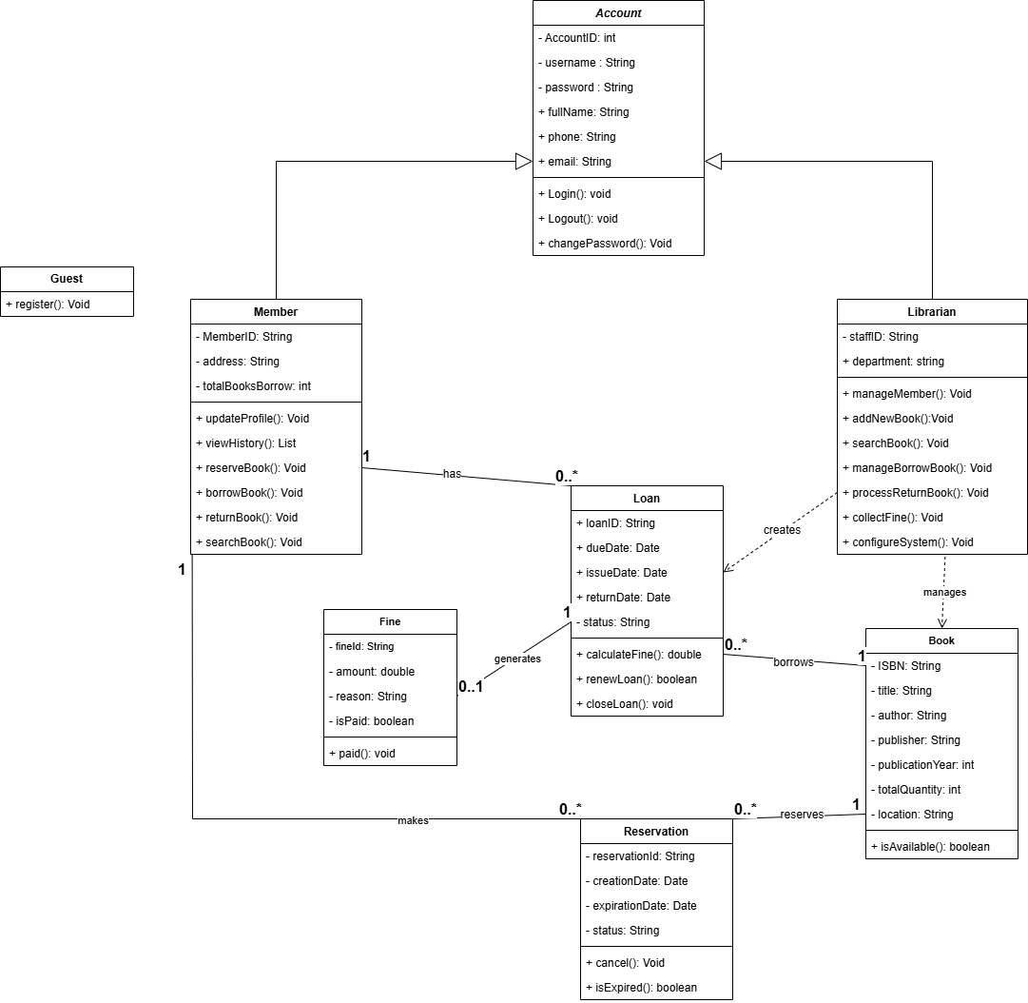
VI. DATA MODEL
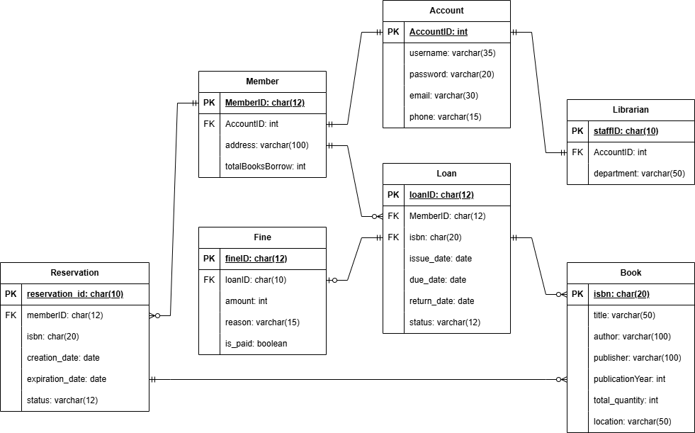

VII. INTERFACE DESIGN DESCRIPTION
Since the system is developed as a Console Application, the user interface is text-based. The interaction flow relies on hierarchical menus and command inputs. Below are the mockups for key screens of the system.
7.1. Main Menu (Guest View)
- Description: The landing screen when the application starts. Guests can search or choose to log in/register.
- Mockup:

============================================================
LIBRARY MANAGEMENT SYSTEM (LMS) v1.0
============================================================
1. Search Materials
2. Login
3. Register New Account
4. Exit
============================================================
Enter your choice [1-4]: _

7.2. Patron Dashboard (After Login)
- Description: The main menu for authenticated Patrons. Shows personalized options like "My Book Bag" and "History".
- Mockup:

============================================================
WELCOME BACK, [Patron Name]!
============================================================
1. Search & Browse Materials
2. View My Book Bag (0 items)
3. View Transaction History
4. View Profile
5. Logout
============================================================
Enter your choice [1-5]: _

7.3. Search Results Screen
- Description: Displays a list of books matching the keyword in a table format.
- Mockup:

[SEARCH RESULTS FOR: "PYTHON"]
---------------------------------------------------------------------------------------
| ID | Title | Author | Year | Location | Availability |
---------------------------------------------------------------------------------------
| 101 | Learning Python | Mark Lutz | 2013 | Shelf A1 | Available |
| 102 | Python Crash Course | Eric Matthes | 2019 | Shelf B3 | Checked Out |
| 103 | Automate the Boring... | Al Sweigart | 2020 | Shelf A2 | Available |
---------------------------------------------------------------------------------------
<P> Previous Page <N> Next Page <M> Main Menu

Enter Book ID to view details: _

7.4. Material Details & Action Screen
- Description: Shows detailed info of a specific book and allows adding it to the Book Bag.
- Mockup:

[MATERIAL DETAILS]
------------------------------------------------------------
Title: Learning Python (5th Edition)
Author: Mark Lutz
Publisher: O'Reilly Media
Category: Information Technology
ISBN: 978-1449355739

[STATUS]
Total Copies: 5
Available: 4
Location: Row A - Shelf 1
------------------------------------------------------------
[1] Add to Book Bag
[2] Back to Search List
[3] Return to Main Menu

Enter your choice: _

7.5. Book Bag & Checkout Screen
- Description: Displays selected books before confirming the loan request.
- Mockup:

[MY BOOK BAG]
------------------------------------------------------------
1. Learning Python (ID: 101)
2. Clean Code (ID: 205)
------------------------------------------------------------
Total Items: 2
Max Limit: 5

[C] Confirm Borrowing Request
[R] Remove an Item
[B] Back to Dashboard

Enter command: _

7.6. Librarian Dashboard (Admin)
- Description: The main menu for Librarians to manage the system.
- Mockup:

============================================================
LIBRARIAN ADMINISTRATION PANEL
============================================================
1. Process Borrowing (Checkout)
2. Process Return (Check-in)
3. Manage Catalog (Add/Edit/Delete Books)
4. Manage Patrons (Block/Unblock)
5. View Overdue List
6. Logout
============================================================
Enter your choice [1-6]: _

