COMPLAINTS POLICY
Policy number | GCBH_Pol009 | Version | 1.0
Drafted by | Phillip Martin | Approved by Board on | 7 November 2026
Responsible person | Helen Omondi | Scheduled review date | 3 years from approval

Introduction
Gentown Community & Business Hub (GCBH) expects its staff and volunteers to be committed to fair, effective and efficient complaint handling.

Purpose
This policy is intended to ensure that GCBH handles complaints fairly, efficiently and effectively.

Scope
This policy applies to all GCBH staff, volunteers, contractors and our Board, receiving or managing complaints from the public and clients made to or about us, regarding our services and staff, or our complaint handling process.

Responsibilities
The CEO of GCBH is to promote a culture that values complaints and their effective resolution. The CEO should:
- report to the Board on GCBH’s complaint handling
- provide adequate support and direction to key staff responsible for handling complaints
- regularly review reports about complaint trends and issues arising from complaints
- encourage all staff to be alert to complaints and assist those responsible for handling complaints to resolve them promptly
- encourage staff to make recommendations for system improvements, and
- support recommendations for service, staff and complaint handling improvements arising from the analysis of complaint data.

GCBH staff whose duties include complaint handling are to demonstrate exemplary complaint handling practices. They should:
- treat all people with respect, including people who make complaints
- assist people to make a complaint, if needed
- comply with our policy and associated procedures
- provide regular feedback to management and/or the Board on issues arising from complaints
- provide suggestions to management on ways to improve our complaints management system, and
- implement changes arising from individual complaints and from the analysis of complaint data as directed by management.
All GCBH staff are to comply with our complaint handling practices.
- Treat all people with respect, including people who make complaints.
- Be aware of our complaint handling policies and procedures.
- Assist people who wish to make complaints access our complaints process.
- Be alert to complaints and assist staff handling complaints resolve matters promptly.

Definitions
“Complaint” Is an expression of dissatisfaction made to or about us, our services, staff or the handling of a complaint where a response or resolution is explicitly or implicitly expected or legally required. (AS/NZ 10002:2014)
As well as complaints being made directly to our organisation, remember that some complaints (or at least negative comments) made be made on social media.
“Complaint handling/management system” consists of all policies, procedures, practices, staff, hardware and software used by us in the management of complaints.
“Dispute” is an unresolved complaint escalated either within or outside of our organisation.
“Feedback” includes opinions, comments and expressions of interest or concern, made directly or indirectly, explicitly or implicitly, to or about us, about our services or complaint handling system where a response is not explicitly or implicitly expected or legally required.
“Grievance” is a clear, formal written statement by an individual staff member about another staff member or a work-related problem.

Guiding Principles
An effective complaint handling system must be modelled on the principles of fairness, accessibility, responsiveness, efficiency and integration into organisational culture.
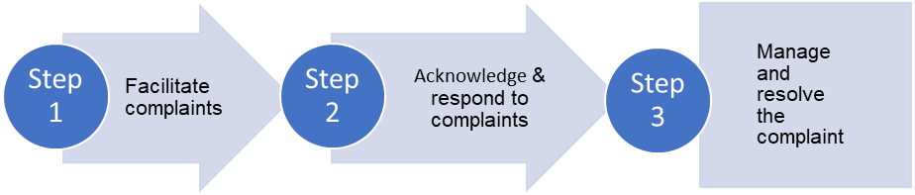
Step 1. Facilitate complaints
People focus
We are committed to seeking and receiving feedback and complaints about our services, systems, practices, procedures, products and complaint handling.
Any concerns raised in feedback or complaints will be dealt with within a reasonable time frame (as in AS/NZ 10002).
People making complaints will be:
- provided with information about our complaint handling process and how to access it
- listened to, treated with respect by staff and actively involved in the complaint process where possible and appropriate, and
- provided with reasons for our decision/s and any options for redress or review.

No detriment to people making complaints
We will take all reasonable steps to ensure that people making complaints are not adversely affected because a complaint has been made by them or on their behalf.
Anonymous complaints
We accept anonymous complaints if there is a compelling reason to do so and will carry out a confidential investigation of the issues raised where there is enough information provided.
Accessibility
We will ensure that information about how and where complaints may be made to or about us is well-publicised on our website. We will ensure that our systems to manage complaints are easily understood and accessible to everyone, particularly people who may require assistance.
If a person prefers or needs another person or organisation to assist or represent them in the making and/or resolution of their complaint, we will communicate with them through their representative if this is their wish. Anyone may represent a person wishing to make a complaint with their consent (e.g. advocate, family member, legal or community representative, member of Parliament, another organisation).
No charge
Complaining to us is free of charge.
Step 2. Respond to complaints
Early resolution
Where possible, complaints will be resolved at first contact with us. When appropriate we may offer an explanation or apology to the person making the complaint.
Responsiveness
We will promptly acknowledge receipt of complaints.
We will assess and prioritise complaints in accordance with the urgency and/or seriousness of the issues raised. If a matter concerns an immediate risk to safety or security the response will be immediate and will be escalated appropriately.
We are committed to managing people’s expectations, and will inform them as soon as possible,
of the following:
- the complaints process
- the expected time frames for our actions
- the progress of the complaint and reasons for any delay
- their likely involvement in the process, and
- the possible or likely outcome of their complaint.
We will advise people as soon as possible when we are unable to deal with any part of their complaint and provide advice about where such issues and/or complaints may be directed (if known and appropriate).
We will also advise people as soon as possible when we are unable to meet our time frames for responding to their complaint and the reason for our delay.
Objectivity and fairness
We will address each complaint with integrity and in an equitable, objective and unbiased manner.
We will ensure that the person handling a complaint is different from any staff member whose conduct or service is being complained about.
Conflicts of interest, whether actual or perceived, will be managed responsibly. In particular, internal reviews of how a complaint was managed will be conducted by a person other than the original decision maker.
Responding flexibly
Our staff are empowered to resolve complaints promptly and with as little formality as possible. We will adopt flexible approaches to service delivery and problem solving to enhance accessibility for people making complaints and/or their representatives.
We will assess each complaint on its merits and involve people making complaints and/or their representative in the process as far as possible.
Confidentiality
We will protect the identity of people making complaints where this is practical and appropriate.
Personal information that identifies individuals will only be disclosed or used by us as permitted under the relevant privacy laws, secrecy provisions and any relevant confidentiality obligations.
Step 3. Manage the parties to a complaint
Complaints involving multiple agencies
Where a complaint involves multiple organisations, we will work with the other organisation/s where possible, to ensure that communication with the person making a complaint and/or their representative is clear and coordinated.
Subject to privacy and confidentiality considerations, communication and information sharing between the parties will also be organised to facilitate a timely response to the complaint.
Where a complaint involves multiple areas within our organisation, responsibility for communicating with the person making the complaint and/or their representative will also be coordinated.
Where our services are contracted out, we expect contracted service providers to have an accessible and comprehensive complaint management system. We take complaints not only about the actions of our staff but also the actions of our service providers.
Empowerment of staff
All staff managing complaints are empowered to implement our complaint management system as relevant to their role and responsibilities.
Staff are encouraged to provide feedback on the effectiveness and efficiency of all aspects of our complaint management system.
Managing unreasonable conduct by people making complaints
We are committed to being accessible and responsive to all people who approach us with feedback or complaints. At the same time our success depends on:
- our ability to do our work and perform our functions in the most effective and efficient way possible
- the health, safety and security of our staff, and
- our ability to allocate our resources fairly across all the complaints we receive.
When people behave unreasonably in their dealings with us, their conduct can significantly affect the progress and efficiency of our work. As a result, we will take proactive and decisive action to manage any conduct that negatively and unreasonably affects us and will support our staff to do the same in accordance with this policy.
Alternative avenues for dealing with complaints
We will inform people who make complaints to or about us about any internal or external review options available to them (including any relevant Ombudsman or oversight regulatory bodies).

The three levels of complaint handling
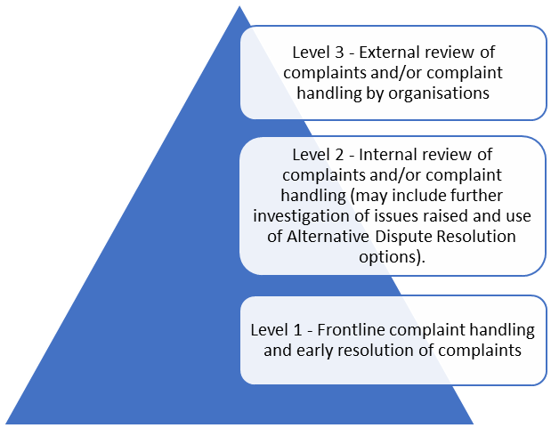
Level 1
We aim to resolve complaints at the first level, the frontline. Wherever possible staff will be adequately equipped to respond to complaints, including being given appropriate authority, training and supervision.
Level 2
Where this is not possible, we may decide to escalate the complaint to a more senior officer within our organisation. This second level of complaint handling will provide for the following internal mechanisms:
- assessment and possible investigation of the complaint and decision/s already made, and/or
- facilitated resolution (where a person not connected with the complaint reviews the matter and attempts to find an outcome acceptable to the relevant parties).
Level 3
Where a person making a complaint is dissatisfied with the outcome of our review of their complaint, they may seek an external review of our decision (by the Australian Charities and Not-for-Profits Commission for example).

Accountability and learning
Analysis and evaluation of complaints
We will ensure that complaints are recorded in a systematic way so that information can be easily retrieved for reporting and analysis by management and the Board.
We will run regular reports on:
- the number of complaints received
- the outcome of complaints, including matters resolved at the frontline
- issues arising from complaints
- systemic issues identified, and
- the number of requests we receive for internal and/or external review of our complaint handling.
Regular analysis of these reports will be undertaken to monitor trends, measure the quality of our customer service and make improvements.
Both reports and their analysis will be provided to our CEO, senior management and to our board for review, at least annually.
Monitoring of the complaint management system
We will continually monitor our complaint management system to:
- ensure its effectiveness in responding to and resolving complaints, and
- identify and correct deficiencies in the operation of the system.

Monitoring may include the use of audits, complaint satisfaction surveys and online listening tools and alerts.
Continuous improvement
We are committed to improving the way our organisation operates, including our management of the effectiveness and efficiency of our complaint management system. To this end, we will:
- support the making and appropriate resolution of complaints
- implement best practices in complaint handling
- recognise and reward exemplary complaint handling by staff
- regularly review the complaint management system and complaint data, and
- implement appropriate system changes arising out of our analysis of complaints data and continual monitoring of the system.
COMPLAINTS PROCEDURES

Policy number | GCBH_Proc009 | Version | 1.0
Drafted by | Phillip Martin | Approved by Board on | 7 November 2026
Responsible person | Phillip Martin | Scheduled review date | 3 years from approval

Introduction
When responding to complaints, GCBH staff and volunteers act in accordance with complaint handling procedures as well as any other internal documents providing guidance on the management of complaints.
Staff should also consider any relevant legislation and/or regulations when responding to complaints and feedback.
The five key stages in our complaint management system are set out below

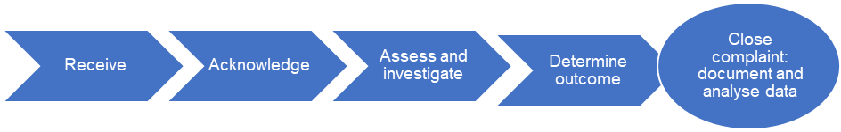

1. Receive
Unless the complaint has been resolved at the outset, we will record the complaint and its supporting information. We will also assign a unique identifier/number to the complaint file.
The record of the complaint will document:
- Contact information of the person making a complaint and the date received
- Issues raised by the person making a complaint and the outcome/s they want
- Any other relevant information, and
- Any additional support the person making a complaint requires.

2. Acknowledge
We will acknowledge receipt of each complaint promptly, and preferably within five working days. When appropriate we may offer an explanation or apology.
Consideration will be given to the most appropriate medium (e.g. email, letter) for communicating with the person making a complaint.

3. Assess and investigate
3.1 Initial assessment
After acknowledging receipt of the complaint, we will confirm whether the issue/s raised in the
complaint is/are within our control. We will also consider the outcome/s sought by the person making a complaint and, where there is more than one issue raised, determine whether each issue needs to be separately addressed. When determining how a complaint will be managed, we will consider:
- How serious, complicated or urgent the complaint is
- Whether the complaint raises concerns about people’s health and safety
- How the person making the complaint is being affected
- The risks involved if resolution of the complaint is delayed, and
- Whether a resolution requires the involvement of other organisations.
3.2 Investigating the complaint
After assessing the complaint, we will consider how to manage it. We may:
- Give the person making a complaint information or an explanation
- Gather information about the issue, person or area that the complaint is about, or
- Investigate the claims made in the complaint.
We will keep the person making the complaint up-to-date on our progress, particularly if there are any delays. We will also communicate the outcome of the complaint using the most appropriate medium. Which actions we decide to take will be tailored to each case and take into account any statutory requirements.

4. Determine outcome and provide reasons for decision
Following consideration of the complaint and any investigation into the issues raised, we will contact the person making the complaint and advise them:
- The outcome of the complaint and any action we took
- The reason/s for our decision
- The remedy or resolution/s that we have proposed or put in place, and
- Any options for review that may be available to the complainant, such as an internal review, external review or appeal.

5. Close the complaint: document and analyse data
5.1 Document
We will keep records about:
- How we managed the complaint
- The outcome/s of the complaint (including whether it or any aspect of it was substantiated, any recommendations made to address problems identified and any decisions made on those recommendations), and
- Any outstanding actions to be followed up, including analysing any underlying or root causes.
5.2 Analyse data
We will ensure that outcomes are properly implemented, monitored and reported to the complaint handling manager, senior management or the Chair of our Board.

Authorisation
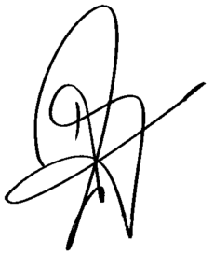
Helen Omondi

