# EMPLOYMENT OF CEO POLICY

|  |  |  |  |
| --- | --- | --- | --- |
| Policy number | GCBH_Pol020 | Version | 1.0 |
| Drafted by | Phillip Martin | Approved by Board on | 4 December 2019 |
| Responsible person | Helen Omondi | Scheduled review date | 3 years from approval |

## Introduction

The Board of Gentown Community & Business Hub (GCBH) is responsible for the employment and monitoring of the organisation’s Chief Executive Officer (CEO), who is the highest-level staff member of the organisation.

## Purpose

To stipulate policy and procedures relating to the appointment and conditions of employment for GCBH’s CEO.

## Policy

GCBH will employ the best available person for the job of CEO, will utilise an open and transparent appointment process, and will be a good employer, providing fair and appropriate terms and conditions of employment.

When a new CEO is to be appointed, the position will be advertised in order to attract the widest possible range of potential applicants.

## Authorisation

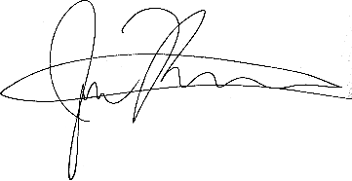  
  
4 December 2019  
Gentown Community & Business Hub

# EMPLOYMENT OF CEO PROCEDURES

|  |  |  |  |
| --- | --- | --- | --- |
| Policy number | GCBH_Proc020 | Version | 1.0 |
| Drafted by | Phillip Martin | Approved by Board on | 4 December 2019 |
| Responsible person | Phillip Martin | Scheduled review date | 3 years from approval |

## Responsibilities

The responsibility for appointing, monitoring and terminating the employment of GCBH’s CEO lies with the Board.

The process of advertising, interviewing and short-listing for the position of CEO is the responsibility of a committee that shall be set up by the Board for this purpose, with a membership selected by the Board. After due deliberation, this committee will make a recommendation to the Board.

The final decision for the appointment of the CEO is to be made by the full Board.

## Procedures

The position statement for the CEO will be that approved by the Board. The CEO’s terms and conditions of employment are contained in the Contract negotiated and signed by the Chair (or a person delegated to this role by the full Board) and the CEO. Procedures for the termination of the CEO’s contract are to be contained in that Contract.

The CEO’s performance, remuneration and conditions of employment are to be reviewed annually by the Board, or a committee delegated to this role. Any variations to the Contract shall be negotiated by the Chair (or delegate) and ratified by the Board.

The CEO and the Chair (or designated committee) will meet annually to carry out a formal appraisal of the CEO’s performance based on criteria agreed to and set at the beginning of the monitoring period. The format and process for this meeting will be negotiated and agreed upon between the CEO and the Chair/committee.

## Related Documents

* Staff Recruitment Policy

## Authorisation

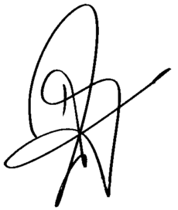  
  
Helen Omondi  
4 December 2019