# CODE OF ETHICS POLICY

|  |  |  |  |
| --- | --- | --- | --- |
| Policy number | GCBH_Pol004 | Version | 1.0 |
| Drafted by | Phillip Martin | Approved by Board on | 4 December 2019 |
| Responsible person | Helen Omondi | Scheduled review date | 3 years from approval |

## Introduction

The ethical climate of an organisation is an essential element in establishing its credibility and furthering its mission. An organisational culture that takes ethical considerations into account at every point cannot be produced simply by having the Board lay down a code; ethical principles must arise from consultation with and responsiveness to the organisation’s members, clients, staff, volunteers, and stakeholders.

## Purpose

This policy is designed to provide guidelines for procedures that will allow Gentown Community & Business Hub (GCBH) to evolve a consensus on the ethical principles that should guide its conduct.

## Policy

GCBH commits itself to operating in accordance with an ethical code drawn up through agreed procedures following consultation with members, clients, staff, volunteers, and stakeholders.

## Authorisation

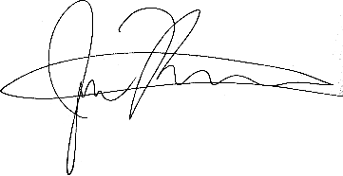  
  
4 December 2019  
Gentown Community & Business Hub

# CODE OF ETHICS POLICY

|  |  |  |  |
| --- | --- | --- | --- |
| Policy number | GCBH_Proc004 | Version | 1.0 |
| Drafted by | Phillip Martin | Approved by Board on | 4 December 2019 |
| Responsible person | Phillip Martin | Scheduled review date | 3 years from approval |

## Responsibilities

It should be the responsibility of the Board to appoint an Ethics Committee headed by a Coordinator and including among its membership the Secretary of the Board.

The Coordinator of the Ethics Committee should be responsible for carrying out the process of developing a Code of Ethics for the organisation.

The CEO should be responsible for disseminating the eventual Code of Ethics and of ensuring its observance.

## Procedures

The Ethics Committee should organise consultation with members, clients, staff, volunteers, and stakeholders on:

* the values that the organisation wishes to embody, and
* the specific ethical imperatives that are implied by these values.

The discussions around these issues should be used to raise awareness of the significance of ethical attitudes to the effective operation of the organisation.

The Committee should then:

* review the policies of the organisation to ensure that these are not in conflict with the organisation’s ethical principles, and
* draw up a draft Code of Ethics for the organisation.

It should be noted that the organisation’s ethical position is represented both by the organisation’s policies and by its Code of Ethics, and any particular ethical guideline does not necessarily need to be repeated in both.

The draft Code of Ethics should then be circulated for discussion and comment to members, clients, staff, volunteers, and stakeholders. Again, the discussion should be used to forward a commitment among all concerned with the organisation to the ethical operation of the organisation.

The Ethics Committee should forward a final draft of the Code of Ethics to the Board. The Board may make any alterations it sees fit, and the resulting Code of Ethics should be presented for the approval of the membership at the next General Meeting.

Once the Code of Ethics has been approved by the General Meeting it should be implemented by the organisation. Procedures should then be instituted to provide sanctions and penalties for breaches of the Code.

## Related Documents

* Acceptable Use of Electronic Media
* Acceptable Use of Vehicles & Equipment Policy
* Anti-discrimination Policy
* Bullying Policy
* Code of Ethics
* Equal Employment Opportunity Policy
* Sexual Harassment Policy
* Staff Conflict of Interest Policy

## Authorisation

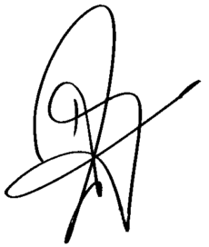  
  
Helen Omondi  
4 December 2019