# CONFIDENTIALITY POLICY

|  |  |  |  |
| --- | --- | --- | --- |
| Policy number | GCBH_Pol010 | Version | 1.0 |
| Drafted by | Phillip Martin | Approved by Board on | 4 December 2019 |
| Responsible person | Helen Omondi | Scheduled review date | 3 years from approval |

## Introduction

Information management systems rely on any necessary restrictions on the free circulation of information being respected by those into whose hands the information is entrusted.

## Purpose

The purpose of this document is to provide a framework for Gentown Community & Business Hub (GCBH) in dealing with confidentiality considerations.

## Policy

GCBH collects and administers a range of information for a variety of purposes. Some of this information is restricted in its circulation for commercial, privacy, or ethical reasons.

GCBH will place the minimum of restrictions on the information it holds but will ensure that such restrictions as are considered necessary are observed by its staff and volunteers.

## Authorisation

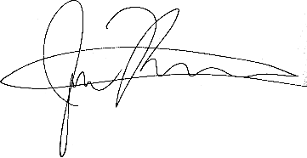  
  
4 December 2019  
Gentown Community & Business Hub

CONFIDENTIALITY PROCEDURES

|  |  |  |  |
| --- | --- | --- | --- |
| Policy number | GCBH_Proc010 | Version | 1.0 |
| Drafted by | Phillip Martin | Approved by Board on | 4 December 2019 |
| Responsible person | Phillip Martin | Scheduled review date | 3 years from approval |

## Responsibilities

GCBH’s CEO is responsible for the implementation of this policy.

GCBH’s CEO is responsible for reviewing this policy as and when the need arises.

All staff are responsible for observing confidentiality procedures in their workplace.

## Processes

The records management processes of the organisation should incorporate procedures for designating information confidential.

**Restriction**

GCBH will place restrictions on the information it holds when the information:

* is commercial in confidence,
* concerns the privacy of its staff, volunteers, clients or customers, or
* requires protection to safeguard the intellectual property of the organisation.

Staff dealing with restricted material will be instructed in the recognition of material falling under these headings.

**Identification**

Any information on which restrictions have been placed shall be as far as possible clearly identified on the document or file. Where categories of information, rather than individual documents, are restricted this restriction will be conveyed to staff and volunteers dealing with this information.

**Protection**

GCBH staff, and volunteers dealing with restricted information, will be required to sign a confidentiality agreement (see Appendix A)

**Training**

All staff will be instructed in the requirements of this policy.

## Related Documents

* Privacy Policy

## Authorisation

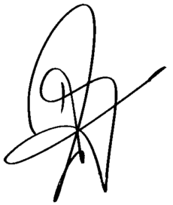  
  
Helen Omondi  
4 December 2019

**APPENDIX A**

**ConfidentIality Agreement**

I agree to hold confidential all information that Gentown Community & Business Hub (GCBH) has placed restrictions on, and to release it to persons outside the organisation only when authorised by the organisation and subject to any conditions set by the organisation.

I undertake to:

1. Access information held by the organisation only when necessary to the performance of my assigned duties
2. Make copies of restricted information only when necessary to the performance of my assigned duties
3. Oversee the storage and handling of restricted information to minimise the risk of its diversion into unauthorised channels
4. Take reasonable care to properly secure confidential information on my computer and will take steps to ensure that others cannot view or access such information
5. Not disclose my personal password(s) to anyone without the express written permission of my department head, or record or post it in an accessible location, and will refrain from performing any tasks using another's password, and
6. Notify my supervisor if I have reason to believe that my access codes and passwords have been compromised.

Signed ________________________________

Date ________________________________