# FAMILY FRIENDLY POLICY

|  |  |  |  |
| --- | --- | --- | --- |
| Policy number | GCBH_Pol028 | Version | 1.0 |
| Drafted by | Phillip Martin | Approved by Board on | 4 December 2019 |
| Responsible person | Helen Omondi | Scheduled review date | 3 years from approval |

## Introduction

Gentown Community & Business Hub (GCBH) is committed to helping its staff achieve their personal, family and relationship goals. As part of this endeavour, the organisation fosters flexibility in employment arrangements to achieve the optimum balance between work and family responsibilities for all staff.

## Purpose

Work flexibility ensures that staff are able to balance work and family commitments while taking into account organisational needs.

## Policy

GCBH will mandate best practice employment arrangements in relation to:

* Parental/maternity/paternity leave
* Personal/Carer's/Family leave
* Bereavement leave
* Flexible working arrangements.

Staff are encouraged to voice their opinions about the availability, accessibility and application of flexible work arrangements in their area.

Managers should:

* become role models for flexibility, where possible accessing flexible work arrangements themselves
* become knowledgeable about the range of flexibility options available and how to manage them
* have the practical skills and confidence to lead a team with different working arrangements
* track the career progression of staff who are working flexibly to ensure they have access to all training and other benefits and to ensure that they suffer no discrimination in opportunities for promotion
* evaluate the outcomes of the arrangement and look for improvements, and
* seek appropriate training if lacking in any of the skills necessary to properly administer this program.

Documenting agreed family-friendly provisions enables both GCBH and its staff to have a clear understanding of the available provisions and how they can be accessed.

## Authorisation

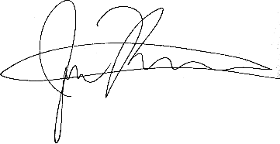  
  
4 December 2019  
Gentown Community & Business Hub

# FAMILY FRIENDLY PROCEDURES

|  |  |  |  |
| --- | --- | --- | --- |
| Policy number | GCBH_Proc028 | Version | 1.0 |
| Drafted by | Phillip Martin | Approved by Board on | 4 December 2019 |
| Responsible person | Phillip Martin | Scheduled review date | 3 years from approval |

## Responsibilities

It should be the responsibility of the Chief Executive Officer to ensure that the procedures specified in this policy are implemented appropriately.

## Procedures

Procedures and arrangements for parental/maternity/paternity leave, personal/carer's/family leave, bereavement leave, and flexible working arrangements should be as set out in National Employment Standards contained in the Fair Work Act 2009 (<https://www.fwc.gov.au/documents/legislation/download/FW_Act_vol_1.pdf>), as modified by the organisation’s provision of additional entitlements in any area.

**Documentation of procedures**

Family-friendly workplace provisions will be negotiated with the staff member at commencement of the position, and as requested or required thereafter.

Any provisions agreed at the outset of employment will be included in the employment agreement, and those agreed later should be placed on the staff member’s file.

Family-friendly clauses in individual staffing agreements should contain information on:

* the nature of the provision (e.g. flexible hours of work)
* entitlements under the provision (e.g. a right to apply for flexible hours of work)
* eligibility criteria (e.g. primary care of a child or children under school age).

As staff and organisational needs change over time, family-friendly provisions will be regularly reviewed via in-house supervision to ensure that provisions are consistent with applicable legislation and do not become outdated or irrelevant to the staff member or the organisation.

## Related Documents

* Staff Induction Policy

## Authorisation

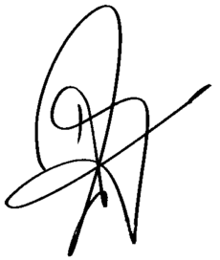  
  
Helen Omondi  
4 December 2019