# STAFF CONFLICT OF INTEREST POLICY

|  |  |  |  |
| --- | --- | --- | --- |
| Policy number | GCBH_Pol025 | Version | 1.0 |
| Drafted by | Phillip Martin | Approved by Board on | 4 December 2019 |
| Responsible person | Helen Omondi | Scheduled review date | 3 years from approval |

## Introduction

When working for Gentown Community & Business Hub (GCBH), staff and volunteers should place the organisation’s interests before any private interests they may have and should be seen to do so. Conflicts of interest, and the perception of conflict of interest, should be avoided.

## Purpose

This policy has been developed to provide a framework for:

* all staff or volunteers in declaring conflicts of interest, and
* the CEO, when determining procedures to deal with situations of possible conflicts of interest.

## Policy

A conflict of interest may occur if an interest or relationship influences or appears to influence the ability of the organisation’s staff or volunteers to exercise objectivity.

GCBH places great importance on making clear any existing or potential conflicts of interest. Staff and volunteers must declare to their supervisor all such conflicts of interest, and the supervisor may issue instructions to the staff member or volunteer regarding relevant workplace matters.

## Authorisation

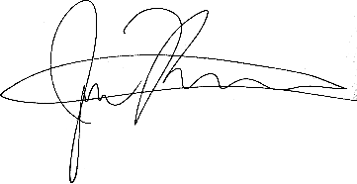  
  
4 December 2019  
Gentown Community & Business Hub

# CONFLICT OF INTEREST PROCEDURES

|  |  |  |  |
| --- | --- | --- | --- |
| Policy number | GCBH_Proc025 | Version | 1.0 |
| Drafted by | Phillip Martin | Approved by Board on | 4 December 2019 |
| Responsible person | Phillip Martin | Scheduled review date | 3 years from approval |

## Responsibilities

The CEO is responsible for bringing this policy to the attention of staff and volunteers.

Staff and volunteers are responsible for complying with this policy.

## Procedures

Where a staff member or volunteer may be seen as having a financial interest in any decision such that it raises the possibility that the staff member or volunteer might be influenced by that interest, the staff member or volunteer must notify this interest to their supervisor. The supervisor may issue instructions to the staff member or volunteer regarding relevant workplace matters.

Where a staff member or volunteer is in a relationship with any other person working or volunteering in or having dealings with the organisation, that relationship must be disclosed to the supervisor of the staff member or volunteer where that relationship may cause or be construed to cause a conflict of interest. That supervisor may issue instructions to the staff member or volunteer regarding relevant workplace matters.

Any such disclosures to supervisors should be held confidentially and may not be taken into account in any employment context other than the avoidance of conflicts of interest.

## Related Documents

* Code of Ethics

## Authorisation

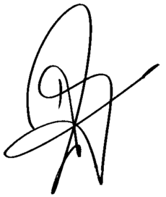  
  
Helen Omondi  
4 December 2019