CSE 4208 Computer Graphics Laboratory

Project Idea: SeaForge: 3D Harbor Simulation Using OpenGL
This project proposes the development of a 3D Harbor or Ship Port Simulation using OpenGL, where ships, water, and harbor infrastructure are modeled and rendered in a three-dimensional environment. The simulation focuses on incorporating real-world physics concepts, such as buoyancy and wave motion, to achieve realistic ship behavior instead of predefined animations.
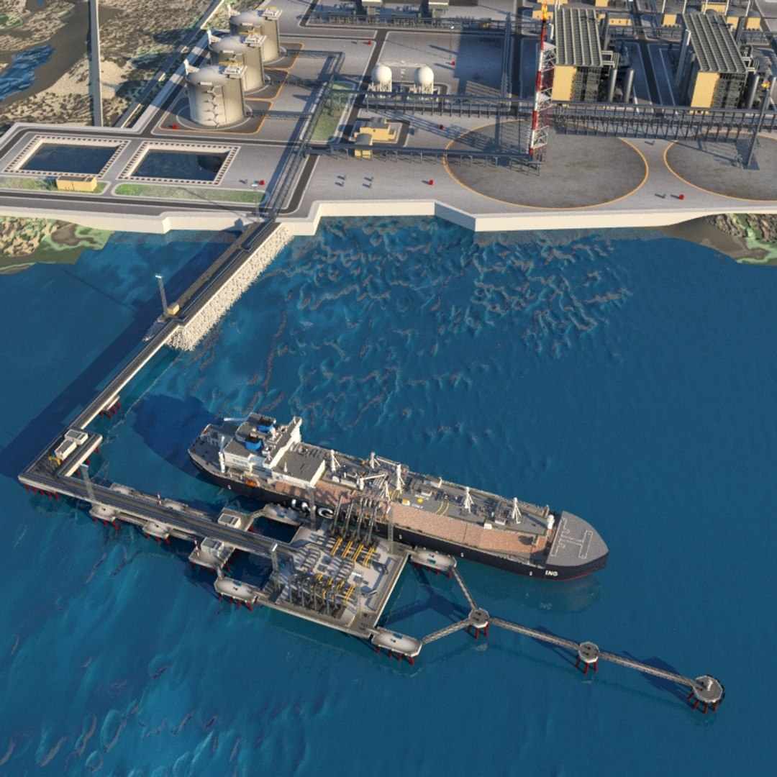

1. Realistic 3D Harbor Environment
The project presents a three-dimensional harbor environment consisting of water surfaces, docking platforms, ships, and port infrastructure. The scene is designed to resemble a real-world ship port with proper spatial arrangement and scale.

2. Dynamic Water Surface
The water body in the harbor exhibits continuous motion, representing sea waves. The dynamic behavior of the water enhances realism and provides a natural interaction between ships and the environment.

3. Physics-Based Ship Floating Behavior
Ships in the simulation demonstrate realistic floating behavior based on physical principles rather than fixed animations. The vertical movement of ships responds naturally to the water surface.
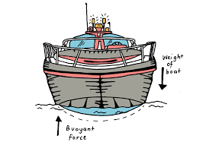

4. Ship Orientation and Stability
The project includes realistic changes in ship orientation such as tilting and balancing, reflecting the effects of waves on large vessels in a harbor environment.

5. Interactive Ship Movement
Users can control ship movement within the harbor area, allowing navigation, positioning, and docking interactions within the simulated environment.

6. Docking and Port Interaction
Ships can approach and align with the harbor dock, simulating real port operations. The docking area acts as an interactive boundary within the scene.

7. Crane and Container Handling System
The harbor includes a crane system for handling cargo containers. Containers can be moved between the dock and ships, representing basic loading and unloading operations.

8. Lighting and Visual Effects
The scene incorporates lighting effects to simulate natural and artificial light sources within the harbor, enhancing depth, visibility, and overall visual quality.

9. Camera Navigation and View Control
The project allows free camera movement, enabling users to explore the harbor scene from multiple viewpoints and perspectives.

10. Modular and Extensible Design
The system is structured in a modular manner, making it easy to extend the project by adding more ships, environmental elements, or advanced visual features in the future.
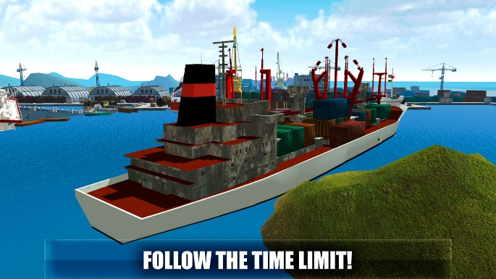
- What are the dynamic interactive objects?
Dynamic interactive objects are the components of the proposed 3D harbor simulation that change their position, orientation, or state over time and interact with the user or the environment during execution.
1. Cargo Ship
The cargo ship is a primary dynamic object in the scene. It moves within the harbor area, changes direction, and adjusts its orientation while navigating and docking. Its motion makes the environment interactive and realistic.
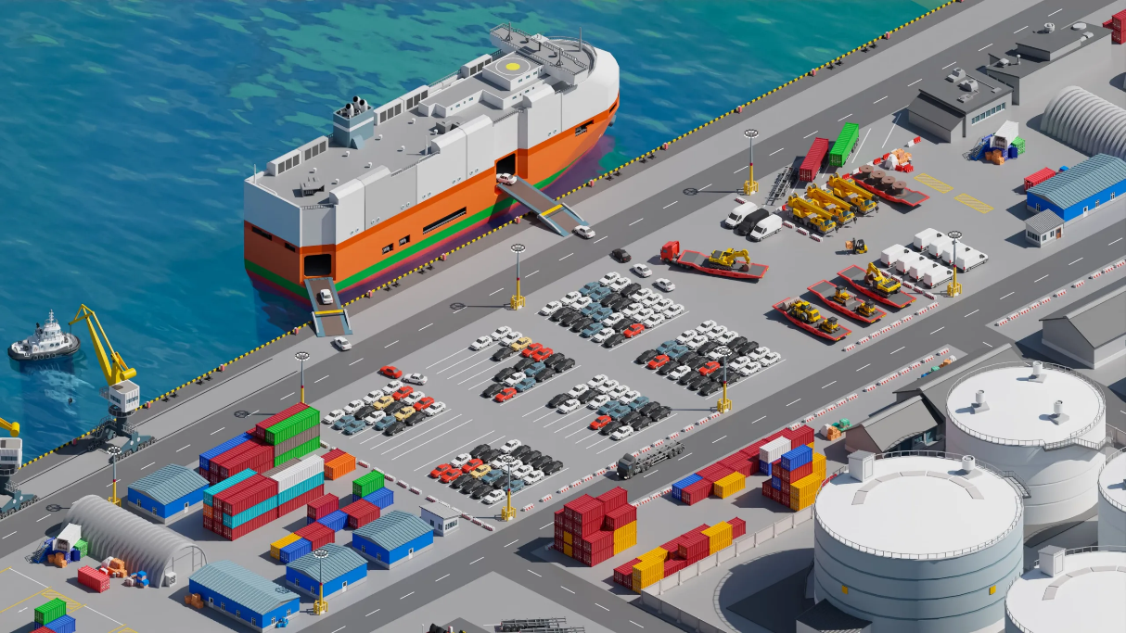
2. Water Surface (Sea)
The water surface is a continuously changing object representing sea waves. Its dynamic behavior affects the visual realism of the harbor and interacts with floating objects such as ships.
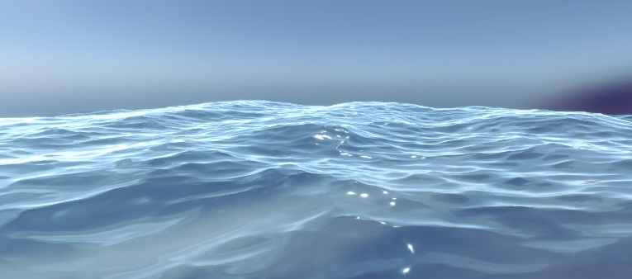
3. Harbor Crane
The crane is a dynamic mechanical structure whose parts can move and rotate. It plays an important role in simulating port activities such as cargo handling.
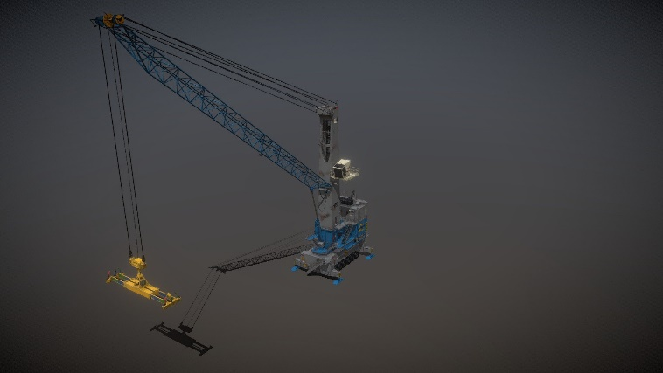
4. Cargo Containers
Cargo containers act as interactive objects that can change position within the harbor environment. Their movement represents loading and unloading operations at the port.
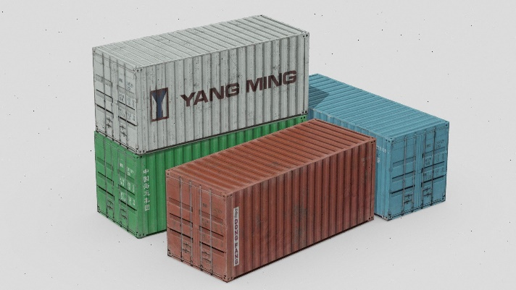
5. Camera/Viewpoint
The camera functions as an interactive element that allows users to dynamically explore the harbor scene from different angles and perspectives.

- What are the objects with complex shapes, etc ?
1. Cargo Ship
The cargo ship is a geometrically complex object composed of multiple primitives. It combines cuboids for the main body, cylinders for chimneys, cones for front detailing, curved surfaces, and hemispherical shapes for smooth edges and hull curvature.
Primitives involved:
Cube, Cylinder, Cone, Hemisphere, Curved surface
2. Harbor Crane
The harbor crane consists of multiple interconnected mechanical parts. It uses cylinders for arms and joints, cuboids for the frame, triangular prisms for supports, and spherical joints at rotation points.
Primitives involved:
Cuboid, Cylinder, Sphere, Triangular Prism, Pyramid
3. Water Surface (Sea Mesh)
The water surface is represented using a plane subdivided into a dense grid mesh. Though based on a plane, the large number of vertices and continuous deformation make it a complex geometric object.
Primitives involved:
Plane, Grid Mesh, Quad surfaces
4. Dock and Port Infrastructure
The dock area includes platforms, stairs, pillars, and boundary walls. These structures are created by combining cubes, cuboids, pyramids, and cylindrical pillars, resulting in a complex architectural form.
Primitives involved:
Cube, Cuboid, Cylinder, Pyramid, Rectangular Prism
5. Cargo Containers and Stacking Structures
Individually, containers are simple cuboids, but stacked and arranged containers form a composite complex structure with repeated geometry and spatial variation.
Primitives involved:
Cuboid, Rectangular Prism
6. Mooring and Safety Elements
Safety elements such as lifebuoys and mooring rings introduce torus geometry, while attached ropes and posts may include cylinders and spheres.
Primitives involved:
Torus, Cylinder, Sphere
7. Signal Towers and Navigation Markers
Signal towers and navigation markers add vertical complexity. These are composed of cones, cylinders, spheres, and capsule-like shapes, enhancing geometric diversity.
Primitives involved:
Cone, Cylinder, Sphere, Capsule
Overall conceptual picture of the project:
