**Automated Elective Processing**

**GROUP-3**

**Member Details**

|  |  |  |
| --- | --- | --- |
| **Roll No** | **Name** | **Role** |
| CB.EN.U4CSE19214 | E Santhosh Bharathi | Tester, Front End developer |
| CB.EN.U4CSE19225 | Maithreyan S | Backend Developer |
| CB.EN.U4CSE19243 | Saurav S | Backend Developer |
| CB.EN.U4CSE19259 | Tejaswi V | Business Analyst, Front End developer |
| CB.EN.U4CSE19263 | Viswabharathi K A | Project Manager |

**About the project**

An application that allocates elective preference of students first come first serve basis automatically. The electives are predefined in the database and the number of electives and the respective credits change dynamically based on the academic year. The main functionality is to allocate electives for students based on their preference. If many students have opted for the same elective, students will be allocated based on the first come first serve basis. The remaining students will be allocated to the elective of their second or next preference based on the availability of seats. If there are over 150% applicants aspiring for the same course, the class would be split into two sections. This allocation will be based on seat availability and faculty availability.

**Stake holders**

* Students
* Teachers
* University Administration

**Modules**

1. **Student Login Module**- The student is required to login his/her college credentials to access the elective preference list and view the final elective allocation list
2. **Elective Selection module** - The student can block/reserve a seat in the favorable elective.
3. **Allocation of elective module** – Elective is allocated to the requested student if the seats are available else the electives are allocated based on student’s priority preference.
4. **Display** - The user can request to view the content.
5. **Elective Change module**- This module is used by the students who are willing to change his/her elective.

**Table (Master/Transaction)**

**1. Student List –Master Table**

* Primary key- Student roll no
* Purpose- Elective allocated to the student

**2. Elective List –Master Table**

* Primary key- Elective course Id
* Purpose- Define the electives offered in a particular academic semester and prerequisites.

**3. Faculty List –Master Table**

* Primary key- Faculty roll no
* Purpose- Maps the faculty to their respective handling course.

**4. Preference list**

* Primary Key – (Student roll no) x (Preference number)
* Purpose – To identify and allocate the preferred elective if seats are available.

**Reports**

1. **Elective allocation report:** Final students list for every elective.
2. **Faculty allocation report:** A report on faculties allocated to every elective batch undertaking
3. **Elective change report**: List the details of students who requested to change electives.
4. **Elective Reallocation report:** Students who have been re-allocated because of course cancellation/ students' choice

**Assumptions**

1.There is a pre-defined list of electives which have its own pre-requisites and faculties that are going to handle them.

2.Web Application (cross platform access)

3.Elective credit requirements must be met.

4.Students do not have the access to reorder the elective preference once they have submitted the preference form.

**Requirements**

**Students:**

1. Uses the student login portal to login and enter the preference page to select the electives for a particular semester.
2. The preferences page displays the available electives with the number of seats remaining and the relevant course information and pre-requisites.
3. Students can make reservations for electives if the present number of seats are full in the same course.
4. Students would be provided with their elective, batch (if any) and their respective batch instructor at the end of the selection phase.
5. Students can request to change their elective at the time given to them and/or finalize their choice.

**Faculties/Staffs:**

1. Login into faculty portal with faculty credentials.

2. The web page consists of the list of electives and the students who have preferred that elective.

3. Faculty can view the finalized list after the end of selection window.

**University administration:**

1. Offers a predefined set of electives for each semester that may change every academic year.
2. Lay out the prerequisites and eligibility criteria for every elective offered.
3. Allocates faculties to every elective course.
4. Take the decision to remove a particular elective course if there are not enough students to form a separate batch.
5. Take the decision to add an additional batch for the same elective if the reservation of that elective surpasses preset capacity.
6. Handles elective change for students who request to change their elective.
7. Add electives if needed

**Software requirements:**

* Internet Browser (Google chrome, Safari, Firefox)

**Hardware requirements:**

* 4GB RAM
* Basic Computer setup
* High speed internet connection

**Epics-**

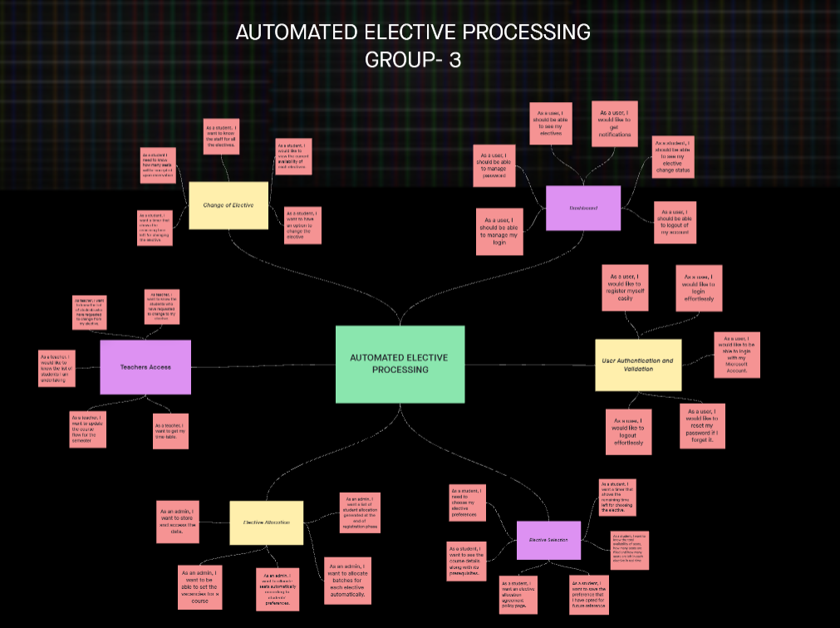[Invision link](https://saurav382032.invisionapp.com/freehand/Board-Alpha-mu0OOmjgp?dsid_h=a827483cd43c630601f06b8599990ec407ac2865b87279cf8a2f93979aa08ac5&uid_h=e1401f478d496b839155f841772a9847128e8ed2e1d1e0cf4d3ea3ae5a2950ae)

* **Epic: User Authentication and Validation**
  + **User Registration – As a user, I would like to register myself easily**
    - Design Registration page
    - Implement the registration page with relevant UI, icons and images
    - Implement registration form validation
    - Create SQL scripts to create tables
    - Create triggers on user registration
    - Store registered user credentials in the database
    - Report of students who have registered successfully on the platform, year, and department wise
  + **User login- As a user, I would like to login effortlessly**
    - Design login page for teachers
    - Design login page for students
    - Design login page for admin
    - User mapping/ authentication (credentials verification)
    - Remember credentials module
    - Keep me signed in module
    - Clear credentials functionality
  + **Forget password workflow- As a user, I would like to reset my password if I forget it**
    - Button to reset password
    - Create password reset link
    - Send password reset link on the registered email id
    - Validating the new password strength
    - Update password in database
    - Implement triggers on password updates
    - Redirect the user to login page
  + **Microsoft login support - As a user, I would like to be able to login effortlessly with my Microsoft Account**
    - Button for Microsoft login
    - Microsoft login screen
    - Fetch organisational mail, password
    - Store secure cookies
    - Redirect to dashboard upon success
  + **User Logout- As a user, I would like to logout effortlessly**
    - Button to logout
    - Confirm mail id for receiving mails about updates – alert
    - Confirm before logout
    - Redirect the user to the logout screen
    - Button lo login from logout screen
    - Redirect to the login screen if button clicked

**Prioritising User stories-**

* + Designing and implementing user registration form –MUST HAVE
  + Designing and implementing user login form- MUST HAVE
  + Validating the fields in the form - SHOULD HAVE
  + Adding a Microsoft login support – COULD HAVE
  + Adding user logout module- MUST HAVE
* **Epic: Dashboard**
  + **Manage login**
    - Sync account with MS
  + **Manage passwords: As a user, I want to be able to change/improve my auth services**
    - Create a change password option.
    - Create a verification dialogue box before changing the password
    - Design a Change Password page
    - Add a button Change password that is connected to Database
    - Design an algorithm to logout and redirect to login page
    - Add an alert dialogue box if there was an error in changing password
  + **Implement change password workflow in DB: As a student, I want to be able to change my password preference.**
    - Validate password
    - Restrict frequent password changes
    - Setup 2FA and/or OTP
    - Trigger mail to Student if password changed
    - Block password reuse.
  + **Elective preferences**
    - Student login, display electives available
    - Display the elective preferences if form already filled
    - If teacher, display students who enrolled in an elective
    - Count of seats left for different electives
  + **Notification**
    - Notify update from the teacher
    - Notify updates about final elective list
    - Notify updates about elective cancellation
    - Notify updates about elective reallocation
  + **Logout**
    - Confirm mail id for receiving mails about updates -alert
    - Confirm before logout - alert
    - Redirect the user to the logout screen
    - Button to redirect to login screen
    - Redirect to the login screen if button clicked

**Epic: Elective Selection**

* **As a student, I need to choose my elective preferences.**
  + - Design an **elective selection webpage.**
    - Lists every elective on the webpage that are offered by accessing the course database.
    - Add a number field alongside the elective name, for ordering the preference.
    - Create a popup window that asks for confirmation, gets invoked if the save button is clicked.
    - Add a query to display an error message if the preference is not properly selected.
* **As a student, I want to see the course details along with its prerequisites**.
  + - Create a hyperlink for every listed elective on the selection webpage and link it to the **course details webpage**.
    - Design a separate webpage that shows course details
    - Create a container that shows the L-T-P plan, CO, PO and the total number of credits in the course details webpage.
    - List the prerequisites in the course details webpage.
    - Create a button and link it to details of the next elective.
    - Create a Back button, that directs the user to the elective selection webpage.
* **As a student, I want an elective allocation agreement policy page.**
  + - Create a button on the elective selection webpage and link it to the **policy webpage**.
    - Design an agreement policy webpage that states the agreement policy.
    - List out all the policies and terms for choosing elective preference in the policy webpage.
    - Create a checkbox and a text alongside stating “I have read the terms and ready to proceed further”.
    - Create a Back button, that directs the user to the elective selection webpage.
* **As a student, I want to save the preference that I have opted for future reference**
  + - Create a Save button on the elective section webpage.
    - Add appropriate tags and icons near the button.
    - Write queries to update the database with the chosen preferences once the save button is clicked.
    - Create a track details button on the elective selection webpage and write appropriate API calls for redirecting.
    - Create a UI to show the selected elective preference if the track details button is clicked.
* **As a student, I want to know the total availability of seats, how many seats are filled and how many seats are left in each elective in real time.**
  + - Create a widget that displays the total availability of seats.
    - Write queries to access the database for getting the remaining available seats and display the seats left in the elective selection webpage.
    - Write appropriate API calls for auto updating the seats left on the elective selection webpage.
    - Highlight the seats left field using bold fonts and dark font colour.
* **As a student, I want a timer that shows the remaining time left for choosing the elective.**
  + - Display the remaining time on the elective selection webpage.
    - Write queries and import appropriate functions to display a countdown timer that operates in real time.
    - Sync the timer with NIST.
    - Write the required API calls for updating the remaining time.
* **Epic: Elective Allocation** 
  + **As an admin, I want to store and access the data.**
    - Analyse the requirements of the user.
    - Design a master table for the system.
    - Normalize the tables.
    - Create a Database and add the tables
    - Connect the Database with the application
    - Design a Page with access to Database for the admin
  + **As an admin, I want to be able to set the vacancies for a course.**
    - Design a page to add courses and max possible number of batches.
    - Add a batch size element for elective.
    - Connect the Faculty Table from DB to allot faculties to the electives.
    - Connect the Database with this page.
    - Create a button in Admin dashboard and link this page.
    - Connect the elements of this page to students’ elective list page.
  + **As an admin, I want to allocate seats automatically according to students’ preferences.**
    - Requirement analysis for the task.
    - Build a flowchart and create a flow of the algorithm.
    - Coding Phase – Code the algorithm
    - Connect the Code with the database.
    - Retrieve the elements from DB and add them as an object to the code.
    - Link the output to the **‘final list of students**’ page.
  + **As an admin, I want to allocate batches for each elective.**
    - Design a page that shows every elective and count of each preference.
    - Frame the conditions for the batch allocation.
    - Build a pseudocode for the algorithm.
    - Develop relevant algorithm
    - Add the batch allocation module to the backend.
    - Sync with User Interface
  + **As an admin, I want a list of student allocation generated at the end of registration phase.**
    - Design the elements of this page.
    - Retrieve the final list from the students’ allocation algorithm.
    - Create a list with all the required details that is to be shown on the page. (Student’s name, Student’s ID, Elective, Batch etc.)
    - Connect to Database and auto update the values.
    - Create a button to publish the elective of students.
    - Connect the functionality of this button to students’ course page where they can see their allocated elective.

* **Epic: Change of Elective**

User Stories:

* + **Elective change request page: As a student, I want to have an option to change the elective.**
    - Check seat availability from Database
    - Request Migration workflow (Enquire concerning tables).
    - Block transfer possibility if seats unavailable
    - Transfer student from course if applicable in records.
    - Write Queries to shift slot in db.
    - Sync UI to update data.
  + **Open and closed electives: As a student, I would like to view the current availability of each elective.**
    - Check seats availability in the DB
    - Ensure faculty availability from the DB
    - Implement API calls to check academic criteria of electives.
    - Dynamic UI to signify elective status (open/closed)
    - Live UI showing activity of registration.
    - Implement student transfer workflow.
  + **Reservation and Acceptance percentage: As a student I need to know how many seats will be accepted upon reservation**
    - Read reservation limit from DB.
    - Ensure faculty availability
    - Ensure enough candidates reserving an elective
    - Create reservation workflow
    - Support workflow based on allocation algorithm.
    - Sync UI to reflect batches.
  + **Time left: As a student, I want a timer that shows the remaining time left for changing the elective.**
    - Live time left calculation.
    - Persistent connection from backend
    - Sync backend clock with NIST.
    - Update DD:HH:MM:SS UI every second.
    - Change colour of UI element according to time left.
    - Block actions if time over.
  + **Elective details with staff Page details: As a student, I want to know the staff responsible for all the electives.**
    - Query details about faculties qualified.
    - Display faculty name against every elective.
    - List faculty details in an expandable widget.
    - Link hyperlink to faculty page
    - Facilitate multiple faculty display if applicable.

* **Epic: Teacher's Access over the portal**

User Stories:

* + **Teacher's homepage**
    - Design a page with profile
    - Design a notification tab
    - Embedded button to edit password
  + **teacher's Schedule Page**
    - Drop down menu
    - Retrieve info on day and time for the course
    - Display the info in a table
    - Buttons to download and share the displayed info
  + **Student's list**
    - Input fields for course details
    - Submit button to accept details from input fields
    - Retrieve names of students enrolled for course from database
    - Retrieve names of students requested for elective change from database
    - Display the retrieved names in a table under 2 separate categories
  + **Allocation of classes to each topic**
    - Input fields for course details
    - Submit button to accept details from input details
    - Input fields for topic/day/time/classes
    - Allocate the classes if available from the database
    - Send notification to student dashboard
  + **Update workflow**
    - Input fields for course details
    - Input fields update by the teacher
    - Update the database with the changes made
    - Notify the update to student dashboard