MEETING MINUTES GROUP 3
Week 1 2 February 2022

Participants:
- Santhosh Bharathi
- Maithreyan
- Saurav
- Tejaswi V
- Viswabharathi

Meeting Agenda:
- Prepare the Abstract.
- Come up with the required modules.
- Sort out the requirements.
- Write down epics and user stories.
- Come up with tasks for each user story.

Actions to be completed:
Action | Person
User stories for the epic ‘User Authentication and Validation’ | Velaga Tejaswi
Tasks for every user story in ‘User Authentication and Validation ‘ | Velaga Tejaswi
User stories for the epic ‘Dashboard’ | Velaga Tejaswi
Tasks for every user story in ‘User Authentication and Validation ‘ | Velaga Tejaswi
User stories for the epic ‘Elective Selection’ | Viswabharathi
Tasks for every user story in ‘Elective Selection ‘ | Viswabharathi
User stories for the epic ‘Elective Allocation’ | Maithreyan
Tasks for every user story in ‘Elective Allocation ‘ | Maithreyan
User stories for the epic ‘Change of Elective’ | Saurav
Tasks for every user story in ‘Change of Elective ‘ | Saurav
User stories for the epic ‘Teacher’s Access | Santhosh Bharathi
Tasks for every user story in ‘Teacher’s Access ‘ | Santhosh Bharathi

Meeting Summary
Prepared the abstract, had a discussion to come up with requirements for different stakeholders. After sorting out the requirements, we came up with five different modules to carry out the requirements. Allocated members to come up with tasks and user stories for different epics.

Week 2 9 February 2022

Participants:
- Santhosh Bharathi
- Maithreyan
- Saurav
- Tejaswi V
- Viswabharathi

Meeting Agenda:
- Come up with tables.
- Come up with the primary keys and foreign keys for the corresponding tables.
- Revisit the requirements, decide what are the reports that should be generated.
- Normalize the tables.
- Decide on the Software for frontend and backend.

Actions to be completed:
Action | Assignee | Deadline
Come up with tables. | Velaga Tejaswi  Viswabharathi | Feb 16
Come up with the primary keys and foreign keys for the corresponding tables. | Maithreyan  Saurav | Feb 16
Decide what are the reports that should be generated. | Santhosh Bharathi | Feb 16
Normalize the tables. | Viswabharathi | Feb 16
Decide on the Software for frontend | Velaga Tejaswi  Santhosh Bharathi | Feb 16
Decide software for backend | Maithreyan  Saurav | Feb 16

Meeting Summary:
Total number of schemas were decided. Frontend and backend teams were assigned to find the suitable software. Tester was assigned to collect information on reports that would be generated. And, finally GitHub project repository was updated with the latest information.

Tracking the tasks assigned in the previous week:
- User stories
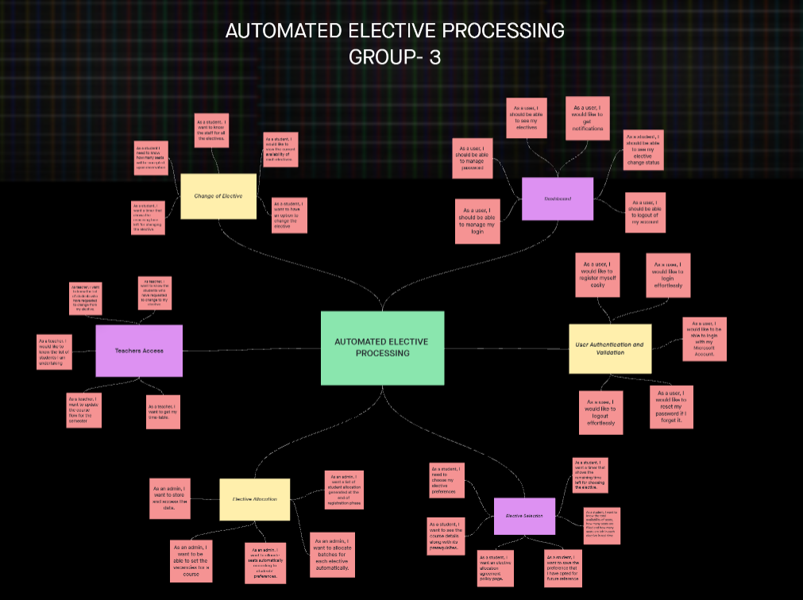
MEETING MINUTES GROUP 3
Week 3 16 February 2022

Participants:
- E Santhosh Bharathi
- Maithreyan S
- Saurav S
- Tejaswi V
- Viswabharathi K A

Meeting Agenda:
- Revise the wireframe model for forms.
- Verify the tables and fix the database.
- Start with Behaviour model diagrams
- Split the work for Use case diagram, Sequence diagram, Class diagram and activity diagram.

Actions to be completed:
Action | Person
Complete Time Sequence diagram | Saurav S
Complete Use Case diagram | Tejaswi
Complete Activity Diagram | Maithreyan
Complete Class Diagram and data flow diagram | Viswabharathi
Start coding Login Page | Santhosh Bharathi

Meeting Summary:
Revisited the tables after normalization. Finetuned the wireframe models that was completed as a part of task assigned in the previous week. Discussed scenarios for Behaviour model diagrams. Assigned different diagrams to team members. Preparing to start coding the webpages.

Tracking the tasks assigned in the previous week:
- Tables after normalization
- Wireframe model
Tables before normalization:
Student Table
Student ID(PK) | Student name | Year | Semester | Course ID(FK) | Elective ID(FK) | Dept ID(FK) | Email | Username (FK) | Enrolment

Faculty Table
Faculty ID(PK) | Faculty Name | Dept ID(FK) | Elective ID(FK) | Course ID(FK) | Qualifications | Date of Join

Department Table
Dept ID(PK) | Dept Name | Dept HOD

Elective Table
Elective ID(PK) | Elective Name | Prerequisite Course ID (FK) | Faculty ID(FK) | Dept ID(FK) | Semester | Credits

Core Course Table
Course ID(PK) | Course Name | Semester | Dept ID(FK) | Credits

Login Table
Username (PK) | Password | Microsoft login

Functional Dependencies:
Student ID Student Name
Student ID Email
Student ID Username
{Student ID, Semester} year
Student ID Class name
Faculty ID Faculty name
Faculty ID Date of join
Faculty ID Qualification
Dept ID Dept Name
Dept ID Dept HOD
Course ID Course Name
Course ID Course_table.Credits
Elective ID Elective Name
Elective ID Elective_table.Credits
Username Password
Student ID Microsoft login
Student ID Username
Course ID Semester
Elective ID Semester
{Student ID, Course ID} Enrolment
{Student ID, Elective ID} Enrolment

Tables after normalization (Till 3NF):
Student’s_ID | Student’s_Name | Year | Semester | Class_Name | Username | Email

Faculty_ID | Faculty_Name | Faculty_DOJ | Faculty_qualification | Username

Dept_ID | Dept_HOD | Dept_Name

Course_ID | Semester | Credits | Course_Name

Elective_ID | Elective_details_PDF_link | Elective_Name

Elective_ID | Dept_ID | Semester

Student’s_ID | Elective_ID | Enrollment

Student’s_ID | Course_ID | Enrollment

Faculty_ID | Semester | Course_ID | Elective_ID

Username | Password | Microsoft_Login

Student’s_ID | Faculty_ID | Dept_ID

Wireframe model:
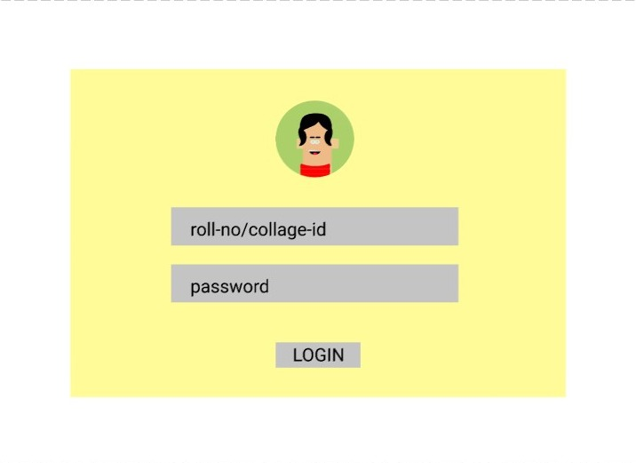
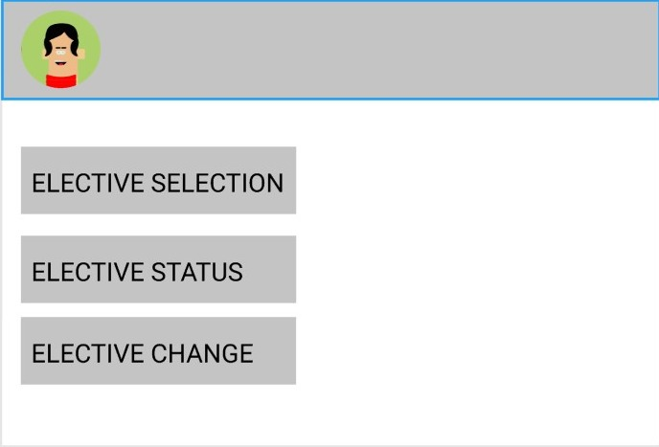

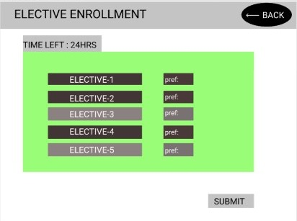

MEETING MINUTES GROUP 3
Week 4 23 February 2022

Participants:
- E Santhosh Bharathi
- Maithreyan S
- Saurav S
- Tejaswi V
- Viswabharathi K A
Meeting Agenda:
- Discuss about the forms that are required
- Come up with the UI design
- Finalize the product backlog and start the sprint backlog
- Finalize the total number of web pages required for sprint1
- Split the tasks

Actions to be completed:
Action | Person
Login Page completion | Santhosh Bharathi
Start coding student dashboard page | Viswabharathi
Start coding elective selection form | Tejaswi
Create tables in database | Maithreyan
Register students and populate the database | Saurav

Meeting Summary:
Discussed about the current progress and future plans for splitting tasks. Finalized the UI designs and the number of pages. Created tables and populated the database.

Tracking the tasks assigned in the previous week:
Use case diagram
Class diagram
Sequence diagram
Activity diagram
State diagram
Dataflow Diagram
Level 1:
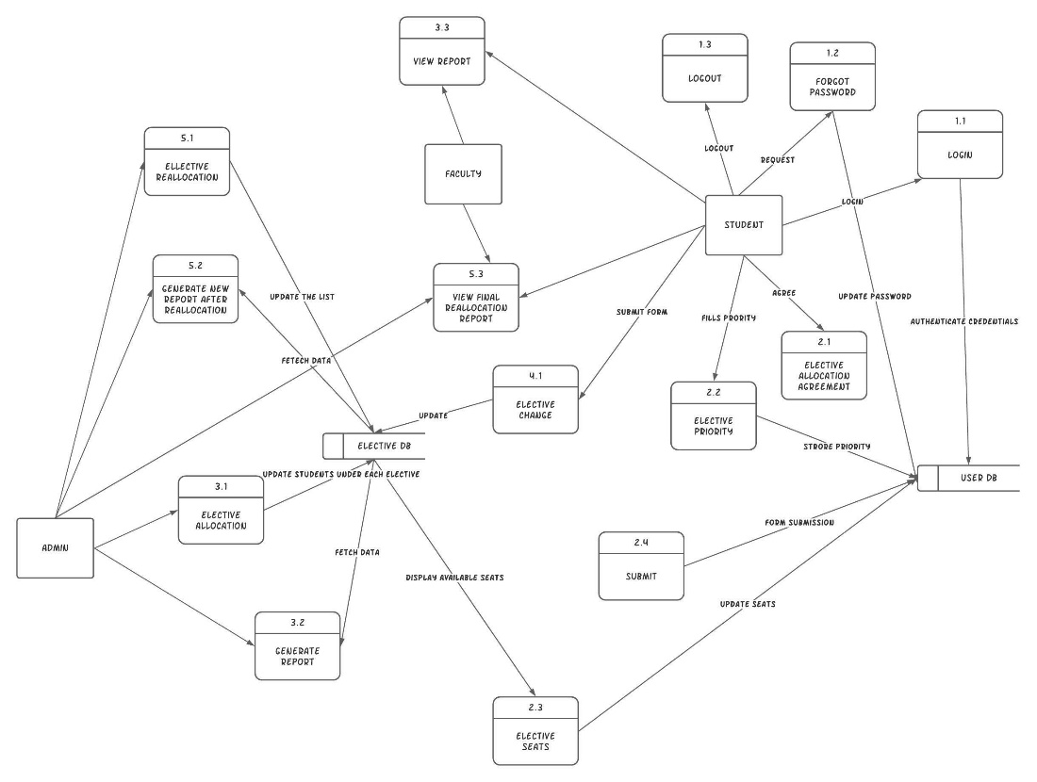

Level 2:
