CLIENT WORKFLOW & TEST GUIDE

Section Measurements
Create a reusable measurement group once, count every occurrence, and keep the original measurements fully editable.
Core result: A section is a project-level counting group. It references existing measurements; it does not create duplicate measurement rows.

Workflow at a glance
- Measure the source area — Create the normal line measurements first.
- Select Section Measurements — Choose the tool from the top toolbar.
- Draw the boundary — Drag a rectangle around the measurements that belong together.
- Name and save — Enter an editable Group / Section Name, then select Save & Start Counting.
- Count other occurrences — Click each additional drawing location where the same section occurs; select Finish Placement or press Esc when done.

How the totals work
Group Qty: Measurements in the section × Used places. Example: 7 measurements × 3 places = 21.

What stays unchanged
- Original measurements remain individually selectable, editable, movable and deletable.
- Member, length, label, color and other properties remain attached to each original measurement.
- Counting a section does not add duplicate rows to the Measurements grid.
- Zoom and pan remain available while creating, reviewing and placing sections.
Use this guide with the current BuildTakeoff Pro interface. Button position may vary slightly with screen size and zoom.

1. Create and place a section
Example shown: Section 1 contains 7 measurements and is recorded at 3 places, so Group Qty is 21.
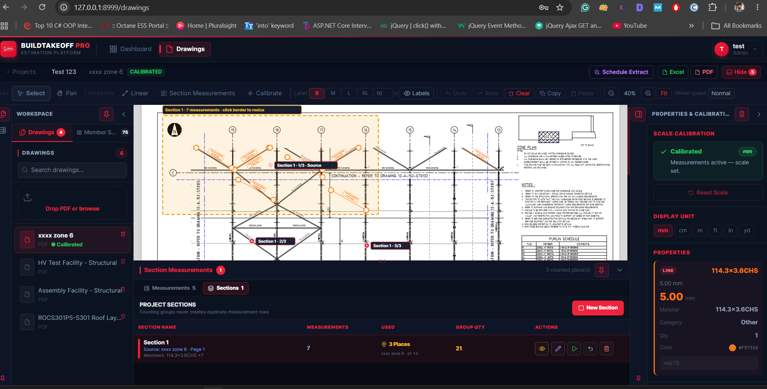
Figure 1. A saved section with its source boundary and counted locations.

Create the group
- Prepare measurements — Make sure every item to include already appears on the PDF and in the Measurements grid.
- Choose the tool — Select Section Measurements in the toolbar.
- Drag a rectangle — Start outside the first item and finish outside the last item. Every measurement inside the boundary is selected.
- Confirm the name — Review the selected count, edit the suggested name if required, and choose Save & Start Counting.

Count repeated locations
- Keep the section active — The green action button starts placement mode for the selected section.
- Mark each occurrence — Click each location where the complete group occurs. The Used total and Group Qty update immediately.
- Finish safely — Choose Finish Placement or press Esc. Existing measurements and rows remain unchanged.
Tip: The source PDF and page are stored with the section, making it easy to identify where the group was created.

2. Review, reuse and manage sections
The Sections view provides the section name, source drawing/page, member summary, measurements, Used places and calculated Group Qty.
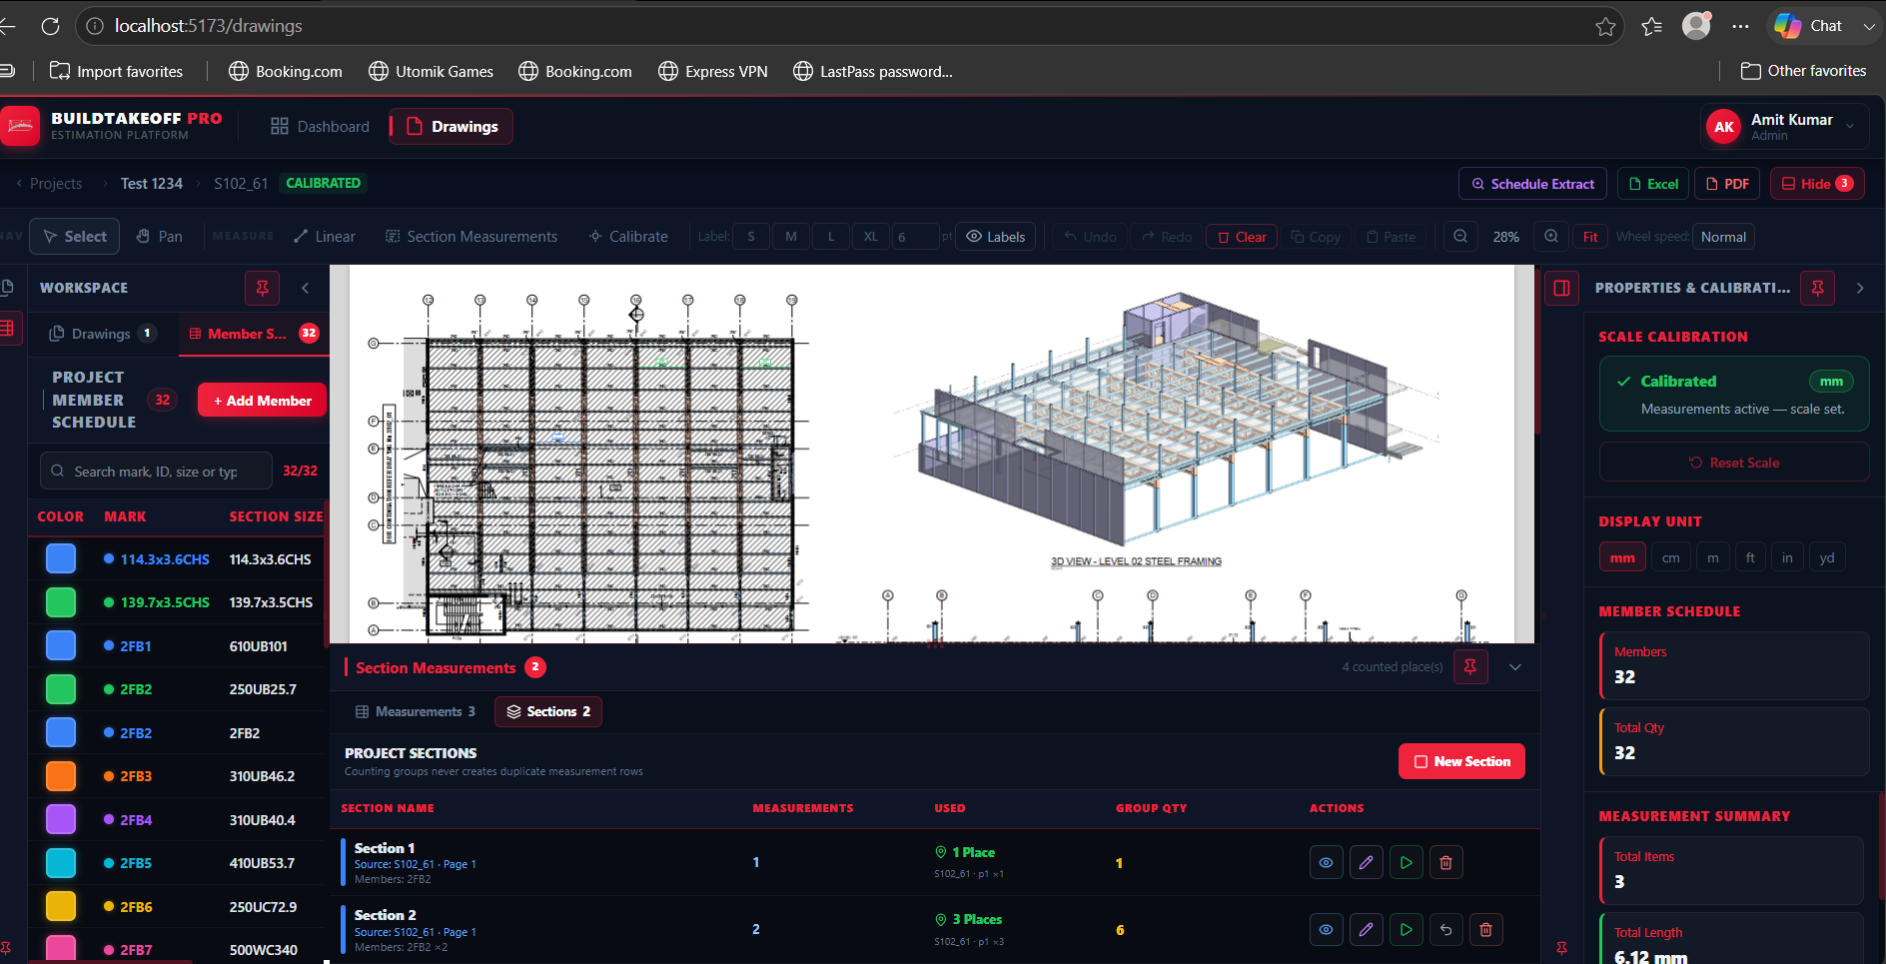
Figure 2. Project Sections view used to review and reuse saved groups.

Section View actions
Action | Purpose | Expected result
Eye / Used places | Review locations | Opens the source drawing and toggles all section/place highlights on or off.
Edit | Resize or update | Shows resize handles. Updating the boundary refreshes included measurements while counted places remain.
Play | Add occurrences | Activates placement mode so additional project locations can be counted.
Undo | Remove last extra place | Removes only the most recent additional counted location.
Delete | Remove the group | Deletes the section group after confirmation; original measurements remain separate.

Client acceptance checklist
- ☐ Create a section around several existing measurements and save a custom name.
- ☐ Confirm the original measurements can still be selected and edited individually.
- ☐ Activate the section and mark at least two additional locations.
- ☐ Confirm Used places and Group Qty match: measurements × places.
- ☐ Use Eye/Used places to show and hide all saved locations; use Edit to resize and update the section.
- ☐ Confirm no duplicate individual measurement rows are created by section counting.

