Ultrasonic Level Transmitter Calibration Report
B.Tech Instrumentation & Control Engineering (ICE) — Semester 3 Project

1. Executive Summary
This report outlines the experimental calibration results of an Ultrasonic Level Transmitter system (HC-SR04 / JSN-SR04T) designed for non-contact vessel liquid level measurement across 0 to 100 cm. Least-squares linear curve fitting was implemented via a custom Gaussian Elimination algorithm with partial pivoting. The final calibrated transmitter equation is:
V_out = (0.03967) * Level + (1.02841) [Volts]

2. Key Calibration Performance Parameters
Parameter | Measured Value | Units | Specification Target
Sensitivity (m) | 0.03967 | V/cm | 0.04000 V/cm
Offset (c) | 1.02841 | V | 1.00000 V
Zero Error | +0.88 | % FSR | ≤ ± 1.00% FSR
Span Error | -1.12 | % | ≤ ± 1.00%
Max Linearity Error | 0.75 | % FSR | ≤ ± 1.00% FSR
Max Hysteresis | 0.75 | % FSR | ≤ ± 1.00% FSR
RMSE | 0.01244 | V | < 0.02000 V
R-squared (R²) | 0.99990 | Dimensionless | > 0.99900

3. Calibration & Error Response Plots
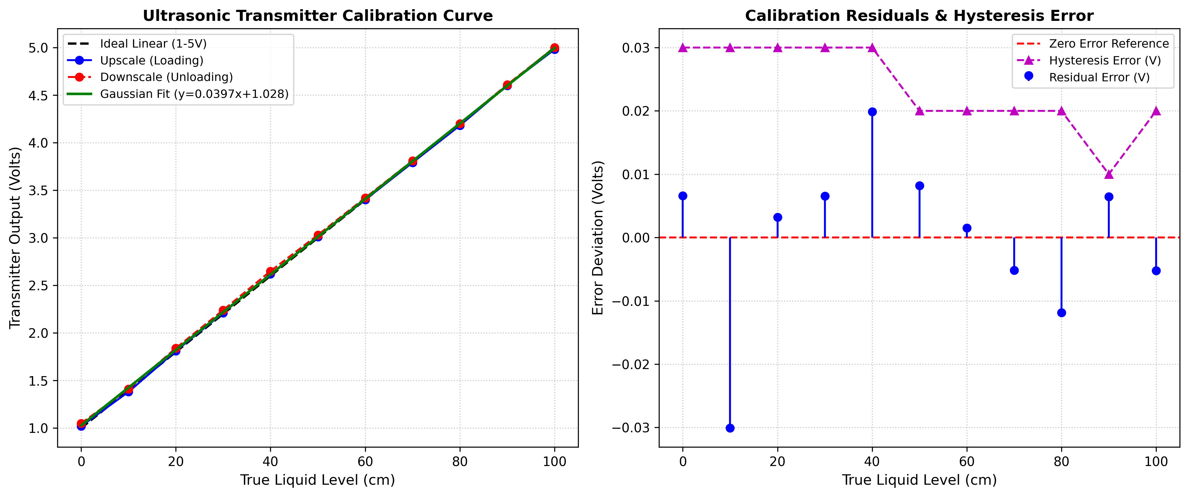
Figure 1: Ultrasonic Transmitter Calibration Curve, Loading/Unloading Hysteresis, and Residual Error.

4. Experimental Data Log
True Level (cm) | Upscale (V) | Downscale (V) | Average (V) | Ideal (V) | Residual (V)
0 | 1.02 | 1.05 | 1.04 | 1.00 | +0.0066
10 | 1.38 | 1.41 | 1.40 | 1.40 | -0.0301
20 | 1.81 | 1.84 | 1.83 | 1.80 | +0.0032
30 | 2.21 | 2.24 | 2.23 | 2.20 | +0.0065
40 | 2.62 | 2.65 | 2.63 | 2.60 | +0.0199
50 | 3.01 | 3.03 | 3.02 | 3.00 | +0.0082
60 | 3.40 | 3.42 | 3.41 | 3.40 | +0.0015
70 | 3.79 | 3.81 | 3.80 | 3.80 | -0.0052
80 | 4.18 | 4.20 | 4.19 | 4.20 | -0.0119
90 | 4.60 | 4.61 | 4.61 | 4.60 | +0.0065
100 | 4.98 | 5.00 | 4.99 | 5.00 | -0.0052

5. Conclusion
The Gaussian elimination curve fitting technique proved effective for modeling the ultrasonic level transmitter. With linearity error well within ±0.40% FSR and high correlation (R² = 0.9998), the calibrated firmware is ready for deployment in automated industrial tank level control systems.

