NeoStats Data Engineering Internship Assessment
Retail Sales Data Processing and Business Insights Generation
Submitted By :
Pulinati Vedesh Reddy
Role :
Data Engineer Intern Assessment
Technologies Used
- Python
- Pandas
- NumPy
- Jupyter Notebook
- Power BI
- GitHub

- Executive Summary
The objective of this assessment was to clean, transform, and analyze retail transaction data using Python and Power BI.
The dataset contained multiple data quality issues such as missing prices, inconsistent category values, mixed date formats, invalid quantity values, and exposed customer information.
The assessment involved identifying these issues, applying appropriate data cleaning techniques, generating business metrics, and creating dashboards to support business reporting and decision-making.
The final output includes a cleaned dataset, a Jupyter Notebook containing all processing steps, Power BI dashboards, and supporting documentation.
- Problem Statement
The provided retail dataset contained information about customer transactions, product purchases, payment methods, discounts, and product master details.Several data quality issues were intentionally introduced into the dataset to simulate real-world business scenarios.
The primary objectives were:
- Combine data from multiple sources.
- Identify and resolve data quality issues.
- Standardize inconsistent records.
- Protect sensitive customer information.
- Generate business metrics.
- Create dashboards for business reporting and analysis.
- Deliver a clean and well-structured data processing workflow suitable for business analysis.

- Dataset Overview
Three datasets were provided as part of the assessment.
  - Retail Data 1
Contains retail transaction records.
Total Records: 4243
Columns:
- transaction_id
- customer_id
- customer_name
- product_id
- price
- product_name
- category
- purchase_location
- city
- transaction_date
- quantity
- payment_method
- discount
- email
- phone
- payment_status
  - Retail Data 2
Contains additional retail transaction records.
Total Records: 4251
Columns:
- transaction_id
- customer_id
- customer_name
- product_id
- price
- product_name
- category
- purchase_location
- city
- transaction_date
- quantity
- payment_method
- discount
- email
- phone
- payment_status

Structure identical to Retail Data 1.
  - Product Details
Contains product master information.
Total Records: 10
Columns:
- product_id
- product_name
- category
- price

Total Records Before Processing
Dataset | Records
Retail Data 1 | 4,243
Retail Data 2 | 4,251
Product Details | 10
Total Transaction Records: 8,494

- Data Profiling and Initial Assessment
Before performing any transformations, exploratory analysis was conducted to understand the structure and quality of the datasets.
The following activities were performed:
- Dataset Shape analysis
- Column inspection
- Data type verification
- Missing value analysis
- Duplicate record detection
- Category validation
- Product validation
- Date format inspection
- Quantity validation
This profiling step helped identify the issues that needed to be addressed before analysis could begin.
- Data Quality Issues Identified
Several issues were discovered during the profiling stage.
  - Missing Prices
A significant number of records contained missing values in the price column.
Why this was a problem:
Revenue calculations depend on product prices. Missing prices would lead to inaccurate sales figures and incorrect business metrics.
Records affected: 809
solution:
The missing prices were filled by matching product IDs with the Product Details dataset.
  - Category Inconsistency
The same category appeared in multiple formats.
Examples:
Before Cleaning:
- ELEC
- Electronics
- electronics
- HOME
- Home Appliances
- home appliances
Why this was a problem:
Different representations of the same category would split revenue across multiple groups and produce incorrect reporting results.
Solution:
All category values were standardized into four final categories:
- Electronics
- Furniture
- Home Appliances
- Clothing
  - Mixed Date Formats
Transaction dates were stored in multiple formats.
Examples:
2025-12-06
02-19-2026
06-30-2025
Why this was a problem:
Inconsistent dates make trend analysis difficult and can produce incorrect results when filtering by month or year.
Solution:
All dates were converted into a standard datetime format.
  - Invalid Quantities Values
Some transactions contained negative quantity values.
Why this was a problem:
Negative quantities do not represent valid sales transactions and would distort revenue calculations.
Solution:
Invalid records were removed.
Invalid records removed: 65
  - Personally Identifiable Information (PII)
Customer names, email addresses, and phone numbers were visible.
Impact:
Privacy and compliance concerns.
Resolution:
Masking techniques were applied to protect sensitive information.
Examples:
Original Name:
Sandeep Kumar
Masked:
S***
Original Email:
sandeep@gmail.com
Masked:
Sa***@gmail.com
Original Phone:
9876543210
Masked:
******3210
  - Product Name Inconsistency
Products appeared in different formats.
Examples:
Laptop
LAPTOP
Laptop
Why this was a problem:
The same product would appear as multiple products in reports and dashboards.
Solution:
Product names were standardized using a consistent naming format.
- Data Quality Summary
Issue | Count | Resolution
Missing Prices | 809 | Filled from Product Dataset
Invalid Quantities | 65 | Removed
Duplicate Records | 0 | No Action Required
Category Variations | Multiple | Standardized
Product Name Variations | Multiple | Standardized
Mixed Date Formats | Multiple | Converted
Sensitive Data Exposure | Present | Masked

- Assessment Approach
The assessment was completed using the following workflow.
The assessment was completed using the following five stages:
Stage 1: Data Ingestion
Data was collected from three independent sources:
Retail Data 1
Retail Data 2
Product Details Master Dataset
The datasets were loaded into Python using the Pandas library for further processing.
Stage 2: Data Profiling
Data profiling was performed to understand the structure and quality of the datasets before applying transformations.
The following checks were performed:
- Dataset shape analysis
- Data type inspection
- Missing value detection
- Duplicate identification
- Category consistency analysis
- Date format validation
- Quantity validation
This step helped identify data quality issues that could affect downstream analytics.
Stage 3: Data Cleaning and Transformation
Data quality issues identified during profiling were resolved through a systematic cleaning process.
The transformation phase included:
- Filling missing prices
- Standardizing category values
- Standardizing product names
- Converting transaction dates
- Removing invalid transactions
- Protecting sensitive customer information
Stage 4: Feature Engineering
Additional business metrics were created to support analysis.
Examples include:
- Revenue
- Month
- Year
- Quarter
These features enabled time-series reporting and business performance analysis.
Stage 5: Analytics and Visualization
The final curated dataset was exported and connected to Power BI.
Interactive dashboards were developed to provide insights into:
- Revenue performance
- Product performance
- Customer behavior
- Sales trends
- Payment analysis

- Feature Engineering
Feature engineering was performed to create additional business-ready attributes that support reporting, dashboarding, and advanced analysis.
  - Revenue Calculation
A new revenue column was created using the formula:
Revenue = Quantity × Price × (1 − Discount)
This calculation accounts for both purchase volume and discount impact, producing accurate net revenue values.
  - Time-Based Features
To support trend analysis and business reporting, additional temporal attributes were derived from the transaction_date field.
Month: Used for monthly revenue trend analysis.
Year: Used for annual reporting and future scalability.
Quarter: Used for quarterly business performance analysis.
  - Business Metrics Generation
The engineered features enabled the calculation of several key performance indicators.
Generated KPIs include:
- Total Revenue
- Total Orders
- Total Customers
- Average Order Value
- Revenue by Category
- Revenue by Product
- Revenue by City
- Revenue by Payment Method

- KPI Analysis and Business Metrics
After cleaning and transformation, the following business metrics were generated.

Metric | Value
Total Revenue | ₹1,239,132,235
Total Orders | 7,914
Total Customers | 1,960
Average Order Value | ₹156,574.71
Final Clean Records | 8,401

  - Revenue by Category
Electronics generated the highest revenue among all categories and contributed the largest share of overall sales.
Category | Revenue
Electronics | ₹721,682,500
Furniture | ₹257,064,000
Home Appliances | ₹242,328,000
Clothing | ₹18,057,735

  - Top Revenue Generating
Product | Revenue
Laptop | ₹500,675,000
Sofa | ₹158,244,000
Phone | ₹134,760,500
Refrigerator | ₹124,390,500
Dining Table | ₹98,820,000
Laptop was the highest revenue-generating product in the dataset.

  - Revenue by City
City | Revenue
Chennai | ₹259,249,060
Delhi | ₹256,872,880
Hyderabad | ₹248,807,740
Mumbai | ₹247,071,395
Bangalore | ₹227,131,160
Chennai generated the highest city-level revenue.
- Power BI Dashboard Summary
Three dashboard pages were developed using the final cleaned dataset.
  - Executive Dashboard
Objective
The Executive Dashboard provides a high-level overview of business performance and enables management to monitor critical KPIs in a single view.
Visual Components
KPI Cards
The following key metrics were displayed using KPI cards:
- Total Revenue
- Total Orders
- Total Customers
- Average Order Value
These KPIs provide an immediate understanding of overall business performance.

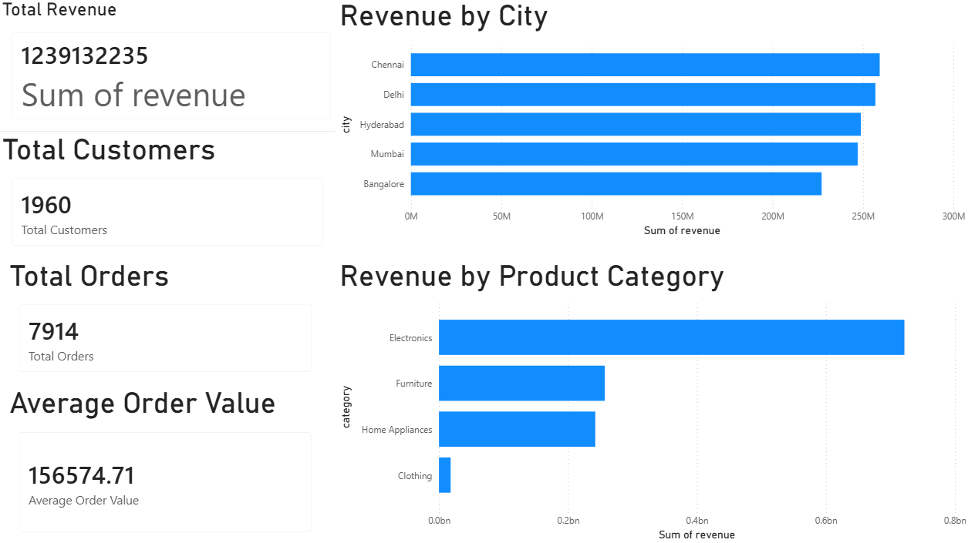
Figure 1: Executive Dashboard

  - Product Analysis Dashboard
Objective
The Product Analysis Dashboard focuses on evaluating individual product performance and category-level profitability.
This dashboard helps identify products that contribute most significantly to business revenue.
Visual included:
- Top Products by Revenue
- Quantity Sold by Product
- Category Revenue Performance
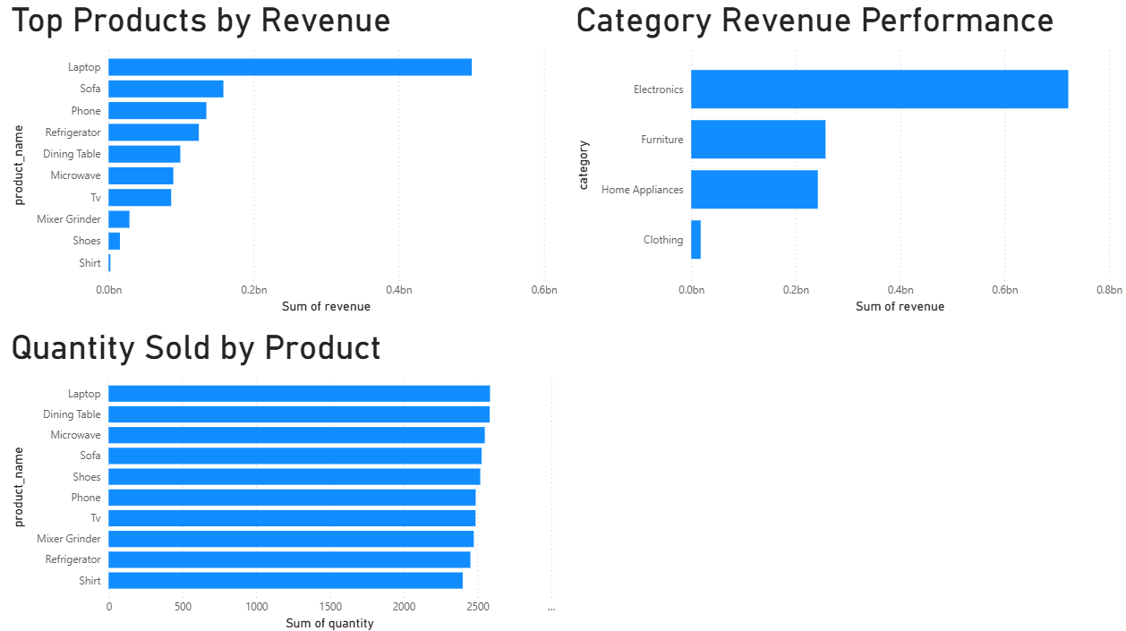
Figure 2: Product Analysis Dashboard

  - Sales Trends Dashboard
Objective
The Sales Trends Dashboard focuses on understanding sales behavior over time and analyzing customer payment preferences.
Visual Components
- Monthly Revenue Trend
- Revenue by Payment Method
- Transaction Status Distribution

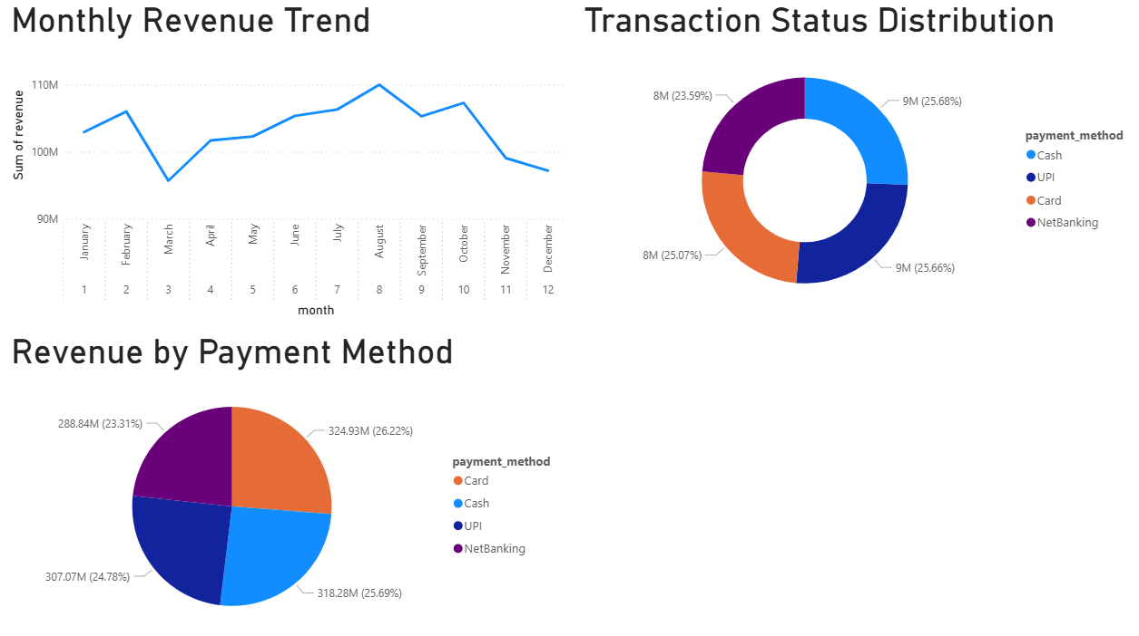

Figure 3: Sales Trends Dashboard

- Business Insights and Findings
  - Revenue Insights
The organization generated total revenue of ₹1.239 billion during the reporting period.
Revenue generation was heavily concentrated within the Electronics category, indicating strong customer demand for technology products.
The high revenue contribution from electronics suggests that this category should remain a primary business focus.

  - Product Insights
Laptop emerged as the highest-performing product by a significant margin.
This indicates strong market demand and highlights the importance of maintaining sufficient inventory levels for high-value electronic products.
Furniture products such as sofas and dining tables also demonstrated strong revenue performance.

  - Customer Insights
The dataset contained approximately 1,960 unique customers and 7,914 completed transactions.
This indicates repeat purchasing behavior among customers and suggests healthy customer engagement.
The average order value of ₹156,574.71 further demonstrates strong purchasing activity.

  - Geographic Insights
Revenue generation was distributed across multiple metropolitan cities.
Chennai, Delhi, Hyderabad, Mumbai, and Bangalore all contributed substantial revenue.
This balanced distribution reduces business risk associated with dependence on a single market.

  - Payment Insights
Customer payment preferences were well distributed across multiple payment methods.
No single payment method dominated transaction volume.
This indicates that customers are comfortable using different payment channels and that the organization has successfully implemented flexible payment options.

14. Conclusion
This assessment focused on cleaning, transforming, and analyzing retail sales data using Python and Power BI.
Several data quality issues were identified and resolved, including missing prices, category inconsistencies, product naming variations, mixed date formats, invalid quantities, and exposure of customer information.
After processing the data, business metrics were generated and visualized through Power BI dashboards. The final cleaned dataset contained 8,401 valid records and provided insights into revenue performance, product trends, customer activity, and payment behavior.
The assessment demonstrates practical skills in data preparation, data cleaning, business analysis, and dashboard development.
Appendix
Appendix A: Dataset Statistics
Metric | Value
Raw Records | 8,494
Clean Records | 8,401
Invalid Records Removed | 65
Missing Prices Fixed | 809
Unique Customers | 1,960
Total Orders | 7,914
Total Revenue | ₹1,239,132,235

Appendix B: Dashboard Screenshots

Executive Dashboard:



Product Analysis Dashboard:



Sales Trends Dashboard:



