RESEARCH REPORT

Uniswap on Base —
Activity, Concentration & Return Behavior
A 31-day on-chain analysis of participation, activity concentration, return behavior, and data quality
Version: 1.3
Observation window: 16 August – 15 September 2026 (31 UTC calendar days)
Scope: Base • Uniswap v2 / v3 / v4 • Dune Spellbook `dex.trades`
Wallet unit: `tx_from` — transaction signer
Transaction unit: distinct `tx_hash`
Production queries: 8733968, 8733972, 8731863, 8733974, 8733441, 8733980
Dashboard: Uniswap on Base — Activity, Concentration & Return Behavior (V1)

Executive summary
This report examines whether observed Uniswap activity on Base is broadly distributed across wallets or disproportionately generated by a smaller high-frequency tail, and whether observed participants return on later days. This study provides a 31-day descriptive analysis of Uniswap activity on Base, examining observed signer participation, transaction frequency, activity concentration, and return behavior. It does not attempt to identify individual humans, classify bots, or construct a formal measure of user quality.
Participating wallets | Distinct transactions | Adjusted reported volume
569,864 | 19,932,002 | $8.26B
Average daily active wallets | Median tx / wallet | Median active days / wallet
58,579 | 2 | 1
Participation is broad, but intensity is highly skewed. 82.8% of wallets made 10 or fewer transactions, while 0.73% made more than 500. The >500 group generated about 65.6% of all transactions.
Transaction and volume concentration are substantial. The top 1% of wallets represented 68.94% of transactions and 71.54% of adjusted volume; the top 0.1% represented 42.44% and 39.51%, respectively.
Return behavior varies by observed activity segment. Across all eligible wallets, 38.26% returned on a later day (2nd-day return) and 37.07% returned within 7 days. Segment results are descriptive because segment membership is defined over the same full window.
A material volume anomaly was independently investigated. Three Uniswap v4 transactions generated about $28.23B of reported volume on 18 August. Raw V4 events matched `dex.trades` 1:1, while reported USDC swap amounts were not backed by comparable ERC-20 settlement. The transactions were excluded from volume metrics only.

1. Research question and analytical frame
The analysis is organized around four dimensions: scale, frequency, concentration, and return behavior. This framing separates how many participants exist from how much activity they generate, and from whether they are observed again on later days.
The wallet unit is `tx_from`, the address that signed and sent the transaction. `taker` is not used because it can represent a router or aggregator contract. A transaction is a distinct `tx_hash`; a single transaction can produce multiple `dex.trades` rows through multi-hop or multi-pool execution.

2. Data and methodology
Method item | Definition
Data source | Dune Spellbook `dex.trades`; Base; Uniswap v2, v3 and v4.
Window | 16 Aug – 15 Sep 2026 inclusive; 31 UTC days; `block_date` with `block_month` partition pruning. V1 snapshot date: 16 September 2026; Dune datasets are continuously refreshed, so future executions may produce different results.
Volume | `SUM(amount_usd)` across trade rows, excluding the three identified anomalous transactions. Multi-hop swaps count each hop; rows without USD price contribute no volume.
Active day | UTC calendar day on which the wallet made at least one Uniswap trade.
Frequency | 1; 2–10; 11–50; 51–100; 101–500; 501–1,000; >1,000 transactions.
Concentration | Wallets ranked by transaction count and grouped into 1,000 equal groups; cumulative transaction and USD-volume shares reported.
Return behavior | Activity on a later calendar day. Same-day activity does not count as return.
Cohort eligibility | 2nd-day return <= 14 Sep; D7 <= 8 Sep; D14 <= 1 Sep; D30 = 16 Aug only.
Segments | Casual 1–10; Regular 11–500; High-frequency >500 transactions across the full window. Descriptive, not predictive.
Source: Dune query 8733980 — Methodology & definitions. Open methodology query

3. Findings

3.1 Scale and activity profile
The production run records 569,864 participating wallets and 19,932,002 distinct transactions over the 31-day window. Adjusted reported volume is $8,260,205,266. The average number of daily active wallets is 58,579. The median wallet makes 2 transactions and is active on 1 day; 37.08% of wallets are active on at least 2 days.

3.2 Transaction frequency distribution
Transaction frequency is highly right-skewed. A large majority of wallets sit at the low-frequency end, while a small high-frequency tail contributes most of the transaction throughput.
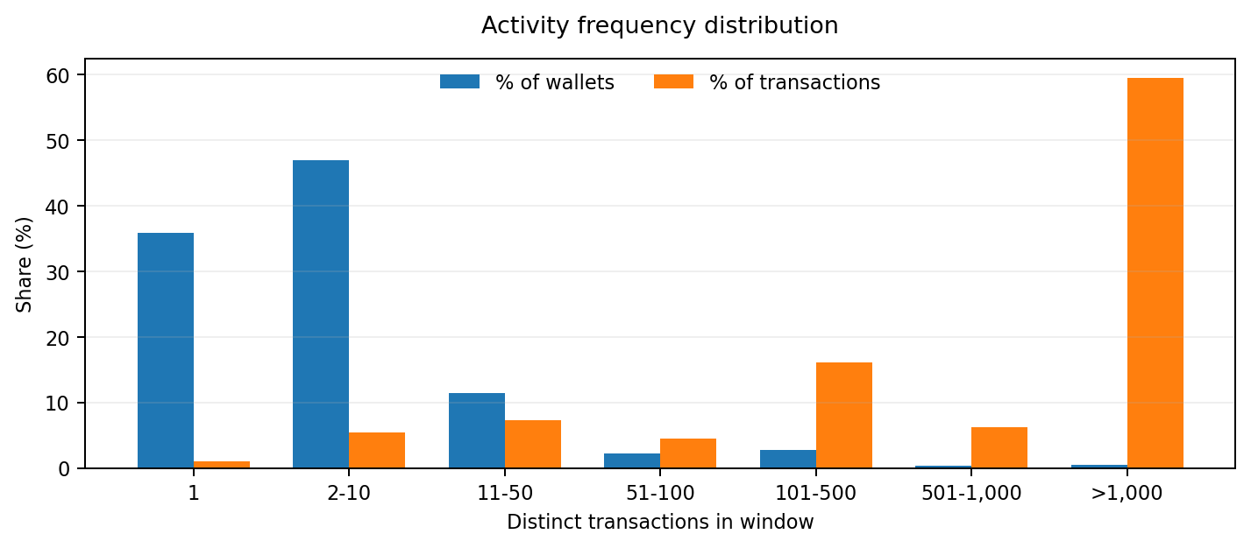
Figure 1. Wallet share versus transaction share by frequency bucket.
Bucket | Wallets | % wallets | Transactions | % tx | Median active days
1 | 204,280 | 35.85% | 204,280 | 1.02% | 1
2-10 | 267,527 | 46.95% | 1,074,025 | 5.39% | 1
11-50 | 65,406 | 11.48% | 1,458,660 | 7.32% | 6
51-100 | 12,678 | 2.22% | 901,036 | 4.52% | 15
101-500 | 15,812 | 2.77% | 3,213,661 | 16.12% | 20
501-1,000 | 1,781 | 0.31% | 1,229,482 | 6.17% | 29
>1,000 | 2,380 | 0.42% | 11,850,858 | 59.46% | 30
The 1 and 2–10 buckets together contain 82.8% of wallets but only about 6.4% of transactions. At the other end, the >500 bucket contains 0.42% of wallets and 59.46% of transactions; including the 501–1,000 bucket raises that activity share to about 65.6% while covering only 0.73% of wallets. These figures describe concentration of observed activity and do not establish that the high-frequency tail consists of bots.

3.3 Wallet concentration
The concentration analysis ranks wallets by transaction count and then measures cumulative shares of transactions and adjusted USD volume. The resulting curve remains far from an equal-share distribution.
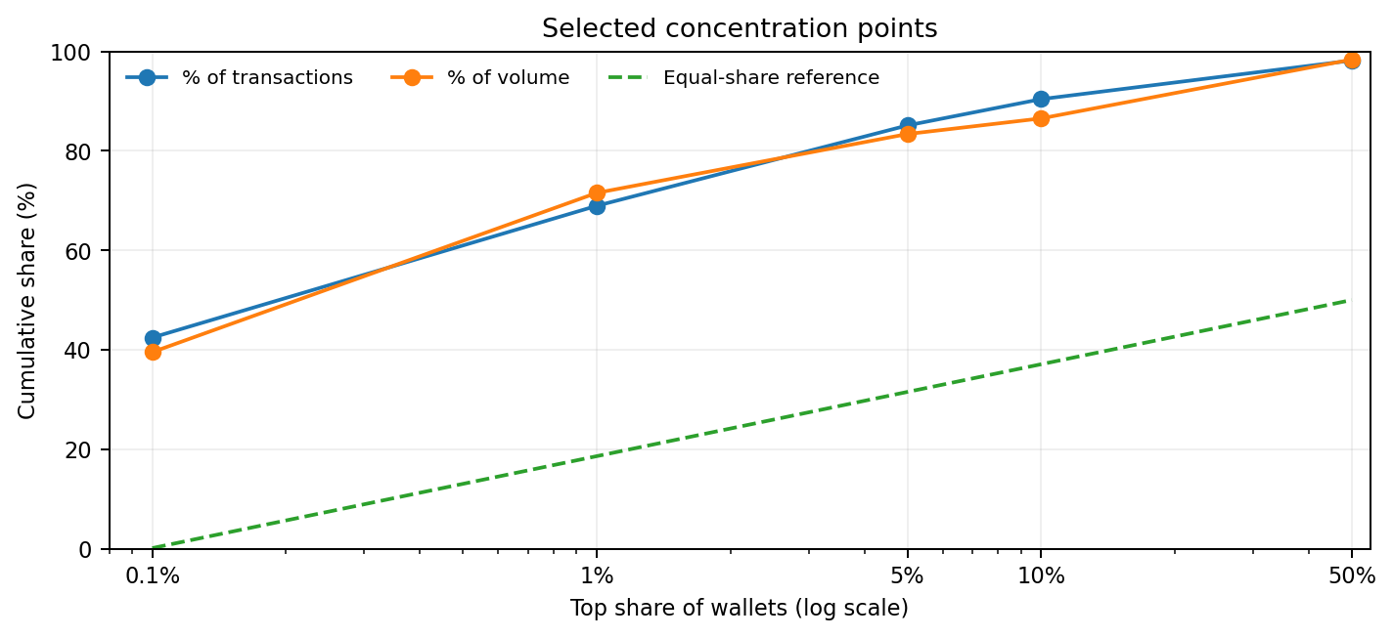
Figure 2. Selected cumulative concentration points; equal-share reference shown for context.
Top wallet share | % transactions | % volume
0.1% | 42.44% | 39.51%
1% | 68.94% | 71.54%
5% | 85.11% | 83.38%
10% | 90.40% | 86.52%
50% | 98.17% | 98.36%
At the 1% cutoff, the leading wallets account for 68.94% of transactions and 71.54% of adjusted volume. At 10%, the corresponding shares are 90.40% and 86.52%. Because the wallet unit is transaction signer, infrastructure such as bundlers and relayers can aggregate multiple end users into one observed signer.

3.4 Observed return behavior
Return is defined as activity on a later UTC calendar day after the wallet’s first active date within the window. This is not conventional retention: wallets active before the window are included, the metric counts any later calendar day rather than a fixed 48-hour horizon, and the signer may not correspond to a single end user.
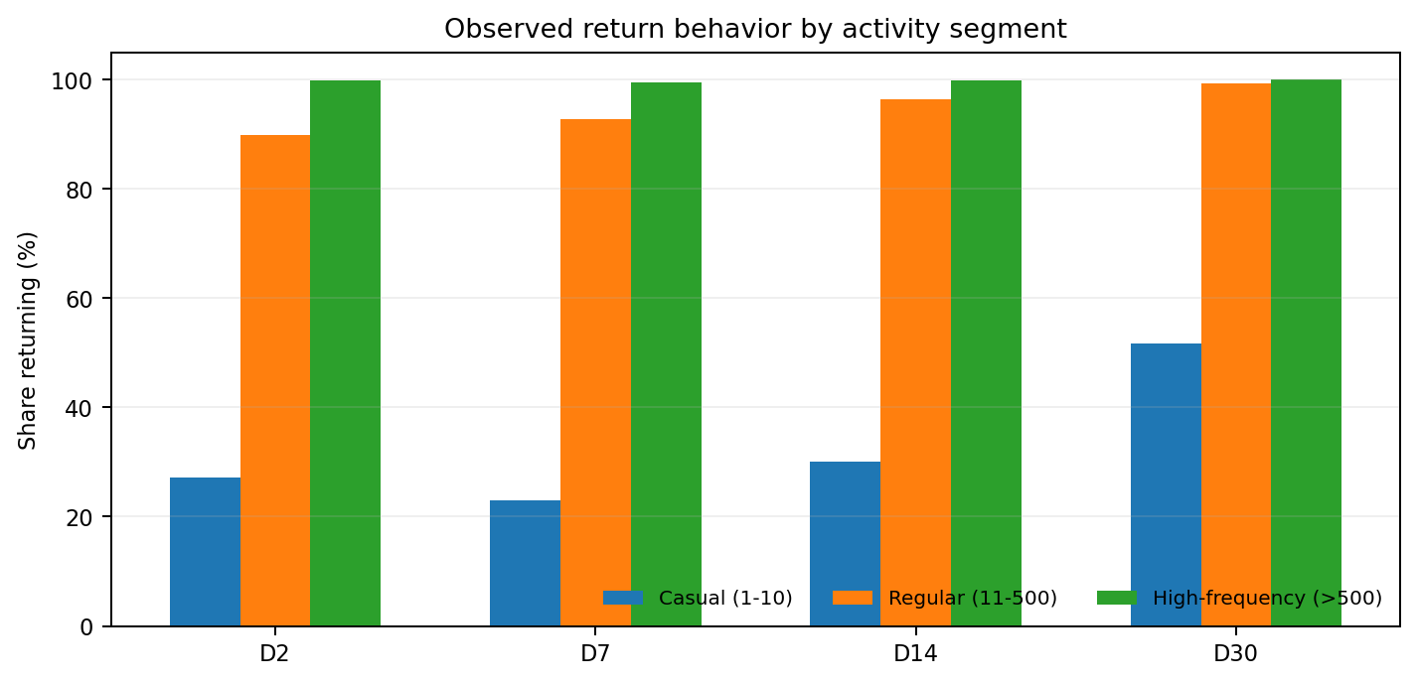
Figure 3. Observed return behavior by full-window activity segment.
Segment | Wallets | Median days | Returned (2nd day) | D7 | D14 | D30
Casual (1-10) | 471,807 | 1 | 27.13% | 22.92% | 30.00% | 51.66%
Regular (11-500) | 93,896 | 8 | 89.93% | 92.70% | 96.35% | 99.27%
High-frequency (>500) | 4,161 | 29 | 99.93% | 99.46% | 99.79% | 99.97%
All | 569,864 | 1 | 38.26% | 37.07% | 45.14% | 82.02%
Across all eligible wallets, 2nd-day return (activity on any later day inside the window) is 38.26%, D7 is 37.07%, D14 is 45.14%, and D30 is 82.02%. The D30 value is based only on the 16 August cohort (37,975 eligible wallets) and is dominated by previously active wallets. Segment results also contain temporal leakage because the segment is defined using full-window transaction count.

4. Data-quality investigation: 18 August 2026
On 18 August, three Uniswap v4 transactions produced approximately $28.23B of reported volume, or 99.6% of the day. The three transactions were sent by one observed wallet and generated 1,276 trade rows. This was investigated at the raw event and token-settlement levels before deciding how to treat the volume.
Tx | Swap events | Reported vol. | Pools | Reported USDC swaps | Actual USDC
0x818c…1553 | 510 | $13.47B | 8 | 13.438B | 0.000096
0x675e…0bbf | 510 | $9.58B | 8 | 9.550B | 0.000101
0x8294…5f47 | 256 | $5.18B | 4 | 5.158B | 0.000050
1. Event-level reconciliation. Raw `uniswap_v4_base.poolmanager_evt_swap` events and `dex.trades` rows matched one-for-one: 510/510, 510/510, and 256/256, with no unmatched events on either side.
2. Liquidity condition. The largest nominal USDC rows came from pools with exactly zero liquidity. The raw events themselves therefore contained the very large nominal quantities that were later reflected in USD volume.
3. Settlement check. Across the three transactions, `dex.trades` reported about 28.15B USDC of swap amounts, while ERC-20 transfer logs showed only 0.000247 USDC transferred into PoolManager and none leaving it.
4. Characterization. The pattern is consistent with Uniswap v4 atomic/flash-accounting behavior: event-level amounts can be emitted while deltas net internally, and zero-liquidity pools can produce nominal amounts that do not represent conventional economically settled volume. The investigation does not establish malicious intent.
5. Production treatment. The three identified transaction hashes are excluded from volume metrics only. Wallet counts, transaction counts, frequency distributions, and return-behavior metrics retain them. No generic `amount_usd` threshold was applied.
Volume correction. In the final synchronized dashboard snapshot, the adjusted 31-day reported volume is $8,260,205,266 after excluding the three identified transactions from volume metrics. Aug 18 falls from $28.334B before exclusion to $101,023,498 after exclusion, which is comparable with neighboring days. The correction is localized and auditable.

5. Limitations and interpretation boundaries
Limitation | Implication
No bot classification | No wallet is labeled or removed as a bot; high-frequency behavior is simply reported.
Smart-account aggregation | ERC-4337 bundlers and relayers can appear as one `tx_from` while representing many end users; EIP-7702 delegated EOAs appear as ordinary wallets.
Window-relative cohorts | First active date is the earliest date inside the window, not lifetime first trade.
Segment leakage | Full-window frequency is used to define segments during the same period in which return is measured.
D30 scope | Only the 16 Aug cohort has a full 30-day horizon; it is dominated by previously active wallets and must not be read as ordinary all-wallet 30-day retention.
Volume coverage | About 10% of trade rows lack USD pricing and do not contribute to volume; multi-hop swaps count each hop.
Snapshot dependence | The underlying Dune dataset can receive late-arriving data, so counts can move modestly between runs.
Anomaly scope | The correction addresses the three identified large unbacked transactions; smaller anomalies outside this investigation would not necessarily be caught.
Signer is not a user | `tx_from` is the transaction signer, not necessarily a human user; a signer can represent a person, bot, smart contract, relayer, router, solver or other infrastructure.
Reported vs settled | Summed `dex.trades` `amount_usd` is reported USD activity, not necessarily economically settled notional.
No benchmark | No cross-period, cross-chain or competing-DEX comparison is included.
Scope of conclusions | V1 is a descriptive activity study. It does not identify individual humans, classify automation, or establish user quality.

6. Reproducibility and query inventory
The dashboard is implemented as six production queries. Query 8733980 is a static methodology reference and does not scan the underlying trade table. The anomaly investigation uses separate diagnostic queries for raw V4 event reconciliation and ERC-20 settlement.
Query | Role | Output
8733968 | Overview KPIs | Scale, wallet counts, transactions, adjusted volume and daily activity.
8733972 | Daily Activity | Daily active wallets, transactions and adjusted volume by date.
8731863 | Transaction Frequency | Wallet frequency buckets and transaction-share distribution.
8733974 | Wallet/Transaction Concentration | Cumulative concentration of transactions and adjusted volume.
8733441 | Return behavior | Observed return behavior and cohort eligibility.
8733980 | Methodology & definitions | Scope, definitions, exclusions and limitations.
Diagnostic checks. Query 8740049 reconciles raw V4 Swap events to `dex.trades`; query 8740085 compares Dune-reported token amounts with ERC-20 transfers and PoolManager settlement.
Public dashboard: Uniswap on Base — Activity, Concentration & Return Behavior (V1)

7. Conclusion
V1 describes a Uniswap-on-Base population with broad wallet participation but strongly concentrated transaction throughput. Most wallets are low-frequency participants, while a small high-frequency tail generates a majority of transactions. Transaction and adjusted USD volume are similarly concentrated among the leading wallets.
The return analysis shows materially different observed behavior across activity segments, but the segment construction and window-relative cohorts mean these figures should be interpreted as descriptive observations rather than predictive retention estimates.
The strongest methodological result is the anomaly investigation. The analysis did not treat an extreme `amount_usd` value as automatically genuine or automatically erroneous. It traced the value from `dex.trades` to raw V4 events and then to ERC-20 settlement, establishing that the transformation was internally consistent while the underlying event amounts were not representative of conventional economically settled USDC volume. The three transactions were therefore excluded from volume only, with the decision documented in the methodology.

Appendix A — Excluded transaction hashes
0x818c97aad39b84bd6502bf8fe56559648a0218dce1f2e94d5aff2a16e1691553
0x675ee1d70de1437ebb21e68a7d87740b57006ff38e42ba08be50452078690bbf
0x82946e71476288c9a8dc58b3d5f03f0ab98280fb9d281bcc7d60ba9f996e5f47
These transactions remain included in wallet counts, transaction counts, frequency analysis and return behavior. They are excluded only where USD volume is summed.

Appendix B — Key result reference
Metric | Value
Unique wallets | 569,864
Transactions | 19,932,002
Adjusted volume | $8,260,205,266
Avg. daily active wallets | 58,579
Median transactions / wallet | 2
Median active days / wallet | 1
Active on 2+ days | 37.08%
Top 0.1% tx share | 42.44%
Top 0.1% volume share | 39.51%
Top 1% tx share | 68.94%
Top 1% volume share | 71.54%
All-wallet 2nd-day return | 38.26%
All-wallet D7 | 37.07%
All-wallet D14 | 45.14%
All-wallet D30 | 82.02%

