MODIFIER:
PUBLIC MODIFIER:
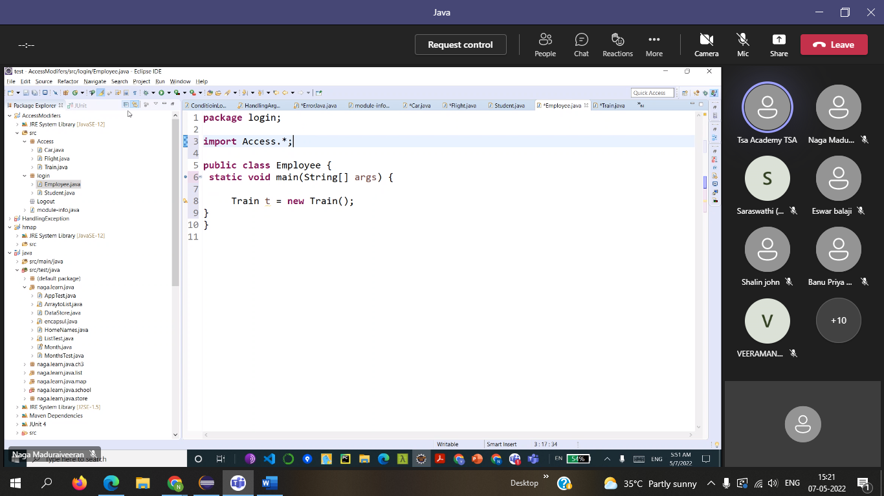

DEFAULT within the package : Only class
Class Train {
Public static void main (String[] args) {
}
}

A method can be public it can use in all the packages
A method can be Default it can use only in the packages
PRIVATE:
Only in that class we can use the private ( Encapsulation)
Not the other class from the package
package Login;

public class Train { // Default Modifier

private static void dologin() {

}
public static void main(String[] args) {

}
}
VARIABLES:
package Login;

public class Train { // Default Modifier
public int a = 10;

private int a = 10;
public static void dologin() {

}
public static void main(String[] args) {

}
}

JAR file
Zip file or archive
More than one file sending bulk a zip
JAVA archive file

import java.io.File;
import java.io.IOException;

public class Filetext {

public static void main(String[] args) throws IOException {
// TODO Auto-generated method stub
File a = new File("D:\\Selenium_class\\Filehand\\apple.txt");

a.createNewFile();

}

}
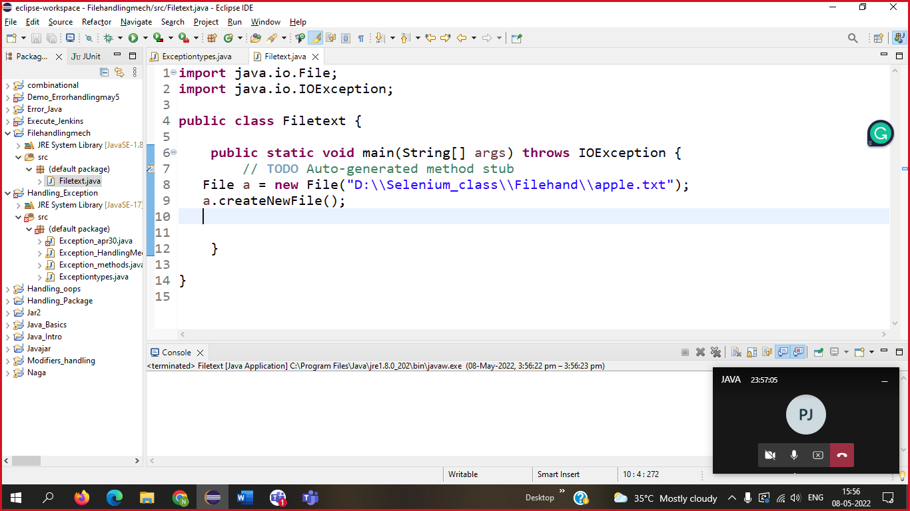

Write in a file
import java.io.BufferedWriter;
import java.io.File;
import java.io.FileWriter;
import java.io.IOException;

public class Filetext {

public static void main(String[] args) throws IOException {
// TODO Auto-generated method stub
//File a = new File("D:\\Selenium_class\\Filehand\\apple.doc");
//a.createNewFile();
FileWriter b = new FileWriter("D:\\Selenium_class\\Filehand\\mango.txt");
BufferedWriter a = new BufferedWriter(b);
a.write("Fruits");
a.newLine();
a.write("Vehicles");
a.write("Electronics");
a.write("1234567");
a.close();

}
}

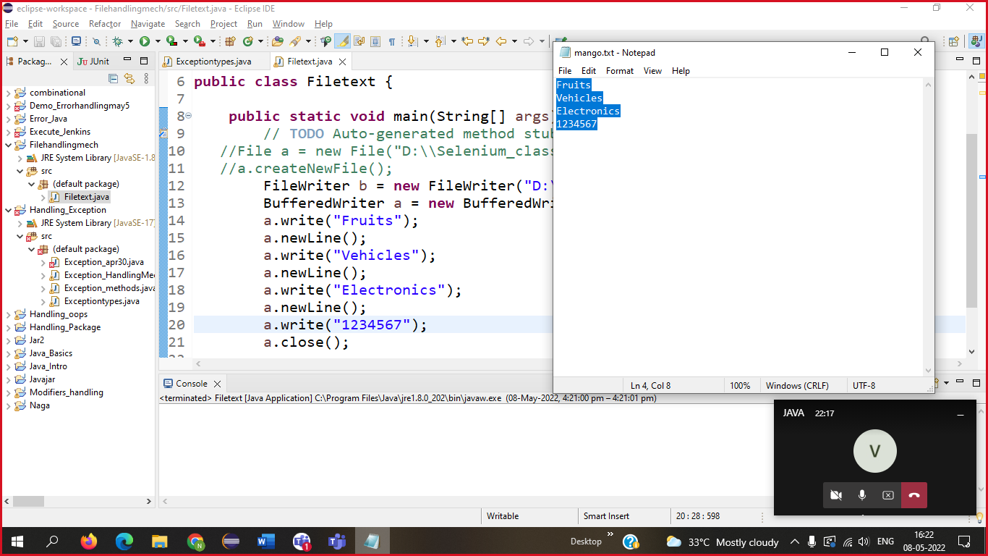

APPEND
import java.io.BufferedWriter;
import java.io.File;
import java.io.FileWriter;
import java.io.IOException;

public class Filetext {

public static void main(String[] args) throws IOException {
// TODO Auto-generated method stub
//File a = new File("D:\\Selenium_class\\Filehand\\apple.doc");
//a.createNewFile();
FileWriter b = new FileWriter("D:\\Selenium_class\\Filehand\\mango.txt",true);
BufferedWriter a = new BufferedWriter(b);
a.write("apple");
a.newLine();
a.write("mango");
a.newLine();
a.write("pomo");
a.newLine();
a.write("v26gh");
a.close();
}
}
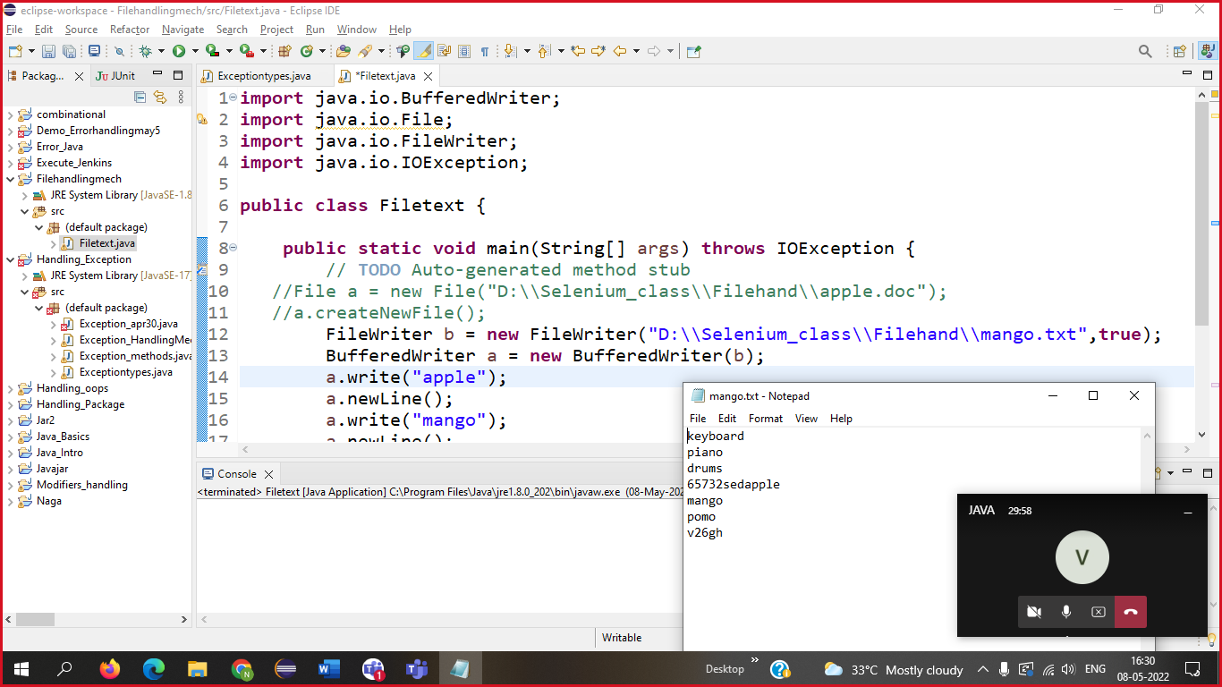

keyboard
piano
drums
65732sedapple
mango
pomo
v26gh

import java.io.FileInputStream;
import java.io.FileNotFoundException;
import java.io.IOException;
import java.util.Properties;

public class HandlingPropertyFile {

public static void main(String[] args) throws IOException {
// TODO Auto-generated method stub
FileInputStream b = new FileInputStream("C:\\Users\\Poongothai\\eclipse-workspace\\Filehandlingmech\\src\\Employee.properties");
Properties a = new Properties();
a.load(b);
System.out.println(a.getProperty("Name"));
System.out.println(a.getProperty("dob"));
System.out.println(a.getProperty("place"));
}
}
