Solution Project 1

Task 1. Setting up master vm install Jenkins and add slave.

Solution :-

$ sudo apt-get update

$ sudo apt-get install Jenkins

$ sudo cat /var/lib/Jenkins/secrets/initialAdminPassword

Adding the slave node using manage Jenkins> managing node > add node using ssh

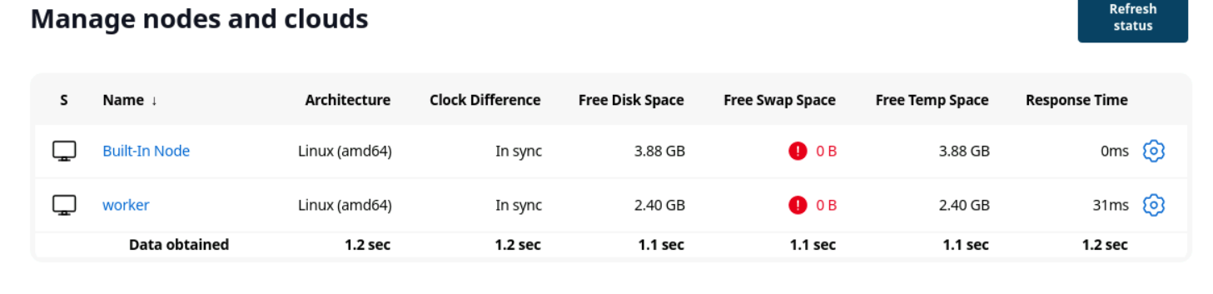

Task 2. Installing pipeline plugin and Post build task plugin.

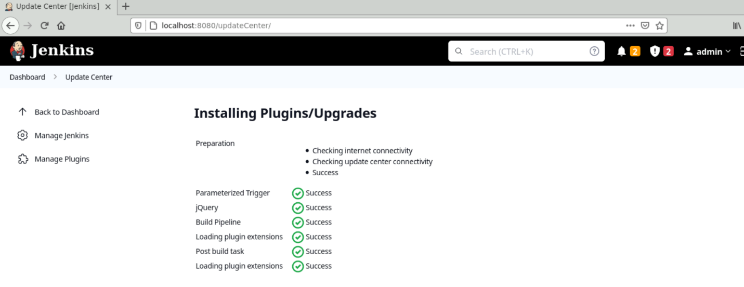

Task 3. Install openSSH python and git on slave node.

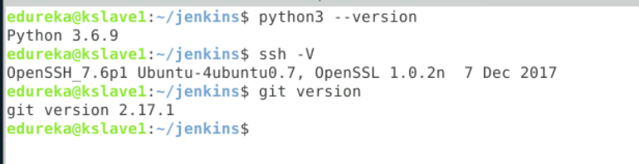

Task 4. Pushing the website and Docker file to git hub.

After cloning the the given project to local push that project to own git hub repo.

Created the docker file .

FROM php.7.0-apache

COPY ./website /var/www/html

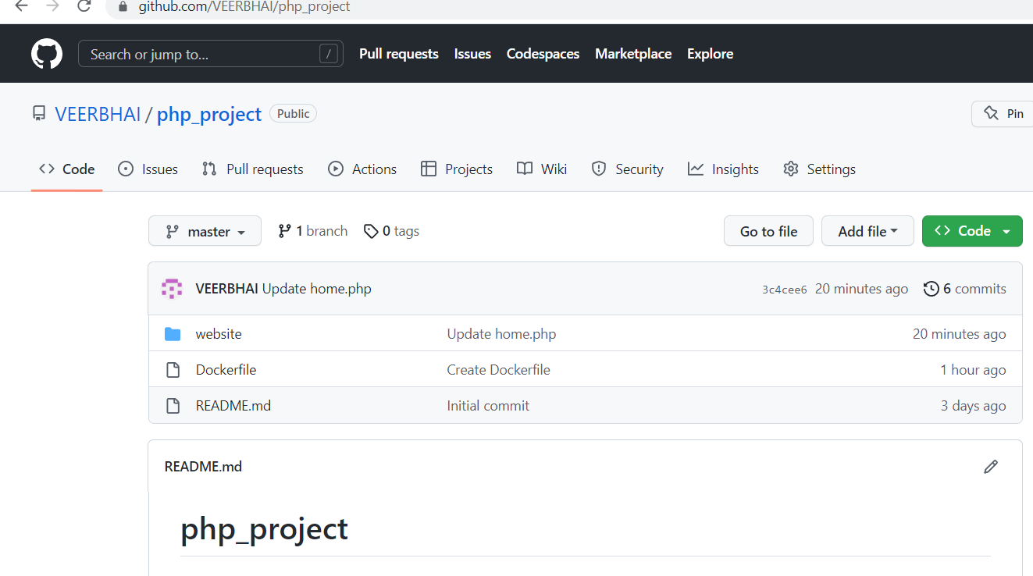

Task 5. Install ansible on master and test connection.

- name: install ansible

  hosts: slave

  become: yes

  tasks:

    - name: update cache

      apt:

        update_cache: yes

    - name: add repo

      command: sudo apt-add-repository ppa:ansible/ansible

    - name: install

      command: sudo apt-get install ansible

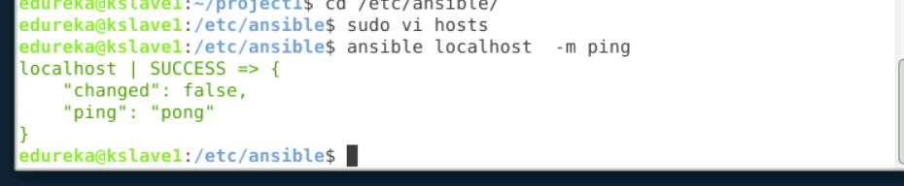

Task 6. Pushing ansible play to install docker

* name: docker install playbook

hosts: localhost

become: yes

tasks:

-name: update cache

Apt:

Update_cache: yes

-name: install docker

Command: |

sudo apt-get update

sudo apt-get install

ca-certificates

curl

gnupg

-name: install

Command: sudo apt-get install docker-ce docker-ce-cli containerd.io docker-buildx-plugin docker-compose-plugin

Task 7. Pull the PHP website, and the Dockerfile from the git repo and build and deploy your PHP docker container. After. (Job 3 ).

Solution:

Create a job php_project .

Use git hub repo to pull the content.

First I have added the ansible server to the ssh connection inside the congif >SSH.

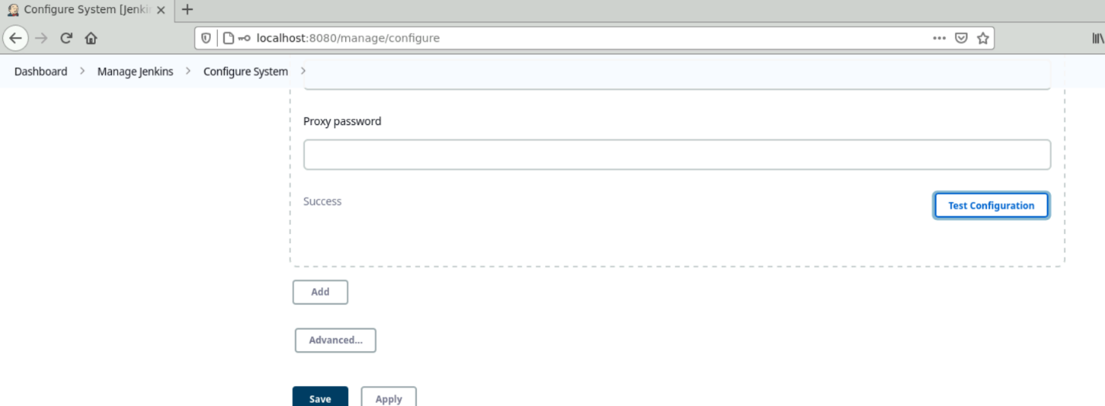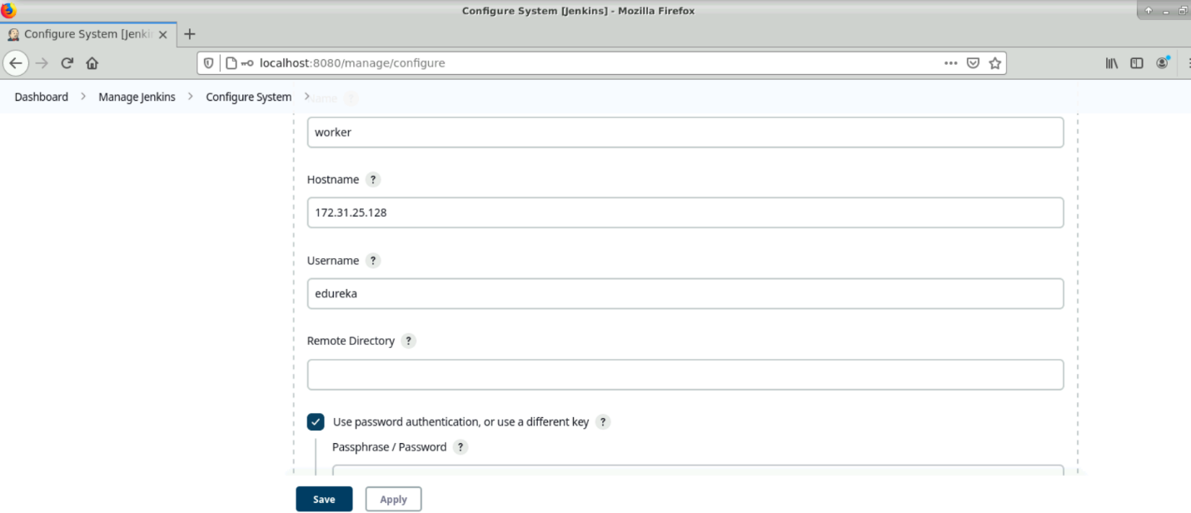 Success status show that ansible configured to Jenkins successfully.

Then in build section select the send and execute over ssh then select the ansible and from workspace copy the content to ansible server local dir i.e /home/edureka/project1.

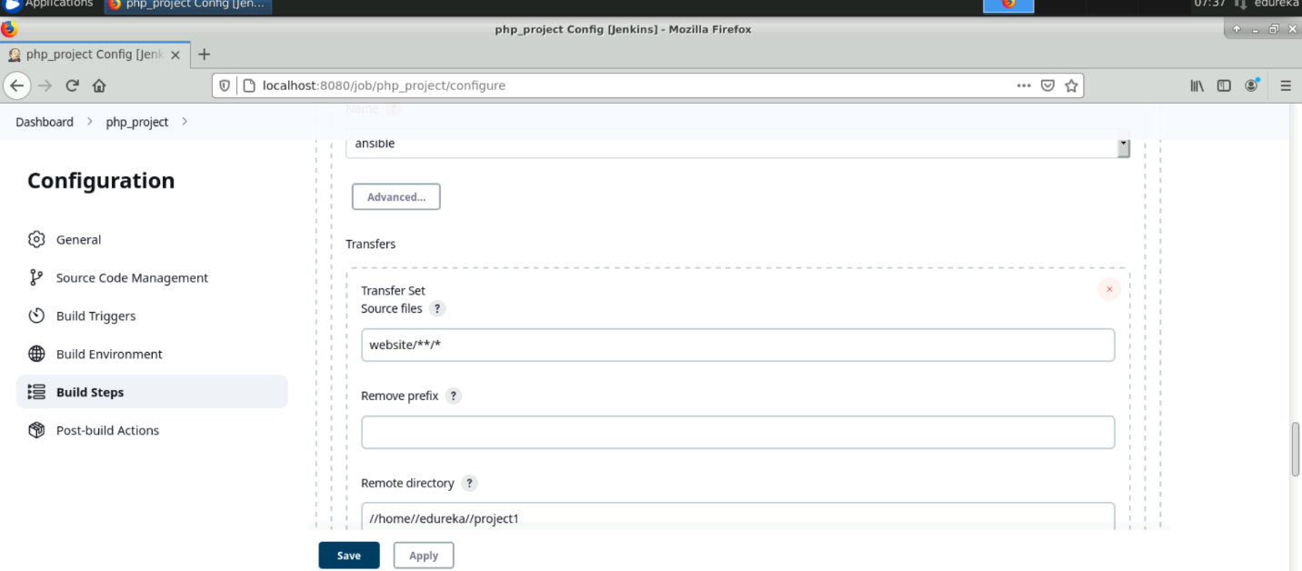

Then run the playbook from Jenkins execute field.

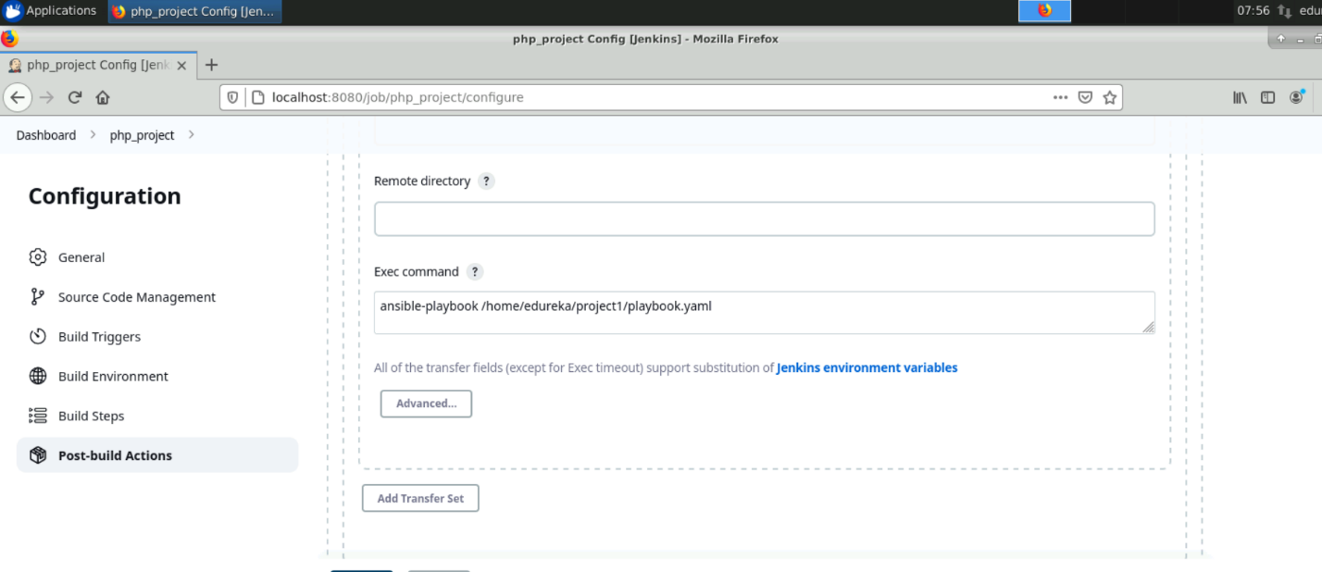

Playbook.yaml

- name: php playbook

hosts: localhost

tasks:

- name: stop existing container

command: sudo docker container stop website

ignore_errors: yes

- name: remove existing container

command: sudo docker container rm website

ignore_errors: yes

- name: remove previous docker images

command: sudo docker image rm -f website:latest

ignore_errors: yes

- name: build docker image

command: sudo docker image build -t website .

- name: run the container

command: sudo docker container run -d --name website -p 8095:80 website

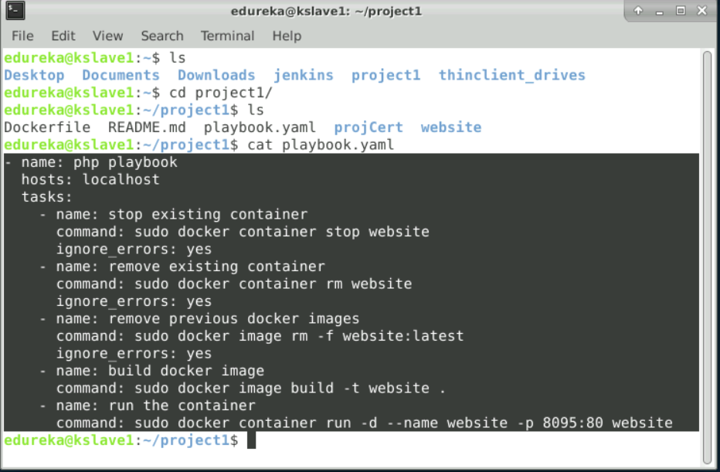

* before execute the Jenkins job
* 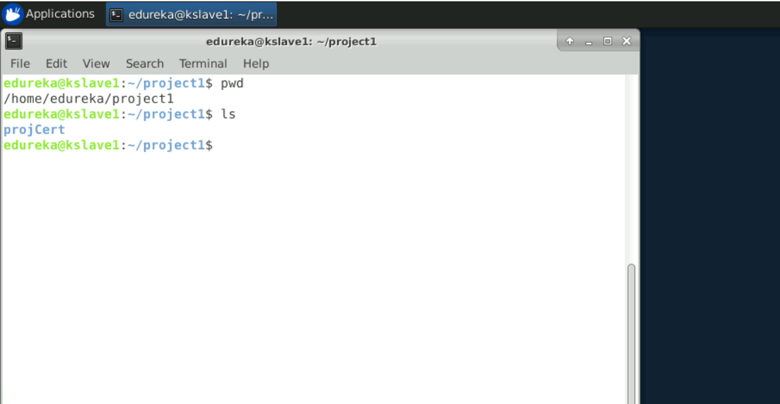
* After running job.

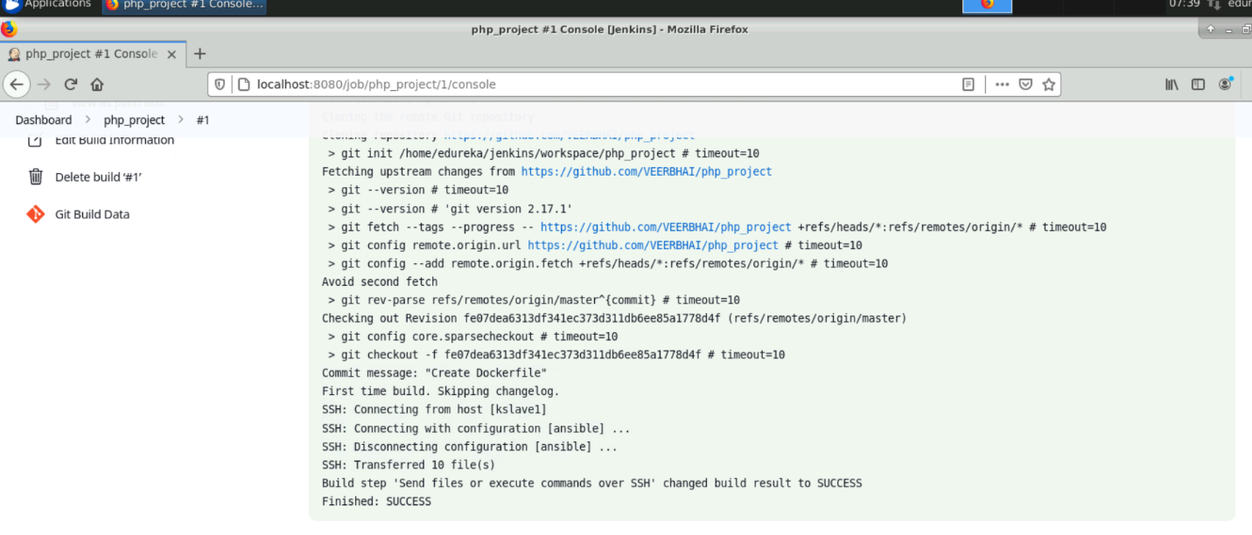

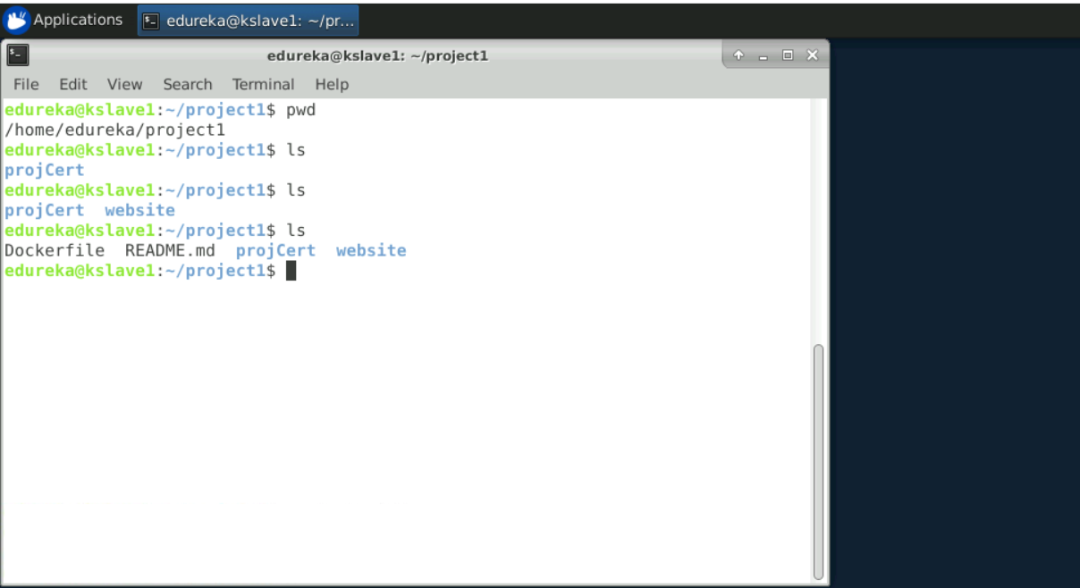

* Set permission to run docker commands by ansible

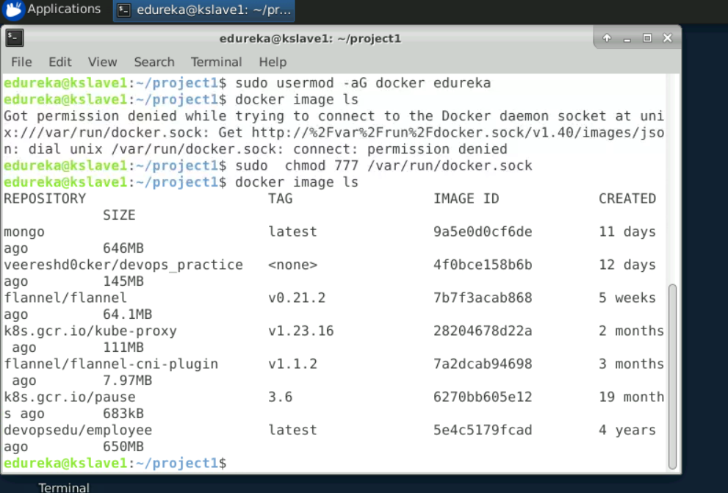

* Image created

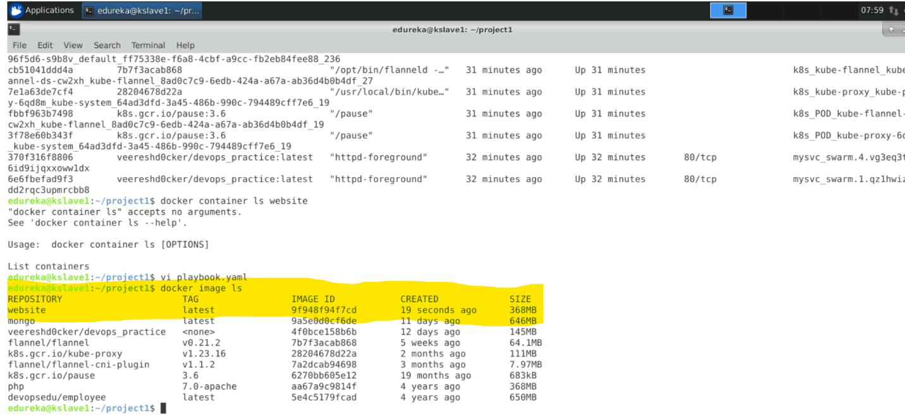

* Container created

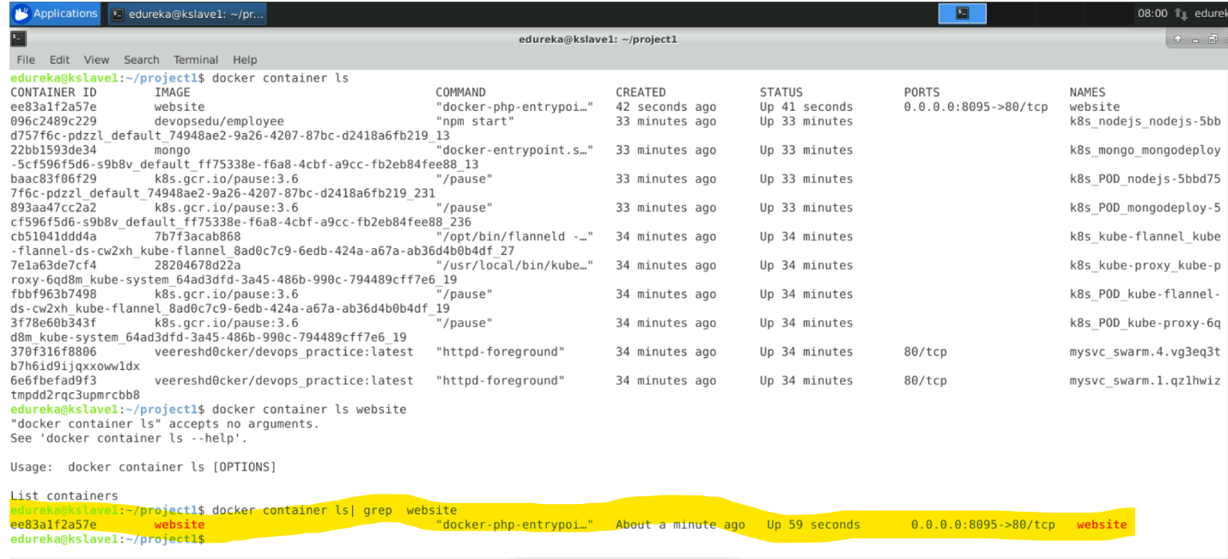

* Output of running the application successfully.

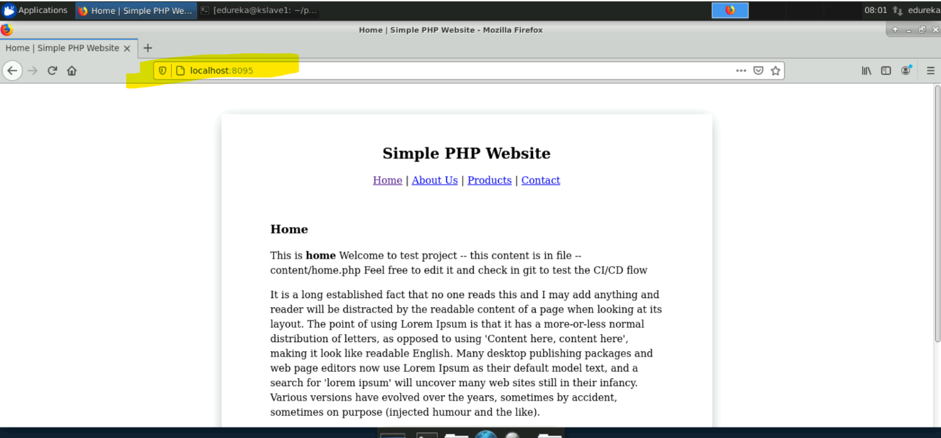

* Setting the poll scm enabled fetch the git hub per min .

And edited in the git hub file content that refelect automatically.

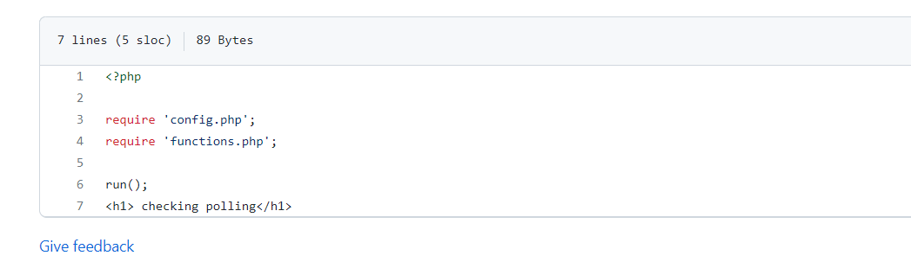

* Final output.

