**Solution**

1. Create a local git repository and move the entire code base to it

Git init

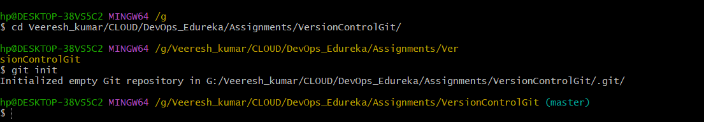

Git add sample-project

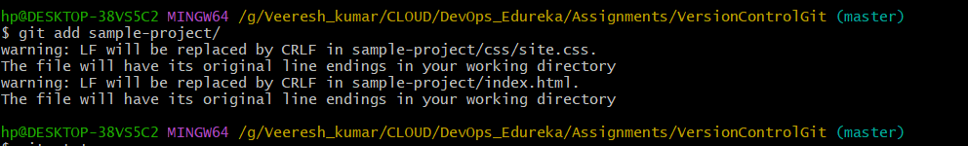

1. Create a new branch for a new feature you want to add to the application

Git checkout –b feature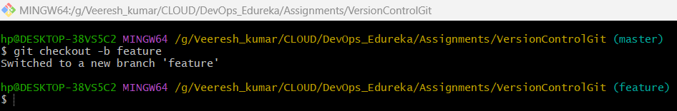

1. Merge back the created branch with the master branch

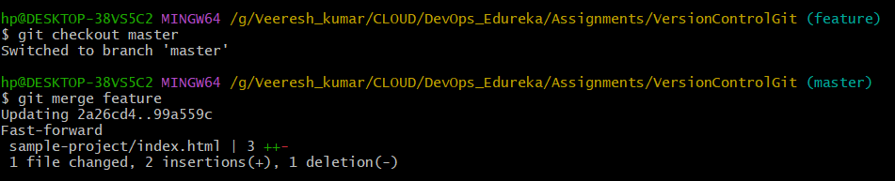

1. Create a remote repository

Git remote add origin git_url

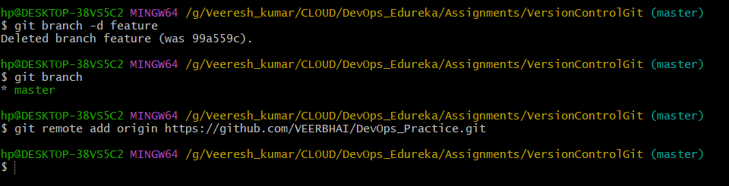

• Push the local repository to company’s remote repository

Gtit push –u origin master

