**Solution**

1. Create two separate branches from master.

Git branch branch1

Git branch branch2

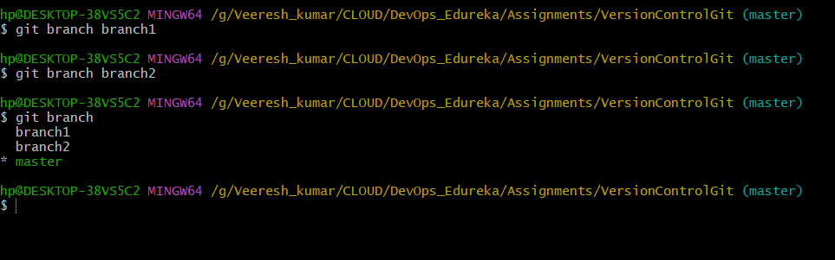

1. Make changes in the same function of the source code in both the branches

Git add sample-project/demo.txt

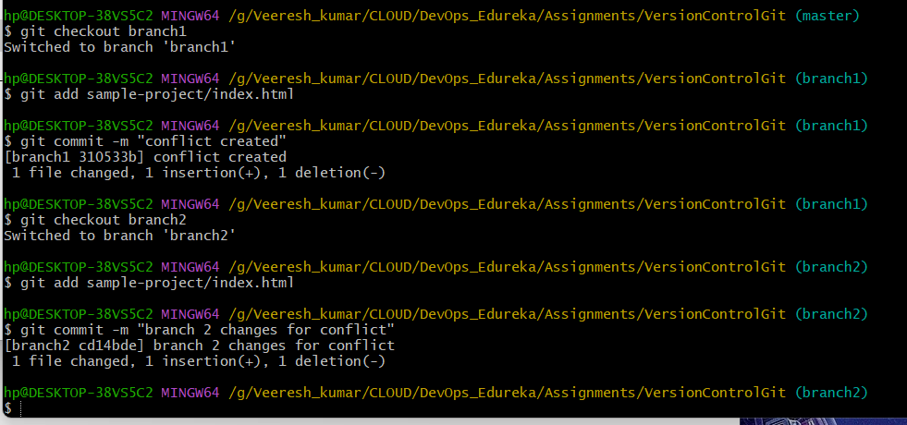

1. Merge branch1 into the master

Git checkout master

Git merge branch1

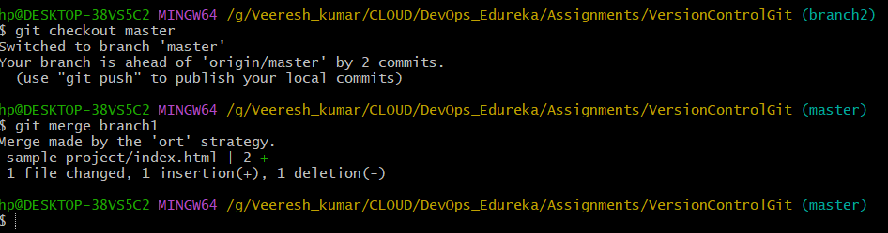

1. Try and merge branch2 into themaster(merge conflict should arise)

Git checkout master

Git merge branch2

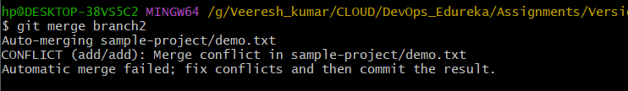

1. Install a merge tool of your choice and resolve the merge conflict usinggit mergetool command

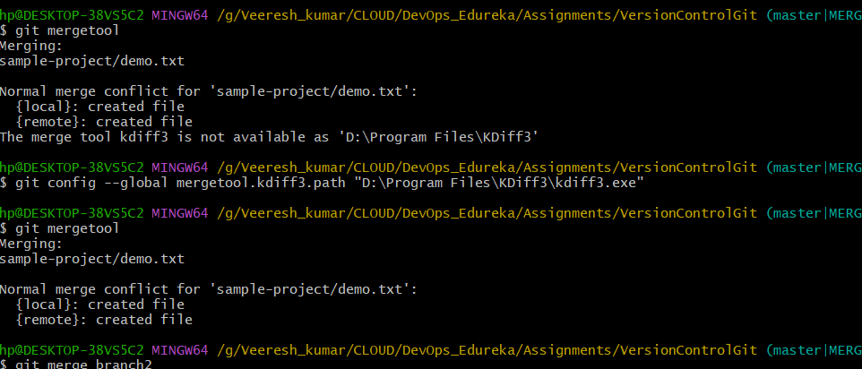 git config --global mergetool.kdiff3.path "D:\Program Files\KDiff3\kdiff3.exe"

git merge branch2

