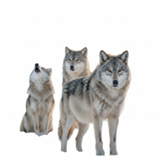

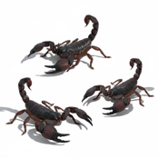
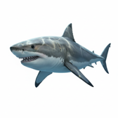
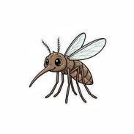

The World's Most Dangerous Animals
When people think about dangerous animals, many of them imagine sharks or lions. But these big predators kill fewer people than you might think. In fact, sharks kill fewer than ten people per year. That's not much.
So which animals are really dangerous? The mosquito is the deadliest animal on Earth. Mosquitoes have much more impact than large predators. They kill around 700,000 people every year because they spread diseases like malaria. That's many more deaths than sharks or lions cause.
Snakes are also very dangerous. Many snakes have long fangs and use toxins to catch their prey. But most snakes have little interest in humans. They only attack when they feel scared. If you give them a little space, they will leave you alone. Few snakes are actually aggressive.
In the desert, scorpions are a danger. When food is scarce, they become more active and search for prey. Scorpions need less water than most animals, so they survive well in hot, dry places.
Wolves hunt in a pack, which gives them much more strength than hunting alone. But there are fewer wolf attacks on humans today than in the past. Wolves usually have little contact with people in their natural habitat.
Many tourists don't know that hippos are more dangerous than lions in Africa. Hippos look slow and calm, but they have much strength. There are fewer hippos than crocodiles in African rivers, but hippos kill more people.
What can we learn? Much of our fear comes from movies, not facts. We worry about sharks, but there is little real danger. With a little knowledge, we can stay safe from the animals that are truly dangerous.
Find the word in the text that means:
- an animal that kills and eats other animals: _____________________________
- the long, sharp teeth that snakes use to bite: ___________________________
- a poison that some animals have in their bodies: __________________________
- an animal that is hunted and eaten by another animal: _____________________
- a very dry, sandy place with little water: ______________________________
- when there is not much of something; hard to find: _______________________
- how strong someone or something is: __________________________________
- when wolves hunt together as a group: ________________________________
- the natural place where an animal lives: _______________________________

