NOBOGYAN A3 Learning System
A3 - Personalized Resource Generation and Learning Multi-Agent System Based on Large Language Models

Team: Velox Studio
Sabbir Hossain · Rahber Hassen · Shoriful Islam

Nanjing University of Posts and Telecommunications (NJUPT)
Advisor: LIU QIANG
Project Duration: 3 months
June 2026

1. Project Overview & Background

1.1 Problem Statement
Traditional online education platforms deliver the same content to every learner, ignoring individual knowledge gaps, learning pace, and cognitive preferences. This one-size-fits-all approach leads to low engagement, poor retention, and inefficient study paths. Students often waste time reviewing material they already know or skip foundational concepts they have not mastered.

1.2 Project Objectives
NOBOGYAN A3 is an AI-native adaptive learning platform that builds a six-dimensional learner profile through natural conversation, generates personalized learning resources via specialized agents, plans adaptive learning paths over a knowledge graph, provides real-time multimodal tutoring, and continuously improves through learning analytics.

1.3 Why This Topic
The rapid development of large language models and multi-agent systems creates an opportunity to move beyond static courses. By combining conversational profiling, orchestrated content generation, graph-based path planning, and data-driven analytics, the project addresses a real educational need while demonstrating advanced software engineering, AI integration, and system design competencies required by the competition.

2. Requirement Analysis

2.1 Functional Requirements
The system implements five core functional modules:
Module | Description | Key Capabilities
Conversational Profiling | Extract learner model from chat | 6 dimensions, confidence scoring, gap detection
Resource Generation | Orchestrate specialized agents | Notes, mind maps, quizzes, media, code exercises
Path Planning | Generate adaptive learning paths | A* search, milestones, dynamic adaptation
AI Tutoring | Real-time Q&A and support | Text, voice, image, diagram, streaming
Analytics | Track and analyze learning | Behavioral insights, predictions, recommendations

2.2 Non-Functional Requirements
Category | Requirement | Target
Performance | Time to first token | < 2 seconds
Performance | Text resource generation | < 60 seconds
Performance | Path planning latency | < 3 seconds
Scalability | Concurrent active users | 50+
Security | Content moderation | Pattern-based filtering on all inputs
Quality | Factual consistency | Faithfulness checker on generated content
UX | Responsive design | Desktop-first web application

3. System Design

3.1 Overall Architecture
The system follows a four-layer architecture:
Layer | Technology | Responsibility
Presentation Layer | Next.js 16 + React 19 + Tailwind | User interface, streaming rendering
Application Layer | FastAPI (Python) | REST APIs, authentication, session management
Intelligence Layer | Kimi + iFLYTEK + RAG | Content generation, reasoning, retrieval
Data Layer | PostgreSQL + Redis + Weaviate | Persistent storage, cache, vector search
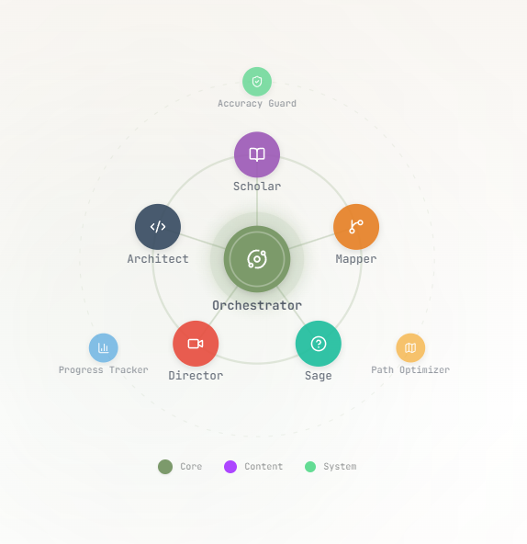
Figure 1: Agent architecture of NOBOGYAN A3

3.2 Database Design
The PostgreSQL schema includes tables for student profiles, learning paths, milestones, quizzes, quiz attempts, chat sessions, generated resources, analytics events, cohorts, and knowledge graphs. JSONB columns store flexible structured content such as profile dimensions and resource payloads.
Table | Purpose | Key Fields
student_profiles | Learner model | knowledge_base, cognitive_style, weak_points, goals
learning_paths | Generated paths | path_sequence, milestones, metrics
generated_resources | Agent outputs | resource_type, content, source, weak_concepts_targeted
quiz_attempts | Assessment records | score, time_taken, answers
chat_sessions | Tutor history | session_type, context_summary, current_node_id
knowledge_graphs | Dynamic graphs | subject, nodes, edges, status

3.3 Module Division
Backend modules are organized under agents/, api/routers/, core/, nlp/, rag/, analytics/, and adaptation/. The frontend uses Next.js app router with route groups for onboarding, dashboard, and authentication.

4. Implementation Details

4.1 Technology Stack
Layer | Technology | Version / Notes
Frontend Framework | Next.js + React | Next.js 16, React 19
Frontend Styling | Tailwind CSS | Tailwind v4
Backend Framework | FastAPI | Python 3.10+
LLM | Kimi (domestic model) | Production reasoning engine
Voice (TTS/ASR) | iFLYTEK | WebSocket TTS and IAT ASR
Vector Store | Weaviate / Chroma | RAG grounding
Database | PostgreSQL + SQLAlchemy + Alembic | 16 tables
Cache | Redis | Session and insights cache
Code Sandbox | Judge0 | Coding exercise execution

4.2 Core Logic and Algorithms

4.2.1 A* Learning Path Planning
The path planner treats topics as nodes and prerequisites as edges. The cost function is f(n) = g(n) + h(n) + profile_bias + preference_bonus, where g(n) accumulates difficulty-weighted time, h(n) estimates importance via PageRank, profile_bias adjusts for weak points and goals, and preference_bonus rewards matching content types.

4.2.2 Dynamic Adaptation Engine
An event-driven engine consumes QuizCompletedEvent, GateCalculatedEvent, GoalChangedEvent, and MilestoneStuckEvent. It selects strategies such as remediate, accelerate, replan, and tutor_nudge with per-student cooldowns to prevent flapping.

4.2.3 Hybrid Recommendation
The recommender fuses content-based scoring (weak points and goals) with collaborative filtering (Jaccard similarity over mastered topics). Weak-point matches receive a 2.0x boost, and already-mastered nodes are excluded.

4.2.4 Faithfulness Guardrail
Every agent output and tutor response passes through a faithfulness checker that classifies claims as supported, contradicted, or unverifiable against retrieved RAG chunks. Low-scoring content receives a warning prefix.

4.3 Interface Design and Screenshots
The user interface follows a calm, focused design system using sage green and sand tones. Key screens include the landing page, learning path creation, interactive mind map, generated notes, code exercises, quizzes, and the AI tutor.

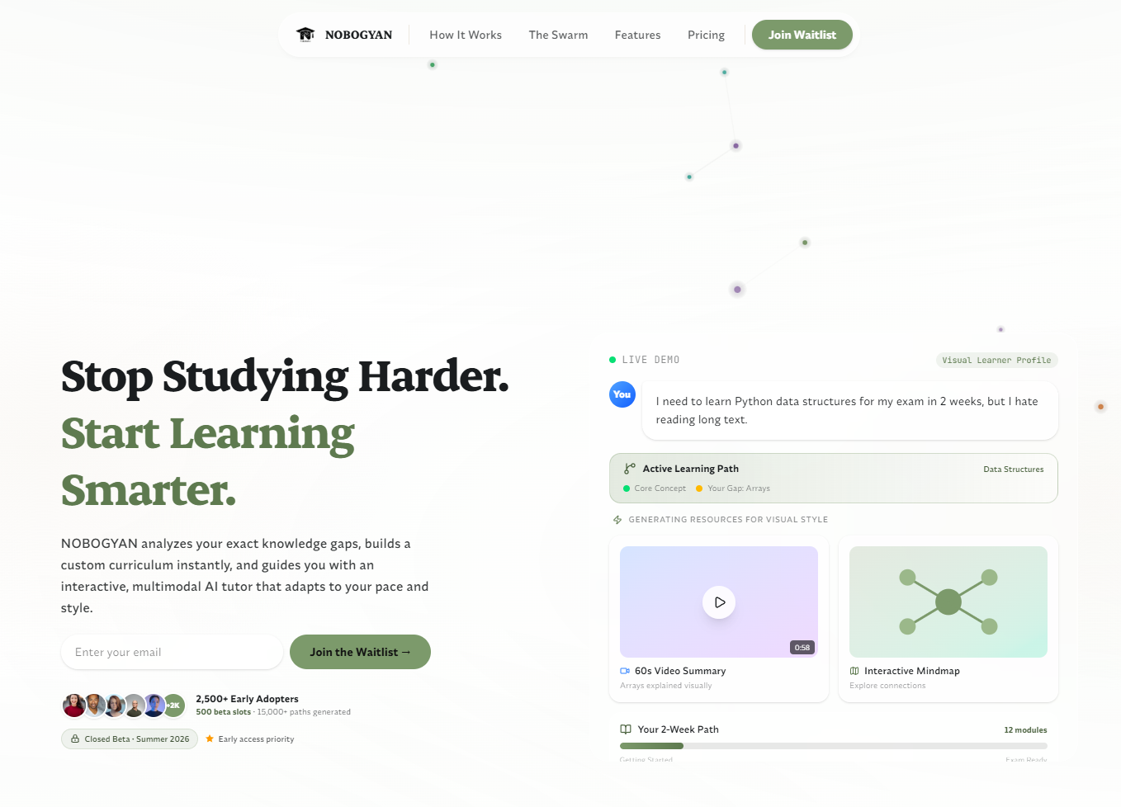
Figure 2: Landing page
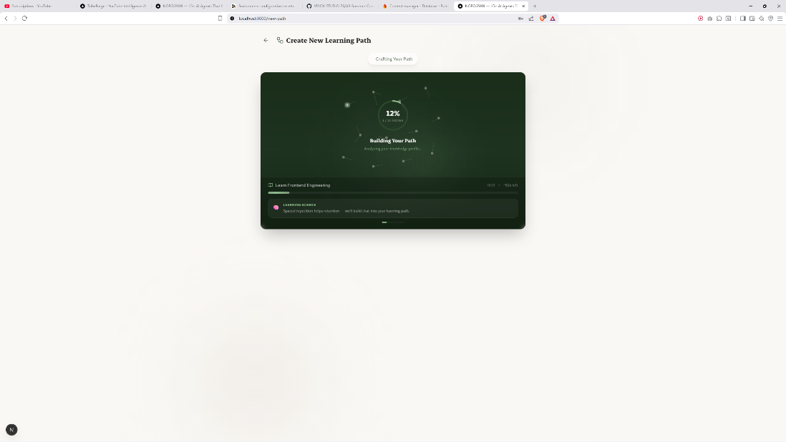
Figure 3: Creating a new personalized learning path
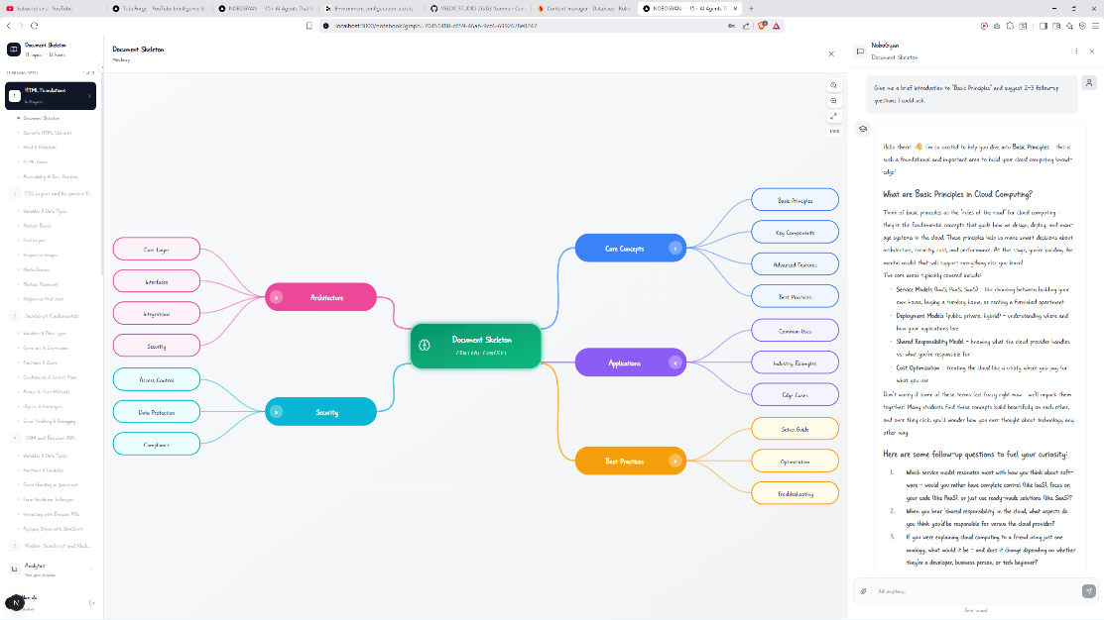
Figure 4: Interactive mind map for Distributed Computing
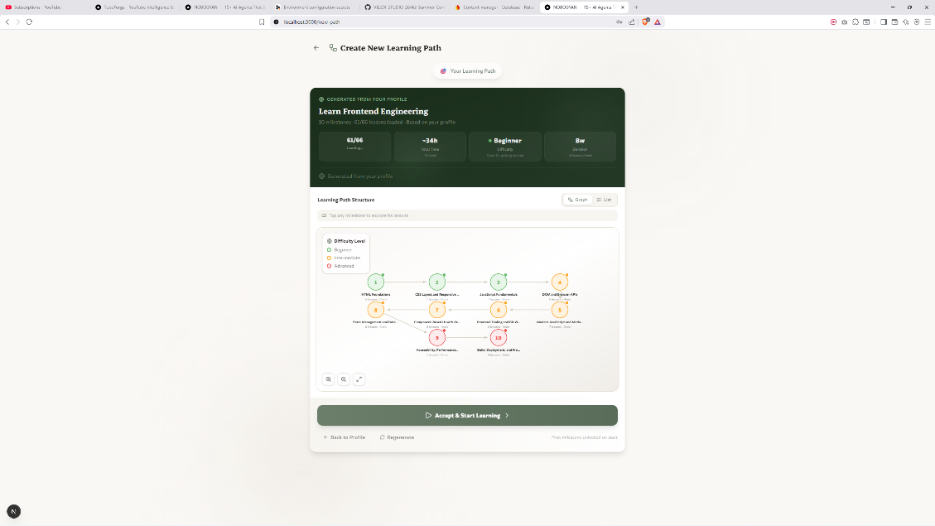
Figure 5: Generated learning notes with analogies and tables
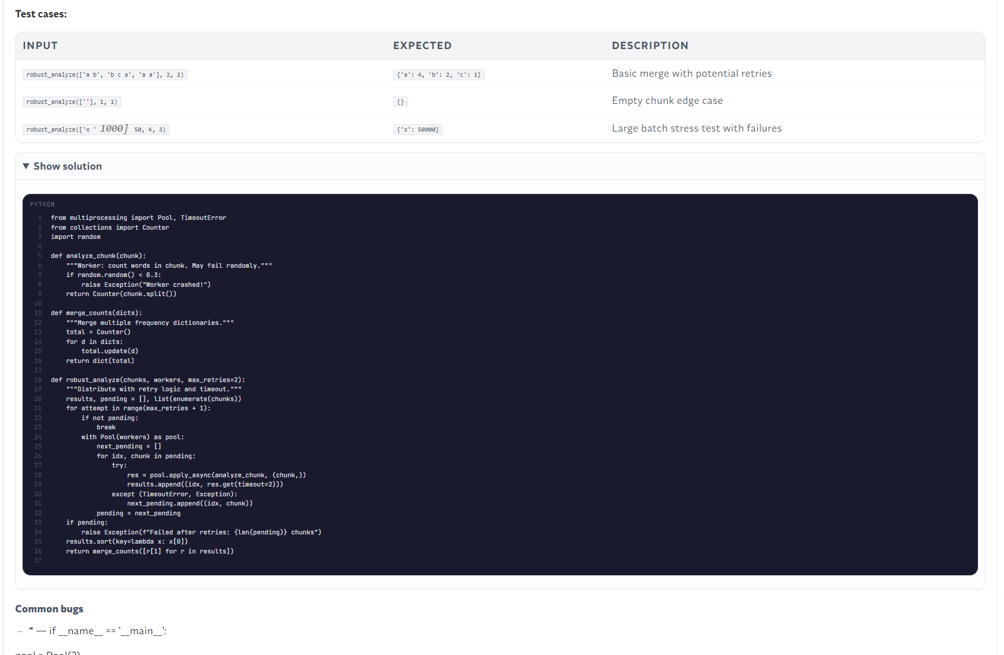
Figure 6: Scaffolded coding exercise with example solution
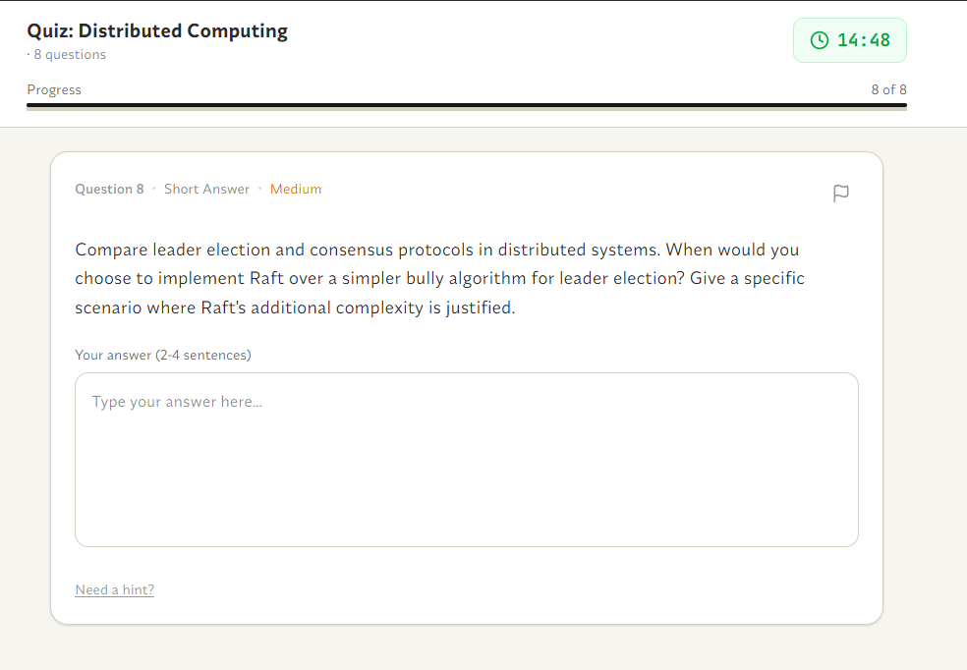
Figure 7: Adaptive quiz interface with scenario-based question
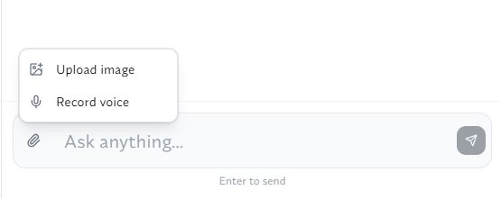
Figure 8: AI tutor input with image, voice, and text support
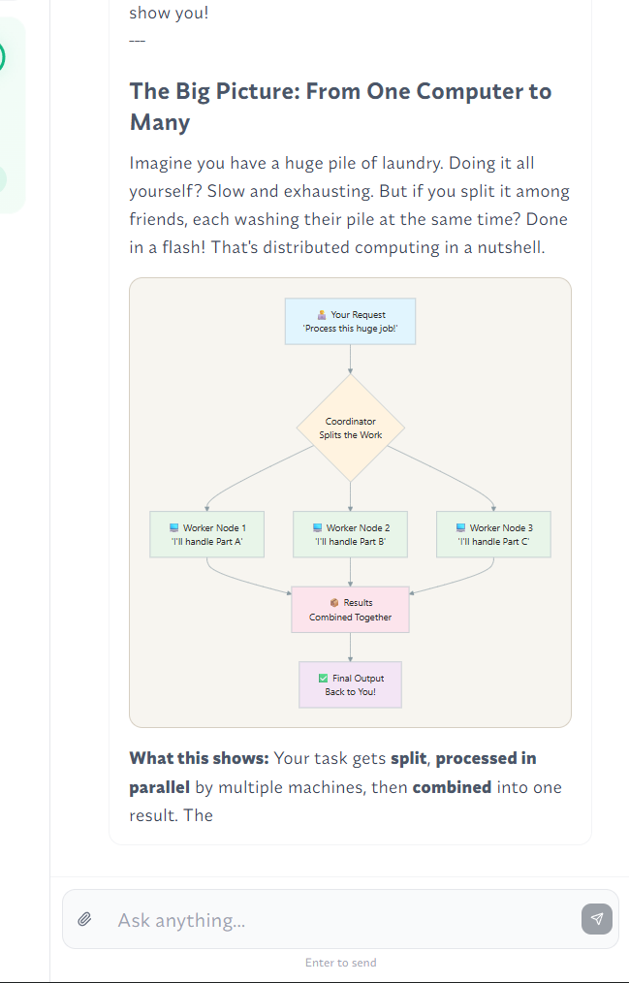
Figure 9: AI tutor generating interactive visual mermaid diagrams

5. Testing & Results

5.1 Backend Unit Tests
The backend includes 35+ pytest files covering critical paths. Test counts per feature are summarized below:
Feature | Tests | Coverage Focus
Conversational Profiling | 30+ | Profile builder + gap detector
Multi-Agent Resources | 35+ | Orchestrator, content, mindmap, media, code
Adaptive Path Planning | 176+ | A*, adaptation engine, recommender, graph generation
AI Tutoring | 94+ | Conversation manager, ASR, faithfulness, moderation
Analytics & Assessment | 25+ | Insights engine, comparative analytics
Total Backend Tests | 360+ | Across 35+ pytest files

5.2 Frontend Testing
Frontend verification is performed through manual testing. The team validated key user flows including registration, onboarding chat, profile summary, learning path generation, resource consumption, quiz submission, and tutor interaction across Chrome and Edge browsers.

5.3 Performance Estimates
Metric | Estimated Value | Notes
Time to first token (tutor) | 2-5 seconds | Includes RAG retrieval and LLM call
Text resource generation | 30-60 seconds | All selected agents in parallel
Path planning (80-node graph) | ~200 ms | A* with custom heuristic
Recommendation latency | ~50 ms | Hybrid CB + CF scoring
ASR partial result latency | ~200 ms | iFLYTEK IAT WebSocket
TTS generation (cached) | ~1 second / 100 words | Edge-TTS with content hashing

5.4 Bug Fixes and Iteration
Recent development addressed race conditions in milestone progress tracking, implemented fallback LLM key rotation, fixed TTS audio playback timeouts, resolved single-slide media agent truncation, and corrected routing between profile summary, new path, and notebook screens.

6. Conclusion & Outlook

6.1 Completed Work
The project delivered a working end-to-end adaptive learning platform. All five core modules are functional: conversational profiling, multi-agent resource generation, A* path planning with dynamic adaptation, real-time AI tutoring, and learning analytics with an interactive dashboard.

6.2 Project Advantages
NOBOGYAN A3 differentiates itself through a closed-loop learning cycle where assessment data continuously refines the learner profile and regenerates resources. The orchestrator-worker agent pattern, RAG-grounded outputs, faithfulness guardrails, and dynamic knowledge graph generation provide strong technical depth.

6.3 Shortcomings and Future Work
Item | Status | Planned Improvement
Teacher dashboard | Future work | Class roster, at-risk flags, progress summary
True video generation | Under evaluation | Testing different models for integration
Frontend automated tests | Not implemented | Add Jest/Playwright coverage
Load testing | Not performed | k6 test at 50 concurrent users
iFLYTEK Spark LLM | Partial | TTS/ASR integrated; evaluating LLM migration

7. References
1. iFLYTEK Developer Documentation (open.xfyun.cn).
2. FastAPI Documentation (fastapi.tiangolo.com).
3. Next.js Documentation (nextjs.org).
4. Tailwind CSS Documentation (tailwindcss.com).
5. Kimi Large Language Model Documentation.
6. Project internal documentation: PROJECT_STATUS.md, GAP_ANALYSIS.md, officialdoc.md.

